

ENVIRONMENTAL AND SOCIAL IMPACT ASSESSMENT FOR THE PROPOSED HYBRID POWER PLANT FOR NECSOM GAROWE, SOMALIA

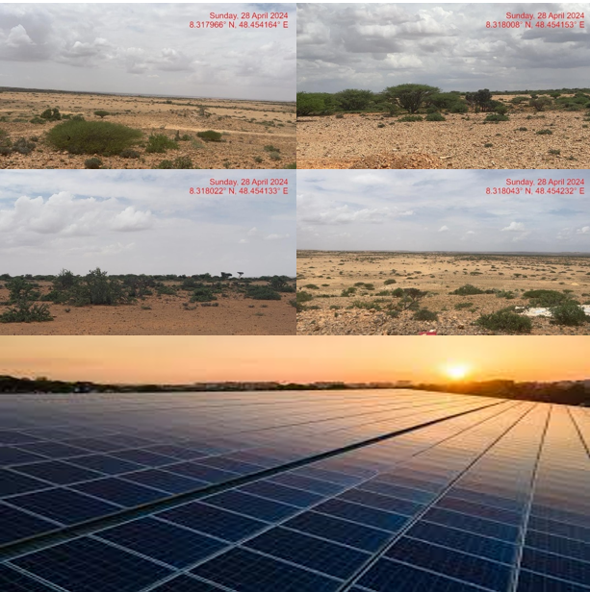

PROJECT
Somali Electricity Sector Recovery Project (SESRP) (P173088)

ELECTRICITY SERVICE PROVIDER

National Energy Corporation of Somalia

JANUARY 2025

DRAFT ESIA REPORT
Title | : | Consultancy Services for Environmental and Social Risk Management Support to the Implementation of the Somalia Electricity Sector Recovery Project (SESRP).

Client | : | Ministry of Energy and Water Resources  Federal Republic of Somalia

Consultant | : | Horizon Developments  https://horizondevelopments.com/

Report: | Name | : | ENVIRONMENTAL AND SOCIAL IMPACT ASSESSMENT FOR THE PROPOSED HYBRID POWER PLANT FOR NECSOM GAROWE, SOMALIA
 | Revision | : | 02
 | Path/Filename | : | NECSOM-ESIA-2024082819
 | Submission Date | : | 31.08.2024

Content

Content iii
Acknowledgement ix
Acronyms and Abbreviations x
Executive Summary xii
1.0. Introduction 33
1.1. Project background 33
1.1.1. Proposed NECOSM Hybrid Power Plant in Garowe 33
1.1.2. Justification for the ESIA 34
1.2. Objectives of the ESIA 34
1.3. Scope of the ESIA study 34
1.4. Terms of reference for the ESIA 35
1.5. ESIA approach and methodology 35
1.5.1. Key activities undertaken during the ESIA 35
1.5.2. Desk study and literature review 36
1.5.3. Environmental and social baseline settings 37
1.5.4. Public consultations 37
1.5.5. Assessment of physical and chemical parameters 37
1.6. Target group for the ESIA report 37
1.7. Key assumptions 38
2.0. Project Description and Context 39
2.1. Overview 39
2.2. Location of the site 39
2.3. project site and surroundings descriptions 39
2.4. Description of the proposed power plant 41
2.4.1. Overview 41
2.4.2. Proposed power generation capacity 41
2.4.3. Architecture and basic design specifications 42
2.4.4. Placement of the solar PV arrays 42
2.4.5. Powerhouse 43
2.4.6. Multi-mode inverter 43
2.4.7. Battery 43
2.4.8. Power evacuation and distribution 43
2.5. The project site 43
2.5.1. Site Ownership 43
2.5.2. Access to the project site 44
2.6. Project activities 44
2.6.1. Construction phase activities 44
2.6.1.1. Outline of the construction activities 44
2.6.1.2. Construction materials, equipment and services 44
2.6.1.3. Input materials and equipment & machinery 44
2.6.1.4. Use of services and resources 45
2.6.1.5. Construction supervision and safety 45
2.6.2. Operation phase activities 46
2.6.3. Decommissioning phase activities 46
3.0. Policy, Legal and Regulatory Framework 47
3.1. Overview 47
3.2. National Laws and regulatory framework 47
3.2.1. Provisional Constitution of Somalia 47
3.2.2. Federal and state regulations on environmental, health, and safety 48
3.2.3. Somalia’s Ninth National Development Plan 48
3.2.4. Environmental protection and land use policy and regulation 49
3.2.5. Labour and employment law 49
3.2.6. Policy and law on gender equality and GBV 49
3.2.7. Somalia’s Power Master Plan, 2018 50
3.2.8. Energy policy and regulations 51
3.2.9. Somalia's Intended Nationally Determined Contributions (INDCs), 2015 51
3.2.10. Customary legal system and sharia law 51
3.3. Puntland State Laws and Regulatory Framework 52
3.3.1. Overview 52
3.3.2. Puntland State Rangeland Management Policy (2016-2025) 52
3.2.3. Puntland State Waste Management Policy (2006) 52
3.3.4. Puntland State ESIA Act and Regulation (2016) Approved by Cabinet and Parliament 53
3.3.5. Puntland State Climate Change Strategy (2016) 53
3.3.6. Puntland State Ministry of Environment and Climate Change Strategic Plan (2016-2020) 53
3.3.7: Puntland State Environmental Policy (2014) Approved by the Cabinet and Parliament 54
3.3.8: Puntland State Environmental Management Act (2016) Approved by Cabinet 54
3.4. The World Bank Environmental and Social Policies and Guidelines 54
3.4.1. World Bank Environmental and Social Standards (ESS) and relevance to the proposed project 54
3.4.2. Resettlement Policy Framework (RPF) for SESRP Projects 56
3.4.3. Comparison between the World Bank and the FGS legislations relevant to the project 57
3.5. International conventions and agreements ratified by the Federal Republic of Somalia (FRS) 59
3.5.1. The United Nations Convention on biological diversity (CBD), 1992 59
3.5.2. The UN Framework Convention on Climate Change (UNFCCC) (ratified in 2009). 59
3.5.3. The UN Convention to Combat Desertification (UNCCD) (ratified in 2002). 59
3.5.4. Convention on the Conservation of Migratory Species of Wild Animals (ratified 1985). 59
3.5.5. Protocol concerning Regional cooperation in Combating Pollution by Oil and other Harmful Substances in Cases of Emergency (ratified 1988). 60
3.5.6. Sustainable Development goals (SDGs) and agenda 2063 in Africa 60
3.5.7. International Labour Organization Agreements 60
4.0. Analysis of Alternatives 62
4.1. Overview 62
4.2. Relocation Option 62
4.3. Zero or No Project Alternative 62
4.4. Alternative Sources of Energy 63
4.4.1. Thermal Power Generation 63
4.4.2. Wind Power Generation 63
4.5. Analysis of alternative construction materials and technology 63
4.7. Selected alternatives 64
5.0. Environmental and Social Baseline 65
5.1. Location 65
5.2. Environmental setting 65
5.2.1. Climatic information 65
5.2.1.1. Rainfall 65
5.2.1.2. Temperature 65
5.2.1.3. Air Quality 66
5.2.1.4. Topography and features 66
5.2.1.5. Geology and soils 66
5.2.1.6. Water resources and hydrology 67
5.2.2. Biophysical environment 67
5.2.2.1. Flora 67
5.2.2.2. Fauna 68
5.2.2.3. Vulnerability to climate change 69
5.2.2.4. Waste management 69
5.2.2.5. Water scarcity and flood risk 69
5.2.2.6. Agricultural land soil contamination 70
5.2.2.7. Land use and land cover 70
5.2.2.8. Protected areas and sensitive habitats 72
5.2.2.9. Environmental management challenges 72
5.3. Socio-economic setting 72
5.3.1. Overview 72
5.3.2. Population 73
5.3.3. Administration and Ethnic Groups 73
5.3.4. Economy and Poverty 74
5.3.4.1. Local Economy 74
5.3.4.2. Poverty and Social Services 74
5.3.5. Electricity generation status 74
5.3.6. Proposed project impact on the local economy 74
5.3.7. Security and conflict environment. 74
6.0. Assessment of Impacts 76
6.1. Overview 76
6.2. Impacts during construction phase 77
6.2.1. Positive impacts 77
6.2.1.1. National, local and regional economy 77
6.2.1.2. Employment and other economic opportunities 77
6.2.2. Negative impacts 78
6.2.2.1. Impacts on biophysical environment 78
6.2.2.1.1. Landscape and visual 78
6.2.2.1.2. Soil, groundwater and surface water contamination 78
6.2.2.1.3. Flood risks 79
6.2.2.1.4. Air quality 79
6.2.2.1.5. Noise 80
6.2.2.1.6. Biodiversity 80
6.2.2.1.7. Soil erosion 81
6.2.2.1.8. Wastes 81
6.2.2.2. Impacts on infrastructure and utilities 82
6.2.2.2.1. Water consumption 82
6.2.2.2.2. Energy consumption 82
6.2.2.3. Impacts on social environment 83
6.2.2.3.1. Impact to livelihoods from grazing land access restrictions 83
6.2.2.3.2. Archaeology and cultural heritage 83
6.2.2.3.3. Trespassing of unauthorized personnel 83
6.2.2.3.4. Worker influx – incoming workforce and workforce accommodation camp 83
6.2.2.3.5. Gender-based violence 84
6.2.2.3.6. Labour disputes 84
6.2.2.3.7. Child and forced labour 84
6.2.2.3.8. Security 85
6.2.2.3.9. Occupational health and safety 85
6.2.2.3.10. Community health and safety risks 86
6.2.2.3.11. Fire hazards 86
6.3. Impacts during Operation Phase 86
6.3.1. Positive impacts 86
6.3.1.1. Employment creation 86
6.3.1.2. Reduction of pollution associated with thermal power generation 86
6.3.1.3. Improved quality of life 87
6.3.2. Negative impacts 87
6.3.2.1. Impacts on biophysical environment 87
6.3.2.1.1. Landscape and visual 87
6.3.2.1.2. Soil, groundwater and surface water contamination 87
6.3.2.1.3. Flood risks 88
6.3.2.1.4. Air quality 88
6.3.2.1.5. Noise 89
6.3.2.1.6. Biodiversity 89
6.3.2.1.7. Soil erosion 91
6.3.2.1.8. Generation of Wastes 91
6.3.2.2. Impacts on infrastructure and utilities 92
6.3.2.2.1. Water consumption 92
6.3.2.2.2. Energy consumption 92
6.3.2.3. Impacts on social environment 93
6.3.2.3.1. Impact to livelihoods from grazing land access restrictions 93
6.3.2.3.2. Trespassing of unauthorized personnel 93
6.3.2.3.3. Worker influx – incoming workforce and workforce accommodation 93
6.3.2.3.4. Gender-based violence 94
6.3.2.3.5. Labour disputes 94
6.3.2.3.6. Child and forced labour 94
6.3.2.3.7. Risks related to poor or inadequate stakeholder engagement (Conflict) 95
6.3.2.3.8. Occupational health and safety 95
6.3.2.3.9. Community health and safety risks 95
6.3.2.3.10. Fire hazards 96
6.4. Key Impacts During the Decommissioning 96
6.4.1. Positive Impacts 96
6.4.1.1. Employment Opportunities 96
6.4.1.2. Site Rehabilitation 96
6.4.2. Negative impacts 97
6.4.2.1. Impacts on biophysical environment 97
6.4.2.1.1. Impacts on landscape and visual 97
6.4.2.1.2. Impacts on biological environment 97
6.4.2.1.3. Solid waste generation 97
6.4.2.1.4. Noise and vibration 98
6.4.2.2. Impacts on Infrastructure & Utilities 98
6.4.2.2.1. Water Resources 98
6.4.2.3. Impacts on social environment 98
6.4.2.3.1. Impacts on Occupational health and safety 98
6.4.2.3.2. Trespassing of unauthorized personnel 99
6.4.2.3.3. Worker influx – incoming workforce and workforce accommodation camp 99
6.4.2.3.4. Gender-based violence 99
6.4.2.3.5. Labour disputes 99
6.4.2.3.6. Child and forced labour 100
6.4.2.3.7. Security 100
6.4.2.3.8. Community health and safety risks 101
6.4.2.3.9. Fire hazards 101
6.5. Summary of the impacts 102
6.5.1. Construction phase 102
6.5.2. Operation phase 102
6.5. 3 Decommissioning Phase 103
6.6. Assessment of cumulative impacts 104
7.0. Mitigation, Monitoring and Reporting 106
8.1. Monitoring 127
8.2. The ESMP implementation tools 166
8.2.1. Construction phase 166
8.2.1.1. Construction management plan 166
8.2.1.2. Rehabilitation and site closure plan 166
8.2.1.3. Local recruitment plan 167
8.2.1.4. Workplace health and safety plan 167
8.2.1.5. Community health and safety plan 167
8.2.1.6. Traffic management plan 167
8.2.1.7. Emergency preparedness and response plan 167
8.2.1.8. SEA/SH prevention and response plan 168
8.2.1.9. Stakeholder engagement plan 168
8.2.1.10. Grievance redress mechanism 168
8.2.1.10. Labour influx management plan 170
8.2.2. Operation phase 170
8.2.3. Decommissioning phase 170
8.3. The ESMP Implementation arrangements 171
9.0. Stakeholder Analysis, Public Consultations and Disclosure 174
9.1. Overview 174
9.2. Objectives of the stakeholder consultations 174
9.3. Approach and methodology 174
9.4. The stakeholders 174
9.5. Summary of key feedback from stakeholders 180
9.5.1. Overall perception about the proposed project 180
9.5.2. Key concerns and recommended action by different stakeholder groups 180
9.6. Expected commitments by NECSOM 185
9.7. Conclusion 185
10.0. Conclusion and Recommendations 186
10.1. Conclusion 186
10.2. Recommendation 187
10.3. Authorization opinion 187
11.0. Annexes 188
Annex 11.1. Land ownership document for the proposed project site 188
Annex 11.2. Public constultation questionnaires 189
Annex 11.3. Focus group discussions outcomes 198
Annex 11.4. Stakeholders consultation attendance sheet (FGD) 207
Annex 11.5. Key informants interviews data sheets 208
Annex 11.6. List of key informants engaged during the ESIA study for the proposed NECSOM hybrid power plant, Garowe 223

List of Figures
Figure 1-1: Summary of ESIA procedure adopted for the proposed hybrid power plant 36
Figure 2-1: Location of the project site in Garowe City, Somalia 39
Figure 2-2: Illustration sketch of the proposed tilt angle of the solar panels placement at the power plant 42
Figure 5-1: Temperature and precipitation in the Puntland region of Somalia 66
Figure 5-2: Land use types in Garowe City and the surrounding areas, Puntland State 71
Figure 5-3: Land cover types in Garowe City and the surrounding areas, Puntland State 72

List of Tables
Table 1-1: Summary of SESRP project components 33
Table 2-1: NECSOM customer base earmarked for connection in the next two years 42
Table 3-1: The ESS triggers and relevance to the proposed Hybrid Power Plant 55
Table 3-2: Comparison between the key WB Environmental and Social Standards relevant to the project and the FGS legislations 57
Table 6-1: Categories of significance 76
Table 6-2: Overall significance criteria for environmental impacts 77
Table 6-4: Summary of key impacts during the Construction phase of the solar plant 102
Table 6-5: Summary of key impacts during the Operation phase of the solar plant 102
Table 6-6: Summary of key impacts during the decommissioning phase of the solar plant 103
Table 6-7: Summary of key cumulative impacts for the proposed power plant project 104
Table 7-1: Mitigation measures, monitoring and reporting during the construction, operation and decommissioning phases for the proposed Hybrid Power Plant 106
Table 8-1: Environmental and social management plan (ESMP) for the proposed NECSOM Hybrid Power Plant-Garowe 129
Table 8-2: The ESMP implementation arrangements for the proposed NECSOM Hybrid Power Plant-Garowe 171
Table 9-1: The stakeholders identified and engaged during the ESIA study for the proposed NECSOM hybrid power plant in Garowe 174
Table 9-2: The stakeholders’ concerns and recommended mitigation actions for the proposed NECSOM hybrid power plant in Garowe 181

Acknowledgement

Horizon Development (the consulting firm) is grateful to the project proponent for commissioning this Environmental and Social Impact Assessment for the National Energy Corporation of Somalia (NECSOM), one of the electricity service providers (ESP) based in Puntland State and a participant in the Somali Electricity Sector Recovery Project. We would like to acknowledge with great appreciation NECSOM management, the local communities and other stakeholders in Puntland State, and the Federal Republic of Somalia (FRS), who were involved in the public participation and consultation process, for their cooperation throughout the exercise. We further acknowledge the support, either direct or indirect, from other various parties who assisted the HD ESIA experts’ team towards the successful completion of the ESIA and production of this report. Finally, the HD wishes to acknowledge and appreciate the efforts and inputs by the SESRP Project Implementation Unit (PIU) and the Ministry of Energy and Water Resources (MoEWR) for their valuable support, inputs, and corporation during the entire exercise.

Acronyms and Abbreviations

AC | : | Alternating Current
ADR | : | Alternative Dispute Resolution
AfDB | : | African Development Bank
ALARP | : | As-low-as-reasonably-possible
BESS | : | Battery Energy Storage Systems
CO | : | Carbon Monoxide
CO2 | : | Carbon Dioxide
CSO | : | Civil Society Organization
DC | : | Direct Current
DIN | : | German Institute for Standardization
DOD | : | Depth of Discharge
DoECC | : | Directorate of the Environment and Climate Change
DRE | : | Distributed Renewable Energy
E&S | : | Environment and Safety
EHSG | : | Environment, Health and Safety Guidelines
ELV | : | Extra-low voltage
ESF | : | Environmental and Social Framework
ESIA | : | Environmental and Social Impact Assessment
ESMF | : | Environmental and Social Management Framework
ESMP | : | Environmental and Social Management Plan
ESP | : | Electricity Services Provider
ESS | : | Environmental and Social Standards
FGS | : | Federal Government of Somalia
FMS | : | Federal Member State
FRS | : | Federal Republic of Somalia
GBV | : | Gender-based Violence
GDP | : | Gross Domestic Project
GHG | : | Greenhouse Gas
GN | : | Guidance Notes
GRM | : | Grievance Redress Mechanism
HD | : | Horizon Development
HIV/AIDS | : | Human Immunodeficiency Virus/Acquired Immunodeficiency Syndrome
ICP | : | Informed Consultation and Participation
IDO | : | Industrial Diesel Oil
IDP | : | Internally Displaced Persons
IEC | : | International Electro technical Commission
ILO | : | International Labour Organization
INDCs | : | Intended Nationally Determined Contributions
ITCZ  JTC | : | Inter-Tropical Convergence Zone  Joint Technical Committee
LV | : | Low Voltage
MoEWR | : | Ministry of Energy and Water Resources
MW | : | Megawatt
NAPA | : | National Adaptation Program of Action on Climate Change
NDP | : | National Development Plan
NECSOM | : | National Energy Corporation of Somalia
NO2 | : | Nitrogen Oxide
NT | : | Near-threatened
NUWACO | : | Nugal Water Company
OHS | : | Occupational Health and Safety
OP | : | Operational Policy
PAP | : | Project Affected Persons
PIU | : | Project Implementation Unit
PMP | : | Power Master Plan
PPE | : | Personal Protective Equipment
PV | : | Photovoltaic
PWD | : | People with Disability
RAP | : | Resettlement Action Plan
REF | : | Renewable Energy Factor
RPF | : | Resettlement Policy Framework
SDG | : | Sustainable Development Goal
SEA/SH | : | Sexual Exploitation and Abuse and Sexual Harassment
SEP | : | Stakeholder Engagement Plan
SESRP | : | Somali Electricity Sector Recovery Project
SME | : | Small and Medium Enterprise
SO2 | : | Sulphur Dioxide
TV | : | Television
UNCCD | : | UN Convention to Combat Desertification
UNFCC | : | United Nations Framework Convention on Climate Change
UNFPA | : | United Nations Fund for Population Activities
UNHSP | : | United Nations Human Settlements Programme
USAID | : | United States Agency for International Development
UV | : | Ultraviolet
VMG | : | Vulnerable and Marginalized Groups
VU | : | Vulnerable
WB-ESS | : | World Bank Environmental and Social Standards
WBG | : | World Bank Group

Executive Summary
- Somalia's electricity sector is fragmented and inefficient, ranking among the world's worst for affordability. The Federal Government of Somalia has received World Bank funding to support the Somali Electricity Sector Recovery Project(SESRP) project, aiming to increase access to cleaner energy. Horizon Development (Consulting firm) is assisting the Project Implementation Unit (PIU) in managing environmental and social risks, implementing mitigation measures, and overseeing the implementation of SESRP in Somalia, ensuring compliance with national laws and World Bank Environmental and Social Framework (ESF) policies. The SESRP Development Objective is to increase access to lower cost and cleaner electricity supply in the project areas and to reestablish the electricity supply industry in different load centres within the Federal Republic of Somalia.

- The SESRP has the following components:
SESRP | - Component 1 – Sub-transmission and distribution network reconstruction, reinforcement, and operations efficiency in the major load centers of Mogadishu and Hargeisa.
 | - Component 2 – Hybridization and battery storage systems for mini grids.
 | - Component 3 – Stand-alone solar off-grid access to public institutions (Health and Education).
 | - Component 4 - Institutional Development and Capacity Building.

- The National Energy Corporation of Somalia (NECSOM) is one of the electricity services providers participating the SESRP project, especially in implementing component 2 on hybridization and battery storage systems for mini-grids in Garowe, Somalia. NECSOM currently has an installed capacity of 10.83MW consisting of 8.88MW (diesel genset), 1MW (solar PV) and 0.75MW (wind energy). Under the proposed arrangement, NECSOM will establish a new and modern hybrid power plant while the MoEWR will provide overall coordination of the project and oversight during planning and implementation of the project, including overall coordination and oversight for safeguards due diligence, and implementation. The joint technical committee (NECSOM and MoEWR) will be responsible for the implementation of the project during construction and operation phases.

- NECSOM is expected to conduct a capacity assessment of its environmental and social management system and identify gaps to assist in the preparation of a robust environmental and social management system before the commencement of the proposed hybrid power plant.

- The main objective of this ESIA was to examine both positive and negative effects of the proposed hybrid power plant on the people, their property and the environment particularly in the Project Area (Garowe City and the surroundings), and proposed measures to mitigate the negative impacts and enhance positive impacts during the construction, operation and decommissioning phases of the project.

- This ESIA study followed World Bank's Environmental and Social (E&S) Framework, national legislations, and international best practices. It focused on understanding the project background, preliminary designs, and implementation plan. Data was collected through both qualitative and quantitative methods, including literature reviews and physical observations, photography, check lists, interviews, and stakeholder consultation. Primary data was collected through interviews, discussions, photography, observations, and checklists to understand the environmental, socio-economic, and cultural setting of the project site and surrounding area.

Project Description and Context
- The proposed hybrid power plant in Garowe District, Nugal region of Puntland State, Somalia, is located 7 km south of the current NECSOM Power Plant in the suburb of Garowe City (8.318043⁰N, 48.454232⁰E). The 290-hectare site, owned by NECSOM, occasionally livestock and herbivorous wildlife graze on the land. The area is sparsely populated, and there is plenty of land for grazing of livestock and habitat for wildlife. NECSOM has already partly rehabilitated the existing road to the proposed site and is scheduled to complete the road before the commencement of the project. The construction of the road is solely funded by NECSOM.

- The feasibility study recommends scenario 2 of 50% REF for detailed design of a hybrid hybrid power plant with a 23.8MW capacity. A transmission line will be constructed from the proposed power plant and linked to an existing sub-station at the current NECSOM power plant in Garowe, The proposed power plant will comprise of PV modules and lithium-ion battery storage system. The plant is expected to operate for 25 years with a battery lifetime of 6000 cycles (approximately 17.5 years), and shall be decommissioned thereafter. Given that the lifetime of a lithium-ion battery is expected to expire after 17 years yet the power plan is to operate for 25 years, a replacement plan will be implemented to ensure continued functionality. This shall include procuring and installing new batteries or upgraded storage technologies, safely recycling or disposing of expired batteries in line with environmental regulations, and allocating funds for the replacement. Battery replacement shall be coordinated with routine maintenance to minimize downtime. Additionally, this shall present an opportunity to adopt newer, more efficient technologies that could enhance the plant's performance for the remainder of its operational life. The proposed power plant will be connected to a substation located in Garowe City, and would require a nine (9) km transmission line, a way leave that runs along an existing road will be used thus there will be no need for land acquisition.

Legal and Regulatory Framework
- The Federal Government of Somalia (FGS) has been struggling with lack of well-developed environmental laws due to political instability. However, the Provisional Constitution of Somalia is explicit on safe and clean environment for the citizens. Additionally, a new Environmental Protection and Management Act (2020) has also been enacted to spearhead environmental management in the Federal Republic of Somalia (FRS). For instance, the lower house of the parliament has approved the new environmental regulations which is now under review by the upper house. Additionally, the FRS is in the process of developing several other regulations under the environmental protection law.
- The World Bank's latest E&S Frameworks and guidance notes were analyzed to determine if any of the ESS was triggered by the proposed project. The ESIA aimed to provide guidance for environmental and social assessment of WB-financed projects, improve decision-making, ensure sustainable options, and properly consult affected people. The ESIA revealed that the proposed project will have both negative and positive impacts on the environment and social spheres, highlighting the importance of sound and sustainable project options.
- The FRS is a signatory to a number of international treaties, conventions and agreements that include legally binding commitments to protect the environment and to ensure the sustainable management of natural resources. For this ESIA, the following multilateral agreements to which FRS is a signatory were reviewed, and their relevance to the proposed project analyzed: The United Nations Convention on biological diversity (CBD); The UN Framework Convention on Climate Change (UNFCCC); The UN Convention to Combat Desertification (UNCCD). Convention on the Conservation of Migratory Species of Wild Animals (ratified 1985); Protocol concerning Regional cooperation in Combating Pollution by Oil and other Harmful Substances in Cases of Emergency; Sustainable Development goals and Agenda 2063 in Africa; and International Labour Organization Agreements.

Analysis of Alternatives
- Two sites were under consideration – the existing power plant and the proposed new site, which is 7km away from the existing power plant. The analysis of alternatives compared the existing power plant location, which lacks adequate space for the new hybrid power infrastructure, with a new site 7 km away that offers sufficient space for expansion. While maintaining the current location would leverage existing infrastructure and minimize relocation costs, space constraints could limit future growth and operational efficiency. On the other hand, the new site (7km away) provided ample room for investment, allowing for optimized layout and future scalability, though it would involve additional costs in terms of infrastructure development, and possibly increased transmission losses due to the distance. Careful consideration of long-term benefits, costs, and operational efficiency are crucial in determining the best option for sustainable power generation.
- The site for the proposed project was selected based on several factors, including geophysical Factors – An open and expansive area with maximal solar irradiance, a location not prone to soil erosion and flooding, and an area with good drainage, etc.; land identified is free from any dispute on ownership or any other encumbrances; and no squatters, encroachers or other claims to the land.
- The No Project Option was deemed least preferred due to socio-economic and environmental factors. It would continue diesel generator-based electricity generation, causing GHG emissions, and affecting local economies due to lack of affordable, clean, and reliable electricity supply. This would also hinder employment opportunities and hinder the Puntland State and FRS from meeting energy requirements, thereby affecting the overall socio-economic status of target communities.

Environmental and Social Baseline
- Garowe City and its surrounding areas are classified as arid to semi-arid, with long periods of drought and minimal rainfall. The Puntland region in Somalia has a diverse topography, with calcareous soils and a long coastline. The city's foundation is based on ancient Precambrian basement rocks. The flora is dominated by species adapted to the arid climate and diverse landscape, with acacia, thorny shrubs, and bushes providing shade and grazing for livestock. Some herbaceous plants and grasses thrive during short rainy seasons, providing fodder for livestock. The city's foundation consists of ancient Precambrian basement rocks.

- The proposed project area is vacant with occasional grazing by livestock and wildlife just like all the vast land of Puntland that is sparsely populated. Livestock includes camels, goats, sheep, donkeys, and chickens. The area is not a breeding site for endangered species but is within the distribution range of Gerenuk, Dorcas gazelle, and Soemmerring’s gazelle.

- The Puntland region's socioeconomic environment is shaped by historical background, cultural diversity, economic activities, infrastructure development, and governance dynamics. Traditional pastoralism, and urban centers like Bosaso and Garowe support local communities. The region invests in road infrastructure, improves access to clean water and sanitation, and provides education and healthcare services.

Assessment of Impacts
- The project aims to positively impact the Puntland State and FRS economy by providing employment opportunities and boosting economic growth. However, it will also have negative impacts on the biophysical environment, infrastructure, utilities, and social environment, including land access restrictions, worker influx, security, occupational health, and fire hazards.

Impacts and mitigation measures
Impact category | Description | Recommended Mitigation Measures | Project Phase
Impacts on biophysical environment | Landscape and visuals | - Fence round the hybrid power plant to keep off/screen the solar panels. | Construction
 | Soil, groundwater and surface water contamination | - Ensure waste water generated is discharged or drained into approved drainage facilities  - Construction vehicles must be maintained in good state and proper servicing to ensure no oils are likely to leak  - Care must be exercised not to spill any fossil fuels  - Any contaminated soil shall be scooped and disposed-off appropriately.  - No servicing vehicles on site  - Infrastructure shall be designed to ensure that contaminated run-off does not reach water source i.e., earth dam.  - Contractor to develop an oil-spill containment plan as part of the emergency response plan. In the event of an oil spill the procedures contained in the emergency response plan of the contractor will come into effect.  - No vehicle maintenance and service shall be done at project site  - Ensure that potential sources of petro-chemical pollution are handled in such a way to reduce chances of spills and leaks. | Construction
 | Flood risk | - Ensure drainage channels are free of any obstruction at all times during construction  - Create flooding diversions and or spill ways to divert water from getting into the construction site, | Construction
 | Air quality (Dust) | - The construction area should be fenced off to reduce dust to the public  - Suppress dust during dry periods by use of water sprays;  - Stockpiles of excavated soil should be enclosed/covered/watered during dry or windy conditions to reduce dust emissions.  - Burning of woody debris & construction waste to be prohibited  - Use of personnel protective equipment (PPE) -masks should be provided to all personnel in areas prone to dust emissions  - Restrict speed on loose surface roads during dry or dusty conditions  - Keep stockpiles and exposed soils compacted and re-vegetate as soon as possible.  - Construction trucks moving materials to site, delivering sand and cement to the site should be covered to prevent material dust emissions into the surrounding areas  - Plant short trees to break speed of wind | Construction
 | Air quality (Vehicle exhaust emissions) | - Drivers of construction vehicles must be sensitized so that they do not leave vehicles idling so that exhaust emissions are lowered.  - Maintain all machinery and equipment in good working order to ensure minimum emissions of carbon monoxide, NO2, SO2 and suspended particulate matter  - Maintain equipment in good running condition – no vehicles to be used that generate excessive black smoke. | Construction
 | Noise & vibration | - Employ modern construction equipment fitted with noise-reduction technologies  - Ensure regular maintenance of machinery to reduce noise emissions.  - Restrict construction activities to daylight hours (e.g., 7:00 AM to 6:00 PM).  - Establish a monitoring program to regularly measure noise and vibration levels.  - Inform nearby communities in advance about scheduled high-noise activities.  - Train workers on the importance of noise control and best practices on noise.  - Provide appropriate PPEs to workers during construction activities.  - Establish a GRM for community to report noise or vibration disturbances. | Construction
 | Biodiversity (Fauna) | - Fence of the project site  - Site clearing work/earthwork shall be carried out during the dry season to minimize impacts on fauna.  - Vehicle movements shall be limited to designated paved/unpaved roads and maintained at 15-20 km/h.  - Site preparation shall minimize clearing of vegetation and topsoil.  - Ensure wildlife-friendly designs for infrastructures.  - Temporary-use areas shall be restored and revegetated | Construction
 | Biodiversity (Flora) | - Clear only the necessary areas  - Ensure proper demarcation and delineation of the project area to be affected by construction works.  - Designate access routes and parking areas  - Re-vegetation including planting of trees around the plant/facility | Construction
 | Soil erosion | - Avoid ground-breaking during the seasons of high rainfall to avoid erosion.  - Monitoring of areas of exposed soil during rainy seasons to ensure that any incidents of erosion are quickly controlled.  - Construction related impacts like erosion and cut slope destabilizing should be addressed through landscaping and grassing, carting away and proper disposal of construction materials  - Use silt traps where necessary  - Cover soil stock piles  - Monitoring of areas of exposed soil during rainy seasons to ensure that any incidents of erosion are quickly controlled.  - Ensure spoil from excavations is arranged according to the various soil layers. This soil can then be returned during landscaping and then rehabilitation, in the correct order which they were removed that is top soil last | Construction
 | Wastes (Solid wastes) | - All hazardous products and waste should be labelled and handled properly to avoid contact with the ground  - Dispose hazardous waste through a approved waste handler  - Segregate waste  - Provide litter collection facilities such as bins  - Contractor to put in place and comply with a site waste management plan  - Use of durable, long-lasting materials that will not need to be replaced as often, thereby reducing the amount of waste generated over time  - Recovery of materials remains and return to stores  - Re-use of materials where possible  - Proper budgeting to avoid waste generation  - Proper disposal of waste in line with solid waste regulation  - Construction wastes to be managed in accordance with internationally accepted construction standards of a hybrid power plant | Construction
 | Wastes (Liquid wastes) | - Provide sanitary waste facilities for both genders clearly marked  - Disposal of waste through septic tanks Proper storage of the oil is required to ensure no leakages  - No vehicles should be serviced or maintained at the project site.  - The waste oil or used oil must be disposed-off appropriately.  - In the event of accidental leaks, contaminated top soil should be scooped and disposed of appropriately.  - Develop and implement a detailed Spill Prevention Plan (SPP)  - Install oil-water separators in drainage systems to capture and remove oil or fuel from stormwater.  - Ensure secure storage of all hazardous materials, including fuel and oil, in compliance with local regulations.  - Refuelling and maintenance of vehicles will not take place at the construction site.  - Create awareness for the employees on site on procedures of dealing with spills and leaks  - In case of spillage the contractor should isolate the source of oil spill and contain the spillage using sandbags, sawdust, absorbent materials and/or other materials approved by materials.  - All chemicals should be stored within the bunded areas and clearly labelled detailing the nature and quantity of chemicals within individual containers. | Construction
Impacts on infrastructure and utilities | Water consumption | - Prudent use of available water  - Consultations with the project local committee on use of water in the community to avoid conflicts with the community  - Source and utilize a sustainable and reliable water supply for both construction and operation phase. | Construction
 | Energy Consumption | - Ensure responsible electricity use at the construction site through sensitization of staff to conserve electricity by switching off electrical equipment or appliances when they are not being used.  - Complementary to these measures, they monitor energy use during construction and set targets for reduction of energy use. | Construction
Impacts on social environment | Impact to livelihoods from grazing land access restrictions | - Consult the community on the upcoming project and the impacts it may have on grazing.  - Establish a grievance redress mechanism to address any conflicts or complaints from herders  - Establish water points for the community near the plant once a source of water for the plant has been established | Construction
 | Archaeology and cultural heritage | - Develop and implement a Chance Finds Procedure and ensure protocols are followed.  - Establish a clear protocol for halting construction activities immediately if any archaeological or cultural materials are found.  - If archaeological artifacts or sites are discovered, establish temporary buffer zones around these areas to protect them from further disturbance.  - If chance finds are made, ensure proper documentation, including detailed records, photography, and GPS coordinates, before any further action is taken. | Construction
 | Trespassing of unauthorized personnel | - Fencing off the construction site to keep of unauthorized personnel  - Controlled access to the site only with prior approval  - Proper barricading  - Hazard communication  - Maintain records of any person who comes to site | Construction
 | Worker influx – incoming workforce and workforce accommodation camp | - Tap into the local workforce to the extent possible to reduce labour influx.  - Recruit local workforce to the extent possible especially for unskilled and semi-skilled jobs.  - Consult with and involve local community in project planning and other phases of the project.  - Raise awareness among local community and workers on the need to have a good /cordial working relation  - Sensitize workers regarding engagement with local community.  - Make provision to provide resources needed by the workers if the need for such resources may result to competition e.g., water.  - Establish and operationalize an effective Grievance Redress Mechanism accessible to community members.  - The contractor and the project/community grievance redress committee to work closely address complains raised on time.  - Respect for community values/culture. All cultural practices that are discriminatory based on ethnic or gender shall be addressed through appropriate mitigation measures  - Prompt payment of workers as per the contractual agreements/terms. | Construction
 | Gender-based violence | - Prepare an SEA/SH Prevention and Response Action Plan, to manage the SEA/SH risks.  - The Action Plan to be proportionate to potential SEA/SH risks, and includes measures such as awareness creation for communities and workers; identification of referral services for survivors and a GRM that ensures confidential reporting of GBV cases.  - Implement a code of conduct signed by all those with physical presence on site. The Code of Conduct shall include measures to prevent/address SEA/SH, and regular training on the subject will be conducted for all workers.  - Establish Workers GRM with multiple channels including SEA/H channels.  - Ensure that Code conducts are singed by all employers or incorporated in the employment contracts. | Construction
 | Labour disputes | - Ensure that all workers receive clear, written contracts outlining their rights, responsibilities, wages, benefits, working hours, and terms of employment.  - Establish mechanisms to guarantee fair and timely payment of wages and benefits.  - Set up a formal, transparent grievance redress mechanism to handle worker complaints and disputes in a timely manner.  - Establish open communication channels between workers, supervisors, and management to address concerns and issues before they escalate into disputes.  - Ensure that all workers have access to a safe and healthy working environment.  - Implement and enforce non-discrimination policies to ensure equal treatment of all workers regardless of gender and clan.  - Conduct induction and training sessions to inform workers about workplace policies, safety protocols, and conflict resolution procedures.  - Ensure full compliance with local labor laws.  - Establish worker welfare committees to represent labor concerns, promote dialogue, and facilitate the resolution of potential issues. | Construction
 | Child and forced labour | - Implement and monitor the employment register regularly.  - Compliance with the national labor laws and labour management practices.  - Put visible signage on site “No Jobs for children”  - Do not allow children at the project site.  - Adhere to the ESS 2 provisions and FRS Employment Act which outlaws any form of forced labour.  - Monitor and report any form of forced labour associated with the project.  - Ensure suppliers and service providers sign code of conducts against use of child/forced labour | Construction
 | Security risks | - Conduct a comprehensive risk assessment to identify specific security threats. If required, a security management measures proportional to the identified risks shall be implemented  - Engage local stakeholders (government, law enforcement, and communities) to understand local security concerns.  - Collaborate with local law enforcement and security agencies to provide support and enhance security measures.  - Hire licensed security personnel familiar with the area to provide 24/7 site surveillance, patrols, and monitoring.  - Use surveillance systems, such as CCTV cameras and motion sensors, to monitor critical areas in real-time.  - Implement strict access control protocols, including identity verification and sign-in procedures for workers.  - Provide workers with ID badges and restrict entry to authorized personnel only.  - Develop a security incident response plan that includes procedures for evacuation, medical emergencies, and reporting incidents.  - Establish positive relationships with the local community through stakeholder engagement and communication to build trust.  - Provide workers with security training, and protocols for responding to security threats.  - Ensure the construction site is well-lit at night, particularly around access points and high-risk areas, to deter criminal activity.  - Maintain constant communication and coordination with local authorities regarding security updates and developments in the region.  - Prepare contingency plans for potential security scenarios, including kidnappings, armed attacks, and civil unrest.  - Have security response teams on standby to address urgent security breaches or emergencies. | Construction
 | Occupational Health and safety Impacts | - Develop and implement a comprehensive OHS plan before the commencement of the project.  - Use skilled personnel for activities which demand skills/technical tasks  - Awareness creation/Tool box talks on safety to workers while at construction site  - Workers coming to the site should be knowledgeable on safety precautions to take  - Appropriate PPE (helmet, safety harness, boots, masks, climbing irons)  - Proper general house keeping  - Close supervision of workers  - Risk assessment by contractor of the construction activities and implement mitigation measures appropriately  - Availability of equipped first aid box on site  - Provide safe drinking water for workers  - Engagement of trained first aider on site  - Establish safety committees | Construction
 | Community health and safety risks | - Awareness creation and consultations with local communities prior and during construction on the dangers of these diseases  - Informing workers on local cultural values and health matters.  - Allowing migrant workers time to be with their families  - The contractor is impressed upon not to set a construction camp on site.  - The contractor will provide public education/information about HIV/AIDS transmission and prevention measures.  - Ensure equal treatment of all workers, including female works  - Set speed limits for vehicles ferrying material to site and ensure drivers sign a code of conduct | Construction
 | Fire Hazards | - Create awareness to the construction workers on potential fire hazards  - Provision of firefighting equipment on site during construction.  - No smoking shall be done on construction site  - ‘No smoking’ signs shall be posted at the construction site  - A fire risk assessment and evacuation plan should be prepared and must be posted in various points of the construction site including procedures to take when a fire is reported.  - Designate an assembly point | Construction
 | Traffic risk | - Develop and implement a Traffic Management Plan (TMP).  - Identify and designate specific routes for construction vehicles to minimize their interaction with community traffic.  - Use traffic signs, barriers, and cones to guide and direct both construction and local traffic.  - Enforce strict speed limits for construction vehicles within the construction site and along designated transport routes.  - Install speed bumps or other traffic-calming measures on roads near the construction site.  - Engage with local communities to raise awareness about increased construction traffic and safety measures.  - Erect temporary road signs warning local road users of construction activities and increased traffic.  - Designate safe parking and loading zones for construction vehicles away from main roads and community spaces. | Construction
 | Risks related to Inadequate stakeholder engagement | - Update the existing SEP to include stakeholders’ engagement plans proportionate to the subproject. Such undertakes shall be annexed to the existing SEP.  - Timely and prior disclosure of project all project information, including project instruments, the full rights and entitlements of project affected persons, sub-project positive and negative impacts and opportunities, proposed subproject budget.  - In line with the SEP, undertake adequate consultations prior to construction and throughout the project cycle with all segments of the community and other relevant stakeholders. Women and marginalized groups shall be consulted separately.  - Prepare and implement a grievance redress mechanism to deal with grievances.  - The grievance redress committee to include representatives from the community.  - Sensitize stakeholders on SEP and GRM. | Construction
 | Inadequate grievances management | - Constitute a Local Grievances Committee is in consultation with all community segments, and incorporates the existing local dispute resolution mechanism.  - Implement a worker’s grievances mechanism.  - Awareness on the culturally appropriate and accessible GRM to all community segments including VMGs, vulnerable individuals and households and CSOs  - All reported grievances are logged, dated, processed, resolved and closed out in a timely manner.  - Proportionate representation of VMGs and vulnerable individuals in the local grievances committee. Women shall be considered separately.  - GRM provides for confidential reporting of particularly sensitive social aspects such as GBV, as well as anonymity. | Construction
Impacts on biophysical environment | Landscape and visual | - Fence round the hybrid power plant to keep off/screen the solar panels. | Operation
 | Soil, groundwater and surface water contamination | - Infrastructure shall be designed to ensure that contaminated run-off does not reach water source i.e., earth dam.  - Contractor to develop an oil-spill containment plan as part of the emergency response plan.  - No vehicle maintenance and service shall be done at project site  - Ensure that potential sources of petro-chemical pollution are handled in such a way to reduce chances of spills and leaks. | Operation
 | Flood risks | - Ensure drainage channels are free of any obstruction at all times i.e., not blocked  - Construct more channels and or expand existing ones  - Raise foundations of the solar panels and ensure a proper and from concrete base  - Create flooding diversions and or spill ways to divert water from getting into the solar power facility | Operation
 | Air quality (Dust) | - Trees can be planted around the plant/facility provided they do not cast shadows to the solar panels to act as wind breakers and hence decrease dust pollution  - Ensure planting of grass around and within the facility compound | Operation
 | Air quality (Vehicle exhaust emissions) | - Vehicles  - Maintain all machinery and equipment in good working order to ensure minimum emissions of carbon monoxide, NO2, SO2 and suspended particulate matter... | Operation
 | Noise & vibration | - Install soundproof or acoustically treated enclosures around noisy inverters and transformers.  - Use quieter, high-efficiency fans and cooling systems, or design them with lower noise outputs.  - Equip the BESS unit with vibration isolators or mounts to reduce noise generated by vibrations  - Install sound barriers or walls around the BESS unit to deflect or absorb noise.  - Use sound-absorbing materials within the BESS unit's housing to absorb sound before it escapes.  - Regularly service and maintain fans, inverters, and other equipment to ensure they operate smoothly | Operation
 | Biodiversity (Fauna) | - Fence of the hybrid power plant  - To protect avian fauna from “lake effect” impacts use specific panel designs, such as white, non-polarizing gridding, matte colors, or anti-reflective coatings  - Bird deterrents will be installed to prevent collisions with solar panels and transmission line | Operation
 | Biodiversity (Flora) | - Maintenance of planted trees and landscaped area | Operation
 | Soil erosion | - Monitoring of areas of exposed soil during rainy seasons to ensure that any incidents of erosion are quickly controlled.  - Landscaping with grass on areas without electrical installation (lower areas)  - Construct the drainage system in a way to follow natural drain of the water  - Concrete only the required area and leave the rest of the land with vegetation like grass  - Construct rain water harvesting system on the control buildings/office and harness into storage tanks for use | Operation
 | Wastes (Solid) | - Provide waste handling facilities such as labelled waste bins  - Emphasis on prudent waste generation and give priority to reduction at source  - Undertake solid waste management awareness to operators  - Operator to contract a licensed waste handler to collect and dispose solid waste  Damaged solar panels and hazardous wastes  - Ensure segregation from other waste streams  - All hazardous products and waste should be labelled and handled properly to avoid contact with the ground  - Dispose hazardous waste through an approved waste handler | Operation
 | Wastes (Liquid) | Sanitary wastes  - Provide sanitary waste facilities for both genders clearly marked  - Disposal of waste through septic tanks  Oils from vehicles  - Refuelling and maintenance of vehicles will not take place at the construction site.  - Create awareness for the employees on site on procedures of dealing with spills and leaks  - Vehicles and equipment must be serviced regularly and kept in good state to avoid leaks.  Chemicals  - All chemicals should be stored within the bunded areas and clearly labelled detailing the nature and quantity of chemicals within individual containers.  Accidental fuel and oil spill  - Develop and implement a detailed Spill Prevention Plan (SPP)  - Ensure that secondary containment systems are in place for all fuel storage tanks, oil storage areas, and transformers.  - Install oil-water separators in drainage systems to capture and remove oil or fuel from stormwater.  - Establish proper waste management protocols for the disposal of used oil, fuel, and filters from equipment maintenance activities.  - Implement a regular environmental monitoring program to check for any signs of contamination in soil, groundwater, and surface water near the plant.  - Ensure secure storage of all hazardous materials, including fuel and oil, in compliance with local regulations.  - Keep accurate documentation of fuel and oil storage volumes, transfer activities, and inspection results to aid in compliance reporting and performance reviews. | Operation
Impacts on infrastructure and utilities | Water consumption | - Ensure prudent use of water.  - Install water-conserving automatic taps.  - Any water leaks through damaged pipes and faulty taps should be fixed promptly. | Operation
 | Energy consumption | - Install an energy-efficient lighting system  - Replace conventional lighting with energy-efficient LED bulbs  - Utilize daylight sensors to adjust indoor lighting levels based on the amount of natural light, reducing the need for artificial lighting during the day.  - Integrate lighting controls into the plant’s energy management system to monitor and optimize energy use in real-time.  - Conduct periodic energy audits to evaluate lighting energy consumption and identify areas for further improvement. | Operation
Impacts on social environment
 | Trespassing of unauthorized personnel | - Fencing off the facility to keep of community members, children and livestock from entering into the facility  - Controlled access to the site only with prior approval  - Maintain records of any person who comes to site | Operation
 | Worker influx – incoming workforce and workforce accommodation | - Prioritize the hiring of local workers to reduce the need for an incoming workforce.  - Establish and enforce a strict code of conduct for incoming workers.  - Implement awareness programs to sensitize both the incoming workforce and local communities on cultural differences.  - Design worker accommodations that are separate from local residential areas but ensure they meet adequate living standards.  - Encourage the use of local suppliers for food, materials, and other needs of the workforce to support the local economy.  - Implement comprehensive waste management systems in worker accommodation areas.  - Ensure both the workforce and the local community have access to a grievance redress mechanism.  - Continuously monitor the behavior of the incoming workforce, addressing issues promptly to prevent tensions with the local population.  - Maintain ongoing dialogue with local communities to understand and address their concerns about the worker influx. | Operation
 | Gender-based violence | GBV- SEA and SH  - Tailor the existing SEA/SH Prevention and Response Action Plan, to manage the SEA/SH risks during the entire operation phase.  - The Action Plan to be proportionate to potential SEA/SH risks, and includes measures such as awareness creation for communities and workers; identification of referral services for survivors and a GRM that ensures confidential reporting of GBV cases.  - Implement a code of conduct signed by all those with physical presence on site.  - Establish Workers GRM with multiple channels including SEA/H channels.  - Ensure that Code of conducts are singed by all employers or incorporated in the employment contracts, and undertake regular training and awareness programmes on SEA/SH to all workers.  Inaccessibility of project benefits to VMGs and other vulnerable individuals due to affordability challenges  - Consult VMGs and Vulnerable individuals and households on charges for sub project services and put in place specific interventions to ensure the vulnerable equally access project benefits. | Operation
 | Labour disputes | - Ensure all employees have clear and legally binding employment contracts that outline their rights, responsibilities, wages, and benefits to prevent misunderstandings.  - Establish an accessible, transparent grievance mechanism for workers to voice their concerns or disputes.  - Maintain open communication between management and workers.  - Ensure full compliance with national labor laws.  - Implement fair and transparent disciplinary procedures.  - Promote equal opportunities and non-discriminatory practices in hiring, promotion, and compensation to avoid conflicts.  - Set up a monitoring system to track and evaluate labor relations, allowing for early detection of potential disputes and timely intervention.  - Conduct regular worker feedback surveys to gauge satisfaction and identify any emerging concerns that could lead to disputes. | Operation
 | Child and forced labour | - Compliance with the national labor laws and labour management practices.  - Put visible signage on site “No Jobs for children”  - -Do not allow children at the project site.  - Adhere to the ESS 2 provisions and FRS Employment Act, which outlaws any form of forced labour.  - Report any form of forced labour associated with the project  - Ensure suppliers and service providers sign code of conduct against use of child/forced labour in their production and operations. | Operation
 | Risks related to poor or inadequate stakeholder engagement (Conflict) | Risks related to Inadequate stakeholder engagement  - Prepare a stakeholder engagement/consultation plan (SEP) that is proportionate to the subproject and the identified stakeholders.  - Timely and prior disclosure of project all project information, including project instruments, the full rights and entitlements of project affected persons, sub-project positive and negative impacts and opportunities, proposed subproject budget.  - In line with the SEP, undertake adequate consultations prior to construction and throughout the project cycle with all segments of the community and other relevant stakeholders.  - Prepare and implement a grievance redress mechanism to deal with grievances.  - The grievance redress committee to include representatives from the community.  - Sensitize stakeholders on SEP and GRM.  Inadequate grievances management  - Employ from the community to the extent possible  - Engage the community members and other stakeholders in a timely manner  - Work closely with the GRM committee members in solving the conflicts  - Solve all conflicts/grievances at the earliest time possible  - Ensure all grievances are logged and closed  - Monitoring the pattern of grievances to come up will long term measures | Operation
 | Occupational health and Safety | - Ensure only qualified staff are employed to work in the facility  - All workers operating the project site must be equipped with appropriate and adequate person protective equipment (PPE) such as; safety footwear, helmet among others.  - Operators must be skilled on firefighting management  - Annual EHS audits should be done | Operation
 | Community health and safety risks | Public Health Impacts  - Informing workers on local cultural values and health matters.  - Allowing migrant workers time to be with their families  - Ensure equal treatment of workers.  Shocks and electrocutions  - Inspect the wiring of the houses before connecting power  - Safety awareness campaigns to the community before connection of power on safety precautions such as:  - Require community to engage a certified technician to do wiring in the premises  - Use of quality materials while wiring  - Refraining from individual illegal extensions of power lines to other houses  - Observing safety measures while using electricity such as not touching sockets and switches with wet hands or wiping with wet cloths  - Keeping off all electricity infrastructure e.g., not tying livestock on electric poles, no cutting earth wires that run along some electric poles, not interfering with sockets or switches  - Reporting any electric wire/conductors if found fallen on the ground  - Report any incident regarding electricity at the local office –staff in charge of operating the power plant.  Public Health Impacts –HIV/AIDs  - Sensitize workers and the community on prevention and mitigation of HIV/AIDS and other sexually transmitted diseases, through staff awareness and awareness campaigns for the community  - Allowing migrant workers time to be with their families | Operation
 | Fire hazards | - The power plant must contain firefighting equipment (Portable fire extinguishers) of recommended standards and in key strategic points, including BESS locations, etc.  - Detection/alarm systems that can detect fire should be and installed  - A fire evacuation plan should be prepared and posted at strategic points and should include procedures to take when a fire is reported.  - Workers especially operators of the plant must be trained on fire management  - ‘No smoking’ signs shall be posted within the power plant area  - A fire Assembly point should be identified and marked | Operation
 | Security risks | - Monitor local security developments and adjust security protocols accordingly.  - Maintain a secure perimeter with robust fencing of the site  - Use remote monitoring where feasible, with a centralized control room for real-time surveillance and immediate response.  - Enforce strict access control measures, ensuring that only authorized personnel can enter the facility.  - Deploy trained security personnel to guard the site 24/7.  - Continue engaging local communities to foster positive relationships and minimize hostility.  - Maintain and regularly update a comprehensive security incident response plan  - Maintain close coordination with local law enforcement and security agencies  - Implement a rigorous vetting process for all employees to minimize the risk of insider threats.  - Develop and periodically review contingency plans for worst-case scenarios, such as armed attacks, civil unrest, or natural disasters. | Operation
Impacts on biophysical environment | Impacts on landscape and visual | - Create a comprehensive decommissioning plan that includes strategies for minimizing visual impacts on the landscape.  - Implement a revegetation plan using native plants and vegetation to restore the natural landscape and improve visual aesthetics.  - Ensure proper management and disposal of all debris and waste materials to prevent visual pollution in the surrounding landscape.  - Conduct regular cleanup and maintenance of the site to remove any debris or unsightly materials, ensuring a tidy landscape.  - Install informational signs explaining the decommissioning process and future land use plans, promoting transparency and community understanding.  - Provide regular updates to stakeholders on decommissioning progress and visual impacts, ensuring ongoing communication and involvement. | Decommissioning
 | Impacts on biological environment | - Implement erosion and sediment control measures to protect soil and water quality, preventing sediment runoff into adjacent habitats.  - Plan for revegetation and habitat restoration using native plant species after decommissioning to promote biodiversity and ecosystem recovery.  - Monitor and manage invasive species during and after decommissioning to prevent their spread into disturbed areas.  - Implement measures to control noise and vibration during decommissioning to minimize disturbance to local wildlife.  - Ensure proper disposal of waste materials to prevent pollution and harm to the biological environment.  - Engage with local communities to raise awareness about the importance of protecting the biological environment during decommissioning.  - Work with environmental specialists and conservation organizations to develop and implement effective mitigation measures.  - Develop detailed site restoration plans that include objectives, timelines, and responsibilities for restoring biological habitats post-decommissioning. | Decommissioning
 | Solid Waste Generation | - Demolition contractor to adhere to the various manufacturer’s guidelines and requirements regarding demolition and disposal  - Segregation of waste in order to separate hazardous waste from non-hazardous waste and other streams of waste  - Provision of facilities for proper handling and storage of demolition materials to reduce the amount of waste caused by damage or exposure to the elements  - Adequate collection and storage of waste on site  - Safe transportation to the disposal sites / designated area  - Hazardous waste must be disposed by approved waste handler | Decommissioning
 | Wastes (liquid) | - Conduct a comprehensive assessment to identify and categorize all sources of liquid waste generated during decommissioning.  - Develop a detailed liquid waste management plan outlining procedure for the collection, storage, treatment, and disposal of liquid wastes.  - Establish temporary storage facilities for liquid wastes to prevent leaks or spills and ensure safe handling until proper disposal.  - Whenever possible, use environmentally friendly materials and products that generate less hazardous liquid waste during decommissioning.  - Ensure that all liquid wastes are disposed of in accordance with local regulations and environmental standards, using licensed waste disposal facilities.  - Provide training for staff on liquid waste handling, storage, and emergency response procedures to minimize risks.  - Identify opportunities for the reuse or recycling of liquid waste materials, where feasible, to minimize waste generation.  - Engage with the local community to inform them about liquid waste management practices and promote awareness of environmental protection.  - Maintain accurate records of liquid waste management activities, including quantities generated, treatment methods, and disposal locations.  - Prepare for emergencies related to liquid waste, including establishing an emergency contact list and response procedures.  - Maintain an inventory of chemicals and hazardous substances to prevent unnecessary waste generation and facilitate proper management. | Decommissioning
 | Noise and Vibration | - Install portable barriers to shield compressors and other small stationary equipment where necessary.  - Use quiet equipment (i.e., equipment designed with noise control elements).  - Co-ordinate with relevant agencies in case the noise produced will require a license.  - Limit pickup trucks and other small equipment to a minimum idling time and observe a common-sense approach to vehicle use and encourage workers to shut off vehicle engines whenever possible.  - Demolish mainly during the day when most of the neighbours are out working. | Decommissioning
 | Air quality (dust) | - Use water sprays or misting systems to dampen surfaces and reduce dust generation, particularly on unpaved roads and active work areas.  - Implement soil stabilization techniques, such as using binders or applying vegetation, to minimize dust from disturbed soil areas.  - Enforce speed limits for vehicles operating on-site and on access roads to reduce dust emissions from vehicle traffic.  - Use tarps or other coverings to protect stockpiles of loose materials from wind erosion and dust generation.  - Engage with local communities to inform them about decommissioning activities and measures being taken to control dust emissions.  - Conduct regular inspections to identify potential sources of dust emissions and ensure that mitigation measures are effectively implemented.  - Plan for site rehabilitation after decommissioning to restore vegetation cover, which can help prevent dust generation in the long term. | Decommissioning
 | Air quality (vehicle fumes) | - Implement a regular maintenance schedule for all vehicles and other machineries to ensure they operate efficiently and emit fewer fumes.  - Implement policies to minimize idling time for vehicles and other machineries, encouraging operators to turn off engines when not in use.  - Provide training for drivers and equipment operators on eco-driving practices that reduce fuel consumption and emissions.  - Establish an air quality monitoring program to track emissions from vehicles and other machineries and ensure compliance with local regulations.  - Engage with local communities to inform them about emissions reduction efforts and address any concerns related to air quality.  - Conduct scheduled checks to ensure that exhaust systems and emission control devices are functioning correctly.  - Establish a reporting system for emissions data to track progress and compliance with environmental standards. | Decommissioning
Impacts on Infrastructure & Utilities | Water Resources | - Conduct a comprehensive assessment to evaluate water needs for decommissioning activities and identify opportunities for reduction.  - Develop a water management plan that outlines strategies for minimizing water consumption throughout the decommissioning process.  - Implement systems to recycle and reuse water for various tasks, such as dust suppression, equipment washing, and site cleanup.  - Provide training for personnel on water conservation practices and the importance of minimizing water use during decommissioning.  - Engage with local communities to raise awareness about water conservation efforts and the importance of sustainable water management.  - Use temporary storage solutions to manage water supplies efficiently and reduce waste.  - Implement measures to prevent leaks and spills from water storage and distribution systems.  - Provide periodic updates to stakeholders and the community on water management practices and progress in reducing consumption. | Decommissioning
Impacts on social environment | Impacts on Occupational health and safety | - Conduct a thorough occupational health and safety risk assessment to identify hazards associated with decommissioning activities.  - Create a comprehensive occupational health and safety management plan outlining procedures, responsibilities, and protocols to mitigate identified risks.  - Ensure that all workers are equipped with appropriate PPE, such as helmets, gloves, goggles, and respiratory protection, to minimize exposure to hazards.  - Conduct regular safety inspections of the worksite to identify and address potential hazards promptly.  - Establish clear emergency response procedures for incidents such as fires, chemical spills, and medical emergencies, and ensure all workers are trained in these procedures.  - Develop and enforce safe work practices and standard operating procedures for decommissioning tasks, including equipment handling, dismantling, and waste disposal.  - Provide first aid facilities and ensure that trained personnel are available to respond to medical emergencies on-site.  - Implement measures to control noise and vibration levels during decommissioning activities, such as using quieter equipment and scheduling high-noise activities appropriately.  - Ensure that all contractors and subcontractors adhere to the same occupational health and safety standards as the main contractor. | Decommissioning
 | Trespassing of unauthorized personnel | - Install clear and visible warning signs around the site indicating that it is a restricted area and unauthorized entry is prohibited.  - Conduct regular patrols of the perimeter by security staff to identify and address any instances of trespassing quickly.  - Partner with local community leaders and organizations to promote site security and encourage community members to report unauthorized access.  - Establish a visitor management system that requires all authorized visitors to sign in and out, ensuring that their presence is monitored.  - Define and communicate restricted access hours during which the site is closed to unauthorized personnel.  - Hold regular community engagement meetings to discuss security concerns and gather feedback on improving site safety. | Decommissioning
 | Worker influx – incoming workforce and workforce accommodation camp | - Tap into the local workforce to the extent possible to reduce labour influx.  - Recruit local workforce to the extent possible especially for unskilled and semi-skilled jobs.  - Consult with and involve local community in the decommissioning activities.  - Sensitize workers regarding engagement with local community.  - Make provision to provide resources needed by the workers if the need for such resources may result to competition e.g., water.  - Establish and operationalize an effective Grievance Redress Mechanism accessible to community members.  - Include gender considerations in employment opportunities.  - Provide appropriate compensation for work done.  - Respect for community values/culture.  - Prompt payment of workers as per the contractual agreements/terms. | Decommissioning
 | Gender-based violence | - Tailor the existing SEA/SH Prevention and Response Action Plan, to manage the SEA/SH risks.  - The Action Plan to be proportionate to potential SEA/SH risks, and includes measures such as awareness creation for communities and workers; identification of referral services for survivors and a GRM that ensures confidential reporting of GBV cases.  - Implement a code of conduct signed by all those with physical presence on site.  - Establish Workers GRM with multiple channels including SEA/H channels.  - Ensure that Code conducts are singed by all employers or incorporated in the employment contracts. | Decommissioning
 | Inadequate grievances management | - Constitute a Local Grievances Committee is in consultation with all community segments, and incorporates the existing local dispute resolution mechanism.  - Implement a worker’s grievances mechanism.  - All reported grievances are logged, dated, processed, resolved and closed out in a timely manner.  - Proportionate representation of VMGs and vulnerable individuals in the local grievances committee.  - GRM provides for confidential reporting of particularly sensitive social aspects such as GBV, as well as anonymity. | Decommissioning
 | Risks related to Inadequate stakeholder engagement | - Conduct a comprehensive stakeholder mapping exercise to identify all relevant stakeholders, including local communities, government agencies, NGOs, and other affected parties.  - Develop a stakeholder engagement strategy that outlines the objectives, methods, and timelines for engaging with different stakeholders throughout the decommissioning process.  - Organize public consultations and forums to solicit feedback from stakeholders, ensuring their voices are heard and concerns are addressed.  - Invest in building the capacity of local communities and stakeholders to engage in the decommissioning process effectively, providing training and resources as needed.  - Collaborate with local leaders and community organizations to facilitate trust-building and effective engagement with the community.  - Provide regular updates and reports to stakeholders on the progress of decommissioning activities and how stakeholder feedback has influenced decisions.  - Ensure that women and vulnerable groups are actively involved in stakeholder engagement processes, addressing any barriers they may face in participation. | Decommissioning
 | Child and forced labour | - Adhere to the ESS 2 provisions and FRS Employment Act which outlaws any form of forced labour.  - Report any form of forced labour at the site.  - Compliance with the national labor laws and labour management practices.  - Put visible signage on site “No Jobs for children”  - -Do not allow children at the project site.  - Ensure service providers and suppliers sign code of conduct against child/forced labour. | Decommissioning
 | Security risks | - Conduct a thorough security risk assessment to identify potential threats and vulnerabilities associated with the decommissioning activities.  - Create a comprehensive security plan that outlines specific measures, protocols, and responsibilities for ensuring site security during decommissioning.  - Employ trained security personnel to monitor the site, control access, and respond to security incidents as they arise.  - Establish partnerships with local law enforcement and security agencies to enhance overall security coordination and response.  - Engage with local communities to build trust and cooperation, encouraging them to report suspicious activities or security concerns.  - Implement strict access control procedures to limit entry to authorized personnel only, including the use of identification badges or passes.  - Develop and communicate an emergency response plan that outlines procedures for handling security incidents, including evacuation protocols.  - Develop a crisis communication plan to inform stakeholders and the community about security incidents promptly and transparently.  - Provide training on risk mitigation strategies for all personnel involved in the decommissioning activities. | Decommissioning
 | Community health and safety risks | - Conduct a comprehensive assessment to identify potential health and safety risks to the local community during the decommissioning process.  - Create a health and safety management plan that outlines strategies for minimizing risks and protecting community health during decommissioning activities.  - Develop and communicate an emergency response plan that includes protocols for medical emergencies, environmental incidents, and community evacuations if necessary.  - Engage with local communities regularly to gather feedback, address concerns, and provide updates on decommissioning activities and safety measures.  - Implement measures to minimize noise pollution during decommissioning.  - Develop a traffic management plan to control vehicle movement to and from the site, reducing risks of accidents and ensuring safe access for the community.  - Implement dust suppression measures, such as regular watering of the site, to minimize dust emissions that can affect community health.  - Ensure proper waste management practices to prevent contamination of land and water resources, which could impact community health.  - Implement sustainable decommissioning practices that prioritize community health and safety while minimizing environmental impacts.  - Establish a feedback mechanism that allows community members to report health and safety concerns related to the decommissioning process. | Decommissioning
 | Fire hazards | - Conduct a comprehensive fire risk assessment to identify potential fire hazards associated with decommissioning activities and materials.  - Create a fire safety plan that outlines prevention measures, emergency response protocols, and responsibilities for all personnel involved in decommissioning.  - Provide fire safety training for all workers, covering fire prevention, emergency procedures, and the proper use of firefighting equipment.  - Ensure the availability of adequate firefighting equipment, such as fire extinguishers, hoses, and water sources, in easily accessible locations throughout the site.  - Store flammable materials in designated, secure areas away from ignition sources, following appropriate storage guidelines.  - Establish fire breaks or cleared areas around the site to help prevent the spread of fire.  - Use clear signage to indicate fire exits, assembly points, and locations of firefighting equipment throughout the site.  - Minimize the accumulation of combustible waste materials on-site and establish a routine waste removal process.  - Establish communication and coordination with local fire services to ensure a rapid response in case of a fire emergency.  - Ensure an adequate supply of water is readily available for firefighting purposes, including water tanks or ponds if necessary. | Decommissioning

Estimated budget for the implementation of the ESMP
The total estimated budget for the implementation of the Environmental and Social Management Plan (ESMP) is projected at approximately USD 334,000. This budget covers a range of activities essential to ensuring compliance with environmental and social safeguards throughout the construction and operation phases. Key components include monitoring environmental impacts such as air quality, noise, and waste management, community engagement initiatives to address concerns and mitigate risks like gender-based violence (GBV) and occupational health and safety, capacity building for local stakeholders, and periodic reporting to regulatory bodies.

Stakeholder Analysis, Public Consultations and Disclosure
- General support for the project: Most stakeholders expressed their agreement and support for the proposed hybrid power plant, recognizing the potential benefits it will bring in terms of improved access to affordable and clean energy, job creation, and enhanced local economic development. However, there were variations of different strengths in the opinions when analysed across gender, as there were feelings that the project will only directly benefit NECSOM from economic perspective (See Annex 10.3).

- Land activity of the project site: Project site and the area in general is private land and is occasionally used by the local communities for livestock grazing. However, there are no any formal agreements between the land owner and the communities on use of the site for livestock grazing. From the consultations with the local communities, it was clear that the communities understood the status of the land as private property. They further expressed no objections to any development activities proposed by the property owner as there were similar alternative sites for occasional grazing across Garowe District.

- Existence of cultural sites: There are no sacred sites or cultural heritage sites in the vicinity of the project area.

- Existence of wildlife: Due to its expansive nature and existence of pockets of vegetation dominated mainly by Acacia tortilis and Salvadora persica, the project site on regular basis hosts a variety of wildlife species, including Gerenuk, Dorcas Gazelle and snakes, especially Gungume (the African Rock Python).

- Land use conflicts: No conflicts over land/land ownership were expressed.

- Expectations for regular information sharing: A common request across all stakeholder groups was the need for ongoing, transparent communication from the NECSOM throughout the construction and operation phases of the project. Stakeholders emphasized the importance of timely updates on construction activities, any potential disruptions, and the environmental and social performance of the plant. Communities expect the ESP to establish clear channels of communication to keep them informed.

- Expectations on social responsibility programmes (SRP): implementation of SRP by NECSOM that focuses on community development projects (that addresses women groups as well) as well community needs (health, education, sanitation, water supply, transport, etc.).

- Concerns about potential disruptions: While stakeholders support the project, some concerns were raised about possible disruptions during construction, including dust, noise, and increased traffic. They expect that NECSOM will implement mitigation measures and keep them informed of any significant changes or delays.
- Employment opportunities: Local stakeholders, particularly youth and women’s groups, emphasized the need for job creation as a significant benefit of the project. They expressed an interest in local recruitment, training, and skills development opportunities provided by the project during both the construction and operational phases.
- Environmental and social performance: Some stakeholders expressed concern about the long-term environmental and social impacts of the project. They called for regular monitoring and reporting on the plant's environmental footprint, including any impacts on water resources, air quality, and land use.

Overall, the stakeholder consultation process for the proposed hybrid power plant in Garowe City was positive, with stakeholders expressing broad support for the project. However, stakeholders emphasized the importance of regular information sharing and engagement throughout the project's lifecycle. NECSOM team acknowledges this expectation and commits to maintaining transparent and consistent communication with all stakeholders, ensuring that their concerns are addressed and that the project contributes positively to the local community and environment.

Conclusion and recommendations
- During the preparation of this report for the proposed development, it is observed and established that most of the negative social and environmental impacts can be mitigated and have potentially short term low significant effects. The positive impacts are highly rated and will benefit the community in the project area and Puntland State at large. The project proponent (MoEWR), the implementing entity (NECSOM) and the contractor must adhere to prudent implementation of the social and environmental and social management plan. The contractor shall commit to obtaining all necessary permits and licenses from the relevant authorities and have qualified and adequate personnel to do the project as proposed. The ESIA has proposed adequate environmental, health and safety mitigation measures as part of the relevant statutory requirements.

- The analysis of the ESIA has demonstrated that the construction and operation of the proposed power plant in Garowe will have positive impacts to the FGS, Puntland State governments, and residents of Puntland State at large. The impacts will include: Increase in reliable and sustainable clean energy, employment (temporary and permanent) to local community members, increase in the national/local investment, increase in government revenue, improvement of standards of living for Garowe residents. However, despite the outlined positive impacts, the proposed development may cause some negative impacts such as noise, dust generation, soil erosion, oil spills, fire hazards, electrocution, shocks, solid waste generation, occupational health hazards, social risks such as labour influx, demand for resources, gender-based violence, among others that need to be avoided, reduced and mitigated against.

- An Environmental and Social Management Plan (ESMP) has been developed to ensure sustainability of the project area activities from construction through operation to decommissioning. The ESMP plan provides a general outlay of the activities, associated impacts, mitigation action plans and appropriate monitorable indicators. Implementation timeframes and responsibilities are defined, and where practicable, the cost estimates for recommended measures are also provided.

- A monitoring plan that highlights some of the environmental performance indicators that should be monitored has been developed. Monitoring creates possibilities to call to attention changes and problems in environmental quality. It involves the continuous or periodic review of operational and maintenance activities to determine the effectiveness of recommended mitigation measures. Consequently, trends in environmental degradation or improvement can be established, and previously unforeseen impacts can be identified, or pre-empted and mitigation measures proposed.

- From the findings of this ESIA, the following specific conclusions can be drawn:
- The proposed project will generate socio-economic benefits which would not be realized if the ‘NO development option’’ is considered.
- The relevant stakeholders have been consulted and the relevant project information shared and the views of the stakeholders is that the project is long overdue.
- The potential adverse impacts associated with the proposed project are possible to be successfully mitigated. Most impacts before implementation of mitigation measures are assessed as very low to medium low and the ratings are expected to improve further with the implementation of the proposed mitigation measures
- The impacts that will be adverse will be temporary during the construction phase and can be managed to acceptable levels with the implementation of the recommendation of the mitigation measures for the project.
- The project will be designed, constructed, and operated according to the acceptable industry norms and standards. Successful implementation of the proposed ESMP will ensure environmental sustainability.
- The proposed project design has integrated mitigation measures with a view to ensuring compliance with all the applicable laws and procedures. The proposed power plant and associated structures will be installed to the required planning/architectural/structural designs and standards. During project implementation, operation and decommissioning stages sustainable environmental management would be ensured; avoiding inadequate use of natural resources, conserving nature sensitively and guaranteeing a respectful and fair treatment of all people working on the project, general public at the vicinity and the expected PAPs of the project.
- In relation to the proposed mitigation measures that will be incorporated during construction, operational and decommissioning phases; the development’s input to the society and environment; the project is considered beneficial and important.

Recommendation
- It is strongly recommended that a concerted effort is made by the MoEWR and NECSOM (the client) in particular, to implement the ESMP provided herein, own this ESIA and entire implementation process including reporting. Following the commissioning of the project, statutory EHS Audits shall be carried out in compliance with the national laws and WB requirements. The environmental performance of the site operations shall be evaluated against the recommended measures and targets laid out in this report.
- On the basis of the findings from this ESIA, the following specific recommendations can be made:
- A capacity assessment of NECSOM’s environment and social management system should be undertaken and an action plan prepared and implemented before commencement of gaps
- NECSOM and the contractor shall adhere to relevant legal and regulatory framework to ensure compliance and success of the project
- Adherence to the mitigation measures as spelt out in the ESMP and monitoring of the same is mandatory to ensure environmental and social sustainability of the project.
- Cultivate and maintain a good working relationship with the community members, and all other relevant stakeholders.
- Ensure social inclusion of the vulnerable groups by paying attention to the most vulnerable and provide ready boards as spelt out
- Contractor to undertake habitat restoration programmes through planting of indigenous vegetation in all cleared areas to promote environmental sustainability
- Stakeholder engagement to the carried out throughout the construction and operation and decommissioning phases.
- Contractor to ensure grievance redress mechanism is established and operational before commencement of the operation.
- EHS Audits shall be carried annually or as prescribed by the FGS Authority during the operational phase.
- Diligence on the part of the contractor and proper supervision by the MoEWR and NECSOM is crucial for mitigating the potential impacts and ensuring environmental, health, safety, and efficient operation of the project.

Authorization opinion
HD believes that sufficient information has been provided in this ESIA to enable the client (MoEWR and NECSOM) in decision making on proceeding with the project. Additionally, HD have shown that the proponent’s preferred alternative and technological alternatives are generally acceptable. Furthermore, the ESIA has also assisted in the identification of essential mitigation measures that will mitigate the impacts associated with the project to within acceptable limits. HD is of the opinion that on purely ‘environmental and social’ grounds (i.e., the project’s potential socio-economic and biophysical implications) the application as it is currently articulated in the applicant’s proposal should be approved provided the essential mitigation measures are implemented. It is in the opinion of the HD that the anticipated negative impacts can be readily and effectively mitigated and the proposed project does not pose any significant threat to the Environment and may be approved to proceed.

1.0. Introduction

1.1. Project background
Since 2012, Somalia has been working to achieve political stability and reconstruction. However, the aftermath of the conflict has left the electricity sector fragmented and inefficient. The current installed capacity of 276 MW in main load centres across the country is insufficient to meet present demand. A combination of high costs and irregular supply compound the electricity generation, transmission, and distribution has made Somalia ranked among the worst in the world for electricity affordability,. To address these difficulties, the Federal Government of Somalia obtained World Bank funding to support the efforts to increase access to cleaner and cheaper electricity supply and to re-establish the electricity supply industry through SESRP project. The SESRP Development Objective is to increase access to lower cost and cleaner electricity supply in the project areas and to re-establish the electricity supply industry in different load centres within the Federal Republic of Somalia”. The Ministry of Energy and Water Resources (MoEWR) with a designated Project Implementation Unit (PIU) coordinate the SESRP. Overall, SESRP project aims to support the Federal Government of Somalia (FGS) initiative of ensuring increased electricity access to the citizens. This proposed project is in line with the commitment of the FGS as outlined in its ninth national development programmes (NDP-9: 2020-2024). Most relevant to the SESRP, the NDP-9 emphasizes increasing energy supply with special focus on renewable energy sources, and energy market regulatory reforms.

The SESRP aligns with the country's Ninth National Development Plan (NDP-9) for 2020-2024 by contributing to key objectives such as economic diversification, infrastructure development, and energy access. NDP-9 emphasizes the importance of sustainable energy solutions to support economic growth and improve living standards. By integrating renewable energy sources, such as solar, with conventional power systems, the SESRP will help to reduce reliance on expensive imported fossil fuels, increase energy security, and promote environmental sustainability. The SESRP also supports efforts to expand energy infrastructure, which is crucial for fostering industrial growth, job creation, and poverty reduction, in line with the development plan's broader goals of inclusive and resilient development.

The SESRP project has the following components:

Table 1-1: Summary of SESRP project components
SESRP | - Component 1 – Sub-transmission and distribution network reconstruction, reinforcement, and operations efficiency in the major load centers of Mogadishu and Hargeisa.
 | - Component 2 – Hybridization and battery storage systems for mini grids.
 | - Component 3 – Stand-alone solar off-grid access to public institutions (Health and Education).
 | - Component 4 - Institutional Development and Capacity Building.

1.1.1. Proposed NECOSM Hybrid Power Plant in Garowe
The proposed NECSOM hybrid power plant in Garowe is one of the sub-projects to be financed under component 2 of the SESRP whose goal is to support the enhancement of the capacities of electricity services providers (ESPs) to supply clean and affordable electricity to the consumers in the targeted load centres spread across the FGS. NECSOM has already undertaken relevant feasibility studies and acquired adequate space to set up a hybrid power plant in the outskirts of Garowe City. Under the proposed arrangement, the MoEWR will provide overall coordination of the project and oversight during planning and implementation of the project. This will include overall coordination and oversight for safeguards due diligence, and implementation. NECSOM will be responsible for the implementation of the project during construction and operation phases.

An Environmental and Social Impact Assessment (ESIA) study is necessary to ensure compliance with international and national environmental and social safeguards. The study evaluates potential impacts on the environment, communities, and local economies, identifying risks such as pollution, land use conflicts, biodiversity loss, and social concerns like labor conditions and community health and safety. Given the World Bank's stringent environmental and social standards, the ESIA ensures that the project adheres to best practices for mitigating negative impacts while enhancing positive outcomes, such as improved energy access and economic development. Additionally, the ESIA facilitates stakeholder engagement, ensuring that the concerns of local communities and other stakeholders are considered throughout the project lifecycle.

1.1.2. Justification for the ESIA
Conducting an Environmental and Social Impact Assessment (ESIA) for the proposed hybrid power plant project in Somalia, funded by the World Bank, is critical to ensuring that the project adheres to the World Bank's Environmental and Social Framework (ESF) and global best practices, and the existing national legal and regulatory frameworks. The ESIA helps to identify, predict, and mitigate potential environmental and social risks, such as air and water pollution, habitat disruption, labor conditions, and community health and safety. By doing so, it promotes sustainability, safeguards the well-being of local communities, and ensures compliance with national environmental regulations. Furthermore, the ESIA fosters transparency and stakeholder engagement, building community support for the project and ensuring that development benefits, such as increased energy access and economic growth, are balanced with responsible environmental stewardship and social equity.

1.2. Objectives of the ESIA
The main objective of this ESIA was to examine both positive and negative effects of the proposed hybrid power plant on the people, their property, and the environment particularly in the Project Area (Garowe City and the surroundings), and proposed measures to mitigate the negative impacts and enhance positive impacts during the construction, operation and decommissioning phases of the project. Directly linked to the main objectives were the specific objectives that included:
- Present an outline of the project background,
- Establish the environmental baseline conditions of the project area and review all available information and data related to the project,
- Identify key areas for environmental, social, health and safety concerns as well as the anticipated impacts associated with the proposed project implementation and commissioning,
- Undertake detailed analysis of project alternatives
- Undertake public consultations with the potentially affected peoples and other interested parties
- Establish a comprehensive environmental and social management plan (ESMP) covering the construction, operation and decommissioning phases of the project,
- Preparation of a comprehensive Project Report in accordance with the World Bank ESS1 guidelines and submission to the MoEWR for further instructions and/or approval.

1.3. Scope of the ESIA study
The ESIA scope largely covered the following areas:
- Baseline Conditions: Environmental setting (climate, topography, geology, hydrology, ecology, water resources, sensitive areas, baseline information, etc.); socio-economic activities in the surrounding areas (land use, human settlements, economic activities, institutional aspects, water demand and use, health and safety, public amenities, etc.), and infrastructural issues (roads, water supplies, drainage systems, power supplies, etc.).
- Legal and policy framework: Focusing on the relevant national and WBG’s EHSG in general, and those relevant to power generation and supply, and other national laws and policies focusing on allied activities relative to the project in question.
- Interactive approach was adopted for the immediate neighbourhood in discussing relevant issues including among others: land use aspects, project acceptability, social, cultural and economic aspects.
- Identification of Environmental impacts namely physical impacts, biological impacts and Legal Compliance.
- Development of ESMP for the proposed hybrid power plant.

1.4. Terms of reference for the ESIA
The Experts from HD were assigned the task of carrying out Environmental and Social Impact Assessment of the proposed hybrid power plant. The scope covered various activities related to; project planning activities, construction works of the proposed development which included all activities necessary to construct, operate and decommissioning of the project. The output of this work is a comprehensive Environmental Impact Assessment project which will aid MoEWR in deciding on the project. The report is also in compliance to the World Bank’s Environment and Social Standards. The ESIA experts conducted the study guided by the following terms of reference:
- Establish the suitability of the proposed site/location to set up the hybrid power plant.
- A concise description of the legal and regulatory frameworks relevant to the project, description of the technology, procedures and processes to be used, in the implementation of the project.
- A description of the potentially affected environment/social economic and cultural setting of the project area.
- Consultation with stakeholders including the potentially project affected persons (PAPs).
- A description of positive and negative impacts of the project on the environmental, health, safety and social cultural aspects of the community
- Analysis of alternatives including project site, design and technologies
- Identification of the most appropriate mitigation measures/interventions against negative impacts during construction, operation and decommissioning.
- Development of an Environmental and Social Management Plan proposing the measures for eliminating, minimizing or mitigating adverse impacts on the environment and society, including the cost, timeframe and responsibility to implement the measures.

1.5. ESIA approach and methodology
The approach chosen in undertaking this study considered World Bank’s ESS guidelines, existing national legislations and guidelines relevant to the project; and international best practices. The study largely involved the understanding of the project background, the preliminary designs and the implementation plan. The approach and methodology applied during the study enabled collection of both primary and secondary data. Qualitative and quantitative methods of data collection were employed. Secondary data was obtained through literature reviews while primary data was obtained through physical observations, photography, check lists, interviews and stakeholders’ consultation.

1.5.1. Key activities undertaken during the ESIA
The ESIA study for the proposed hybrid power plant involved a comprehensive assessment of both environmental and social impacts. Baseline environmental and socioeconomic surveys and analysis were done to gather data/information from both primary and secondary sources. Stakeholder engagement was crucial, with consultations held with different stakeholders, including the local communities, government bodies, and other stakeholders to gather input and address concerns. Risk assessments were performed to identify potential environmental and social impacts, and mitigation measures were developed to ensure compliance with regulations and minimize adverse effects, promoting sustainable development in the region.

In summary, the following key activities undertaken during the study:
- Physical inspections of the proposed project area and site
- Literature review of relevant documents
- Stakeholder consultations with different stakeholders and project-affected persons
- Gathering environmental and socio-economic data of the area by use of checklist
- Continuous discussions with the stakeholders and accessing other sources of information on the proposed project details, the site planning and implementation plan,
- Photography, and interviews with people in the immediate neighbourhood.
- Evaluation of the activities around the site and the environmental setting of the wider area.
- Report writing and submission.

The initial stage of this assessment was project screening. Other considerations made during this stage included a preliminary assessment of the environmental sensitivity of the proposed project area/site. This screening indicated that the proposed hybrid power plant falls under Category B (Moderate Impacts) – a project that has potential adverse environmental and social impacts that are site-specific, reversible, and can be mitigated with standard procedures. As such, a more focused Environmental and Social Impact Assessment (ESIA), including the development of an Environmental and Social Management Plan (ESMP) with specific mitigation measures.

Figure 1.1 summarizes the basic steps used in developing this ESIA. The details can be described as follows:
- Step 1: Project concepts: The project details regarding; scope, design, implementation, tests, commissioning were first analysed. A feasibility study report was obtained and analysed.
- Step 3: Project Screening: Details about baseline conditions and potential environmental and social impacts were collected through desktop study, stakeholder consultations, site visits, photography, and inductive methods.
- Step 4: Identification of Potential Environmental and Social Impacts: The Potential Environmental impacts were identified, Classified and magnitude determined.
- Step 5: Impact Assessment and Consultations: The Environmental and Social Impacts were analysed, assessed and discussed in details involving consultations with the NECSOM and other stakeholders.
- Step 6: Formulation of Mitigation measures: Mitigation measures to ameliorate or minimize the potential Environmental and Socio – economic impacts were formulated for the entire project life.
- Step 7: Development of an Environmental & Social Management and Monitoring Plan: An E&SMMP for the project life was developed indicating parameters to be monitored, persons responsible, timing and costs involved.

Figure 1-1: Summary of ESIA procedure adopted for the proposed hybrid power plant
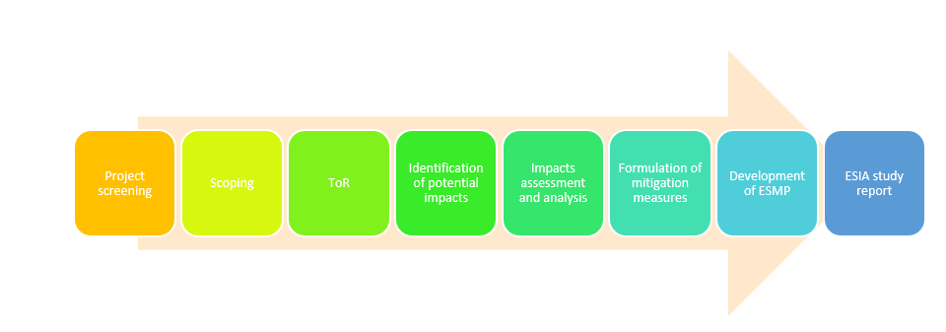

1.5.2. Desk study and literature review
The main objective was to gather and analyse existing information relevant to the environmental and social impacts of the proposed hybrid power plant through secondary data sources with a clear focus on environmental conditions, social demographics, regulatory frameworks, and previous relevant studies. The study involved gathering information and data from several sources including government reports, academic research, industry reports, non-governmental organizations’ reports, local publications and other relevant reports from the World Bank. We utilized academic databases (e.g., Google Scholar, JSTOR) and government and industry repositories to find relevant documents; and online Sources - search for relevant information on organizational websites, online journals, and other credible sources. From the information and data gathered, we undertook review and analyses that focused on summarizing key findings from each source, focusing on the relevance to the proposed power plant’s impacts, identifying common themes, and gaps in information. This was followed with comparative analyses that focused on comparing our findings with other similar projects to assess potential impacts and mitigation strategies. The regulatory review focused on examining the existing regulations and guidelines (national, state and World Bank) to ensure compliance and identify necessary permits and approvals. Some of the documents reviewed included the feasibility study documents, various FRS legislations, World Bank safeguard policies, project frameworks (ESMF and RPF), topographical maps, Google Earth/maps, and other relevant documents, including targeted studies commissioned by NESCOM such as geotechnical studies and the MoEWR among other documents.

A critical literature review of secondary data focused on the followings:
- Relevant legislation and institutional framework governing the proposed project
- Licenses and permits requirements and conditions.
- Types of waste likely to be generated.
Documents relevant to the proposed development were reviewed.

1.5.3. Environmental and social baseline settings
To gain a better understanding of the environmental, socio-economic and cultural setting of the project site and it’s surrounding the ESIA team needed to gather primary data. This entailed collection of the data using various tools and methods. Interviews, discussions, photography and observations and check lists are some of the methods employed in gathering the data needed from different stakeholders.

1.5.4. Public consultations
The aim of the PC was to ensure that the opinions of all relevant stakeholders interested in a proposed project such as project affected persons, and the public in the vicinity of the proposed project are considered during project planning, design, construction, operation and decommissioning phases. The consultations also presented an opportunity for the community to raise issues and concerns pertaining to the project. Public consultations were conducted using standardized questionnaires and key informant interview guides. An interactive approach was adopted for discussing relevant information key among them being neighbourhood issues, project acceptability, social, cultural and economic aspects, and environmental Impacts.

1.5.5. Assessment of physical and chemical parameters
No in-situ sampling of air, noise, soil analysis and water quality analysis, due to the fact that the proposed project will have minimal impacts on these parameters. The assessment of physical chemical parameters relied mainly on secondary information gathered from literature for Garowe as gathered during the desktop studies for soil, air, noise, and water quality,. The most recent topographic and geotechnical study commissioned by NECSOM for the new project site was also a key reference document

1.6. Target group for the ESIA report
The ESIA Report has been prepared for use by different stakeholders to be involved in the construction and operation of the proposed project. This report contains useful information on policies and procedures to be adhered to, implementation modalities, analysis of potential environmental and social impacts and suggested mitigation measures at various stages of project activities. The information will be useful in planning, implementation, management and maintenance of the project.
In this regard, the report is useful to the following stakeholders:
- Engineers to be involved in preparation of designs and plans for the proposed hybrid power plant.
- Contractors to be engaged in the construction works for the project
- MoEWR and other relevant FGS and Puntland State Government ministries and agencies.
- Funding agencies
- Project affected persons and other stakeholders drawn from the local communities, civil society groups, businesses, local and international non-governmental organizations, private and public organizations, amongst others.

1.7. Key assumptions
The Experts made the following assumptions in preparing this ESIA
- All the technical data and information provided by the proponent, implementing and the specialists are accurate and up-to-date
- The design features will be put in place to minimize risks from external factors which could threaten the integrity of the facility which include: risks from other natural calamities; measures to minimize threats or damage from third parties e.g., terrorist attack
- The NECSOM and the Contractor will implement the measures in the proposed ESMP
- The NECSOM will undertake monitoring to track the implementation of the ESMP to ensure that management measures are effective to avoid, minimize and mitigate impacts and that corrective action will be undertaken to address shortcomings and/or non-performances.

2.0. Project Description and Context

2.1. Overview
This section provides an overview of the proposed NECSOM Power Plant in Garowe as currently designed. The description borrows largely from preliminary project designs, discussions with the project engineers, field observations, feasibility study, interviews and available project documentation availed by NECSOM.

2.2. Location of the site
The proposed hybrid power plant (8⁰24’00” N, 48⁰30’08” E altitude 465m) shall be located in Garowe District, Nugal region of Puntland State within the North-Eastern Somalia (Figure 2.1). Garowe is traversed by a 750 km North-South highway, which connects it with major cities in the northern parts of the country, including Bossaso and Galkayo. The Project Site is located approximately 7 km to the south of the current NECSOM Power Plant in the City. The project site is in an open area without settlements in the immediate vicinity within 290 hectares piece of land acquired by NECSOM for the project. The proposed hybrid power plant will have both direct and indirect impacts on the environment and communities. Overall, the direct and indirect areas of influence is expected to be 2km and 5km respectively.

Figure 2-1: Location of the project site in Garowe City, Somalia
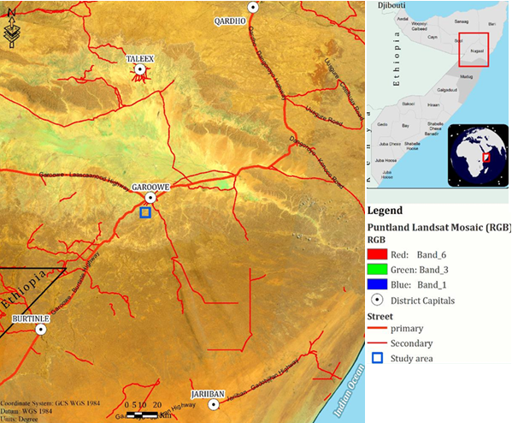
Source: Modified from NECSOM (2024). Topographic and geotechnical final report for NECSOM new plant- Garowe District, Nugal Region, Puntland Somalia. NECSOM, Garowe, Somalia.

2.3. project site and surroundings descriptions
Consultations with the local community indicated that the land is solely owned by NECSOM and has been acquired legally through willing seller-willing buyer arrangement. No objections were raised by the community in regard to acquisition of the land by NECSOM for the development of the power plant. The land is currently unused but the expansive nature of the land makes it ideal for potential occasional livestock grazing, especially by camels and goats but there are no community grazing land rights associated with the proposed project site. Additionally, there was evidence as observed during the site visit that the land also hosts wildlife species such as the near-threatened Gerenuk (Litocranius walleri), this is common in most of Somalia where humans and wildlife co-exist. Pockets of vegetation comprising mainly of Acacia tortilis and Salvadora persica were observed with little to no grass. Additionally, there are no documented water catchment areas within the 3km radius of the project site.

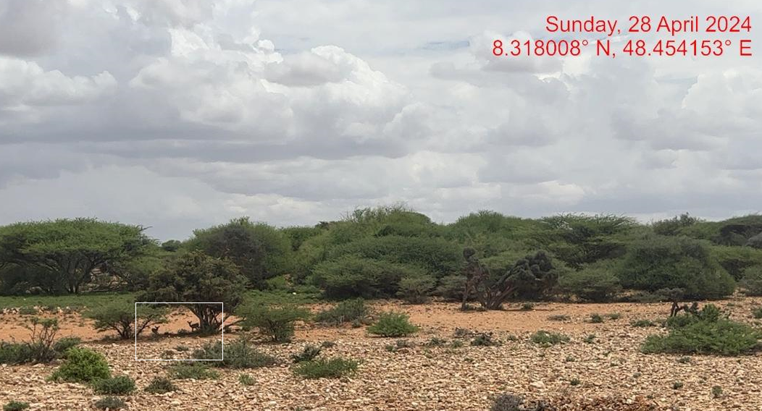
Plate 1. View of Gerenuk (Litocranius walleri) observed during the visit at the proposed project site

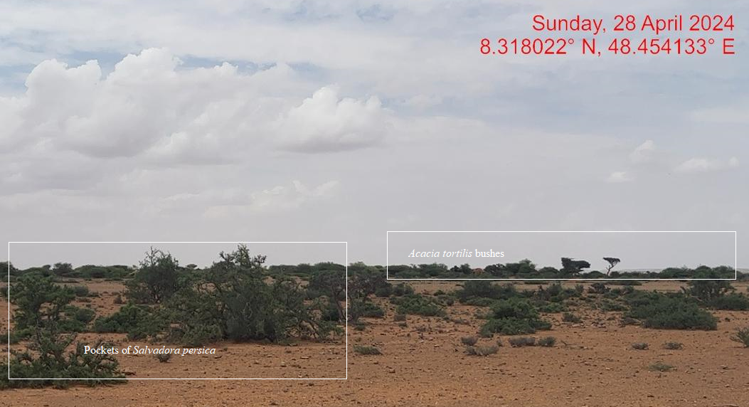
Plate 2. View of pockets of Salvadora persica and Acacia tortilis bushes observed during field visit at the project site

The major land uses near and around the proposed project site include livestock keeping, and the area is sparsely population. However, given the projected human population growth in and around Garowe City, there is likelihood that public facilities (dispensary, a school), shopping centres and residential houses will spring-up in the project site’s surroundings in the future. The site is connected by a gravel road but NECSOM also plans to construct a proper access road during the construction and operation phases of the project.

2.4. Description of the proposed power plant

2.4.1. Overview
The feasibility study for the proposed project undertaken by MoEWR showed that NECSOM is a leading electricity service provider in Garowe City with a customer base of over 20,000 comprising mainly households with an increasing number of large-scale consumers whose demand levels are determined after a comprehensive survey is done. Given the increasing electricity demand both within Garowe City and the surrounding areas. Currently, NECSOM uses both analogue and digital metering systems but is increasingly investing in smart metering systems, and their current Supervisory Control and Data Acquisition (SCADA) system has synchronized generators, solar, and windmills, and is able to evacuate 6MW of power to the grid. The company has experienced an annual load growth rate of 16% per year for the last six years, starting in 2018.

Given that the proposed new site is only 7 km away from the current site, it would be much easier to integrate the supply grid and SCADA systems, and this makes economic sense from an investment perspective. The proposed new site is in a peri-urban area of Garowe City (i.e., 7km from the city’s central business district) and has been modified by human activities. Our preliminary analysis indicates that ESS1,2,3,4,6,8 and 10 are relevant while ESS5, ESS7 and ESS9 will not be relevant to the proposed investment in the new site.

ESS8 may be relevant to the project, especially if there is a chance find particularly during construction phase of the project. In the event of a chance find triggering the WB-ESS8, especially during the construction phase, immediate measures shall be implemented to ensure the protection of cultural heritage. First, construction activities shall be halted near the find to prevent further disturbance. A qualified heritage specialist should be engaged to assess the significance of the find and determine the necessary steps for its protection, documentation, and preservation. The project team must notify relevant authorities and local communities about the discovery to facilitate transparent communication and compliance with legal obligations. A protocol shall be established for future chance finds, including training for construction personnel to recognize potential artifacts or heritage sites. This proactive approach ensures that cultural heritage is respected and safeguarded, aligning with the objectives of ESS8 and promoting responsible development practices.

Overall, it would be important that the project complies with ESS1, ESS2, ESS3, ESS4, ESS8 and ESS10 guidelines during all the project phases from construction, and operation to decommissioning. In addition, compliance with the Federal State of Somalia and state laws for Puntland need to be complied with in this new venture. On the basis of the feasibility study, the proposed project is category B as per the World Bank guidelines, and as such requires environmental and social impact assessments.

2.4.2. Proposed power generation capacity
From the feasibility study analysis, scenario 2 of 50% REF has been recommended for detailed design. Given this scenario selection, the current location cannot accommodate the expectation, and a new location that is about 7 km away from the current location has been proposed. The coordinates for this location are 8⁰24’00” N, 48⁰30’08” E. On the basis of this analysis and from the environmental and social impacts perspectives, HD concluded and recommended that the proposed new site would be ideal for the planned investment to meet the required expectations of boosting production capacity.

The proposed NECOSM Garowe hybrid power plant will consist of solar PV and battery storage (Figure 2,2) and associated facilities such as offices, sanitary facilities and masonry fence. The electricity generation capacity of the proposed hybrid power plant is10 MWp (Solar Photovoltaic), 13.8MWh (Battery storage systems (BESS lithium ion storage systems), and 9 km of 33kv distribution network system from the power plant to an existing substation at the current NECSOM power (7km away). The existing sub-station at the current power will be upgraded to accommodate the additional 33kV from the proposed plant. The power plant is expected to operate for a period of twenty-five (25) years, after which it shall be decommissioned. The design for power evacuation and transmission from the proposed power plant has been completed

Figure 2-2: Schematic presentation of the proposed hybrid power plant for NECSOM in Garowe City, Somalia

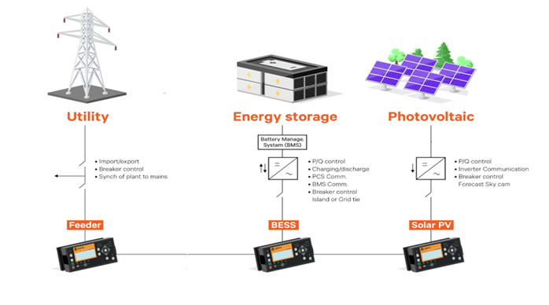
Modified from : https://www.vertiv.com/

The system will be modular, so that it can be upgraded easily to meet future demand needs. The proposed power plant will be configured as AC coupled due to the significant portion of daytime loads that can be fed directly from the solar PV without intermediate battery storage.

2.4.3. Architecture and basic design specifications
This hybrid power generation site is projected to generate 23.8MW and is meant to serve the increasing customer base. NECSOM has experienced annual load growth of 16% per annum for the last 6 years (between the years 2018 to 2023). This growth is expected to increase at a rate of 20% per annum considering the loads that NECSOM is targeting to connect in the next 2 years. Table 2.1 summarizes the customer base of NECSOM earmarked for connection in the next two (2) years.

Table 2-1: NECSOM customer base earmarked for connection in the next two years
Customer Name | Expected daily  demand (kWh) | Peak Load  (kW) | Remarks
Nugal Water Company (NUWACO)-7 Wells | 4,536 | 189 | To be connected by the end 2024
Amal Village (Amal Real state) 1200 houses | 14,420 | 960 | To be connected by 2025
Palm Hotel-5 Star Hotel | 49,800 | 1,800 | To be connected by the end 2024
Golis Village (Emaad Real state)-2000 houses | 24,000 | 1,300 | To be connected by the end 2025
Total | 92,756 | 4,249
Source: MoEWR (2024). Technical due diligence and proposed design report for NECSOM power plant, Garowe, Somalia

The proposed mini-grid installations will be built to comply the International Electro technical Commission (IEC) standards. It will have an installation of solar panels and BESS. The solar panels will have a connection to the batteries through underground cables.

The PV plant and the battery capacity have been sized according to the daily demand and the solar resources. In addition to this Design architecture, the project site shall have a site office that shall also have a Control Room adjacent as well as a guard house. The Solar PV hybrid system will be based on a centralized photovoltaic plant connected to a 3-phase 415V AC busbar line, where the multi-mode battery inverters are also connected.

2.4.4. Placement of the solar PV arrays
The PV array module support structure shall be ground-mounted on arid soil with a base made of concrete. The support shall have a tilt angle between 10°-15° from the horizontal (Figure 2.2). Hydrological and geotechnical study has already been undertaken at the site. The support frame shall be of either lightweight aluminium or galvanized steel and it shall be easy for installation, maintenance and disassembly at the end-of-life cycle. Cables used within the PV shall have a voltage rating; have a temperature rating higher than 40°C above ambient temperature; they will be UV-resistant; water resistant and it is recommended that they be flexible (multithreaded) to allow for thermal/wind movement of modules. The PV inverter shall be of type current source grid-tied to convert DC to an AC Sinusoidal current. String inverters shall be installed indoors or outdoors with a cover and suitable for desert conditions with high ambient temperatures and dust.

Figure 2-2: Illustration sketch of the proposed tilt angle of the solar panels placement at the power plant
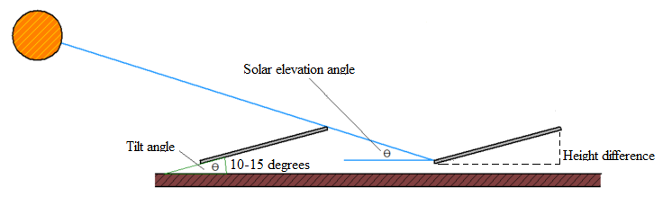

2.4.5. Powerhouse
The battery, multi-mode inverter and all monitoring equipment will be installed indoors with adequate air ventilation according to the manufacturer’s recommendations. Thus, a powerhouse or a containerized solution, considering the equipment manufacturer’s recommendations shall be installed. All electrical boards and LV protections will also be installed indoors.

2.4.6. Multi-mode inverter
The priority function of the Multi-Mode Inverter shall be to adjust the instantaneous power consumed from the source according to the battery voltage. The operation of the solar priority function shall be done with an automatic adjustment algorithm of the input limit current. The input limit current is decreased, if there is enough energy available at the DC side, from the initial value.

2.4.7. Battery
The battery considered is lithium ion battery technology. Lithium-ion batteries, have longer lifetime, are lighter and smaller. The battery nominal voltage does not need to be established at this stage as different technology providers may offer different solutions on this issue. Nevertheless, it must be noted that the voltage class, either ELV or LV, will determine the electrical isolation and accessibility requirements of the battery room. The battery shall have at least a rated capacity of 2.16V at the C10 discharge rate according to DIN 43539-9.

The battery shall have a self-discharge when new of less than 5% per month (at 25⁰C and fully charged) of its rated capacity and shall have a Coulombic efficiency of at least 85% and energy conversion efficiency of at least 85% when new and charged to more than 50% of capacity. The battery cycle life for discharge/charge regular cycles down to 80% DOD shall be more than 1500 cycles (According to IEC 896-1).

2.4.8. Power evacuation and distribution
The electricity distribution from the generation plant to the end consumers will be done by means of a 33KV transmission line (TL) that will be linked to the current NECSOM power plant located in Garowe City before eventually being distributed to the consumers. All lines shall be over-head mounted on concrete poles or eco poles. NECSOM will seek approval from the local Authority to utilize the existing way leave that runs along road reserves from the new power plant to the existing NECSOM sub-station. A right of way (RoW) of between 3 and 5m would be appropriate. Recommended safety measures for 33kV and 11kV power transmission lines include maintaining appropriate clearance distances to ensure public safety and reduce the risk of electrical hazards. Way leave standards typically mandate a minimum horizontal clearance of 10-15 meters from the centre of the transmission line to the nearest structure or vegetation. For safety, lines should be well-marked, protected by grounding systems, and equipped with appropriate warning signs. Regular inspections and maintenance are essential to identify potential hazards like encroaching vegetation or structural damage, while public education on staying clear of power lines enhances overall safety.

2.5. The project site

2.5.1. Site Ownership
The proposed works will be carried out on approximately 290 hectares piece of land located approximately 7km to the south of Garowe City. The proposed project site is under the legal ownership of NECSOM. No compulsory land acquisition, displacement or resettlement is anticipated. Although the local communities occasionally use the site for grazing, there are no formal agreements between NECSOM and the local communities on the use of the site for grazing. Indeed the occasional grazers at the site do understand the ownership status, and have no customary rights to the site as a grazing area. As such, NECSOM is not obligated to undertake any compensatory measures. The 33K transmission line run a long an existing road for 7KMs to the existing NESCOM power plant, no land acquisition is anticipated for the way leave. An approval will be sought from the local authority to use the existing way leave.

2.5.2. Access to the project site
The project site is accessed through an existing road which is paved for about 4km and the remining 3 km shall be paved by NECSOM for public use, the transmission line will run along this road. No resettlement or land acquisition is envisioned for this road.

2.6. Project activities
The final design and construction of the power plant shall be undertaken by a contractor selected through a bidding process. Construction will be supervised by NECSOM and MoEWR to ensure works are undertaken in accordance with specifications. This is to ensure quality work is achieved. It is anticipated that the proposed site will undergo alteration during construction to install the power plant and the associated structures. Some of the activities envisaged in this project include site clearance and levelling, civil works and construction of utilities and structures for the facilities, and installation and connection of the power plant.

2.6.1. Construction phase activities
All construction activities including ground preparation, earth moving, materials delivery, building, walling, roofing and the installation of amenities (power, water, communication equipment, etc.), fittings (doors, windows, safety provisions, etc.) will be carried out by competent personnel obtained through contractors to ensure consistent high standard of finish and providing superb value for money.

2.6.1.1. Outline of the construction activities
Construction activities will involve the following:
- The contractor shall perform site investigations in good time to ensure appropriate designs and construction is done on a sound engineering basis.
- Site preparation (ground-breaking, clearance of vegetation, preparation of a site office and stores, fencing to avoid intrusion)
- Disposal of any soil that could is not required, excavations/earth moving, filling and foundation laying
- Procurement of construction materials and delivery of the same to the site
- Storage and utilization of materials
- Civil, mechanical, and electrical works
- Building works, trampling and removal of construction wastes
- Construction of fuel storage tank
- Piping of fuel lines
- Cabling
- Installation of the solar panels
- Completion of the plant
- Post construction clean–up, restoration and landscaping of site
- Load testing
- Remedying of defects after functional tests
- Solid waste collection and commissioning of the plant.

During construction, the contractor shall observe safety and shall erect warning signs to warn on any potential hazards, ensure proper and efficient use of Personal Protective equipment (PPE) for all on site and observe safe work procedures.

2.6.1.2. Construction materials, equipment and services
All materials that will be used in construction of this project shall be of high quality in line with the international standards. Sufficient materials and equipment shall be purchased and stored on site to avoid wastage.

2.6.1.3. Input materials and equipment & machinery
Works and construction activities are expected to use quality construction materials and procedures to ensure quality work, occupational and public safety and environmental protection. The following inputs and equipment will be required for construction:
- building stones
- bus bars, switch gears, circuit breakers
- concrete mixers
- conductors
- electrical equipment (solar panels, lithium ion batteries, supporting structures, invertors etc.)
- excavators
- glass
- hardcore
- labour force (of both skilled and unskilled workers).
- lightning arrestors and steel structure members
- lorries
- meters
- paints, solvents, whitewash, etc.,
- plumbing equipment
- poles
- raw construction materials (sand, cement, natural building stone blocks, hard core, gravel, concrete among others).
- sand
- solar panels
- timber (e.g., doors and frames, fixed furniture, etc.),
- water
- welding machines, wheelbarrows

2.6.1.4. Use of services and resources
- Water: Water is key in the construction of this project. Water will be required for potable use and in the construction of the foundations for the control room, guard house and any other works. The contractor will source water from elsewhere rather than the community water resources. One key option would be for contractor to sink a borehole to supply water during all phases of the project – construction, operation and decommissioning phases. The water demand during construction activities is not expected to be significant. It is estimated that during construction phase, approximately 2000-5000 litres of water will be required, and will mainly be used for sanitary support services (especially for workers), cleaning, palliating soil piles to suppress dust, drinking, amongst others. On average, cleaning solar panels typically requires about 2-4 litres of water per panel. For the proposed 10 MW solar farm, the number of panels can vary based on the panel specifications, but a rough estimate can be made. For example, if each panel is around 300 watts, a 10 MW installation would have about 33,333 panels (10,000,000 watts/300 watts per panel) translating to approximately 126,000 litres per cleaning session. It is expected that the panels shall be cleaned twice in a year.

- Labor: The size and the composition of the workforce will be at the discretion of the contractor(s). The contractors will adhere to all the relevant employment legislations in the FGS, and ensure compliance with the World Bank’s ESS2. It is recommended that the contractor seeks unskilled labour from the surrounding areas.
- Sewerage: A negligible sewerage flow is anticipated for the duration of the construction period. On site, use will be made of toilets with septic that will be serviced periodically.
- Electricity: Electricity will be essential for the proposed project both during construction and operation. The contractor will most probably have a portable generator during construction for fabrication and welding where necessary but NECSOM will provide electricity for during operations from the proposed plant.

2.6.1.5. Construction supervision and safety
Throughout the construction phase, supervision shall be carried out by the NECSOM to ensure:
- Workers use personal protective equipment (such as hand gloves, helmets, safety shoes, earmuffs, overalls and dust coats) at all times as is appropriate.
- Motorized equipment is checked to ensure that they are in good working condition, safe to use and produce minimal noise levels and reduced smoke emission.
- Provision of first aid kit and firefighting equipment (portable cylinders) and placement at strategic positions for access.
- Proper disposal of waste material and toilet facilities are provided for construction workers.
- Emergency response procedures are in place and all workers are aware of them like in case of fire.
- Any work involving deep excavations, elevated heights and lifting heavy loads, poses a number of risks to personnel. The contractor shall develop a worksite plan before commencement of each of the construction. This will ensure that personnel are equipped with the correct protective clothing and equipment and are ready to work safely while also safeguarding the environment.
- Workers shall be provided ablutions facilities and changing rooms. Provisions shall be given for separate ablution facilities for women.

2.6.2. Operation phase activities
The power plant shall be operated and maintained by NECSOM. During operation phase of the project, no unauthorized person shall access the power plant. This is in line with NECSOM policy to ensure safety of staff and the public. Routine maintenance is to be done under supervision by authorized staff from NECSOM. Throughout the project life, the NECSOM shall adhere to all requirements of EHSG guidelines and any other applicable legislation in the FRS.

2.6.3. Decommissioning phase activities
NECSOM shall submit a decommissioning plan to relevant authorities in the FRS in good time prior to decommissioning. The decommissioning plan should include a restoration plan. At the decommissioning/demolition phase, the following activities will take place;
- Removal of Solar panels and their associated switching equipment’s
- Given that the lifetime of a lithium-ion battery is expected to expire after 17 years yet the power plan is to operate for 25 years, a replacement plan will be implemented to ensure continued functionality. This shall include procuring and installing new batteries or upgraded storage technologies. The decommissioned batteries shall be transferred to recyclers in the region or to the manufacturers. Battery replacement shall be coordinated with routine maintenance to minimize downtime. Additionally, this shall present an opportunity to adopt newer, more efficient technologies that could enhance the plant's performance for the remainder of its operational life.
- Removal of electrical fittings, bus bars and steel poles/structures
- Ensure proper handling of the demolished materials and have an authorized and guided transportation and disposal away from human settlement, water bodies and wildlife conservation areas.
- Demolish and remove all the concrete works

3.0. Policy, Legal and Regulatory Framework

3.1. Overview
This section gives the legal and regulatory framework relevant to the proposed project. Owing to FRS's protracted political instability over the last few decades, there has been the general lack of well-developed environmental laws and administrative frameworks. As such, environmental and natural resources management matters have over the years been managed in accordance with the existing statutes in place. However, FRS is moving towards strengthening its environmental management systems. For instance, a draft environmental and social impact assessment and audit regulations has been finalized. Despite the recent constitutional reforms that define natural resources, common environmental goods, and ecosystem services as protectable public assets and declare the right to a clean and healthy environment, there are still significant gaps in the implementation of environmental legislation in the FRS. On the basis of our evaluation, the following laws and regulations will apply in the implementation of the environmental and social risk management for the project:

3.2. National Laws and regulatory framework

3.2.1. Provisional Constitution of Somalia
The Provisional Constitution of Somalia, which was ratified in 2012, emphasizes the value of safeguarding the environment and managing the country's natural resources, particularly in Articles 25, 44, and 45 (which deal with the environment, natural resources, and land, respectively). Relevant provisions include:
- Article 25 guarantees Somali citizens’ rights such as a share of the nation's natural resources, protection from excessive exploitation, a healthy environment, and protection from pollution and harmful materials.
- Article 44 mandates the federal government to prioritize environmental protection, conservation, and preservation, preventing harm to natural biodiversity and the ecosystem.
- Article 45 encourages the Somali people to actively participate in the development, execution, management, conservation, and protection of natural resources and the environment.

The Constitution provides for the protection of workers' rights, non-discrimination, human rights promotion, and defence against gender discrimination and GBV in the workplace. Articles 11 ("Equality"), 14 ("Slavery, Servitude, and Forced Labour"), 15 ("Liberty and Security of the Person"), 24 ("Labour Relations"), and 27 ("Economic and Social Rights") contain important clauses.
- According to Article 11, "all citizens shall have equal rights and duties before the law, regardless of sex, religion, social or economic status, political opinion, clan, disability, occupation, birth, or dialect." In addition, it says that "even if the actor did not intend this effect, discrimination is deemed to occur if the effect of an action impairs or restricts a person's rights." It further states that no one shall be subjected to discrimination by the official on the grounds of age, race, colour, tribe, ethnicity, culture, dialect, gender, birth, handicap, religion, political opinion, occupation, or wealth and that this prohibition applies to all official programs.
- "A person may not be subjected to slavery, servitude, trafficking, or forced labour for any purpose," according to Article 14.
- Every person has the right to physical integrity, security, and personal liberty, according to Article 15. "The prohibition of all forms of violence, including any form of violence against women, torture, or inhumane treatment" is one of the provisions that falls under this category.
- Article 24 states that "all workers, particularly women, have a special right of protection from sexual abuse, segregation, and discrimination in the workplace." It also enshrines everyone's right to fair labour relations. All labour laws and practices must adhere to the principle of gender equality in the workplace. It also guarantees every worker the freedom to organize and become a member of a trade union, to go on strike, and to negotiate collectively with employers, trade unions, and employees on labour-related matters.
- Every person's access to clean, drinkable water, healthcare, social security, and the realization of their constitutional rights is upheld by Article 27. Additionally, it says, "It shall be ensured that minorities who have long faced discrimination, women, the elderly, and people with disabilities get the necessary support to realize their socio-economic rights."

Relevance
The proposed project complies with the Provisional Constitution of Somalia by proposing mitigation measures on how to deal with the social, health, safety and environmental issues for sustainable development. Additionally, the proposed project aims to produce clean and reliable electricity that will enhance the FRS objectives of reducing global warming through a reduction in greenhouse gas emissions in electricity generation.

3.2.2. Federal and state regulations on environmental, health, and safety
Somalia is currently developing its environmental laws and policies. A National Environmental Policy created by the FGS was accepted by the Cabinet on February 13, 2020. On November 26, 2020, the Cabinet adopted the National Environmental Act after it had been drafted. To be effective, both documents must be authorized by the Parliament. Their adoption has no set schedule in place. Environmental Quality Standards, Sectoral Environmental Assessments, Environmental Impact Assessments, and Environmental Audits are among the national environmental policies, regulations, and laws that must be drafted at the federal level by the MoECC that has formed an ESIA council to help with the coordination of ESIA activities and operations in the FRS. Overall, there is concurrence at the national and state levels that the international standards and best practices in compliance with the WB-ESS should serve as a foundation for conducting the ESIA.

Relevance
The MoEWR (the proponent) including the contractors will be required to fully comply with the environmental and quality standards as per the draft national environment act. The proponent and the contractors engaged in the project will:
- Develop and implement a formal construction health and safety plan.
- Constitute health and safety committee to oversee safety and health during the construction and operation phases of the project.
- Ensure the that the workers exposed to hazards and or accidents undergo requisite medical examinations.
- Ensure that equipment is serviced properly and/or use of the equipment complies with the threshold noise values provided in the EHSG guidelines
- Carry out, and record, a fire risk assessment identifying any possible dangers and risks, and where possible remove, the risk of fire and take precautions to deal with the remaining risks.
- Develop and implement and emergency preparedness and response plan (EPRP) to be applied during the construction and operation phases of the project.
- Implement mitigation during construction to ensure neighbouring properties are not impacted by nuisance dust.
- Observe any existing provisions in the FRS on management of traffic of construction vehicles as guided by the ESMP.

3.2.3. Somalia’s Ninth National Development Plan
Somalia’s ninth National Development Plan (NDP-9), covering the period 2020-2024, identifies recurrent drought, climate change and environmental degradation as major causes of poverty and food insecurity in Somalia. The NDP-9 prioritizes environmental management, gender and social equity. It focuses on increasing energy supply, particularly from renewable sources, and energy market regulatory reform. Unregulated power production poses a major economic and environmental challenge, leading to high electricity prices and forest destruction. Access to energy is crucial for economic growth and poverty reduction, and the NDP-9 prioritizes investment in the energy sector and energy market regulation. Somalia intends to implement the Power Master Plan (PMP) with support from the World Bank, increasing the supply of renewable energy and establishing regulatory bodies to enhance market efficiency. The PMP highlights the need to diversify energy portfolios and lessen reliance on fossil fuels while identifying supply-side issues such as inadequate capacity for the production of power. Particularly for women and young people, renewable energy can speed inclusive growth and create jobs.

Relevance
The proposed project supports the NDP-9 aims of increasing electricity generation capacity from renewable resources and reducing tariffs, thereby contributing to human and economic development.

3.2.4. Environmental protection and land use policy and regulation
Somalia's environmental protection and natural resources are under limited federal oversight, with the National Environmental Policy and Act approved by the Cabinet but not yet passed by Parliament. A Climate Change Policy has also been developed. However, federal and state standards and regulations for environmental pollution prevention, waste management, water quality, air quality, and noise have not been formulated or approved. Land use policy and regulation oversight mechanisms are also lacking, with instruments like zoning and land use planning largely absent at federal and state levels.

Relevance
The proposed project will contribute to protection of the environment and climate change mitigation by increasing electricity generation capacity, especially by working towards focusing more on solar electricity production systems thereby reducing GHG emissions.

3.2.5. Labour and employment law
The Labour Code of Somalia (Law No. 65, adopted in 1972), governs labour and working conditions, including employment contracts, terms and conditions, remuneration, occupational health and safety, trade unions, labour authorities, and maternity leave. The code is currently being reviewed to align with the Provisional Constitution and International Labour Organization (ILO) conventions. The Federal Ministry of Labour and Social Affairs is reviewing the revised draft, which was finalized in February 2019 and awaits Parliamentary approval. The current Labour Code remains in effect until the revised code becomes law. The State laws on labour and employment are also under review to align them to the Provisional Constitution and ILO standards.

Relevance
- The proposed project has an obligation to adhere to all the principles and tenets of the Labour Code (1972) pending any ongoing changes and amendments. The proposed project will adhere to the principles of the ILO conventions ratified by the Federal Government of Somalia (FGS), and the relevant provisions of the Provisional Constitution, when dealing with work and labour aspects during construction and operation phases of the project.
- The proponent and the contractors will be by the existing labour laws, including any amendments thereof, including abiding with all stipulations on employee management and relations in all the phases of the project.
- The Proponent and Contractor will maintain an insurance policy cover for its employees, record of accident, carryout proper accident investigations; organize for pre-employment and regular medical examinations for staff during construction and operation phases of the project.
- The proponent and the contractor will sensitize workers against abuse and exploitation of children, and shall not engage in any child labour during all phases of the project.

3.2.6. Policy and law on gender equality and GBV
Gender Based Violence (GBV) remains one of the most serious threats to the health and safety of women and girls globally. The situation is dire in Somalia where women are girls are at more risk of rape, Intimate Partner Violence (IPV), early and forced marriage and FGM. The Somalia context is fraught with GBV and protection concerns, especially for women and girls. For example, a recent study on GBV in Somalia found out that 18.5% of the women and girls in the IDP camps had experienced gender-based violence in the last 12 months. Further investigation into the nature of the violence revealed that 44.0% of the violence against women and girls were physical assaults, followed by psychological abuse (24.8%), forced marriage (18.8%), attempted rape (7.2%), rape (4.0%) and denial of resources (1.6%). The study showed that about half (57.7%) of that violence were committed by intimate partners or relatives, mostly (60.6%) during the daytime. Moreover, a little over half (57.7%) of the victims were over 20 years old, and 43.7% of them experienced assault more than once.

While there are no specific data on GBV in Puntland State, considerable progress has been made by the Puntland State in addressing the GBV. For example, a ‘Report of the Independent Expert on the Situation of human rights in Somalia’, dated 6 September 2017, submitted to the United Nations Human Rights Council, stated: The Puntland Minister of Women and Human Rights Development explained that the Government had taken measures to protect women against sexual and gender-based violence, and described the progress made in their protection. In 2015, Puntland adopted the Puntland Rape Act, which facilitated the trial of rape cases in formal courts. Chapter 19 of the Rape Act, on the special duties of the prosecution authorities where the accused is charged with a sexual offence, provides that the decision to prosecute the perpetrator of a sexual offence or any other offence under that law will be made by the Attorney General, not the complainant, and that the Somali Penal Code shall not apply to rape cases. It also provides that the prosecution authorities may establish specialized units with specialized

Somalia's National Gender Policy (2016) has been approved by the Federal Council of Ministers. The Policy aims to promote gender equality and sustainable human development by valuing women and men's contributions in economic empowerment, education, health, and political transformation. The policy outlines gender priorities in health, education, economic empowerment, and political participation. Prioritizing rural areas, the policy focuses on creating economic opportunities for both genders, including vocational, entrepreneurs, and skills enhancement programs and training for women and men, including those with disabilities. The FGS has drafted the Sexual Offenses Bill (2017) with support from the UN, which has been tabled with the Parliament and is still under review. The pre-existing Penal Code (1962) includes some provisions relevant to addressing GBV, including criminalizing rape, but it does not provide an adequate legal framework for dealing with GBV cases. In practice, most GBV cases are dealt with by the customary system.

Relevance
In the absence of appropriate measures, the project can exacerbate gender inequalities and sexual and gender-based violence. In adherence to this policy, measures will be put in place to ensure gender inclusivity in decision making, employment opportunity and access to the energy generated by the project, and mitigate social risks including sexual and gender-based violence, and any form of discriminations.

3.2.7. Somalia’s Power Master Plan, 2018
Developed by government of Somalia in coordination with the World Bank, the PMP seeks to create an enabling environment for independent power producers and the policy, legal and regulatory framework for the sector.
Relevance
The proposed project will be a forerunner for independent renewable power producers and will serve as a model for similar renewable energy plants in other locations in Somalia.

3.2.8. Energy policy and regulations
At the moment, Somalia lacks both an energy sector regulatory framework and an energy policy. However, the FGS has made the creation of an energy policy, strategy, and regulatory framework a top priority, in accordance with the NPD-9 and PMP, and a number of laws and rules are presently being developed. At the moment, the responsibility for managing the energy industry rests with the Federal Ministry of Energy and Water Resources (MoEWR). A draft Energy Policy was created by the MoEWR in 2018, and in order to give the industry a complete framework, they are currently working on an Energy Act and Regulations. Currently, the World Bank, African Development Bank (AfDB), and United States Agency for International Development (USAID) are some of the main partners supporting the implementation of the PMP and providing technical assistance to the FGS in the energy sector. In the absence of regulations, standards and codes of practice, there is no mechanism to vet and enforce ESP services quality, health and safety standards. This is compounded by the limited capacity of federal and state institutions to develop, enforce and monitor the sector. Currently, the Federal and State MoEWR are mandated to issue operating licenses to power plant. However, there are no licensing guidelines and there is not yet any legal basis to regulate their operations once licenses are granted.

Relevance
- The proposed project shall align it operations to the Somalia’s Power Masterplan and ensure that they operate within the principles of the existing energy policy and regulations. The proposed project is relevant in the sense that it will provide sustainable and reliable energy supply, including applying measures to protect and conserve the environment during its construction and operation phases. MoEWR will work closely with NECSOM to ensure the project complies with the current energy policy and regulations, and any amendments thereof.
- The proposed project is in line with the energy policy and regulations in the following ways: (i) the proponent (NECSOM) has identified and designated a site for the proposed project, and the proposed project is aligned the Somalia Power Masterplan. Additionally, and in collaboration with the MoEWR, there is technical capacity to undertake the project under SESRP.

3.2.9. Somalia's Intended Nationally Determined Contributions (INDCs), 2015
The report notes that Somalia has vast untapped renewable energy resources, stating that average solar potential stands at 5-7 kWh/m²/day.
Relevance
The project will reduce GHG emissions, helping Somalia meet its Paris Agreement commitments.

3.2.10. Customary legal system and sharia law
Somalia's legal system comprises of civil law, sharia law, and customary law. The Provisional Constitution (2012) defines the country's federal structure and hierarchy of laws. The customary legal system in Somalia, known as the xeer system, is crucial for land rights and resource management due to weak formal regulation. This system governs property, enforces contracts, and resolves disputes. Despite variations across regions and clans, it is applicable in most of the country. The xeer system is compensatory, majoritarian, and uses clan insurance to protect against violations. Elders act as judges or mediators, considering precedent and custom.

The customary xeer system also handles most cases of sexual violence and GBV. The FGS and some Federal Member States are making efforts to reintroduce law courts, but the capacity of and trust in the formal justice system remains weak, and the customary system functions in parallel to state law. A number of customary practices go against basic human rights standards and serve to re-victimize GBV survivors, for example, crimes of rape are commonly resolved through the marriage of the victim to the perpetrator, and revenge and honour killings are tolerated. Numerous cultural and institutional barriers limit women’s access to justice, including fear of punishment, reprisals and harassment for reporting GBV incidents, and social stigma.

Relevance
- The power plant is required to operate under the existing customary laws within the states where their projects are located. They are further expected to respect the existing customary laws in handling their relationships with all the stakeholders they engage in their areas of operation. All cultural practices that are discriminatory, especially to women, including negative practices such as SEA/SH shall be addressed through appropriate mechanisms as outlined in the ESMP of this ESIA.
- The land proposed for the project has been legally acquired by NECSOM under willing buyer-willing seller. NECSOM will observe all the relevant provisions of the customary legal systems and sharia laws related to land management (as appropriate) in all phases of the project.

3.3. Puntland State Laws and Regulatory Framework

3.3.1. Overview
Puntland State has several key environmental policies and frameworks in place. The Environmental Policy, produced in 2014 and approved by both the Cabinet and Parliament, serves as a foundational document. Additionally, the Environmental and Social Impact Assessment (ESIA) guidelines and regulations are supported by the Puntland Environmental Impact Assessment Act, which operationalizes the "Environmental Impact Assessment Unit" within the Ministry. This unit is headed by a Director of ESIA and includes a team of qualified professionals with specialized training in Environmental Impact Assessment. Their functions include: receiving, processing, and safeguarding all ESIA-related documents submitted to the Ministry, Reviewing and making recommendations to the Director General, and advising the Ministry on whether a proposed major project should be objected to or halted due to unacceptable environmental impacts.

The following are the relevant policies, laws, and regulations in Puntland State shall be applicable to the proposed project:

3.3.2. Puntland State Rangeland Management Policy (2016-2025)
The Puntland Rangeland Management Policy 2nd Edition (2016-2025) outlines a strategic framework to sustainably manage and rehabilitate rangelands in Puntland, Somalia. The policy emphasizes the protection of natural resources, restoration of degraded lands, and sustainable grazing practices to support pastoral livelihoods. It promotes community participation, equitable resource access, and collaboration among stakeholders, including government, local communities, and development partners. The policy also addresses climate change adaptation, drought resilience, and the importance of environmental conservation for the long-term productivity of rangelands, aiming to balance ecological integrity with socio-economic needs.
Relevance
The Puntland State Rangeland Management Policy is crucial for the proposed hybrid power plant in Garowe, as it emphasizes sustainable land use and natural resource management. Aligning the project with the policy's objectives, such as minimizing land degradation and ensuring local pastoralist communities' protection, supports sustainable development goals.

3.2.3. Puntland State Waste Management Policy (2006)
The Puntland Waste Management Policy (2016) provides a comprehensive framework aimed at addressing waste management challenges in Puntland, Somalia. It emphasizes the need for effective waste collection, transportation, and disposal systems, with a focus on minimizing environmental pollution and health hazards. The policy promotes waste reduction, recycling, and the safe handling of hazardous materials, while encouraging community participation and private sector involvement in waste management initiatives. It also seeks to strengthen institutional capacity, legal frameworks, and public awareness to foster sustainable waste management practices that protect both human health and the environment.
Relevance
The policy emphasizes waste reduction, proper handling, and disposal of hazardous materials, and the importance of minimizing pollution. By adhering to these guidelines, the power plant can manage its waste streams responsibly, prevent environmental contamination, and align with best practices for waste management. This alignment not only helps in complying with regulatory requirements but also supports broader environmental protection goals and contributes to sustainable development in the region.

3.3.4. Puntland State ESIA Act and Regulation (2016) Approved by Cabinet and Parliament
The Puntland Environmental and Social Impact Assessment (ESIA) Act and Regulation (2016), approved by the Cabinet and Parliament, establishes a legal framework for assessing the environmental and social impacts of development projects in Puntland, Somalia. The act mandates that all significant projects undergo an ESIA process to identify potential adverse effects on the environment and communities before they are approved. It sets guidelines for public participation, environmental protection, and social safeguards, ensuring that projects align with sustainable development goals. The act also strengthens the role of regulatory authorities in monitoring compliance and enforcing mitigation measures to minimize negative impacts on natural resources and local populations.
Relevance
The Act mandates that all significant projects, such as the power plant, undergo an ESIA to identify, evaluate, and mitigate potential environmental and social impacts before project approval. By following these regulations, the project ensures compliance with legal requirements, addresses potential environmental and social risks proactively, and promotes transparency and stakeholder engagement. This adherence helps to safeguard environmental quality and community well-being while supporting sustainable development goals in Puntland.

3.3.5. Puntland State Climate Change Strategy (2016)
The Puntland Climate Change Strategy (2016) outlines a comprehensive plan to address the impacts of climate change in Puntland, Somalia, by focusing on adaptation and mitigation measures. The strategy emphasizes strengthening the resilience of communities, particularly those dependent on pastoralism and agriculture, by promoting sustainable land and water management practices. It prioritizes climate-smart approaches, such as reforestation, renewable energy, and disaster risk reduction, while enhancing institutional capacity and policy coordination. The strategy also highlights the importance of research, data collection, and public awareness to better understand climate risks and implement effective responses, contributing to long-term environmental sustainability and socio-economic stability.
Relevance
The strategy emphasizes the need for integrating climate resilience into development projects, promoting renewable energy, and reducing greenhouse gas emissions. By aligning the power plant with these strategic goals, the project can enhance its climate resilience, contribute to reducing carbon footprints, and support sustainable energy solutions. This alignment not only complies with regional climate goals but also strengthens the project’s overall sustainability and environmental stewardship.

3.3.6. Puntland State Ministry of Environment and Climate Change Strategic Plan (2016-2020)
The Puntland Ministry of Environment and Climate Change Strategic Plan (2016-2020) sets a roadmap for safeguarding the region's environment and addressing climate change through sustainable resource management and policy implementation. The plan focuses on enhancing institutional capacity, strengthening environmental governance, and promoting climate adaptation and mitigation strategies. Key priorities include biodiversity conservation, combating land degradation, and advancing renewable energy and waste management solutions. The strategy also emphasizes community involvement, stakeholder collaboration, and raising public awareness to foster sustainable development while improving resilience to climate change and environmental challenges across Puntland.
Relevance
The plan focuses on enhancing environmental governance, promoting sustainable resource management, and improving climate resilience, which are essential for ensuring that the power plant’s development aligns with these objectives. By integrating the strategic priorities of the plan, such as effective environmental monitoring and stakeholder engagement, the project can better manage its environmental impacts, adhere to regulatory requirements, and contribute positively to regional sustainability and climate goals.

3.3.7: Puntland State Environmental Policy (2014) Approved by the Cabinet and Parliament
Puntland's Environmental Policy (2014), approved by the Cabinet and Parliament, establishes a foundational framework for the protection, conservation, and sustainable use of natural resources in Puntland, Somalia. The policy focuses on addressing environmental degradation, promoting biodiversity conservation, and ensuring the sustainable management of land, water, and forests. It advocates for integrating environmental considerations into all development plans and projects while enhancing institutional capacities to enforce environmental regulations. The policy also encourages community participation, public awareness, and partnerships with various stakeholders to foster sustainable development and resilience to environmental challenges, such as desertification and climate change.
Relevance
The policy emphasizes the need for balancing economic growth with environmental protection, particularly in the energy sector. It outlines guidelines for minimizing environmental impacts, promoting renewable energy, and ensuring community participation in decision-making processes.

3.3.8: Puntland State Environmental Management Act (2016) Approved by Cabinet
Puntland's Environmental Management Act (2016), approved by the Cabinet, provides a legal framework for the protection, conservation, and sustainable management of the environment in Puntland, Somalia. The Act establishes regulations for preventing environmental degradation and promoting responsible resource use across various sectors, including land, water, and forestry. It mandates environmental assessments for development projects, reinforces institutional responsibilities for environmental monitoring, and ensures compliance with environmental standards. The Act also fosters public participation, transparency, and accountability in environmental governance, aiming to balance economic development with the preservation of natural ecosystems and biodiversity in the region.
Relevance
This act mandates comprehensive environmental assessments and enforces regulations on waste management, pollution control, and the conservation of natural resources. For the hybrid power plant, it ensures that environmental impacts such as emissions, waste generation, and land use are thoroughly evaluated and mitigated. Compliance with this act is essential for obtaining the necessary permits and ensuring that the project adheres to Puntland's environmental standards.

3.4. The World Bank Environmental and Social Policies and Guidelines

3.4.1. World Bank Environmental and Social Standards (ESS) and relevance to the proposed project
The World Bank currently emphasises system guidelines focusing Environmental Social Frameworks (ESF). The ESF supports green, resilient, and inclusive development by strengthening environmental and human rights protections, with an emphasis on labour, inclusion, gender, climate change, biodiversity, community health, and stakeholder involvement. It takes a risk-based approach, which allows for more monitoring and resources for complicated projects while encouraging adaptive risk management and stakeholder engagement. The ESF also focuses on developing national environmental and social management systems, enhancing borrower capacity, and encouraging openness and stakeholder participation through timely information disclosure, continuous consultations, and effective grievance processes.

The consultant also referred to all the latest environmental and social standards (ESS) with all the relevant guidance notes (GN) utilized by the World Bank for new projects. The aim of the evaluation was to examine if the proposed project triggered any other the ESS. Table 3.1 summarizes the ESS from the perspectives of triggers and relevance considering the outcomes from the present ESIA.

Table 3-1: The ESS triggers and relevance to the proposed Hybrid Power Plant
ESS | Triggered? | Relevance
ESS1: Assessment and Management of Environmental and Social Risks and Impacts | Yes | Compliance with ESS1 requirements will help the proposed project to minimize adverse environmental and social effects, and promote sustainable development outcomes. By commissioning this ESIA, the proponent is cognisant of the need to comply with the ESS1 requirements
ESS2: Labor and Working Conditions | Yes | Compliance with ESS2 requirements will help project ensure the well-being of workers, protect the health and safety of local communities, and minimize risks associated with project implementation.
ESS3: Resource Efficiency and Pollution Prevention and Management | Yes | The operation of the power plant may result in increased air emissions and waste generation throughout the project, as well as their potential impacts. Additionally, during construction and operation phases, different sets of materials will be used, and this would require prudent resource efficiency and waste management.
ESS4: Community Health and Safety | Yes | Predicated on the assumption that the proposed project and its associated activities such as power transmission, construction and the associated equipment and exposure to local community are expected to have potential hazards with impacts of different strengths on community health and safety. The proponent will be required to comply with all the provisions of ESS4
ESS5: Land Acquisition, Restrictions on Land Use and Involuntary Resettlement | No | ESS5 ensures that any land acquisition or restrictions on land use for the solar plant are conducted in a manner that minimizes displacement and provides fair compensation and resettlement assistance to affected communities. By adhering to ESS5, the project proponents can mitigate social risks, ensure the equitable treatment of displaced persons, and align the project with international best practices for social sustainability. This helps in fostering community acceptance and reducing potential conflicts, thereby contributing to the overall success and long-term viability of the proposed solar PV project.
ESS6: Biodiversity Conservation and Sustainable Management of Living Natural Resources | Yes | Despite the proposed project being planned in a less modified area, it is still possible that the project could have impacts of different strengths on biodiversity. For example, Near-threatened (NT) species such as Gerenuk (Litocranius walleri) are found within the Project Site. Compliance with the ESS6 will ensure that the project is designed and implemented in a way that avoids or mitigates negative impacts on biodiversity. Adhering to ESS6 helps ensure that the solar PV project contributes positively to environmental sustainability while meeting energy needs, and it supports compliance with global environmental standards, thereby enhancing the project's long-term feasibility and community support.
ESS7: Indigenous Peoples/Sub-Saharan African Historically Underserved Traditional Local Communities | No | Predicated on the assumption that the project area has no indigenous people who may be affected by the project
ESS8: Cultural Heritage | Yes | Predicated on the assumption that there may be cultural artefacts or resources in the project area. It is acknowledged that these may be affected, particularly during the execution of civil works for new lines and hybridization activities. By adhering to ESS8, the project proponent will be required to engage with any affected communities, implement measures to avoid or mitigate impacts on cultural heritage, and ensure that any necessary alterations are conducted respectfully and in accordance with local and international guidelines. This not only preserves cultural heritage but also fosters positive relationships with local communities, enhancing the project's social license to operate.
ESS9: Financial Intermediaries | No | This standard will not apply because SESRP is fully funded directly by WB without involving financial intermediaries.
ESS10: Stakeholder Engagement and Information Disclosure | Yes | The proposed project, much like any other development initiative, encompasses stakeholders—individuals or groups with an interest in or potential impact from the project. It is crucial to furnish them with comprehensive information about the project, establish relationships, and provide an opportunity for them to offer feedback. Considering their interests and concerns during the planning and preparation stages is integral to fostering a collaborative and inclusive project environment.

3.4.2. Resettlement Policy Framework (RPF) for SESRP Projects
A resettlement policy framework report was prepared following World Bank ESS5 policy on involuntary resettlement. The RPF states that SESRP component 2 (SESRP, hybridization and battery storage systems for mini-grids) may require land acquisition. The Framework further seeks to avoid, manage, and/or mitigate potential risks arising out of damage to assets, disruption to work, temporary negative impacts on livelihoods and/or in the unlikely case of displacement. The RPF proposes guidelines to develop a Resettlement Action Plan (RAP) and propose an implementation framework for RAP to mitigate such effects. The RPF states that involuntary resettlement and land acquisition will be avoided where feasible, or minimized or compensated where it cannot be eliminated. Where involuntary resettlement and land acquisition are unavoidable, resettlement and compensation activities will be conceived and executed as sustainable development programs, providing resources to give people affected by the project (PAPs) the opportunity to share project benefits.
Relevance
Available information indicates that ESS5 is not relevant to this project.

3.4.3. Comparison between the World Bank and the FGS legislations relevant to the project
A comparison between the WB policies and the FRS law is presented in this section. The objective is to find out any gaps and propose a recommendation.

Table 3-2: Comparison between the key WB Environmental and Social Standards relevant to the project and the FGS legislations
World Bank ESFs | FRS laws | Comparison | Recommendation
ESS1requires screening to determine level of environmental and social assessment to be done. An ESIA is prepared before project implementation  ESIA is needed once determination had been established and should be prepared identifying all environmental and social impacts and mitigation measures proposed to address the impacts | - The environmental law requires screening of project to determine level of environmental and social assessment to be done  - An ESIA is required once determination is done  - ESIA is needed once determination had been established and should be prepared identifying all environmental and social impacts and mitigation measures proposed to address the impacts | - Similar both require screening  - Similar-both require ESIA depending on the project impacts | Screening has been done and the project is established as medium risk which requires and ESIA  ESIA is prepared in line with FRS environment laws and to WB safeguard policies
ESS5 Land Acquisition and Involuntary resettlement should be avoided wherever possible or minimized and exploring all alternatives | - Somalia’s transitional constitution emphasizes that Land shall be held, used and managed in an equitable, efficient, productive and sustainable manner. The Federal Government shall develop a national land policy, which shall be subject to constant review. That policy shall ensure: (a) Equity in land allocation and the use of its resources; (b) The guarantee of land ownership and registration; (c) That land is utilised without causing harm to the land; (d) That any land and property dispute is resolved promptly and satisfactorily for all; (e) That the amount of land that a person or a company can own is specified; (f) That the land and property market is regulated in a manner that prevents violations of the rights of small land owners; and (g) That the Federal Member States may formulate land policies at their level. No permit may be granted regarding the permanent use of any portion of the land, sea or air of the territory of the Federal Republic of Somalia. The Federal Parliament shall enact a law regulating the size, timeline and conditions of permits of land use. (5) The Federal Government, in consultation with the Federal Member States and other stakeholders, shall regulate land policy, and land control and use measures (Art. 43). | - Similar- displacement in projects should be avoided to the extent possible by exploring alternatives. | WB policy is more elaborate than the FGS Law.
ESS7 on indigenous people seeks to promote the inclusion of these group in development project and especially through consultation to ensure they also share in the project benefits and ensure negative impacts do not disproportionately fall on them  The policy requires these groups to be consulted separately to enhance their participation | - Article 11 of the Constitution regarding nondiscrimination and equality sets forth that ‘ All citizens, regardless of sex, religion, social or economic status, political opinion, clan, disability, occupation, birth or dialect shall have equal rights and duties before the law. Discrimination is deemed to occur if the effect of an action impairs or restricts a person’s rights, even if the actor did not intend this effect. The State must not discriminate against any person on the basis of age, race, colour, tribe, ethnicity, culture, dialect, gender, birth, disability, religion, political opinion, occupation, or wealth. All State programs, such as laws, or political and administrative actions that are designed to achieve full equality for individuals or groups who are disadvantaged, or who have suffered from discrimination in the past, shall be deemed to be not discriminatory’(Art. 11). It is also stated in Article 27 regarding economic and social rights that ‘it shall be ensured that women, the aged, the disabled and minorities who have long suffered discrimination get the necessary support to realize their socio-economic rights’.  - No provisions regarding indigenous rights. | - Similar-both seek to promote inclusion of these group so that they do can share the projects benefits and ensure that negative impacts of the project do not fall on them disproportionately  - WB needs a social assessment to be conducted | WB policy more elaborate and the two are being used to compliment
Project affected persons should be meaningfully consulted and be given opportunities to participate in planning and implementing of projects and especially where there is resettlement | - Article 26 regarding the right to property states that every person has the right to own, use, enjoy, sell, and transfer property. The state may compulsorily acquire property only if doing so is in the public interest. Any person whose property has been acquired in the name of the public interest has the right to just compensation from the State as agreed by the parties or decided by a court. | - Both are similar | Consultation has been done and will be progressed in line with the two WB policy and FRS legislations.

3.5. International conventions and agreements ratified by the Federal Republic of Somalia (FRS)
The FRS is a signatory to a number of international treaties, conventions and agreements that include legally binding commitments to protect the environment and to ensure the sustainable management of natural resources. These include:

3.5.1. The United Nations Convention on biological diversity (CBD), 1992
Article 8 – In-situ conservation (d) Promoting protection of ecosystems, natural habitats and maintenance of viable populations of species in natural surroundings (j) Respecting, preserving and maintaining knowledge, innovations and practices of indigenous and local communities embodying traditional lifestyles relevant for the conservation and sustainable use of biological diversity and promote their wider application.
Relevance
While hybrid power plants contribute to renewable energy production and reduced greenhouse gas emissions, their construction and operation may pose risks to local biodiversity. The relevance of the CBD underscores the need for sustainable energy solutions that balance technological advancement with ecosystem conservation.

3.5.2. The UN Framework Convention on Climate Change (UNFCCC) (ratified in 2009).
The primary objective of the Convention is to stabilize greenhouse gas concentrations "at a level that would prevent dangerous anthropogenic (human induced) interference with the climate system." Somalia submitted its new climate action plan (Intended Nationally Determined Contribution) to the UNFCCC in 2015. Somalia has also developed the National Adaptation Program of Action on Climate Change (NAPA), which includes a climate risk assessment.
Relevance
The project will provide over 50% electricity generation from solar array supplementing existing diesel power generation and thereby cutting GHG emissions.

3.5.3. The UN Convention to Combat Desertification (UNCCD) (ratified in 2002).
The Convention combats desertification in those countries that experience serious droughts and/or desertification. Somalia has developed a National Action Programme for the UNCCD.
Relevance
To comply with the UNCCD, it is essential that the project integrates sustainable land management practices, minimizes soil erosion, and rehabilitates affected areas post-construction. The hybrid power plant could also positively contribute to combating desertification by reducing reliance on unsustainable energy sources, which can lead to deforestation and land degradation. By aligning with the UNCCD’s goals, the plant can promote energy development while protecting and restoring ecosystems, ensuring that the project contributes to land conservation and sustainable use of natural resources.

3.5.4. Convention on the Conservation of Migratory Species of Wild Animals (ratified 1985).
This Convention aims to protect those species of wild animals that migrate across or outside national boundaries from becoming endangered.
Relevance
Hybrid power plants, especially large-scale installations, can pose risks to migratory birds and other wildlife through habitat disruption, collisions with infrastructure, and changes to the local environment. To adhere to the principles of the CMS, the proposed hybrid power plant will adopt a design layout of the solar panels by implementing bird-friendly infrastructure designs, and monitoring wildlife movements. Aligning the project with the CMS support global biodiversity conservation efforts, ensuring that the solar power development is environmentally responsible and sustainable.

3.5.5. Protocol concerning Regional cooperation in Combating Pollution by Oil and other Harmful Substances in Cases of Emergency (ratified 1988).
Combats pollution by oil and other harmful substances by enhancing measures for responding to pollution emergencies on a national and regional basis.
Relevance
Although the proposed hybrid power plant will primarily generate clean energy, its construction and operation can still involve activities that carry pollution risks, such as the use of machinery, transportation of hazardous substances, and the potential for spills during maintenance or installation processes. This protocol emphasizes regional cooperation and preparedness to address pollution emergencies, ensuring that any accidental releases of harmful substances are swiftly and effectively managed. The proponent will align with the protocol by developing contingency plans and EPRP for effective emergency responses, and implement best practices to minimize environmental risks. This not only helps protect against pollution but will also strengthen the project's commitment to environmental stewardship and regional cooperation.

3.5.6. Sustainable Development goals (SDGs) and agenda 2063 in Africa
Key targets of the SDG 7 – Ensure access to affordable, reliable, sustainable and modern energy for all – are by 2030, ensure universal access to affordable, reliable and modern energy services
Relevance
Implementation of the project will contribute increased Renewable energy generation capacity in Somalia. This is one barrier to increasing affordable access to electricity. However, the project, in itself, will not automatically increase access to electricity for households as this also depends on the tariffs, distribution networks, and regulatory frameworks that are beyond the scope of the project itself. It is hoped that the project will generate interest in and incentivize complementary investment and intervention in the energy sector by the government, development partners, and private sector in Puntland State to expand access to electricity in the city. It is also hoped that it will provide a model for hybrid power plants in other locations within Somalia.

3.5.7. International Labour Organization Agreements
Somalia is also a signatory to the International Labour Organization (ILO) Conventions that include legally binding commitments relevant to labour and employment conditions and the social aspects of the project. These include commitments to equal opportunities for women in employment, ending violence and harassment in the workplace, workplace health and safety, and ending child and forced labour, among other areas. Some of the relevant provisions of the ILO that the Country has ratified include:
- Discrimination (Employment and Occupation) Convention (No. 111) (ratified in 1961).
- Forced Labour Convention (No.29) (ratified in 1960).
- Freedom of Association and Protection of the Right of Organize Convention (No. 87) and Right to Organize and Collective Bargaining Convention (No.98) (ratified in 2014).
- Abolition of Forced Labour Conventions (No. 105) (ratified in 2014).
- Worst Forms of Child Labour Convention (No. 182) (ratified in 2014).
- Violence and Harassment Convention (No 190) (ratified in 2021).
- The Tripartite Consultation (International Labour Standards) Convention (No. 144) (ratified in 2021).
- The Occupational Safety and Health Convention (No. 155) and Promotional Framework for Occupational Safety and Health Convention (No. 187) (ratified in 2021).
- Private Employment Agencies Convention (No. 181) (ratified in 2021).
- The Migration for Employment Convention (Revised) (No. 97) and Migrant Workers (Supplementary Provisions) Convention (No. 143) (ratified in 2021).

Relevance
Project implementation will adhere to the principles of the ILO conventions ratified by Somalia. These include that:
- Contractors will be obliged to have policies and procedures in place to ensure equal opportunities for and treatment of employees regardless race, color, gender/sex, religion, political opinion, or social opinion.
- Employment practices are non-discriminatory, and to take active measures to prevent and violence, harassment and discrimination in the workplace;
- They will be obliged to adhere to workplace health and safety standards.
- Contractors and suppliers will be contractually obligated to comply with the required local and international practices, to have a human rights policy, and to have employment processes that provide the standard terms of employment for casual and temporary workers.

3.5.8. Convention on Elimination of All Forms of Discrimination Against Women (CEDAW)
The Convention on the Elimination of All Forms of Discrimination Against Women (CEDAW) is a pivotal international treaty aimed at eliminating gender-based discrimination and advancing women’s rights globally. Although 189 countries have ratified it, Somalia remains one of the few states yet to do so, limiting formal recognition and enforcement of women's rights in the country. Ratification would demonstrate Somalia's commitment to addressing systemic gender disparities and aligning its legal and policy frameworks with international human rights standards. This step could empower Somali women by fostering equality in education, employment, political participation, and protection from violence. However, implementing CEDAW’s provisions would require significant institutional reforms, political will, and culturally sensitive approaches, making ratification both a critical opportunity and a substantial challenge for Somalia.

The Convention on the Elimination of All Forms of Discrimination Against Women (CEDAW) is highly relevant to the proposed solar power plant by NECSOM in Garowe, Somalia, as it underscores the importance of gender equality in development projects. Integrating CEDAW’s principles into the project can ensure equitable access to employment opportunities, capacity-building initiatives, and decision-making roles for women, fostering inclusivity in the traditionally male-dominated energy sector. Additionally, CEDAW provides a framework to address gender-based challenges, such as preventing workplace discrimination and mitigating risks of gender-based violence during construction and operation. By aligning the project’s social and environmental impact assessments with CEDAW’s objectives, NECSOM can contribute to advancing women’s rights while supporting Somalia’s broader development and human rights commitments.

4.0. Analysis of Alternatives

4.1. Overview
In this chapter, various alternatives available to the project are discussed. The alternatives are as follows; “no-go/do nothing” alternative, alternative construction materials and technology, the alternative sites and alternative sources of energy identified during the ESIA process. The identification and examination of alternatives is fundamental to environmental assessment. It provides decision-makers with information that enables them to properly consider optimal solutions to development proposals. Alternatives illustrate and contrast the environmental implications and consequences of different options available to achieve the same end.

4.2. Relocation Option
The site for the proposed project was selected based on several factors, including:
- Geophysical Factors – An open and expansive area with maximal solar irradiance, a location not prone to soil erosion and flooding, and an area with good drainage, etc.
- Land identified is free from any dispute on ownership or any other encumbrances
- No squatters, encroachers or other claims to the land.

Relocation option to a different site is an option available before the project implementation. However, at present NESCOM does not have alternative sites in the general direction of the proposed sites. Looking for alternative land to accommodate the scale and size of the proposed project and completing transaction may take a long time with no guarantee that the land would be available. The proposed project is meant to improve electrification and accessibility to an already established customers/consumers in Garowe City, and the surrounding areas. Several alternatives to supply reliable electricity were considered but the proposed project was selected because it met the electrification needs of the City and surrounding areas. In consideration of the above concerns and assessment, relocation of the proposed project to a different area is NOT a viable option.

4.3. Zero or No Project Alternative
The No Project option in respect to the proposed project implies that the status quo is maintained. This option is the most suitable alternative from an extreme environmental perspective as it ensures non-interference with the existing conditions. This option will, however, involve several losses both to NECSOM and the increasing customers in Garowe City and the surrounding areas. The target majority of the consumers will lack a clean and reliable electricity supply, and the FGS objectives of bringing a reliable, clean and affordable electricity in order to spur economic growth, opportunities for investment and better public services may not be realized. The No Project Option is the least preferred from the socio-economic and partly environmental perspective due to the following factors:
- Electricity generation relying on diesel generators with the accompanying GHG emissions will continue;
- The socio-economic status of target communities the local economy would remain unchanged due to lack of affordable, clean and reliable electricity supply;
- Generation of employment opportunities through expansion of business activities that would have been spurred by availability of affordable and reliable electric power will not occur
- Opening up the area for investors will not occur as anticipated;
- Community health benefits that come with electricity will not be realized;
- The targeted consumers will forgo the desired electricity supply in the area;
- The Puntland State and FRS will be impeded in achieving the objectives of the PMP in meeting the energy requirements.
- The objectives of the FGS’s efforts towards achieving NDP-9 will not be realized.
From the analysis above, it becomes apparent that the no project alternative means no project to the local people and the FGS, and the benefits outlined above and other indirect benefits that would accrue from construction of the proposed project.
Conclusion
It is thereby concluded that the ‘do-nothing’ option is not a good option economically and should therefore be discouraged and rejected. It is therefore imperative for NECSOM to establish a new Hybrid Power Plant at the proposed site and supply clean and affordable electricity to Garowe City and surrounding area.

4.4. Alternative Sources of Energy

4.4.1. Thermal Power Generation
Improving and expanding the current thermal power through installation of more diesel gensets is an option which can be considered to provide power to Garowe City and surrounding areas. However, this would imply more diesel would be needed, approximately over 250-300litres of Industrial Diesel Oil (IDO) is burnt daily to generate targeted 50kWp of electricity at the current NECSOM electricity generation sites. Thermal generation can also be fueled using alternative fuels such as natural gas, bio diesel, industrial kerosene, heavy vehicle fuel, coal and unleaded petrol. Thermal power generation has serious negative environmental impacts including an increase greenhouse gas emission. This approach will go against the FRS goals towards meeting the Paris Agreement targets.

4.4.2. Wind Power Generation
NECSOM generates additional electricity using wind power systems in the current location in Garowe City. Wind power generation, while a valuable renewable energy source, has several limitations compared to the proposed hybrid power plant. Wind power is highly dependent on geographic location, and suitable sites for wind farms are limited (areas with consistent and strong winds) in the Puntland State. Wind energy is more variable and unpredictable because wind speeds tend to fluctuate significantly within short time frames, leading to inconsistent power generation,,,. Wind turbines can have a greater visual and noise impact on the landscape, leading to community resistance, particularly in populated areas. They can also pose risks to wildlife, especially birds and bats. Wind turbines generally have higher initial capital costs due to the complexity of the technology and the need for substantial infrastructure, such as tall towers and foundations, and require regular maintenance, particularly in harsh environments, to ensure reliable operation,,. Wind power generation often requires more sophisticated grid management due to its variability and the potential need for energy storage or backup systems to ensure a stable power supply. Finally, wind farms require large tracts of land, which can lead to land use conflicts.

4.5. Analysis of alternative construction materials and technology
The proposed Hybrid Power Plant will be constructed using modern, locally and internationally accepted materials to achieve public health, safety, security and environmental aesthetic requirements. Because of its durability and strength, steel is the best choice and all support structures will be steel for the solar panels.

4.7. Selected alternatives
The analysis of alternatives compared the existing power plant location, which lacks adequate space for the new hybrid power infrastructure, with a new site 7 km away that offers sufficient space for expansion. While maintaining the current location would leverage existing infrastructure and minimize relocation costs, space constraints could limit future growth and operational efficiency. On the other hand, the new site (7km away) provided ample room for investment, allowing for optimized layout and future scalability, though it would involve additional costs in terms of infrastructure development, and possibly increased transmission losses due to the distance. Careful consideration of long-term benefits, costs, and operational efficiency are crucial in determining the best option for sustainable power generation. The transmission line has already been selected, and the selection considered the following factors distance, cost, grid stability, capacity needs, terrain, geographical constraints, and technical complexity.

A hybrid energy system was chosen consisting of solar PV and BESS plant to ensure reliable and stable energy supply. Solar power is intermittent and depends on sunlight availability, while the Battery Energy Storage System (BESS) allows for energy storage during high solar generation.

Conclusion
A hybrid power plant located approximately 7km from the existing NECSOM power plant was selected for consideration. It is therefore imperative for NECSOM to establish a new Hybrid Power Plant at the proposed site and supply clean and affordable electricity to Garowe City and surrounding areas.

5.0. Environmental and Social Baseline

This section outlines the existing biophysical and socioeconomic background of the proposed project region, which serves as the foundation for identifying and evaluating the project's possible environmental and social implications. It includes both project-specific information regarding the project's area of influence and regional baseline data to help put the project in context.

5.1. Location
The proposed NECSOM Hybrid Power Plant (8⁰ 24’ 00” N, 48⁰ 30’ 08” E) is located around south of Garowe City in Puntland State. The site is about 7 kilometres from the current NECSOM Power Plant and is planned to become a major facility in the future, providing reliable and economical electricity to Garowe City and the neighbouring areas. The location is accessible via an all-weather road connecting the city centre to the southern portion of the city. The site covers around 290 hectares and is mostly open and flat, with pockets of flora and a few towns in the surrounding area.

5.2. Environmental setting

5.2.1. Climatic information

5.2.1.1. Rainfall
Garowe City and the surrounding areas are classified as arid to semi-arid, with long periods of drought being common. The dry season extends from November to April and is characterized by clear skies and minimal precipitation. The region receives very little rainfall annually, typically less than 300 mm per year but can go as high as 500mm (Figure 5.1). The rainy season runs from April to June. However, the rainfall amounts are often irregular and insufficient for sustained agricultural activities. Overall, the region’s rainfall patterns are influenced by the northeast monsoon (known locally as the "Hagaa"), which brings mainly dry winds from the Arabian Peninsula, contributing to the arid conditions. However, there are seasonal patterns of rainfall that are strongly influenced by the Inter-Tropical Convergence Zone (ITCZ), the north south movement of which results in two dry seasons and two wet seasons in a year. The supply of clean water normally goes up during the dry period when water availability from natural sources decline, while local food prices increase during the wet season especially in June-September when monsoon winds hinder shipping of imported food commodities which supplement limited domestic sources.

5.2.1.2. Temperature
Puntland State of FRS is predominantly hot and dry, characterized by a combination of desert and semi-desert conditions. The region experiences high temperatures throughout much of the year, with average daytime temperatures often exceeding 35°C (Figure 5.1).

Figure 5-1: Temperature and precipitation in the Puntland region of Somalia
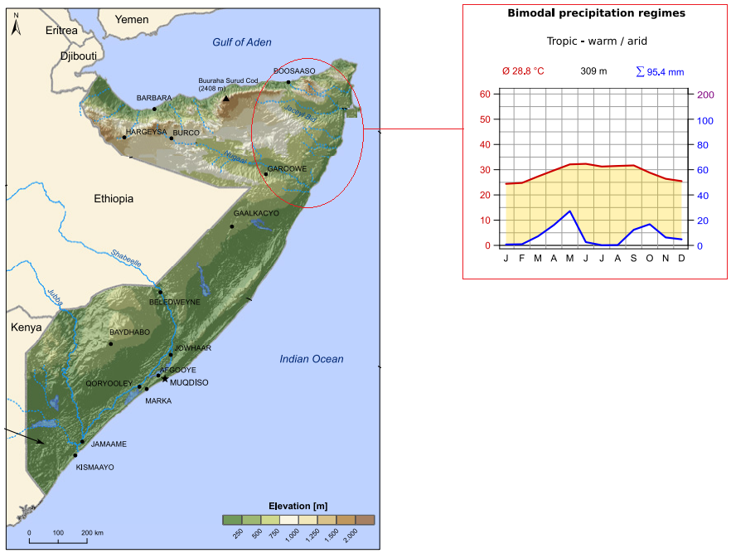
Source: https://weatheringrisk.org/sites/default/files/document/220214_SomaliaClimateRiskProfile-05.pdf

5.2.1.3. Air Quality
There are no published ambient air quality data for the municipality of Garowe.

5.2.1.4. Topography and features
The topography of the Puntland region in Somalia is diverse and influenced by its location in the Horn of Africa. The region has a long coastline along the Gulf of Aden, stretching for approximately 1,900 kilometers (1,180 miles). The coastline is generally low-lying and sandy in many areas, with occasional cliffs and rocky formations. Inland from the coast, the terrain consists mainly of plateaus and plains that are generally flat to gently undulating, with elevations ranging from sea level along the coast to higher altitudes further inland. The region has several, which include the Cal Madow Mountains and the Nugaal Valley. Along the southern and southwestern parts of Puntland, the terrain transitions into desert and semi-arid landscapes.

5.2.1.5. Geology and soils
Soils are generally calcareous. Many of the seasonal rivers have rich alluvial soils. Most of the drier parts of the country have thin and relatively infertile desert soils. The geology and soils of Puntland reflect a diverse landscape shaped by geological processes over millions of years with soils generally calcareous. The City's foundation consists of ancient Precambrian basement rocks, which are predominantly granitic and metamorphic in nature. The overlying basement rocks are sedimentary layers, which are more prevalent along the coastal plains and low-lying areas. These sediments consist of sandstones, limestones, and shales deposited over millions of years. Puntland is known to have significant mineral potential, including deposits of gypsum, limestone, and other industrial minerals. Along the coastline, soils are typically sandy and low in organic content. Inland areas often have reddish-brown soils, which are characteristic of the tropical weathering of underlying rocks. Along river valleys, particularly the Nugaal and Dheer rivers, alluvial soils are found. In the southern and southwestern parts of Puntland, where the climate is more arid, soils are often sandy and less suitable for agriculture without significant irrigation and soil improvement efforts.

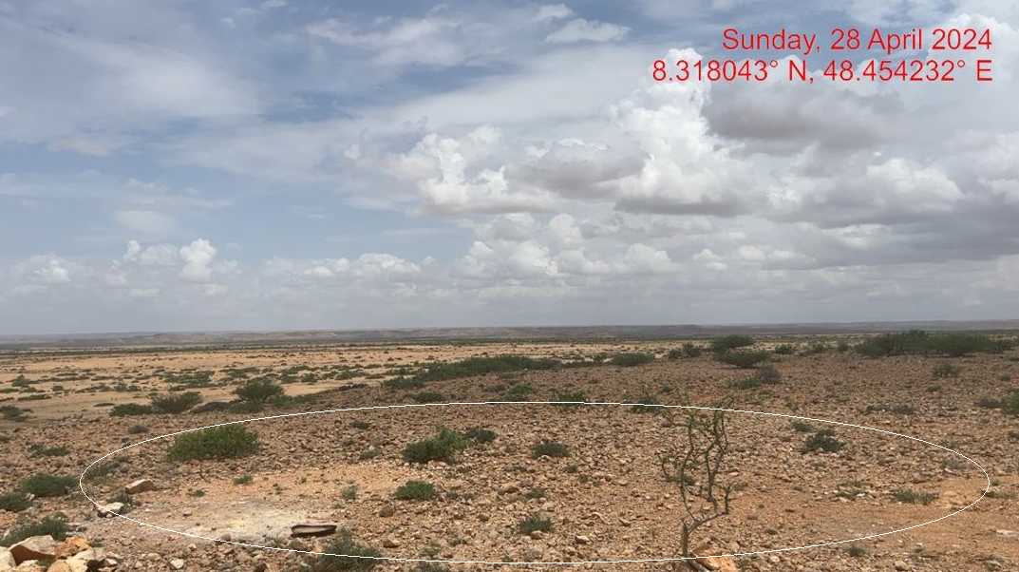
Plate 3. View of the characteristic soil types at the proposed site

5.2.1.6. Water resources and hydrology
There are two wadis or natural waterways in Garowe town, one is the Togga-Garowe river at the northern portion that bisects the municipality, and the seasonal Lan Alifrin stream in the southern part. Both waterways serve as Garowe’s main natural drainage. It is along these waterways that new bridges could be financed. Most of the urban infrastructures are found adjacent to the Togga-Garowe river. Seasonal flash floods are recorded to occur much of which originate from the Lan Alirin stream which affects large parts of town most especially the eastern part of Garowe. The storm water drainage will be designed to ensure that it is not contaminated and does not cause erosion.

The construction of a hybrid power plant could will have minimal impact on water resources and hydrology of Garowe City and the surrounding areas. The construction phase will require water for activities like dust suppression, concrete mixing, and worker sanitation. The operational phase will require water for sanitation services, cleaning solar panels, and standby water for fire suppression system, though this demand may be lower. Water sources for the plant could include groundwater extraction, local surface water bodies. The construction and operation of the hybrid power plant could alter local hydrology, potentially affecting surface water runoff and groundwater recharge. Proper wastewater management is essential to prevent contamination of surface water and groundwater, impacting human health and local biodiversity.

5.2.2. Biophysical environment

5.2.2.1. Flora
The flora at the site is dominated by species adapted to its arid to semi-arid climate and diverse landscape. Various species of acacia, such as Acacia tortilis (Umbrella Thorn Acacia) and Acacia senegal (Gum Arabic tree), are common at the site and appear in clusters/pockets distributed randomly across the site. Many of the flora tree species are well-adapted to dry conditions and play a crucial role in providing shade and grazing for livestock. Numerous thorny shrubs and bushes, such as Commiphora spp. (myrrh trees) and Salvadora persica (toothbrush trees), are also found at the site and the surrounding areas, and are important for soil stabilization and provide food livestock and even wildlife found in the area. Despite the arid environment, some herbaceous plants and grasses manage to thrive during the short rainy seasons. These include species like Cenchrus ciliaris (Buffel grass) and Cymbopogon spp. (Lemongrass), which provide fodder for livestock.
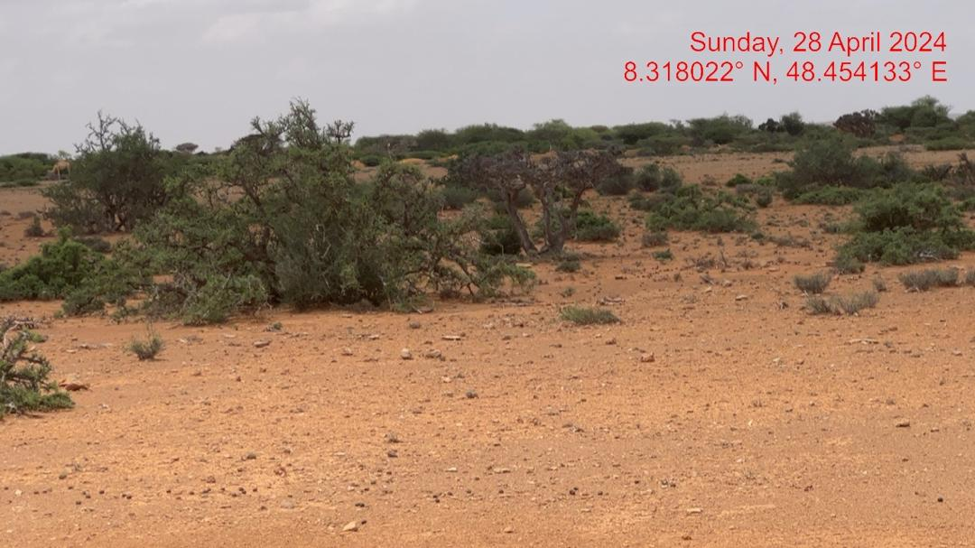
Plate 4. View of the characteristic vegetation stands dominated by Acacia tortilis and Salvadora percica at the proposed site.

5.2.2.2. Fauna
The proposed project area is largely a rangeland, where the pastoralism is a major form of livelihood for the local community. Some of the livestock include camel, goats, sheep, donkey, chicken and other domestic pets. The area and its environs are not a known breeding site for any endangered species. However, the area is within the distribution range of the near-threatened (NT) Gerenuk (Litocranius walleri), the Vulnerable (VU) Dorcas gazelle (Gazella dorcas pelzelni (Somali: dhero), and the Vulnerable Soemmering’s Gazelle (Nanger soemmerringii) . Overall, Puntland state is known to host a diverse range of bird species, including migratory birds, vultures, eagles, bustards, and even waterfowl. Like other open plains and semi-arid areas of Somalia, mammal species such as gazelle, ground squirrel are known to be widespread, especially in open plains. Various reptile species, include snakes (African Rock Python, Spitting Cobra, Black Mamba and Vipers) can also be found in the area.

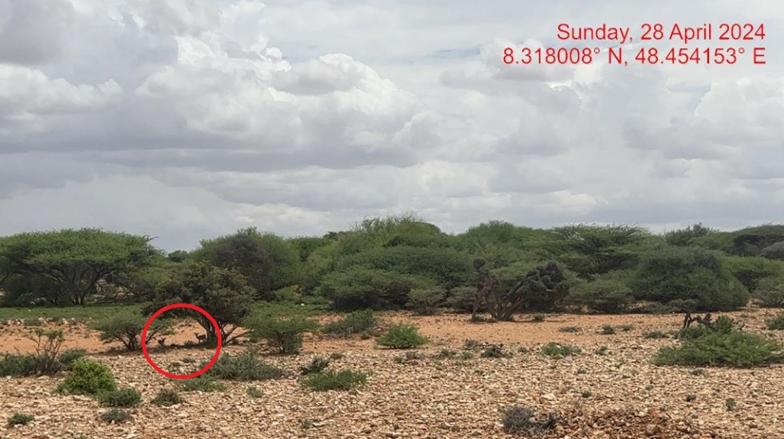
Plate 5. View of Gerenuk (Litocranius walleri) at the site

5.2.2.3. Vulnerability to climate change
Garowe city and the surrounding areas have a few options for natural drainage of excess precipitation during rainy seasons. Due to the absence of a drainage network and the increasing urbanisation, flooding could affect more and more of those living in town, and have drastic consequences for the urban poor and IDPs. Urbanization and economic activities also slowly reduce permeable soil and rural areas and cause removal of vegetation. This provokes erosion as well as maceration of the soil, posing additional environmental threats. Furthermore, reduction of green areas has a deep social and health impact. Garowe and its hinterland also face severe environmental challenges, associated with poverty and vulnerability because of recurring drought and desertification. Moreover, climate change affects food security, especially in time of drought. Facilitation of trade is therefore of vital importance to increase food security.

5.2.2.4. Waste management
Waste water: Water supply is overstretched in most urban areas due to a growing urban population and increasing demand. As a result, people suffer from insufficient water supply and rely on aging and inadequate water sources to meet their needs. Uncontrolled and informal exploitation of the aquifer threads sustainability, safety and access to water supplies in the city. The lack of an adequate sewage system, the insufficient waste collection and the location of the dumping sites further threatens water resources, health and hygiene within the population.

Solid waste: For solid waste management, a private company has been contracted by the municipality, Garowe municipality generates about 50-60metric tonnes per day assuming 0.5 kg/capita/day. The few waste collection sites in Garowe are located in close proximity to the riverbeds, This could easily cause contamination in times when the seasonal rivers are full, affecting water resources and Beerab Jillab, the agricultural land located along the riverbeds. The main landfill site is located north of the town along the National Road, approximately 4km from the new airport. The potential hazard that bird wildlife attracted by organic waste may cause to aircraft operation must be addressed in order to assess the suitability of this location. Targeting key locations for waste collection and waste management facilities would have the potential to have a positive effect on the socio-economic conditions in addition to the environmental factors.

5.2.2.5. Water scarcity and flood risk
Due to the unregulated and uncontrolled pumping of groundwater, there is a high risk to the groundwater table and the regeneration of aquifer resources. More in-depth studies are required to address this challenge. Given the mostly unpaved roads and being an urban area mostly composed of large plots only partially built, Garowe has very limited impervious surfaces. However, urban development is reducing ground permeability and resulting in increased storm water runoff volume and peak discharge, which is evidenced by chronic flooding and degraded water quality. As the runoff flows over the land or impervious surfaces (paved streets, parking lots, and building rooftops), it accumulates debris, chemicals, sediment, or other pollutants that could adversely affect water quality if the runoff is discharged immediately or left untreated.

5.2.2.6. Agricultural land soil contamination
The main vegetation in the Garowe consists of grasslands, shrubs, acacia trees, and native grasses. The valley is fertile and rich in local endemics as well as succulent flora. There are hardly any farmlands in Garowe, and the few that exists are subject to seasonality. However, some agricultural uses can be found along the southern riverbed, and a large agricultural area is present about 20 kilometres east of town. While agricultural land should be viewed as an asset instead of a constraint limiting urban growth, over the years, built-up areas are encroaching on fertile land, and waste collection points and landfills in close proximity to the riverbed and water resources are likely to contaminate this valuable resource.

5.2.2.7. Land use and land cover
Overall, land use and land cover in Puntland reflect a balance between traditional livelihoods (pastoralism), limited agriculture, urbanization, conservation efforts, and potential resource exploitation (Figure 5.2). The dominant land use in Puntland is pastoralism, which involves the raising of livestock such as camels, goats, sheep, and cattle. Agricultural activities are limited due to the region's arid climate and limited water resources. However, there are pockets of fertile land along river valleys, such as the Nugaal and Dheer rivers, where irrigation supports crop cultivation. The region has sparse natural vegetation, mainly consisting of thorny shrubs and acacia trees adapted to dry conditions. The urban centers in Puntland, such as Garowe (the capital), Bosaso, and Galkayo, are hubs of economic activity and administrative centers. Urban areas are characterized by infrastructure development, residential areas, commercial establishments, and governmental institutions. Coastal land use includes fishing villages, ports, and occasional tourist developments, although these are limited compared to other coastal regions due to security concerns.

Garowe is an urban area that is predominantly residential. Small Institutional and commercial areas are located along and near the southern banks of the Togga-Garowe River where the Gambol road serves as the main access facility. Education facilities are found in the northern portion of town across the Togga-Garowe River, while the farmlands are found at the southern part of Garowe by the northern banks of the Lan Alirin stream. IDP camps are also found adjacent to the farmlands. Figures 5.2 and 5.3 show the land use and land cover in and around Garowe City.

Figure 5-2: Land use types in Garowe City and the surrounding areas, Puntland State
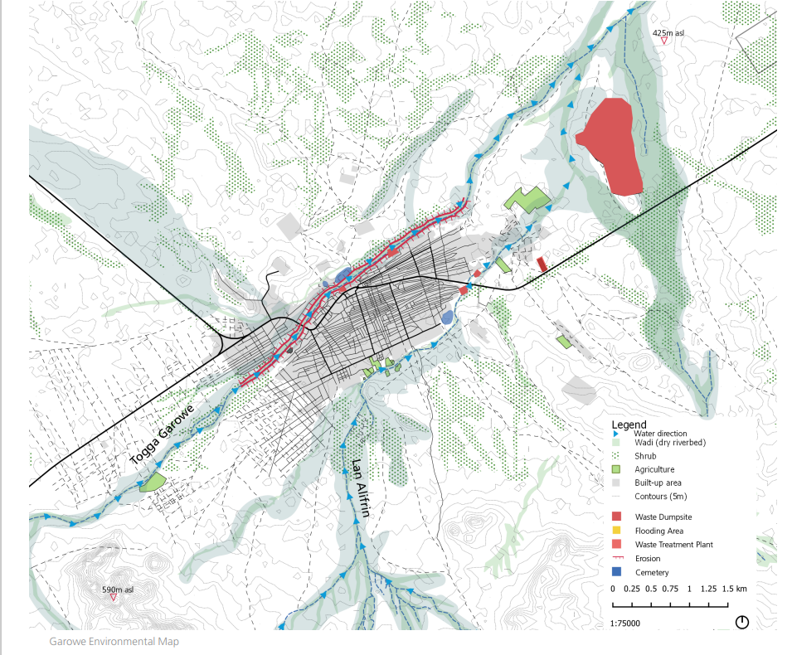
Source: UNHSP (2019). Garowe Urban Profile: Working Paper and Spatial Analyses for Urban Planning Consultations and Strategic Spatial Planning - May 2019. United Nations Human Settlements Programme (UNHSP), Nairobi, Kenya

Figure 5-3: Land cover types in Garowe City and the surrounding areas, Puntland State
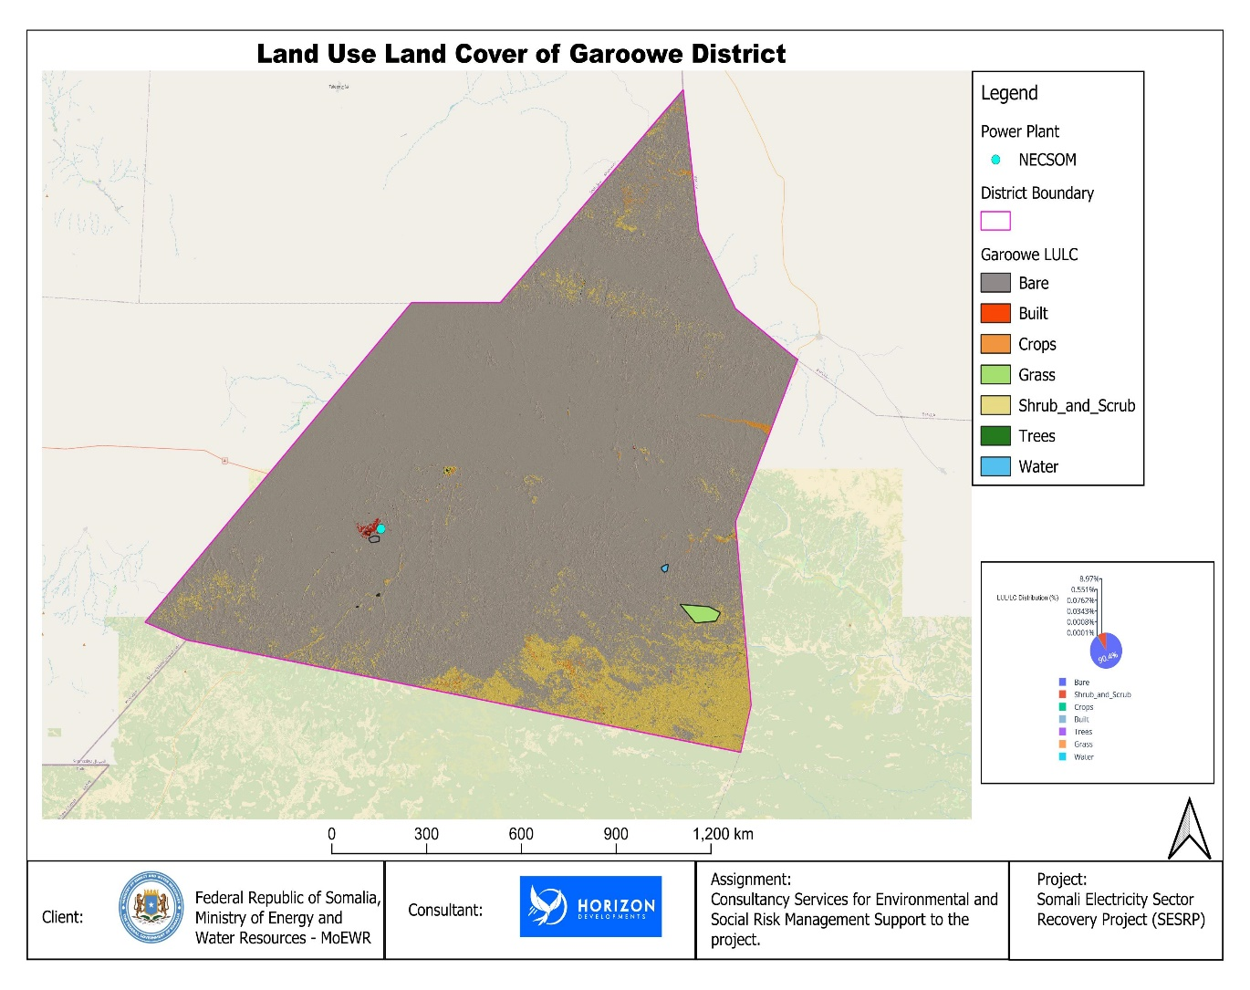

5.2.2.8. Protected areas and sensitive habitats
Most of Somalia is located within the Horn of Africa Biodiversity Hotspot. However, Somalia including Garowe District are among the most degraded environments with only 5% of its original habitat still remaining. Currently, there are no sensitive or protected habitats around the proposed project site.

5.2.2.9. Environmental management challenges
Garowe and the surrounding areas face numerous environmental challenges due to its arid climate, limited natural resources, and socio-economic conditions. The area is prone to droughts and erratic rainfall, exacerbated by water scarcity. Over-extraction of groundwater and inadequate water management practices contribute to declining water tables and degradation of water quality. Deforestation, overgrazing, and unsustainable agricultural practices further degrade land, leading to soil erosion and reduced fertility. Puntland is also increasingly vulnerable to climate change impacts, including rising temperatures, prolonged droughts, and extreme weather events. Urban centres face challenges in waste management and pollution control, with inadequate infrastructure and untreated sewage contributing to environmental pollution and public health risks. Enhancing education and training on sustainable natural resource management practices is crucial for effective environmental governance and compliance with environmental standards.

5.3. Socio-economic setting

5.3.1. Overview
The Puntland region's socioeconomic environment is influenced by historical background, cultural diversity, economic activities, infrastructure development, and governance dynamics. Traditional pastoralism, involving livestock herding, is a primary economic activity, despite challenges like drought and limited grazing land. Fishing, both artisanal and commercial, provides livelihoods to the local communities. Urban centers like Bosaso and Garowe serve as trade hubs, connecting Puntland with other Somalia and international markets. The region's coastline supports fishing and maritime activities, contributing to the local economy through fish exports and related industries. The region has been investing in improving road infrastructure to facilitate goods and people movement. Access to clean water and sanitation facilities remains a challenge in rural areas, but efforts are ongoing to improve these. Education is provided through schools and educational institutions, while healthcare services are provided through public hospitals, clinics, and private facilities.

Somalia is recovering from a long period of conflict and lawlessness, and the country is now in the process of building public institutions. Governance and security in the Puntland region of Somalia are critical aspects that influence its socio-political landscape and development trajectory. Puntland is an autonomous region within Somalia, governed by its own regional administration and political institutions. It has a president and a parliament that oversee regional affairs while also interacting with the federal government of Somalia. Puntland has generally been more stable compared to other regions of Somalia, but it still faces challenges related to political stability, including occasional disputes over power and resources among clans and political factions. Puntland has its own police force responsible for maintaining law and order within the region. These forces work alongside the PSF and other security agencies to address security challenges.

5.3.2. Population
The United Nations Population Fund (formerly the United Nations Fund for Population Activities) estimated that in 2014 the total population of Somalia was 11,800,833; which is broken down to 1,830,073 for Puntland; 3,508,180 for Somaliland and 6,462,580 for Jubaland and the rest of Somalia (UNFPA Population Estimates Survey of Somalia 2014). Table 4.2 contains the breakdown of the population of Somalia in 2014 based on the UNFPA survey. Garowe municipality on the other hand has an estimated total population of 33,395 residents in the year 2005. The population is mostly Somalis from the Harti Darod clan confederation, specifically the Majerteen and leelkase Darood clans.

5.3.3. Administration and Ethnic Groups
Puntland is one of the 6 federal member states of Somalia. The region experienced political unrest in 2001 due to President's attempts to increase his term. In 2009, the government passed a new regional draft constitution, introducing a multi-party-political system. Garowe, administered by a municipal government, provides basic social services and supports international organizations. The municipality has main offices and facilities, including a parliament building, hospitals, schools, and an international airport.

In Garowe City, the governance structure operates within the framework of Puntland State's sub-national administration, which comprises both state-level and district-level authorities. The Puntland State government is responsible for establishing regional policies and overseeing broader developmental initiatives, including security, infrastructure, and public services. At the district level, local administrations implement these policies, manage day-to-day governance, and address community-specific issues. The interrelationship between these levels is crucial, as district authorities rely on state-level support for resources and guidance, while the Puntland government seeks to ensure that local needs and priorities are effectively met. This collaborative dynamic is essential for promoting effective governance, enhancing service delivery, and fostering sustainable development within Garowe City.

The dominant clan is the Majerteen, a sub-clan of the Darod clan family, which holds significant influence over local governance, politics, and resource allocation. This clan's prominence is reflected in its representation within Puntland State's administration and its involvement in various economic activities, including trade and pastoralism. In contrast, the Majeerteen, while also part of the broader Darod clan family, represents non-dominant clans in the area. These clans may experience marginalization in political representation and access to resources, leading to social tensions and competition for power. The dynamics between the dominant and non-dominant clans in Garowe City shape local governance and community relations, necessitating efforts to promote inclusivity and equitable resource distribution to foster social cohesion and stability.

5.3.4. Economy and Poverty

5.3.4.1. Local Economy
Somalia, classified as the least developed country by the United Nations, relies heavily on livestock, remittances, and telecommunications for its economy. Livestock contributes 40% to GDP and over 50% of export earnings. Garowe municipality, a key trading center for livestock and agricultural products, has seen significant growth during relative peace. The municipality also provides temporary employment for IDPs, urban poor, and surrounding pastoral communities. The construction industry in Garowe is mainly funded by local government, international organizations, and the Diaspora, with men dominating manual labor.

5.3.4.2. Poverty and Social Services
Garowe city and the surrounding areas have a high poverty rate, with nearly 40% of the population living in urban areas and 52.3% in rural areas. The municipality has three main income classes: poor, middle income, and better-off. The poor have 7-8 members household sizes, with only one wife and two children in school. They have an annual average income of $1,500-2,550 and can only provide 91% of their daily food requirement. The middle class has 8-9 members, with 1-2 wives and 2-3 children in school. They have an annual average income of $2,565-6,410 and can only provide 104% of their daily food requirement. The better-off have 10-12 members, with 1-2 wives and 2-4 children in school. The spend 118% of their income on food.

Garowe City offers a range of social services aimed at improving the quality of life for its residents. The local government, along with various non-governmental organizations (NGOs), provide essential services such as education, healthcare, and sanitation. Educational institutions, including primary and secondary schools, have been established to cater to the youth, although challenges like inadequate facilities and resources persist. In healthcare, Garowe has over the years seen the establishment of several clinics and hospitals that offer basic medical services, though access to specialized care remains limited. Additionally, efforts are underway to improve water and sanitation infrastructure, addressing critical needs for clean drinking water and waste management. Despite these advancements, the city faces ongoing challenges, including resource constraints and the need for enhanced service delivery to meet the growing population's demands.

5.3.5. Electricity generation status
The energy and electricity sector in the Puntland State of Somalia faces significant challenges but also presents opportunities for development and improvement. Like in other regions in the Federal Republic of Somalia, access to reliable electricity is a major challenge in Puntland State, and there is more focus on renewable energy sources like solar power to address challenges in the electricity sector in the State. The NECSOM Power Plant, Garowe is a hybrid power plant currently generating and supplying over 10 megawatts from thermal sources and is connected to the grid system for Garowe and surrounding areas. The plant has launched solar and wind electricity generation to meet the growing demand for clean, reliable energy.

5.3.6. Proposed project impact on the local economy
The proposed project aims to boost the energy sector in the FRS and Puntland State, promoting economic growth and investment. It will benefit SMEs, local manufacturing, and provide temporary jobs for local residents, IDPs, urban poor, and migrant workers. The infrastructure will also benefit women's micro, small to medium-scale trading through better availability, quality, and lower costs. Family members engaged in the project's construction work can use income for trading activities, and remittances can be easily brought into the local market. More investment and trade facilitated by affordable and reliable electricity supply will generate tax revenues for the Puntland Regional Authority, which can use it for operations and basic service delivery. Key investments could include the development of small and medium enterprises (SMEs) that leverage reliable electricity to expand local industries, such as agro-processing, cold storage for perishable goods, and digital services. Investments in modernizing healthcare facilities with energy-efficient equipment and powering schools with renewable energy can improve public service delivery and community well-being. Additionally, establishing vocational training programs in renewable energy technologies can build local capacity and create sustainable employment opportunities. Strengthening energy infrastructure, such as mini-grids for rural areas and reliable transmission systems, can extend the plant’s benefits to underserved communities, promoting inclusive growth across the region.

5.3.7. Security and conflict environment.
Puntland generally benefits from a more stable security environment compared to other states of the country. In Garowe, the capital of Puntland, security has been relatively strong due to effective local governance and security forces. The Puntland State government has implemented measures to ensure safety, such as enhanced policing and community-based security initiatives. However, Garowe is not entirely free from security concerns. The security situation around the site is relatively secure. There have been approximately zero (0) incidents within a 5 km radius of the site in the last 12 months.

6.0. Assessment of Impacts

6.1. Overview
This section examines how the solar plant will interact with parts of the physical, biological, and social environments, as well as infrastructure and utilities, to produce effects on resources and receptors. It has been grouped according to the phases of the project life cycle in order to better understand the risks and implications connected with each one. The following definitions are applied:
- Project Site: is the area where the solar PV field and BESS will be constructed and will be fenced. No gensets will be installed at the power plant.
- Project Area: is the project site and its nearest surroundings where indirect, and combined, and cumulative effects are likely to occur on the surrounding areas and communities; and
- Study Area: is the wider area of influence where indirect, combined, and cumulative effects are likely to occur at the scale of the Garowe City and the surrounding areas, and the entire Puntland State.

Criteria for assessing the significance of impacts stemed from the following key elements:
- The magnitude (including nature, scale and duration) of the change to the natural or socioeconomic environment (e.g. an increase in erosion, or an increase in employment opportunities), expressed, wherever practicable, in quantitative terms. The magnitude of all impacts is viewed from the perspective of those affected by considering the likely perceived importance as understood through stakeholder engagement;
- The nature and sensitivity of the impact receptor (physical, biological, or human). Where the receptor is physical, the assessment considered the quality, sensitivity to change and importance of the receptor. For a human receptor, the sensitivity of the household, community or wider societal group was considered along with their ability to adapt to and manage the effects of the impact; and
- The likelihood (probability) that the identified impact will occur. This is estimated based upon experience or evidence that such an outcome has previously occurred.

For this assessment, significance has been defined in Table 6.1 based on five levels.

Table 6-1: Categories of significance
Category | Significance
Negligible impacts (or Insignificant impacts) | Negligible impacts (or Insignificant impacts) are where a resource or receptor (including people) will not be affected in any way by a particular activity or the predicted effect is deemed to be ‘negligible’ or ‘imperceptible’ or is indistinguishable from natural background variations.
Minor | An impact of minor significance (‘Minor impact’) is one where an effect will be experienced, but the impact magnitude is sufficiently small (with or without mitigation) and well within accepted standards, and/or the receptor is of low sensitivity/value.
Moderate | An impact of moderate significance (‘Moderate impact’) is one within accepted limits and standards. Moderate impacts may cover a broad range, from a threshold below which the impact is minor, up to a level that might be just short of breaching a legal limit. Clearly to design an activity so that its effects only just avoid breaking a law and/or cause a major impact is not best practice. The emphasis for moderate impacts is therefore on demonstrating that the impact has been reduced to a level that is ALARP (as-low-as-reasonably-possible). This does not necessarily mean that ‘Moderate’ impacts have to be reduced to ‘Minor’ impacts, but that moderate impacts are being managed effectively and efficiently.
Major | An impact of major significance (‘Major impact’) is one where an accepted limit or standard may be exceeded, or large magnitude impacts occur to highly valued/sensitive resource/receptors. An aim of ESIA is to get to a position where the Project does not have any major residual impacts, certainly not ones that would endure into the long-term or extend over a large area. However, for some aspects there may be major residual impacts after all practicable mitigation options have been exhausted.

For environmental impacts the significance criteria used in this ESIA is shown in Table 2.2.

Table 6-2: Overall significance criteria for environmental and social impacts
Receptor sensitivity | Impact Magnitude
 | Low | Medium | High
Low | Minor | Minor | Moderate
Medium | Minor | Moderate | Major
High | Moderate | Major | Major

For the social impact assessment, the perceptions of stakeholders, expressed as opinions around certain issues, can be as important as actual impacts. Consequently, the concept of perception is explicitly brought into the evaluation of significance after an impact is evaluated. When an impact is of significant stakeholder concern, this may be causing to raise the significance rating. This prompts the formulation of more rigorous and appropriate mitigation measures, which focuses on the source of the impact and address stakeholder perceptions. The risk of not addressing stakeholder perceptions is that reputational damage could arise, resulting in the loss of a ‘social license to operate. The impacts are categorized in the three phases of the project, i.e., construction, operation and decommissioning.

6.2. Impacts during construction phase
This section identifies and assesses the anticipated positive and negative impacts within the solar plant and surrounding areas during the construction phase. For each positive impact, enhancement measure is proposed, for negative impacts, a set of mitigation and monitoring measures are identified to avoid and minimize adverse impacts as outlined in Section 6 of this ESIA report.

6.2.1. Positive impacts

6.2.1.1. National, local and regional economy
The Project will positively influence the Puntland State FRS economy during construction from the direct procurement and supply of materials and services from companies based in the Puntland State and elsewhere in FRS. This includes for example, companies providing earth-moving equipment, workers to complete general civil works, logistics services to transport the solar panels to the Project area, and construction of the worker accommodation camp. Other companies located outside of FRS will be responsible for the supply of the solar panel components, such as the panels and supporting structures and cables. The impact is positive because construction activities will generate economic growth at a local, regional and national level through the procurement of services and materials. The increased demand for business-to-business services to small-to-medium enterprises (SMEs) will generate increased revenue across Garowe District, resulting in higher turnover for the SMEs involved. The impact is reversible as it will be only limited to the construction phase.
Impact | National, local & regional economy
Type of impact | Positive
Type of effect | Direct & Indirect
Duration | Short-term as it is expected during the construction
Reversibility | Reversible as it will be only limited to the construction phase.
Receptor Sensitivity | Medium as the businesses involved will benefit directly from the increased revenue.
Magnitude | Medium as a number of local and regional businesses may be involved in the supply chain.
Significance of the impact without mitigation | Minor

6.2.1.2. Employment and other economic opportunities
Various employment opportunities will be available during construction. The opportunities will be both skilled and unskilled. Majority of the unskilled and semi-skilled jobs will be taken up by the local community. Employment of the locals will increase skill transfer from the contractors. The approximate number of workers to be employed by the proposed project is not yet known, however, this will contribute to easing unemployment level in the area. There will be a trickledown effect to the economy at large resulting from new income revenues as well as services provided through this project. Several enhancement measures are proposed, including NECSOM ensuring that they prioritize the local community in allocating job opportunities, that job opportunities are not discriminatory, and equal opportunities given to both men and women on employment.
Impact | National, local & regional economy
Type of impact | Positive
Type of effect | Direct & Indirect
Duration | Short and long-term as it is expected during the construction and operation phases.
Reversibility | Reversible as it will be only limited to the construction and operation phases.
Receptor Sensitivity | Medium as the businesses involved will benefit directly from the increased revenue.
Magnitude | Medium as a number of local and regional businesses may be involved in the supply chain.
Significance of the impact without mitigation | Minor

6.2.2. Negative impacts

6.2.2.1. Impacts on biophysical environment

6.2.2.1.1. Landscape and visual
Site preparation will involve installing project components, including transmission cables, access roads, storage buildings and other ancillary facilities. Land clearance, ground levelling, excavations, and grading are required. Visual changes will occur from modified ground surfaces and construction equipment and machinery at the project site.
Impact | Landscape and visual
Type of impact | Negative
Type of Effect | Direct
Duration | Long-term: The effects will commence from the start of construction and thereafter-permanent changes in visual character will occur, including into operations.
Reversibility | Irreversible until the entire Project infrastructure is decommissioned.
Receptor Sensitivity | Low on the basis that there is no international or national tourism receptors in the area, and the land has little, if any aesthetic value.
Magnitude | Medium – the changes to the visual condition of the land will occur within the Project Site and will be noticeable across the surrounding area.
Significance of the impact without mitigation | Minor
Significance of the impact with mitigation | Negligible

6.2.2.1.2. Soil, groundwater and surface water contamination
The project site, located in an arid region, is prone to water accumulation during wet seasons. Construction machinery can degrade soil and alter local drainage flows, leading to turbidity in surrounding surface water receptors. The potential sources of soil contamination during construction phase are oil /fuel leaks or spills from machinery used in site preparation and trucks used in transporting construction materials. Depending on the size and source of the spill, liquid and gaseous state, petroleum hydrocarbons may remain mobile for long periods of time, threatening to contaminate the soil. The significance of the impact to the soil will be minor due to the nature of the works and the fact that construction activities will be confined in the small project area.
Impact | Soil, ground water and surface water contamination
Type of impact | Negative
Type of effect | Direct as it will affect soil only
Duration | Short-term changes in soil character and chemical composition may occur, but long-term consequences are unlikely unless major contamination is cleaned up.
Reversibility | Reversible as localized spills and soil compacted areas can be cleaned and restored.
Receptor Sensitivity | Low – the quality of the soil is not unique in the area and does not have significant agricultural value.
Magnitude | Low as site construction activities will be restricted to occur only in the Project Site
Significance of the impact without mitigation | Moderate
Significance of the impact with mitigation | Minor

6.2.2.1.3. Flood risks
Project area in general intersects with temporary streams. Such streams could be subject to local flood hazards especially during the rainy season and during flash flood events. Such flood risks could entail impacts on the Project components (resulting in damage and destruction of equipment and machinery onsite) and could also entail health and safety impacts on workers onsite.
Impact | Flood risk
Type of impact | Negative
Type of Effect | Direct
Duration | Long-term if changes to natural drainage patterns are introduced, although this will be avoided to the extent possible.
Reversibility | Reversible: Changes to natural drainage flows are likely to be reversible as they could be restored once the site is decommissioned and restored.
Receptor Sensitivity | Medium – nearby land users that could be impacted from changes in drainage flows.
Magnitude | Low-to medium as the generation of floodwater is seasonal although could impact receptors outside of the Project Site located within the Project Area.
Significance of the impact without mitigation | Moderate
Significance of the impact with mitigation | Minor.

6.2.2.1.4. Air quality
Dust
Construction equipment can produce dust and fumes on the Project Site, which can have an impact on surrounding land users. The most significant effects will be dust generation from earthworks, vehicle traffic across dirt roads, topsoil, and excavated soil management. However, dust formation and dispersion are weather dependent, with dry conditions producing abundant dust and wet conditions producing none. Dust will be generated from construction earthworks, transportation activities and aggregate mixing. Due to the variability of the weather, it is impossible to predict what the weather conditions will be when specific construction activities are being undertaken. Therefore, the assessment of construction dust impacts is typically qualitative.
Impact | Air quality (Dust)
Type of impact | Negative
Type of effect | Direct
Duration | Short term as it is limited to construction phase only
Reversibility | Reversible given that air quality would revert back to baseline conditions after construction works is completed
Receptor sensitivity | Low given that there are no settlements adjacent to the Project Site.
Magnitude | Medium given that the generation of dust is limited to the Project Site, and the area is not prone to large-scale wind-blown erosion.
Significance of the impact without mitigation | Moderate
Significance of the impact with mitigation | Minor

Vehicle exhaust emissions
Exhaust emissions, mostly from vehicles and other construction machinery, are anticipated to add to SO2, NO2, CO, and CO2. There are few Receptors (settlements) within 500 m of the project site and the impact magnitude will be medium and sensitivity medium hence the impact significance will be moderate.

Impact | Air quality (Vehicle exhaust emissions)
Type of impact | Negative
Type of Effect | Direct
Duration | Short term/long-term as it is limited to construction and operation phases.
Reversibility | Irreversible given that air quality will be impacted over a long period of time, especially during operation phase of the project
Receptor Sensitivity | Low given that there are no settlements adjacent to the Project Site.
Magnitude | Medium given that the generation of dust is limited to the Project Site, and the area is not prone to large-scale wind-blown erosion.
Significance of the impact without mitigation | Moderate
Significance of the impact with mitigation | Minor

6.2.2.1.5. Noise
The usage of construction machines and vehicles will cause noise on the project site and in the project area. Off-site noise impacts may cause a nuisance to the adjacent land users engaged in grazing activities. Vehicles used to carry staff and materials can add to the noise during construction.
Impact | Noise
Type of impact | Negative
Type of Effect | Direct
Duration | Short term as it is limited to construction phase only
Reversibility | Reversible given that noise levels will rapidly revert to baseline conditions after construction works is completed
Receptor Sensitivity | Low given that there are no permanent/temporary settlements adjacent to the Project Site.
Magnitude | Medium given that the generation of noise is likely to be limited to the use of construction machinery and earth movements.
Significance of the impact without mitigation | Minor
Significance of the impact with mitigation | Negligible

6.2.2.1.6. Biodiversity
Fauna
The foreseeable impacts related to the construction phase were identified. Site preparation activities which are to take place onsite for installation of PV arrays and the various project components including to inverters, transmission cables, internal road network, buildings, etc. The installation of these project components is expected to include land clearing activities, excavation, grading, etc. Such construction activities could result in the alteration of the site’s habitat and thus potentially disturb existing habitats for fauna and result in the displacement or exclusion of species particularly the near-threatened (NT) Gerenuk (Litocranius walleri), the Vulnerable (VU) Dorcas Gazelle (Gazella dorcas) and Soemmerring's gazelle (Nanger soemmerringii) whose distribution ranges fall within the project site, and are likely present within the Project site and surrounding areas. Other impacts on fauna will come from improper housekeeping practices by workers (i.e. poor waste management, including discharge of hazardous waste to land, etc.).
Impact | Fauna
Type of impact | Negative
Type of effect | Direct and indirect as it will affect fauna/flora
Duration | Long term as impacts will persist throughout the operating period
Reversibility | Reversible: some species could be displaced from the project site during construction, including the NT and VU species.
Receptor Sensitivity | Presence of NT and VU fauna species in and around the project area.
Magnitude | Medium as site construction activities will be restricted only in the project site. Fauna could move away to similar habitats in the adjacent areas.
Significance of the impact without mitigation | Moderate
Significance of the impact with mitigation | Minor

Flora
The construction process of the proposed solar PV and other associated facilities and structures will involve clearing of the existing vegetation cover (mainly grass) and trees. Although the project will be located in an area with sparse vegetation, various pockets of vegetation was evident during the site visit, with characteristic vegetation dominated mainly by Acacia tortilis and Salvadora persica. However, both magnitude and significance of the impact will be direct, permanent and minor.
Impact | Flora
Type of impact | Negative
Type of effect | Direct and indirect as it will affect fauna/flora
Duration | Long term as impacts will persist throughout the operating period
Reversibility | Reversible: Vegetation restoration activities can be undertaken during the operation phase.
Receptor sensitivity | Low – no documented presence of endangered flora species
Magnitude | Low-to-medium: Vegetation clearance will be restricted only for the targeted sections of the Project site earmarked for installation of solar panels, and the accompanying infrastructure, including ancillary facilities.
Significance of the impact without mitigation | Moderate
Significance of the impact with mitigation | Minor

6.2.2.1.7. Soil erosion
During construction, excavation activities will involve soil exposure which results in soil erosion due to wind and surface runoff due to rains. This is bound to happen because the soil characteristic in the project site is loose. Additionally, the site is generally flat with gentle slopes in some sections. It is therefore prone to soil erosion, especially during rain seasons. The impact significance will be minor because construction activities will be confined within particular locations within the project site.
Impact | Soil erosion
Type of impact | Negative
Type of effect | Direct and indirect as the project site is located in an area prone to soil erosion
Duration | Short term as it will likely occur only during construction phase.
Reversibility | Reversible: Proper mitigation measures will ensure the impact is minimized. Additionally, the agents of erosion tend to be seasonal and spatial.
Receptor sensitivity | Low – the project site is located in an area with low agricultural activities so eroded soil will not cause eutrophication/alter water quality of any nearby surface water resources in the Project Area.
Magnitude | Low – soil disturbance and loosening will be restricted only for the targeted sections of the Project site earmarked for installation of solar panels, and the accompanying infrastructure, including ancillary facilities.
Significance of the impact without mitigation | Moderate
Significance of the impact with mitigation | Minor

6.2.2.1.8. Wastes
Solid waste generation
It is expected that solid waste will be generated during construction phase of the project. Solid waste is anticipated to be produced during site preparation, civil works, spoil from excavations and will include; mortar, wood, paper, waste paper wrappings, conductor off cuts, masonry chips and left-over food stuffs. Overall, the effects of mismanaged solid wastes will include: public nuisance due to littering or smell in case of rotting, contamination of soils and water courses, creation of breeding grounds for vermin like rodents and cockroaches. Solid waste, including construction and general municipal waste, is expected to be handled by the nearest approved disposal facility, such as the main public landfill site located north of the city along the National Road, and approximately 4km from the new airport. Hazardous waste, including spent oil, lubricants, paint cans, and solvents, is not expected to be significant and will be recovered by companies authorized by the State and Federal ministries of environment. The significance of solid waste during construction is expected to be minor because most materials will be used in the construction activities.
Impact | Solid wastes
Type of impact | Negative
Type of effect | Direct and indirect as the project will involve the use of different sets of materials during construction.
Duration | Short term as it will likely occur only during construction phase.
Reversibility | Reversible: Proper mitigation measures will ensure the impact is minimized.
Receptor sensitivity | Low – the project site is located in an area with no adjacent settlements.
Magnitude | Low – Vegetation clearance will be restricted only for the targeted sections of the Project site earmarked for installation of solar panels, and the accompanying infrastructure, including ancillary facilities.
Significance of the impact without mitigation | Moderate
Significance of the impact with mitigation | Minor

Liquid waste generation
Wastewater, including black and grey water from toilets and sanitation facilities, is expected to be generated because of workers’ sanitation facilities. Sealed septic tanks will be installed at the site and will be evacuated to a wastewater treatment plant for Garowe City. Seepage from spilled fuels and oils and leaking machinery can also negatively impact groundwater water which could lead to potential contamination. Generally, due to the localized area of impact, the overall significance of the related impacts, especially on water quality is considered to be minor, provided the necessary mitigation/ management measures are implemented.
Impact | Liquid wastes
Type of impact | Negative
Type of Effect | Direct
Duration | Short Term during construction phase.
Reversibility | Water abstraction is expected to be reversible. The use of waste treatment/disposal facilities is expected to be non-reversible as once space in landfill facilities is used, this will be permanently used.
Receptor Sensitivity | Low as such utilities are expected to be able to handle project requirements
Magnitude | Low as waste generated from project is considered relatively minimal
Significance of the impact without mitigation | Minor
Significance of the impact without mitigation | Negligible

6.2.2.2. Impacts on infrastructure and utilities

6.2.2.2.1. Water consumption
During the construction of the project there will be increased demand for water by the construction workers and the construction works. Water will be mostly used in the construction works and for wetting surfaces or cleaning completed structures. The construction workers to wash themselves and even drink will also use it. Although the sensitivity of the receptor (surface water) in the project area is high owing to unavailability of feasible alternative source of water for the local community, the overall significance of impacts is assessed to be negligible due to negligible magnitude of the impact.
Impact | Water consumption
Type of impact | Negative
Type of Effect | Direct
Duration | Short term and long-term as the water will be required during both construction and operation phases
Reversibility | Reversible as water resources in general can be considered rechargeable
Receptor sensitivity | Medium due to importance of water supply conditions within the project area. Additionally, NECSOM will invest in its own borehole for the project activities
Magnitude | Low as water requirements are considered relatively low during the construction phase of the project
Significance of the impact without mitigation | Minor
Significance of the impact with mitigation | Negligible

6.2.2.2.2. Energy consumption
The construction works will consume fossil fuels (mainly diesel) to run transport vehicles and construction machinery. Fossil energy is non-renewable and its excessive use may have serious environmental implications on its availability, price and sustainability. This impact will be negligible owing to the size of the project that will require very few trucks during the construction phase.
Impact | Energy consumption
Type of impact | Negative
Type of Effect | Direct
Duration | Short term and long-term as energy will be required during both construction and operation phases
Reversibility | Reversible with proper mitigation measures
Receptor sensitivity | Low but NECSOM will be required to implement energy saving measures at the project site during construction and operation phases.
Magnitude | Low as energy requirements are considered relatively low during the construction phase of the project
Significance of the impact without mitigation | Minor
Significance of the impact with mitigation | Negligible

6.2.2.3. Impacts on social environment

6.2.2.3.1. Impact to livelihoods from grazing land access restrictions
The solar power facility will be erected on approximately 290 hectares of private land. The land is occasionally utilized by pastoralists who visit the location at specific times of the year with livestock, primarily sheep, goats, and camels. However, there are no formal agreements between NECSOM and the local communities on use of the site for grazing. The livestock grazers are well aware of the land ownership status, and have not attached any claims that obligate NECSOM to undertake any compensatory measures to the livestock grazers or the community at large. The primary impact of the project on land use will be a decrease for available land for occasional grazing, though negligible as Somalia is a low population density country. This is because the property will be permanently secured/fenced off, and livestock farmers will no longer be able to occasionally use the site for grazing purposes.
Impact | Impact to livelihoods from grazing land access restrictions
Type of impact | Negative
Type of effect | Direct
Duration | Long Term as such impact will occur during construction and continue into the operation phase as the boundary fence will still be present.
Reversibility | Irreversible as land area will be changed into a solar PV project development which no longer can be used for grazing
Receptor Sensitivity | Low as the area to be occupied by the site is not unique pastureland and there are adjacent areas of similar quality available locally and throughout the region.
Magnitude | Low as the number of pastoralists active is relatively low
Significance of the impact without mitigation | Minor
Significance of the impact with mitigation | Negligible

6.2.2.3.2. Archaeology and cultural heritage
According to the site survey (conducted in April 2024) and desktop/literature reviews, the project site contains no traces or signs of historical and/or prehistoric habitation. However, site preparation and earthwork activities for the installation of PV arrays and other Project components, such as central inverters, underground transmission cables, internal road network, buildings, and so on, may result in fortuitous discoveries of prehistoric or historical vestiges.
Impact | Archaeology and cultural heritage
Type of impact | Negative
Type of effect | Direct
Duration | Short term as it is limited to the construction phase only
Reversibility | Could be irreversible as if sites are damaged or disturbed
Receptor Sensitivity | Low as the likelihood of such discoveries is low
Magnitude | Medium given that if sites are discovered they could be of value and importance
Significance of the impact without mitigation | Minor
Significance of the impact with mitigation | Negligible

6.2.2.3.3. Trespassing of unauthorized personnel
Construction activities may pose health and safety risks to locals. Unauthorized entry into the project site by curious locals without authorization and even herdsmen, especially during excavation can result in injury or fatality. The engagement process will be undertaken to ensure that all the potential trespassers, including herdsmen are duly informed of the new conditions.
Impact | Trespassing of unauthorized personnel
Type of impact | Negative
Type of effect | Direct
Duration | Short term as it is expected during the construction phase only
Reversibility | Could be irreversible as it could result in potential permanent health and safety impacts
Receptor Sensitivity | High on the basis that safety is the Project’s highest priority.
Magnitude | Low given distance of any nearby settlements or villages
Significance of the impact without mitigation | Minor
Significance of the impact with mitigation | Negligible

6.2.2.3.4. Worker influx – incoming workforce and workforce accommodation camp
The anticipated impacts that could be generated by the influx of workers and the construction of the living camp are similar in nature to the impacts assessed during the construction phase. In particular, the influx of workers may create a strain on existing infrastructure, mainly water and sanitation systems, as well as road accidents and other adverse consequences of the increased traffic generated by the project (dust, noise and pollution). In addition, the presence of a large number of workers, mainly men, may lead to an increased spread of communicable diseases, and gender-based violence. Women, especially young girls, are threatened by the presence of the incoming workforce seeking sexual services. Interactions between incoming workers and women are likely to increase the incidence of communicable diseases, raise tensions and increase gender-based violence.
Impact | Worker influx
Type of impact | Negative
Type of Effect | Direct
Duration | Short term as it is expected during the construction phase only
Reversibility | Could be irreversible as it could result in potential irreversible risks on health and safety
Receptor Sensitivity | High on the basis that safety is the Project’s highest priority.
Magnitude | Moderate as over 200 workers are expected to engaged directly or indirectly during the construction phase with over 60% being locals.
Significance of the impact without mitigation | Moderate
Significance of the impact with mitigation | Minor

6.2.2.3.5. Gender-based violence
The influx of workers during the construction phase of a hybrid power plant in Garowe could lead to an increased risk of gender-based violence (GBV) in the local community. This is often associated with power imbalances, increased interaction between workers and local populations, and a lack of effective safeguards. Potential negative impacts include physical, emotional, and sexual abuse, which could disproportionately affect women and girls, leading to long-term social and psychological harm. Furthermore, GBV incidents can strain community relations, disrupt local social structures, and undermine the project’s social sustainability if not properly addressed with preventive measures and community engagement.
Impact | Gender-based violence
Type of impact | Negative
Type of Effect | Direct
Duration | Short term as it is expected during the construction phase only
Reversibility | Could be irreversible as it could result in potential irreversible risks on health and safety of the victims
Receptor Sensitivity | High on the basis that safety is the Project’s highest priority.
Magnitude | Medium
Significance of the impact without mitigation | Moderate
Significance of the impact with mitigation | Minor

6.2.2.3.6. Labour disputes
Labor disputes during the construction phase can have significant impacts on both the project and the local community. Such disputes may arise due to wage disagreements, poor working conditions, unequal employment opportunities, or conflicts between local workers and external laborers. These disputes can lead to work stoppages, delays in project timelines, increased costs, and potential damage to relationships between the project developers and local communities. Additionally, labor unrest can escalate tensions within the workforce, negatively impacting morale and productivity. If not properly managed, labor disputes can also contribute to broader social issues, including security risks and disruption of local livelihoods. Effective communication, fair labor practices, and dispute resolution mechanisms are crucial to minimizing these impacts.
Impact | Labour disputes
Type of impact | Negative
Type of Effect | Direct
Duration | Short term during the construction phase
Reversibility | Reversible with appropriate mitigation measures
Receptor Sensitivity | High on the basis that it can disrupt timelines for construction activities.
Magnitude | Medium
Significance of the impact without mitigation | Moderate
Significance of the impact with mitigation | Minor

6.2.2.3.7. Child and forced labour
During the construction phase, the use of child and forced labor can have severe negative impacts on both the project and the local community. Child labor exposes children to hazardous working conditions, deprives them of education, and causes long-term physical and psychological harm, while forced labor exploits vulnerable individuals under coercion or threat. These unethical labor practices not only violate human rights but also create unsafe work environments, undermine workers’ dignity, and contribute to social inequality. The presence of such practices can damage the project's reputation, resulting in legal and regulatory repercussions, loss of investor confidence, and community opposition. Additionally, it can lead to operational disruptions, as labor exploitation often fosters resentment and low productivity among the workforce. Preventing child and forced labor through strict enforcement of labor standards, regular monitoring, and collaboration with local stakeholders is essential to ensure ethical and sustainable project development. Suppliers will be required to sign codes of conduct to ensure that child and forced labor is not used in their production processes.
Impact | Child and forced labour
Type of impact | Negative
Type of Effect | Direct
Duration | Short term during construction phase
Reversibility | Reversible with appropriate mitigation measures
Receptor Sensitivity | High on the basis that it violates human rights
Magnitude | Medium
Significance of the impact without mitigation | Moderate
Significance of the impact with mitigation | Minor

6.2.2.3.8. Security
The security situation in Garowe City, Somalia, while relatively stable compared to other regions of the country, still faces challenges such as sporadic threats from insurgent groups, local conflicts, and crime. These security risks can significantly impact the construction phase of the proposed hybrid solar power plant. Threats to worker safety, equipment theft, and disruptions from localized violence could lead to delays, increased project costs, and potential harm to personnel. Moreover, heightened security measures, such as hiring security personnel and securing the site, may be necessary to mitigate these risks, further increasing operational expenses. It is essential for project developers to collaborate with local authorities, implement robust security protocols, and engage with the community to ensure the project progresses smoothly without major disruptions.
Impact | Security
Type of impact | Negative
Type of Effect | Direct
Duration | Short-term as it is expected during the construction phase only
Reversibility | Could be irreversible as it could result in potential irreversible risks on health and safety
Receptor Sensitivity | Medium given that could result in potential health and safety risks
Magnitude | Low given distance of any nearby settlements or villages
Significance of the impact without mitigation | Moderate
Significance of the impact with mitigation | Minor

6.2.2.3.9. Occupational health and safety
Workers will face occupational health and safety risks during the construction phase. Such risks include slips and falls, tool use, being struck by objects, moving machinery, working in confined spaces, exposure to chemicals, hazardous materials, sunny conditions, high temperatures, and electric shocks and burns when touching live components. These risks enhance the likelihood of injury or death as a result of an accident. The influence on occupational health and safety during the construction phase is estimated to be moderately significant. All construction operations will be limited to the project site, resulting in high sensitivity and low magnitude.

In particular, the contractor shall develop adequate health and safety (H&S) plan covering all potential OHS issues that the personnel could face during construction phase. The contractor must prioritize the development of a comprehensive Health and Safety (H&S) plan that addresses all potential occupational health and safety (OHS) issues. The construction phase presents various risks to personnel that must be identified, assessed, and mitigated through well-defined measures. Electrical hazards, a critical concern in power plant projects, require stringent safety protocols such as grounding, insulation, and regular equipment inspections. Workers should receive training on the dangers of live wires and electrical arcs, complemented by access to personal protective equipment (PPE) such as rubber gloves and insulating footwear. Similarly, fall hazards during the installation of elevated components, such as solar panels, must be addressed with measures including proper use of fall arrest systems, scaffolding inspections, and adherence to safe working heights.

The H&S plan must also account for environmental and ergonomic risks that construction workers face. Heat stress and exposure to ultraviolet (UV) radiation are prevalent in solar power projects. The plan should include provisions for shaded rest areas, hydration schedules, and protective clothing such as hats and UV-blocking attire. Education on recognizing symptoms of heat-related illnesses is vital. Chemical exposure, another critical hazard, may arise from the use of adhesives, solvents, or cleaning agents. Workers must be trained in the safe handling of such materials and provided with adequate ventilation, respiratory protection, and chemical spill kits. Additionally, ergonomic risks such as repetitive movements, awkward postures, and heavy lifting can be mitigated through training on proper techniques, use of lifting aids, and task rotation to reduce strain.

Finally, the plan must address risks associated with adverse weather conditions, such as high winds, storms, or extreme temperatures, which can affect both safety and productivity. Weather monitoring systems should be implemented, along with contingency plans to halt work during unsafe conditions. Workers must be equipped with appropriate gear for varying weather, including raincoats and thermal clothing when necessary. Regular safety briefings and drills should ensure that all personnel are familiar with emergency procedures for weather-related incidents.

Impact | Occupational health & safety
Type of impact | Negative
Type of effect | Direct
Duration | Short Term as it is expected during the construction phase only
Reversibility | Could be irreversible as it could result in potential irreversible risks on health and safety
Receptor Sensitivity | High as safety s the Project’s highest priority.
Magnitude | Low given that it is generally controlled throughout general best practice measurements
Significance of the impact without mitigation | Moderate
Significance of the impact with mitigation | Minor

6.2.2.3.10. Community health and safety risks
During the construction phase, community health and safety risks shall include exposure to sexually transmitted diseases, exposure to dust, noise, and air emissions from heavy machinery, which can impact respiratory health and overall well-being. There is also potential for increased traffic accidents due to higher vehicle movement, posing risks to both workers and nearby residents. Construction activities may also increase the risk of accidents or injuries in communities, particularly if safety protocols are not adequately enforced or communicated. Although the project site is not close to the local community neighborhoods, the increase in traffic volume during the project construction phase will be potentially accompanied with high risks to people, and even livestock.
Impact | Community health and safety risks
Type of impact | Negative
Type of effect | Direct
Duration | Short-term as it is expected during the construction phase only
Reversibility | Could be irreversible as it could result in potential irreversible risks on health and safety
Receptor Sensitivity | High as safety is the Project’s highest priority.
Magnitude | High as the number of road movements could be substantial when compared to the existing situation.
Significance of the impact without mitigation | Major
Significance of the impact with mitigation | Minor

6.2.2.3.11. Fire hazards
During construction of the project, fire hazards are likely to occur especially when precaution measures are not taken to account. Smoking is one of causes of fires and this can happen if cigarette butts are left carelessly. Additionally, keeping of fuels onsite during construction can be a potential cause of fire. This impact is evaluated to be of moderate significance. All the construction activities will be confined at the project site hence high sensitivity and low magnitude.

Impact | Fire hazards
Type of impact | Negative
Type of effect | Direct
Duration | Short-term during the construction phase.
Reversibility | Could be irreversible as it could result in potential irreversible risks
Receptor sensitivity | High as safety s the Project’s highest priority.
Magnitude | Low given that it is generally controlled throughout general best practice measurements
Significance of the impact without mitigation | Minor
Significance of the impact with mitigation | Negligible

6.3. Impacts during Operation Phase

6.3.1. Positive impacts

6.3.1.1. Employment creation
Employment opportunities will also be created during the operation phase of the project. The operation phase will generate more stable, long-term employment, albeit for a smaller workforce, with a focus on technical and managerial roles. This phase presents opportunities for capacity building, as skilled positions in plant maintenance, monitoring, and management can foster sustainable livelihoods and contribute to workforce development in the region. Overall, opportunities that will be created include unskilled, semi-skilled to skilled jobs. These will involve security personnel, and staff to operate and maintain the Mini-grid. Employment will increase skill transfers. The impact significance is low as it will employ people to manage the station. The recommended enhancement measures include; NECSOM ensuring that they prioritise the local community in allocating job opportunities, ensure that job opportunities are not discriminatory; and provide equal opportunities to both men and women in employment.

6.3.1.2. Reduction of pollution associated with thermal power generation
With the establishment of the proposed hybrid power plant, NECSOM expects to scale down on thermal power generation in its operations. A reliable and affordable electricity supply will imply that many consumers will desire to be connected with electricity for domestic and even commercial. This will result in reduced number of consumers using thermal generators upon power connections, less reliance on kerosene, wood fuel and charcoal. Under the proposed hybrid power generation, it is expected that NECSOM will scale down its current reliance on thermal power generation leading to a reduction greenhouse gas emission. The hybrid power plant, combining solar and Battery Energy Storage System (BESS) is expected to significantly reduce greenhouse gas (GHG) emissions compared to the existing diesel power plant. Estimates suggest that solar energy can replace a substantial portion of diesel-generated electricity, potentially cutting GHG emissions by up to 40-60% depending on the plant’s operational capacity. The Battery Energy Storage System (BESS) further enhances efficiency by storing excess solar energy for later use. This transition will not only lower carbon emissions but also decrease the proposed hybrid power plant's overall environmental footprint, contributing to long-term sustainability goals.

6.3.1.3. Improved quality of life
Access to electricity at the household level and schools will create opportunities for children be able to study even for longer hours. Additionally, children in households can also access education programs being aired through different radio and T.V. channels. Schools will be able to take advantage of information technology and communication that are becoming a way of life in education sector and learning in general. The impact significance is high as it will provide power to schools over a long period for additional study time in the night and morning. The enhancement measures proposed include, NECSOM consider having connecting more learning institutions with electricity, and partnering with the Puntland State government in providing street lighting.

Access to electricity will lead to improved communication. This will be enabled by the fact that charging of mobile phones will be easier and cheaper. Access to mass media like radio and T.V will provide opportunity for the households to access a wide range of information which is useful for decision making.

This is a maiden project with an aim of supplying power through solar because of the increasing demand for electricity in Garowe, Puntland State and the FRS. Once operational, household and public institutions (dispensary, primary school) and shopping centre in the area will greatly benefit from the stable and affordable power supply. The improved power supply from NECSOM’s proposed solar power plant in Garowe is expected to attract investments by small and medium enterprises (SMEs) in energy-dependent sectors such as agro-processing, cold storage, and digital services. Reliable electricity will enable SMEs to expand operations, reduce operational costs, and enhance productivity, fostering economic growth and job creation in the region. The impact significance is high as it will provide reliable and affordable power over a longer period. Several enhancement measures are proposed, including NECSOM ensuring that they have a functional customer support team and a field response team; and ensuring that they communicate with the customers regularly, especially in instances of power outages to the consumers.

6.3.2. Negative impacts

6.3.2.1. Impacts on biophysical environment

6.3.2.1.1. Landscape and visual
The project is expected to be visible in the immediate vicinity and on the site, resulting in visual impacts. Due to low amenities, the landscape impact may be minimal and readily hidden by vegetation. The physical presence of solar panels will form a reflective surface, resulting in a direct visual alteration. However, being noticeable does not imply being obtrusive; aesthetic considerations are subjective. Some spectators may perceive PV plants as man-made constructions with visual burdens, but others regard them as a good alteration that breaks up boring views.
Impact | Landscape and visual
Type of impact | Negative
Type of effect | Direct and Indirect
Duration | Long term as it will be relevant all throughout operation phase
Reversibility | Irreversible as visual impacts will be relevant all throughout the operation phase
Receptor Sensitivity | Low given that the location of the project in an otherwise rural setup with a few settlements.
Magnitude | Medium given that project will be visible within immediate vicinity and up to some kilometers
Significance of the impact without mitigation | Minor
Significance of the impact with mitigation | Negligible

6.3.2.1.2. Soil, groundwater and surface water contamination
During the operation phase of the proposed power plant, soil, ground, and surface water contamination risks will typically be low. However, the contamination will arise from specific issues such as improper handling or disposal of hazardous materials, like cleaning chemicals or transformer oils. Leaks or spills from equipment, including inverters and transformers, and accidental transformer oil spills may introduce harmful substances like heavy metals, which can infiltrate the soil and potentially reach groundwater. Additionally, inadequate stormwater management could lead to runoff that carries pollutants into nearby surface water bodies, potentially affecting water quality and aquatic ecosystems downstream. Effective containment, waste management, and pollution prevention practices are essential to mitigate these risks.
Impact | Soil, ground water and surface water contamination
Type of impact | Negative
Type of effect | Direct as it will affect soil only
Duration | Short-term changes in soil character and chemical composition may occur, but long-term consequences are unlikely unless major contamination is cleaned up.
Reversibility | Reversible as localized spills and soil compacted areas can be cleaned and restored.
Receptor Sensitivity | Low – the quality of the soil is not unique in the area and does not have significant agricultural value.
Magnitude | Low as site the contamination is likely to occur only in a few restricted locations within the Project Site.
Significance of the impact without mitigation | Minor
Significance of the impact with mitigation | Minor

6.3.2.1.3. Flood risks
While Garowe and surrounding areas generally experiences low annual rainfall, flash floods can occur during the rainy seasons, particularly when the land is dry, compacted soil is unable to absorb water quickly. This can result in localized flooding, potentially threatening the plant's infrastructure, such as damage to electrical systems and solar panels. Poor drainage systems or inadequate site preparation could exacerbate flooding risks, making it essential to implement robust stormwater management strategies, including proper grading, and drainage channels to minimize operational disruptions and protect equipment. The impact is assessed to be low-to- medium magnitude of the impact.
Impact | Flood risk
Type of impact | Negative
Type of Effect | Direct
Duration | Long-term if changes to natural drainage patterns are introduced, although this will be avoided to the extent possible.
Reversibility | Changes to natural drainage flows are likely to be reversible as they could be restored once the site is decommissioned and restored.
Receptor Sensitivity | Medium – nearby land users that could be impacted from changes in drainage flows.
Magnitude | Low-to medium as the generation of floodwater is seasonal although could impact receptors outside of the Project Site located within the Project Area.
Significance of the impact without mitigation | Moderate
Significance of the impact with mitigation | Minor.

6.3.2.1.4. Air quality
Dust
Direct dust emissions from the project site is not anticipated because the solar panels will cover a significant portion of the Project Site. However, exterior dust will be of notable concern due to the Study Area's dry and arid climate. Frequent winds combined with minimal vegetation cover can stir up dust, which can accumulate on solar panels, reducing their efficiency and increasing maintenance demands. Additionally, dust emissions can affect air quality, potentially impacting the health of workers and nearby communities. Regular cleaning of panels, dust suppression measures, and careful site design, such as graveling access roads or maintaining buffer zones with vegetation, can help mitigate dust generation and its adverse effects on both the plant's performance and the surrounding environment. The impact is assessed to be low-to- medium magnitude of the impact.
Impact | Air quality (Dust)
Type of impact | Negative
Type of effect | Direct
Duration | Short term as it is limited to construction phase only
Reversibility | Reversible given that air quality would revert back to baseline conditions at the end of the project when appropriate mitigation measures are implemented.
Receptor sensitivity | Low given that there are no settlements adjacent to the Project Site.
Magnitude | Low-to-medium given that the generation of dust is expected to be from extent sources during the operation phase.
Significance of the impact without mitigation | Moderate
Significance of the impact with mitigation | Negligible

Vehicle exhaust emissions
Exhaust and fumes from vehicles during the operation phase are generally expected during operation phase. The main sources of emissions would come from maintenance vehicles, such as those used for cleaning solar panels, inspecting equipment, and transporting personnel or materials to the site. Diesel and gasoline-powered vehicles and machineries emit pollutants such as nitrogen oxides (NOx), carbon monoxide (CO), and particulate matter, which can degrade local air quality, especially in the arid, wind-swept environment of the Study Area.

While these emissions are expected to be typically low in frequency, implementing appropriate mitigation measures would be necessary. Since there are few Receptors (settlements) within 500 m of the project site and the impact magnitude will be medium and sensitivity medium hence the impact significance will be moderate.
Impact | Air quality (Vehicles exhaust emissions)
Type of impact | Negative
Type of Effect | Direct
Duration | Short term
Reversibility | Reversible given that air quality would revert back to baseline conditions after construction works is completed
Receptor Sensitivity | Low given that there are no settlements adjacent to the Project Site.
Magnitude | Low given that the number of vehicles during operation is limited.
Significance of the impact without mitigation | Moderate
Significance of the impact with mitigation | Minor

6.3.2.1.5. Noise
Noise pollution during the operation phase will generally be minimal. However, some noise sources can still affect the surrounding environment. These include the hum of electrical equipment like transformers and inverters, as well as occasional noise from maintenance activities, such as vehicle movement or cleaning processes. Due to the Project Area's typically quiet, even low-level noise may be noticeable to nearby communities or wildlife. While the noise levels are unlikely to exceed harmful thresholds, implementing sound-dampening measures, scheduling maintenance during daytime hours, and maintaining equipment in good condition can help mitigate any potential disturbances, ensuring the plant operates with minimal impact on local noise levels.
Impact | Noise
Type of impact | Negative
Type of Effect | Direct
Duration | Short term
Reversibility | Reversible given that noise levels will be temporal and will rapidly revert to baseline conditions.
Receptor Sensitivity | Low given that there are no permanent/temporary settlements adjacent to the Project Site.
Magnitude | Low as the humming noise may not go beyond the four walls of the plant
Significance of the impact without mitigation | Minor
Significance of the impact with mitigation | Negligible

6.3.2.1.6. Biodiversity
Fauna
The effects on local fauna can be varied but will generally be minimal. The presence of solar panels will alter the natural habitat by reducing vegetation cover, which may affect grazing animals particularly the near-threatened (NT) Gerenuk (Litocranius walleri), the Vulnerable (VU) Dorcas Gazelle (Gazella dorcas) and Soemmerring's gazelle (Nanger soemmerringii) whose distribution ranges fall within the project site, and are likely present within the Project site and surrounding areas, including the ground-dwelling species. The solar panels themselves can also cause behavioral changes in some animals, as they may reflect light or create temperature differentials, and the “lake effect”,, which could negatively affect avifauna by creating the “lake effect”. , The "lake effect" of solar power plants refers to the reflective properties of large solar panel arrays, which can resemble water bodies to migratory birds. This visual illusion may cause birds to attempt landing on the panels, mistaking them for lakes or wetlands. As a result, birds can collide with the panels or exhaust themselves searching for water, leading to injury or death. This effect can be particularly concerning for migratory species that rely on specific water bodies during their long journeys. In areas like Garowe, where migratory routes pass through, the "lake effect" could negatively impact local and migratory bird populations. Mitigation measures, such as using less reflective materials or creating visual deterrents, are crucial to minimizing the ecological impact on bird species.

Additionally, the proposed power plant infrastructure, such as fencing, may limit animal movement across their natural ranges, potentially disrupting migration patterns or access to water and food sources. However, the overall impact is expected to be low as the area to be utilized compared to the open areas available for grazing is negligible.
Impact | Fauna
Type of impact | Negative
Type of effect | Direct and indirect as it will affect fauna/flora
Duration | Long term as impacts will persist throughout the operating period
Reversibility | Irreversible: some species could be displaced from the project site during construction, including the NT and VU species.
Receptor Sensitivity | Low as the area for wildlife dispersal and grazing is vast in Garowe and Puntland
Magnitude | Low-medium as site operation activities will be restricted only in the project site. Fauna could move away to similar habitats in the adjacent areas while others become habituated.
Significance of the impact without mitigation | Minor
Significance of the impact with mitigation | Minor

Flora
The effects of the hybrid power plant on local flora is not significant and can be managed by implementation of mitigation measures. The primary impact will be associated with the alteration of land use due to the installation of solar panels, which typically requires clearing vegetation to create space for the solar arrays. This reduction in vegetation cover can lead to soil erosion and loss of habitat for local plant species. Additionally, the shading effect of the panels can limit sunlight availability to the ground, potentially affecting the growth of understory plants. However, the long-term impact can be mitigated through measures such as implementing ground cover plants or grasses that are resilient to the local climate and can help stabilize soil and maintain some level of habitat. Proper planning and management practices, such as maintaining buffer zones and conducting regular vegetation assessments, are essential to minimize adverse effects on the local flora and promote ecological balance.
Impact | Flora
Type of impact | Negative
Type of effect | Direct and indirect as it will affect fauna/flora
Duration | Long term as impacts will persist throughout the operating period
Reversibility | Reversible: Vegetation restoration activities can be undertaken during the operation phase, including the management of invasive plant species such as Prosopis juliflora, Solanum incanum and Datura stramonium that occur in the Study Area.
Receptor sensitivity | Low – no documented presence of endangered flora species
Magnitude | Low – Vegetation regeneration and restoration will ensure most open locations in the Project Site recover.
Significance of the impact without mitigation | Minor
Significance of the impact with mitigation | Minor

6.3.2.1.7. Soil erosion
The installation of solar panels typically involves clearing the land and removing existing vegetation, which can initially increase the risk of soil erosion, especially in an arid environment like Garowe where soil is often loose and prone to erosion. However, once operational, the panels themselves can provide some protection by reducing the impact of wind and water on the soil surface. To mitigate erosion, it will be crucial to implement effective ground cover strategies, such as planting drought-resistant vegetation or using erosion control mats around the site. Additionally, proper design of drainage systems will help manage runoff and reduce erosion potential, ensuring the long-term stability of the soil.
Impact | Soil erosion
Type of impact | Negative
Type of effect | Direct and indirect as the project site is located in an area prone to soil erosion
Duration | Short term as it will likely occur only during construction phase.
Reversibility | Reversible: Proper mitigation measures will ensure the impact is minimized. Additionally, the agents of erosion tend to be seasonal and spatial.
Receptor sensitivity | Low – the project site is located in an area with low agricultural activities so eroded soil will not cause eutrophication/alter water quality of any nearby surface water resources in the Project Area.
Magnitude | Low – the solar panels will provide protection by reducing the impact of wind and water on the Project Site’s soil surface.
Significance of the impact without mitigation | Minor
Significance of the impact with mitigation | Minor

6.3.2.1.8. Generation of Wastes
Solid waste generation
It is expected that solid waste will be generated during operation phase of the project. However, solid waste generation will generally be modest but will require management to minimize environmental impact. The wastes will typically arise from routine maintenance activities, such as the replacement of faulty components like inverters or transformers, and the cleaning of solar panels, which may generate discarded materials or packaging. Additionally, occasional repairs or upgrades to equipment will produce metal, plastic, and electronic waste. To address these waste management challenges, it will be essential to implement a robust waste management plan that includes recycling and proper disposal practices through a waste management plan. Establishing procedures for handling and recycling materials, reducing the use of single-use items, and ensuring regular waste audits will help minimize the impact of solid waste and promote sustainability at the hybrid power plant. Solid waste, including construction and general municipal waste, is expected to be handled by the nearest approved disposal facility, such as the main public landfill site located north of the city along the National Road, and approximately 4km from the new airport in Garowe City. The significance of solid waste during operation phase is expected to be minor.
Impact | Solid wastes
Type of impact | Negative
Type of effect | Direct and indirect as the project will involve the use of different sets of materials during construction.
Duration | Short term as it will likely occur only during construction phase.
Reversibility | Reversible: Proper mitigation measures will ensure the impact is minimized.
Receptor sensitivity | Low – the project site is located in an area with no adjacent settlements.
Magnitude | Low – Vegetation clearance will be restricted only for the targeted sections of the Project site earmarked for installation of solar panels, and the accompanying infrastructure, including ancillary facilities.
Significance of the impact without mitigation | Moderate
Significance of the impact with mitigation | Minor

Liquid waste generation
Liquid waste generation is expected to be minimal during the operation phase, but will still require careful management. Potential sources of liquid waste will include runoff from solar panels cleaning processes, which may involve the use of water and cleaning agents for maintaining the solar panels, and small amounts of wastewater from maintenance facilities or sanitary systems. Although the volumes will typically be low, improper handling of these liquids can lead to contamination of soil or water resources if not managed properly. To mitigate these risks, it will be essential to implement best practices for wastewater management, including using environmentally friendly cleaning agents, ensuring proper containment and treatment of any wastewater, and regularly inspecting and maintaining drainage systems. This approach helps ensure that liquid waste is managed effectively, protecting local water resources and minimizing environmental impact. Sealed septic tanks will be installed at the site, and will be evacuated to a wastewater treatment plant for Garowe City. Seepage from spilled fuels and oils and leaking machinery can also negatively impact groundwater water which could lead to potential contamination. Generally, due to the localized area of impact, the overall significance of the related impacts, especially on water quality is considered to be minor, provided the necessary mitigation/ management measures are implemented.
Impact | Waste water
Type of impact | Negative
Type of Effect | Direct
Duration | Short Term as it is limited to the construction phase only
Reversibility | Water abstraction is expected to be reversible. The use of waste treatment/disposal facilities is expected to be non-reversible as once space in landfill facilities is used, this will be permanently used.
Receptor Sensitivity | Low as such utilities are expected to be able to handle project requirements
Magnitude | Low as waste generated from project is considered relatively minimal
Significance of the impact without mitigation | Minor
Significance of the impact without mitigation | Negligible

6.3.2.2. Impacts on infrastructure and utilities

6.3.2.2.1. Water consumption
During the operation phase, water consumption is relatively low compared to other types of power generation. However, some water is required for routine maintenance activities, such as cleaning the solar panels to ensure optimal performance. On average, cleaning solar panels typically requires about 2-4 litres of water per panel. For the proposed 10 MW solar farm, the number of panels can vary based on the panel specifications, but a rough estimate can be made. For example, if each panel is around 300 watts, a 10 MW installation would have about 33,333 panels (10,000,000 watts / 300 watts per panel) translating to approximately 126,000 litres per cleaning session It is anticipated that two cleaning seasons will be conducted per year, the two rain seasons will also provide natural cleaning for the panels.

In arid regions like Garowe, where water resources are scarce, the amount of water used for these cleaning operations can be a concern. Efficient water management practices, such as using minimal amounts of water and employing alternative cleaning methods like dry or semi-dry techniques, can help reduce water consumption. Additionally, capturing and reusing rainwater or implementing water-saving technologies can further mitigate the impact on local water resources. By adopting these measures, the hybrid power plant can minimize its water footprint and contribute to the sustainable management of scarce water resources in the region. The impact is assessed to be negligible due to very low magnitude of the impact.
Impact | Water consumption
Type of impact | Negative
Type of Effect | Direct
Duration | Short term and long-term as the water will be required during both construction and operation phases
Reversibility | Reversible as water resources in general can be considered rechargeable
Receptor sensitivity | Medium due to importance of water supply conditions within the project area. Additionally, NECSOM will invest in its own borehole for the project activities
Magnitude | Low as water requirements are considered relatively low during the operation phase of the project
Significance of the impact without mitigation | Minor
Significance of the impact with mitigation | Minor

6.3.2.2.2. Energy consumption
Energy consumption will be relatively low, especially for ancillary systems such as inverters, control systems, and monitoring equipment, as well as maintaining the infrastructure, including lighting and security systems. However, the hybrid power plant, while integrating renewable energy primarily from solar PV and Battery Energy Storage Systems (BESS), there will be no integration of diesel power generation in the energy production mix.
Impact | Energy consumption
Type of impact | Negative
Type of Effect | Direct
Duration | Short term and long-term as energy will be required during both construction and operation phases
Reversibility | Reversible with proper mitigation measures
Receptor sensitivity | Low but NECSOM will be required to implement energy saving measures at the project site during construction and operation phases.
Magnitude | Low as energy requirements are considered relatively low during the operation phase of the project
Significance of the impact without mitigation | Minor
Significance of the impact with mitigation | Minor

6.3.2.3. Impacts on social environment

6.3.2.3.1. Impact to livelihoods from grazing land access restrictions
The installation of solar panels and associated infrastructure may limit the availability of traditional grazing areas, the reduction in grazing area is minimum as the area covered by the project is negligible compared to the land available for grazing in Garowe. Despite the anticipated minor impact, appropriate mitigation measures as outlined in the ESMP of the ESIA will have to be implemented by the project proponents.
Impact | Impact to livelihoods from grazing land access restrictions
Type of impact | Negative
Type of Effect | Direct
Duration | Long-term the potentials of grazing within the Project Site will be gone permanently.
Reversibility | Irreversible
Receptor sensitivity | Low
Magnitude | Low
Significance of the impact without mitigation | Minor
Significance of the impact with mitigation | Minor

6.3.2.3.2. Trespassing of unauthorized personnel
The risk of trespassing by unauthorized personnel into the Project Site can pose several challenges, but is expected to be minimal during the operation phase of the Project. Unauthorized access to the site can lead to safety hazards, including potential accidents or injuries due to unfamiliarity with the equipment and operational protocols. Additionally, there is a risk of vandalism, theft, or damage to valuable components such as solar panels and electrical systems.
Impact | Trespassing of unauthorized personnel
Type of impact | Negative
Type of Effect | Direct
Duration | Short term depending on security measures at the Project Site.
Reversibility | Reversible with proper mitigation measures
Receptor sensitivity | Low
Magnitude | Low
Significance of the impact without mitigation | Moderate
Significance of the impact with mitigation | Negligible

6.3.2.3.3. Worker influx – incoming workforce and workforce accommodation
Given that there will be a reliable and enhanced power supply in the city and surrounding areas, investments in other sectors is likely to increase the influx of workers that may not be directly related in the power plant project but other sectors.
Impact | Worker influx – incoming workforce and workforce accommodation
Type of impact | Negative
Type of Effect | Direct
Duration | Short term and long-term as some workers are likely to permanently settle in the Project Area
Reversibility | Reversible with proper mitigation measures
Receptor sensitivity | Low because of homogenous nature of the local Somali communities.
Magnitude | Low
Significance of the impact without mitigation | Minor
Significance of the impact with mitigation | Minor

6.3.2.3.4. Gender-based violence
During the operation phase of a hybrid power plant in Garowe, the risk of gender-based violence (GBV) may persist, albeit at a potentially reduced scale compared to the construction phase. Operational staff may still interact with the local community, leading to possible power dynamics that could result in harassment, exploitation, or other forms of GBV. These impacts may be exacerbated if there is inadequate monitoring, weak enforcement of workplace policies, or insufficient community awareness programs. The presence of long-term employees could perpetuate unequal gender relations and create environments where GBV might occur, impacting the community's social fabric and the well-being of vulnerable groups. Effective operational protocols and ongoing community engagement are essential to mitigate these risks.
Impact | Gender-based violence
Type of impact | Negative
Type of Effect | Direct
Duration | Short term and long-term as some workers are likely to permanently settle in the Project Area
Reversibility | Reversible with proper mitigation measures
Receptor sensitivity | High
Magnitude | Low-to-medium
Significance of the impact without mitigation | Major
Significance of the impact with mitigation | Minor

6.3.2.3.5. Labour disputes
Labor disputes can significantly impact the project's performance and the local community. These disputes can lead to strikes, disrupting the plant's operations and affecting power reliability. Financial losses for operators and negative impacts on local businesses and residents are also expected. Prolonged disputes can damage relationships, fostering mistrust and tension, and increase the risk of violence or unrest. Addressing these disputes promptly is crucial for the plant's smooth operation and the well-being of the local community.
Impact | Labour disputes
Type of impact | Negative
Type of Effect | Direct
Duration | Short term
Reversibility | Reversible with appropriate mitigation measures
Receptor Sensitivity | High on the basis that it can disrupt power plant operations
Magnitude | Medium
Significance of the impact without mitigation | Moderate
Significance of the impact with mitigation | Minor

6.3.2.3.6. Child and forced labour
During the operation phase, the risks of child and forced labor can have profound negative impacts on both the workforce and the community. The exploitation of vulnerable populations, including children, undermines local socio-economic structures and perpetuates cycles of poverty and inequality. Child labor not only deprives children of their right to education and a healthy childhood but also exposes them to hazardous working conditions, leading to long-term physical and psychological harm. Forced labor can occur in various forms, often involving coercion or deception, which not only violates human rights but also creates an atmosphere of fear and mistrust among workers. These practices can lead to significant reputational damage for the power plant and its stakeholders, deterring potential investors and partners. Moreover, labor violations can result in legal consequences and increased scrutiny from regulatory bodies, further complicating operations and impacting the overall sustainability of the project. Addressing child and forced labor issues through strict adherence to ethical labor practices, community engagement, and effective monitoring systems is crucial for ensuring the integrity of the hybrid power plant's operations and fostering a safe, equitable work environment.
Impact | Child and forced labour
Type of impact | Negative
Type of Effect | Direct
Duration | Short term
Reversibility | Reversible with appropriate mitigation measures
Receptor Sensitivity | High on the basis that it violates human rights
Magnitude | Medium
Significance of the impact without mitigation | Moderate
Significance of the impact with mitigation | Minor

6.3.2.3.7. Risks related to poor or inadequate stakeholder engagement (Conflict)
Poor or inadequate stakeholder engagement during the operation phase can lead to significant negative impacts, including strained relationships between the plant operators, local communities, government agencies, and other key stakeholders. Without effective communication and consultation, local concerns such as environmental impacts, land use, and employment opportunities may be overlooked, fuelling dissatisfaction and potential opposition to the project. This can result in protests, operational delays, or even legal challenges that disrupt power supply and increase operational costs. Additionally, failure to engage stakeholders can erode trust, damage the plant’s reputation, and hinder opportunities for collaboration on future projects. Inadequate engagement may also prevent the identification of risks and grievances early on, allowing them to escalate into more severe conflicts. To mitigate these risks, continuous, transparent, and inclusive stakeholder engagement is essential for the plant's smooth operation and long-term success.

Impact | Risks related to poor or inadequate stakeholder engagement (Conflict)
Type of impact | Negative
Type of Effect | Direct
Duration | Short term and long-term as community/stakeholders’ engagements need to be a continuous and regular exercise.
Reversibility | Reversible with proper mitigation measures
Receptor sensitivity | Low but NECSOM will be required to implement stakeholders’ engagements programmes.
Magnitude | Low-to-medium depending on implementation of mitigation measures.
Significance of the impact without mitigation | Major
Significance of the impact with mitigation | Minor

6.3.2.3.8. Occupational health and safety
During the operation phase of the proposed solar PV, workers are likely to face occupational health and safety risks such as slips and falls, working at heights, using powered and hand-held tools, trench work, working in sunny conditions and high temperatures, and exposure to electric shocks and burns.
Impact | Occupational health and safety
Type of impact | Negative
Type of Effect | Direct
Duration | Long term as it is expected during the entire operation phase
Reversibility | Could be irreversible as it could result in potential irreversible risks on health and safety
Receptor Sensitivity | High given that could result in potential health and safety risks to the workforce.
Magnitude | Low given that it is generally controlled throughout general best practice measurements
Significance of the impact without mitigation | Moderate
Significance of the impact with mitigation | Minor

6.3.2.3.9. Community health and safety risks
The impacts on community health and safety during operation phase are generally expected to be minimal but should be carefully managed. The primary health and safety concerns would include potential accidents related to plant operations, such as exposure to electrical-related hazards. Additionally, while the plant's operation itself is low in emissions and pollutants, there may be occasional noise from maintenance activities and vehicle movement. Ensuring that safety protocols are followed, such as providing appropriate training for plant staff and implementing strict operational procedures, can help minimize these risks. Regular safety inspections and clear communication with the local community about emergency procedures and potential hazards are also essential to ensure the well-being of both workers and nearby residents. With the implementation of these mitigation measures the impact significance will be minor to negligible.
Impact | Community health and safety risks
Type of impact | Negative
Type of effect | Direct
Duration | Short-term & long-term
Reversibility | Could be irreversible as it could result in potential irreversible risks on health and safety
Receptor Sensitivity | High as safety is the Project’s highest priority.
Magnitude | High as the number of road movements could be substantial when compared to the existing situation.
Significance of the impact without mitigation | Moderate
Significance of the impact with mitigation | Minor

6.3.2.3.10. Fire hazards
Fire risks are a critical concern due to the potential presence of electrical equipment and dry, arid conditions of the Project Site. The risk of fires can arise from electrical faults, overheating of components, or the accumulation of dust and debris, which may be exacerbated by the Study Area's high temperatures and low humidity. Risks are heightened by factors such as poor ventilation, inadequate fire suppression systems, and exposure to heat or electrical sparks. To mitigate these risks, it will be crucial to implement stringent safety protocols, including proper fuel storage procedures, regular inspections, and well-maintained firefighting equipment, ensuring that the hybrid power plant remains a safe and secure from fire risks. To manage these risks, NECSOM shall implement stringent fire prevention and safety measures, including regular inspection and maintenance of electrical systems, installation of fire detection and suppression systems, and maintaining clear access for emergency services.

The integration of a Battery Energy Storage System (BESS) in the proposed hybrid power plant by NECSOM introduces specific safety risks, particularly the potential for "thermal runaway," a scenario in which a battery experiences a rapid release of energy due to internal or external faults, leading to fire or explosion. To mitigate these risks, the contractor must conduct a thorough safety analysis to determine the optimal location for the BESS, ensuring sufficient separation from critical infrastructure and personnel. The analysis should consider factors such as ventilation, fire suppression systems, and thermal management technologies to control overheating. Additionally, the plan should incorporate regular maintenance protocols, monitoring systems for early detection of faults, and emergency response measures to address incidents swiftly.

Impact | Fire hazards
Type of impact | Negative
Type of effect | Direct
Duration | Short-term as it is expected that appropriate measures on fire suppression will be implemented during the operation phase
Reversibility | Could be irreversible as it could result in potential irreversible risks
Receptor sensitivity | High as safety s the Project’s highest priority.
Magnitude | Low given that it is generally controlled throughout general best practice measurements
Significance of the impact without mitigation | Moderate
Significance of the impact with mitigation | Minor

6.4. Key Impacts During the Decommissioning
In the case of the complete decommissioning of the PV farm, decommissioning activities could include the disconnection of the various Project components (PV array, central inverter stations, substation, etc.) for Re-use, recycling and then, if these options are not available, final disposal. In addition, the internal road network will be restored, and gates and fences will be removed. Generally, the anticipated impacts throughout the decommissioning phase are similar in nature to impacts assessed during the construction phase. Therefore, the assessment of impacts for those receptors and mitigation identified during the construction phase is assumed to apply to this phase. this includes impacts related to the following: landscape and visual, biological environment, infrastructure & utilities, waste management; and occupational health and safety

6.4.1. Positive Impacts

6.4.1.1. Employment Opportunities
Once the project has served its purpose it will then be decommissioned. This will involve demolition and removal of the facility. During demolition, unskilled, semi-skilled and skilled employment opportunities will be available to the public.

6.4.1.2. Site Rehabilitation
After demolition of the proposed project, rehabilitation of the project site will be carried out to restore it to its original status or to a better state than it was. This will include replacement of topsoil and re-vegetation which will lead to restoration of the visual, vegetative and aesthetic state of the site.

6.4.2. Negative impacts

6.4.2.1. Impacts on biophysical environment

6.4.2.1.1. Impacts on landscape and visual
Site activities will include the decommissioning of arrays and the various Project components, including transmission cables, access roads and internal road network, storage buildings, etc.
From the start of decommissioning activities, visual changes will occur from the modified ground surface and the presence of construction equipment and machinery (excavators, trucks, front end loaders, compactors, and others).
Impact | Landscape and visual
Type of impact | Negative
Type of Effect | Direct
Duration | Short-term: The effects will commence from the start of decommissioning and thereafter permanent restauration in visual character will occur.
Reversibility | Irreversible
Receptor Sensitivity | Low on the basis that there is no international or national tourism receptors in the area, and the land has little, if any aesthetic value.
Magnitude | High – the restoration of visual condition of the land will occur within the Project Site and will be noticeable across the surrounding area.
Significance of the impact without mitigation | Minor
Significance of the impact with mitigation | Minor

6.4.2.1.2. Impacts on biological environment
The decommissioning phase involve the dismantling and removal of security perimeter fencing, buildings and access tracks required for operation, electrical infrastructure (transformers, the on-site substation and transmission lines connected to the power grid), and solar panel arrays and their associated structural components. Many of the same procedures and equipment used during construction is employing in decommissioning phase. Generally, the anticipated impacts throughout the decommissioning phase are similar in nature to impacts assessed during the construction phase (alteration and disturb of existing habitats, improper management of the site, collision risk and roadkill, etc.).
Impact | Biological environment
Type of impact | Negative
Type of Effect | Direct and indirect as it will affect Fauna / Flora
Duration | Short Term as impacts will be limited to the decommissioning period.
Reversibility | Reversible: some species could be removed from the site after decommissioning.
Receptor Sensitivity | Low
Magnitude | Medium as site decommissioning activities will be restricted only in the project site. Fauna could move away to similar habitats in the surrounding activities also.
Significance of the impact without mitigation | Moderate
Significance of the impact with mitigation | Minor

6.4.2.1.3. Solid waste generation
The decommissioning phase will generate various solid wastes. The waste will contain the materials used in construction including concrete, metal, wood, glass, paints, adhesives, sealants and fasteners, conductors, poles solar panels and batteries. Although demolition waste is generally considered as less harmful to the environment since they are composed of inert materials, there is growing evidence that large quantities of such waste may lead to release of certain hazardous chemicals into the environment. The impact will be of major significance due to high magnitude and medium receptor sensitivity. The batteries and panels need to be disposed in a specific way, in accordance to the manufacturer’s guidelines and relevant national and EHSG regulations.
Impact | Solid wastes
Type of impact | Negative
Type of effect | Direct and indirect as different sets of materials from decommissioning will be available
Duration | Short term as it will likely occur only during decommissioning phase.
Reversibility | Reversible: Proper mitigation measures will ensure the impact is minimized.
Receptor sensitivity | Low – the project site is located in an area with no adjacent settlements.
Magnitude | Low – Vegetation clearance will be restricted only for the targeted sections of the Project site earmarked for installation of solar panels, and the accompanying infrastructure, including ancillary facilities.
Significance of the impact without mitigation | Major
Significance of the impact with mitigation | Minor

6.4.2.1.4. Noise and vibration
The demolition works will lead to significant deterioration of the acoustic environment within the project site and the surrounding areas. This will be as a result of the noise from demolition works. The impact significance has been assessed minor due to the fact that the impact magnitude is low and the receptor sensitivity is medium.
Impact | Noise
Type of impact | Negative
Type of Effect | Direct
Duration | Short term as it is limited to a few occasions associated with particular activities with the Project Site.
Reversibility | Reversible given that noise levels will be temporal and will rapidly revert to baseline conditions.
Receptor Sensitivity | Low given that there are no permanent/temporary settlements adjacent to the Project Site.
Magnitude | Medium given that the generation of noise is likely to be limited to the use of construction machinery and earth movements.
Significance of the impact without mitigation | Minor
Significance of the impact with mitigation | Negligible

6.4.2.2. Impacts on Infrastructure & Utilities

6.4.2.2.1. Water Resources
Water requirements for the decommissioning phase are low and are limited to sanitary use by site personnel (drinking, showering, etc.) and the decommissioning activities such as cleaning of machinery and equipment, dust control, etc. The source of water for the decommissioning phase is likely to be the same as that used for the construction stage.
Impact | Water resources
Type of impact | Negative
Type of Effect | Direct
Duration | Short Term as it is limited to the decommissioning phase
Reversibility | Reversible as water resources in general can be considered rechargeable
Receptor Sensitivity | Medium due to importance of water supply conditions within the area
Magnitude | Low as water requirements are considered relatively low
Significance of the impact without mitigation | Minor
Significance of the impact with mitigation | Negligible

6.4.2.3. Impacts on social environment

6.4.2.3.1. Impacts on Occupational health and safety
During the decommissioning phase, workers face occupational health and safety risks due to onsite work. These risks include slips, falls, heights, using tools, being struck, moving machines, working in confined spaces, exposure to chemicals, hazardous materials, sunny conditions, high temperatures, and electric shocks when touching live components.
Impact | Occupational health & safety
Type of impact | Negative
Type of effect | Direct
Duration | Short Term as it is expected during the decommissioning phase only
Reversibility | Could be irreversible as it could result in potential irreversible risks on health and safety
Receptor Sensitivity | High as safety s the Project’s highest priority.
Magnitude | Low given that it is generally controlled throughout general best practice measurements
Significance of the impact without mitigation | Moderate
Significance of the impact with mitigation | Minor

6.4.2.3.2. Trespassing of unauthorized personnel
Decommissioning activities may pose health and safety risks to locals. Unauthorized entry into the project site by curious locals, contractors without authorization and even herdsmen, especially excavation-area working areas can result in injury or fatality.
Impact | Trespassing of unauthorized personnel
Type of impact | Negative
Type of effect | Direct
Duration | Short term
Reversibility | Could be irreversible as it could result in potential permanent health and safety impacts
Receptor Sensitivity | High on the basis that safety is the Project’s highest priority.
Magnitude | Low given distance of any nearby settlements or villages
Significance of the impact without mitigation | Minor
Significance of the impact with mitigation | Negligible

6.4.2.3.3. Worker influx – incoming workforce and workforce accommodation camp
The influx of workers and the establishment of workforce accommodation camps during the decommissioning phase can lead to several negative impacts on the local community and environment. A sudden increase in the population can strain local resources, including water, food, and healthcare services, creating competition with the local population for these essential needs. Additionally, the temporary accommodation camps may cause environmental degradation, such as improper waste disposal, pollution, and pressure on land use. The social fabric of the community could also be disrupted, with the potential for increased tensions, security risks, and social issues, including conflicts between workers and local residents. Poorly managed worker camps can exacerbate these issues, leading to health hazards and safety concerns. Proper planning, including effective resource management, community engagement, and the provision of adequate facilities for the workforce, is crucial to mitigate these negative impacts.
Impact | Worker influx
Type of impact | Negative
Type of Effect | Direct
Duration | Short term
Reversibility | Could be irreversible as it could result in potential irreversible risks on health and safety
Receptor Sensitivity | High on the basis that safety is the Project’s highest priority.
Magnitude | Low
Significance of the impact without mitigation | Moderate
Significance of the impact with mitigation | Minor

6.4.2.3.4. Gender-based violence
The presence of a predominantly male workforce, coupled with the stress and uncertainties of decommissioning activities, may exacerbate power imbalances and vulnerabilities within the community, leading to heightened risks of sexual harassment, exploitation, or abuse, especially for women and girls. Inadequate supervision, limited access to reporting mechanisms, and weak enforcement of protective measures can further contribute to GBV incidents. These issues can have long-term negative impacts on the safety, well-being, and socio-economic stability of affected individuals and families. Preventive measures such as strong policies on GBV, awareness training, and access to support services are crucial to protect the community and ensure a safe decommissioning process.
Impact | Gender-based violence
Type of impact | Negative
Type of Effect | Direct
Duration | Short term as it is expected during the construction phase only
Reversibility | Could be irreversible as it could result in potential irreversible risks on health and safety of the victims
Receptor Sensitivity | High on the basis that safety is the Project’s highest priority.
Magnitude | Medium
Significance of the impact without mitigation | Moderate
Significance of the impact with mitigation | Minor

6.4.2.3.5. Labour disputes
Labor disputes during the decommissioning phase can have significant negative impacts on both the project's completion and the local economy. Workers may face uncertainty regarding job security, severance pay, or contract termination, leading to disputes over wages, benefits, or working conditions. Such conflicts can cause delays in decommissioning activities, increasing project costs and potentially extending the disruption to the surrounding community. Additionally, unresolved labor disputes can escalate tensions between the workforce, management, and local stakeholders, negatively affecting morale and productivity. If not addressed through effective conflict resolution and communication strategies, labor unrest during this phase can result in strikes or protests, further delaying the process and creating security risks. Transparent communication, fair compensation, and grievance mechanisms are essential to mitigate these challenges.

Impact | Labour disputes
Type of impact | Negative
Type of Effect | Direct
Duration | Short term during the decommissioning phase
Reversibility | Reversible with appropriate mitigation measures
Receptor Sensitivity | High on the basis that it can disrupt timelines for decommissioning activities.
Magnitude | Medium
Significance of the impact without mitigation | Moderate
Significance of the impact with mitigation | Minor

6.4.2.3.6. Child and forced labour
The decommissioning phase can present a risk of child and forced labor if proper labor practices are not enforced. The demand for temporary, low-skilled labor during this phase may increase the vulnerability of marginalized groups, including children and those subject to coercion, exploitation, or unsafe working conditions. Child labor deprives young individuals of education and development opportunities, while forced labor, driven by threats or exploitation, violates basic human rights and dignity. These unethical labor practices not only harm the individuals involved but also damage the project’s reputation, resulting in legal consequences and undermining community trust. Furthermore, reliance on child or forced labor can contribute to unsafe working environments, reduce productivity, and escalate social tensions. To prevent these issues, strict monitoring and adherence to labor laws and ethical standards are essential, ensuring a fair and safe working environment for all.
Impact | Child and forced labour
Type of impact | Negative
Type of Effect | Direct
Duration | Short term during decommissioning phase
Reversibility | Reversible with appropriate mitigation measures
Receptor Sensitivity | High on the basis that it violates human rights
Magnitude | Medium
Significance of the impact without mitigation | Moderate
Significance of the impact with mitigation | Minor

6.4.2.3.7. Security
The security situation in Garowe City, Somalia, while relatively stable compared to other regions of the country, still faces challenges such as sporadic threats from insurgent groups, local conflicts, and crime. The decommissioning phase can pose several security risks that can negatively impact the project, workers, and the local community. As valuable equipment and materials are dismantled and transported, the site may become a target for theft, vandalism, or sabotage, especially if security measures are inadequate. The influx of temporary workers and the potential loss of jobs can also lead to social unrest, with tensions between the workforce, contractors, and local residents. Additionally, a reduction in on-site security staff during this phase could expose the project to unauthorized access, increasing the risk of accidents or sabotage. These security challenges may result in delays, financial losses, and disruptions to the decommissioning process. To mitigate these risks, it is essential to maintain robust security protocols, ensure proper site management, and engage with local stakeholders to minimize potential conflicts.
Impact | Security
Type of impact | Negative
Type of Effect | Direct
Duration | Short-term as it is expected during the construction phase only
Reversibility | Could be irreversible as it could result in potential irreversible risks on health and safety
Receptor Sensitivity | Medium given that could result in potential health and safety risks
Magnitude | Low given distance of any nearby settlements or villages
Significance of the impact without mitigation | Minor
Significance of the impact with mitigation | Negligible

6.4.2.3.8. Community health and safety risks
The decommissioning phase can negatively impact community health and safety due to increased risks associated with dismantling activities. Dust, noise, and air pollution from demolition work, transportation of materials, and waste handling can harm the health of nearby residents, particularly children, the elderly, and those with pre-existing conditions. Improper disposal of hazardous materials, such as oils or chemicals, may also contaminate soil and water resources, posing long-term environmental and health risks. Additionally, the movement of heavy machinery and vehicles around the project site can increase the risk of accidents and injuries for both workers and the surrounding community. Inadequate safety protocols or a lack of communication with local residents about the potential dangers could further exacerbate these risks. To safeguard community health and safety, it is crucial to implement strict environmental and safety measures, proper waste management practices, and maintain transparent communication with local stakeholders.
Impact | Community health and safety risks
Type of impact | Negative
Type of effect | Direct
Duration | Short-term as it is expected during the construction phase only
Reversibility | Could be irreversible as it could result in potential irreversible risks on health and safety
Receptor Sensitivity | High as safety is the Project’s highest priority.
Magnitude | High as the number of road movements could be substantial when compared to the existing situation.
Significance of the impact without mitigation | Moderate
Significance of the impact with mitigation | Minor

6.4.2.3.9. Fire hazards
During the decommissioning phase, fire hazards can pose significant risks to both the facility and the surrounding community. The dismantling of equipment and the presence of combustible materials, such as fuel residues, lubricants, and construction debris, increase the likelihood of accidental fires. Inadequate fire prevention measures, such as insufficient fire suppression systems or poor site management, can exacerbate these risks, leading to potential injuries, loss of property, and environmental damage. Furthermore, a fire outbreak could disrupt decommissioning activities, delay project timelines, and strain local emergency response resources. The smoke and pollutants released during a fire can also negatively impact air quality, posing health risks to nearby residents. To mitigate these hazards, it is essential to implement robust fire safety protocols, conduct regular risk assessments, and ensure that all personnel are trained in fire prevention and emergency response procedures.

Impact | Fire hazards
Type of impact | Negative
Type of effect | Direct
Duration | Short-term during the decommissioning phase.
Reversibility | Could be irreversible as it could result in potential irreversible risks
Receptor sensitivity | High as safety is the Project’s highest priority.
Magnitude | Low given that it is generally controlled throughout general best practice measurements
Significance of the impact without mitigation | Moderate
Significance of the impact with mitigation | Minor

6.5. Summary of the impacts
The tables below provide a summary of the key impacts of the Project on the physical, biological, and social environment and infrastructure and utilities during the construction, operation and decommissioning phases. The final specific plan and monitoring requirement for the project will be annexed to the ESIA while all inputs will be completed.

6.5.1. Construction phase
Table 6-4: Summary of key impacts during the Construction phase of the solar plant
Impact | Attribute | Type of effect | Duration | Reversibility | Receptor  Sensitivity | Magnitude | Significance  without mitigation | Significance  with mitigation
Impacts on biophysical environment | Landscape and visual | Direct | Long term | Irreversible | Low | Medium | Minor | Negligible
 | Soil, ground and surface water contamination | Direct | Short term | Reversible | Low | Low | Moderate | Minor
 | Flood risk | Direct | Long term | Reversible | Medium | Low/medium | Moderate | Minor
 | Air quality (Dust) | Direct | Short term | Reversible | Low | Medium | Moderate | Negligible
 | Air quality (vehicle exhaust t emissions) | Direct | Short-term | Reversible | Low | Medium | Moderate | Minor
 | Noise | Direct | Short term | Reversible | Low | Medium | Minor | Negligible
 | Biodiversity (Fauna) | Direct | Long-term | Irreversible | Low | Low/medium | Moderate | Minor
 | Biodiversity (Flora) | Direct | Long-term | Reversible | Low | Low/medium | Moderate | Minor
 | Soil erosion | Direct/indirect | Short-term | Reversible | Low | Low | Moderate | Minor
 | Wastes (solid wastes) | Direct/indirect | Short-term | Reversible | Low | Low | Moderate | Minor
 | Wastes (liquid wastes) | Direct | Short-term | Reversible | Low | Low | Minor | Negligible
Impacts on infrastructure and utilities | Water consumption | Direct | Short-term | Reversible | Medium | Low | Minor | Negligible
 | Energy consumption | Direct | Short-term | Reversible | Low | Low | Minor | Negligible
Impacts on social environment | Impacts on livelihoods from grazing land access restrictions | Direct | Long term | Irreversible | Low | Low | Minor | Negligible
 | Archaeology and cultural heritage | Direct | Short term | Irreversible | Low | Medium | Minor | Negligible
 | Trespassing of unauthorized personnel | Direct | Short term | Irreversible | High | Low | Minor | Negligible
 | Worker influx – incoming workforce and workforce accommodation camp | Direct | Short term | Irreversible | High | Medium | Moderate | Minor
 | Gender-based violence | Direct | Short term | Irreversible | High | Medium | Moderate | Minor
 | Labour disputes | Direct | Short term | Irreversible | High | Medium | Moderate | Minor
 | Child and forced labour | Direct | Short term | Irreversible | High | Medium | Moderate | Minor
 | Security | Direct | Short term | Irreversible | Medium | Low | Moderate | Minor
 | Occupational health and safety | Direct | Short term | Irreversible | High | Low | Moderate | Minor
 | Community health and safety risks | Direct | Short term | Irreversible | High | High | Major | Minor
 | Fire hazards | Direct | Short-term | Irreversible | High | Low | Minor | Negligible

6.5.2. Operation phase
Table 6-5: Summary of key impacts during the Operation phase of the solar plant
Impact | Attribute | Type of effect | Duration | Reversibility | Receptor  Sensitivity | Magnitude | Significance  without mitigation | Significance  with mitigation
Impacts on biophysical environment | Landscape and Visual | Direct/indirect | Long term | Irreversible | Low | Medium | Minor | Negligible
 | Soil, groundwater and surface water contamination | Direct | Short-term | Reversible | Low | Low | Moderate | Minor
 | Flood risks | Direct | Long term | Reversible | Medium | Low | Moderate | Minor
 | Air quality (Dust) | Direct | Short-term | Reversible | Low | Low/medium | Moderate | Negligible
 | Air quality (Vehicle exhaust emissions. | Direct | Short-term | Reversible | Low | Medium | Moderate | Minor
 | Noise | Direct | Short-term | Reversible | Low | Medium | Minor | Negligible
 | Biodiversity (Fauna) | Direct/indirect | Long-term | Irreversible | High | Low/medium | Moderate | Minor
 | Biodiversity (Flora) | Direct/indirect | Long-term | Reversible | Low | Low | Moderate | Minor
 | Soil erosion | Direct/indirect | Short-term | Reversible | Low | Low | Moderate | Minor
 | Wastes (Solid wastes) | Direct/indirect | Short-term | Reversible | Low | Low | Moderate | Minor
 | Wastes (Liquid wastes) | Direct | Short-term | Reversible | Low | Low | Minor | Negligible
Impacts on infrastructure and utilities | Water consumption | Direct | Short/long-term | Reversible | Medium | Low | Minor | Minor
 | Energy consumption | Direct | Short/long-term | Reversible | Low | Low | Minor | Minor
Impacts on social environment | Impacts to livelihoods from grazing land access restrictions | Direct | Long term | Irreversible | Low | Low | Minor | Minor
 | Trespassing of unauthorized personnel | Direct | Short-term | Reversible | Low | Low | Moderate | Negligible
 | Worker influx-incoming workforce and workforce accommodation | Direct | Short/long-term | Reversible/irreversible | Low | Low/medium | Moderate | Minor
 | Gender-based violence | Direct | Short/long-term | Irreversible | High | Low/medium | Major | Minor
 | Impact to livelihoods from grazing land access restrictions |  |  |  |  |  | Minor | Minor
 | Trespassing of unauthorized personnel |  |  |  |  |  | Minor | Negligible
 | Worker influx – incoming workforce and workforce accommodation camp |  |  |  |  |  | Moderate | Minor
 | Labour disputes |  |  |  |  |  | Moderate | Minor
 | Child and forced labour |  |  |  |  |  | Moderate | Minor
 | Security |  |  |  |  |  | Minor | Negligible
 | Community health and safety risks |  |  |  |  |  | Moderate | Minor
 | Fire hazards |  |  |  |  |  | Major | Minor
 | Risks related to poor or inadequate stakeholder engagement (conflicts) | Direct/indirect | Short/long-term | Reversible | Medium | Low/medium | Major | Minor
 | Occupational health and safety | Direct | Long-term | Irreversible | High | Low | Moderate | Minor
 | Community health and safety risks | Direct | Short/long-term | Irreversible | High | High | Major | Minor
 | Fire hazards | Direct | Short/long-term | Irreversible | High | Low | Moderate | Minor

6.5. 3 Decommissioning Phase
Table 6-6: Summary of key impacts during the decommissioning phase of the solar plant
Impact | Attribute | Type of effect | Duration | Reversibility | Receptor  Sensitivity | Magnitude | Significance  without mitigation | Significance  with mitigation
Impacts on biophysical environment | Landscape and visual | Direct | Short term | irreversible | Low | High | Minor | Minor
 | Biological environment | Direct/indirect | Short term | Reversible/Irreversible | Low | Medium | Moderate | Minor
 | Solid waste generation | Direct/indirect | Short-term | Reversible | Low | Low | Major | Minor
 | Noise and vibration | Direct | Short-term | Reversible | Low | Medium | Minor | Negligible
Impacts on infrastructure and utilities | Water utilities | Direct | Short-term | Reversible | Medium | Low | Minor | Negligible
Impacts on social environment | Occupational health and safety | Direct | Short term | Irreversible | High | Low | Moderate | Minor
 | Impact to livelihoods from grazing land access restrictions | Direct | Short term | Irreversible | High | Low | Moderate | Minor
 | Trespassing of unauthorized personnel | Direct | Short term | Irreversible | High | Low | Moderate | Minor
 | Worker influx – incoming workforce and workforce accommodation camp | Direct | Short term | Irreversible | High | Low | Moderate | Minor
 | Gender-based violence | Direct | Short term | Irreversible | High | Low | Moderate | Minor
 | Labour disputes | Direct | Short term | Irreversible | High | Low | Moderate | Minor
 | Child and forced labour | Direct | Short term | Irreversible | High | Low | Moderate | Minor
 | Security | Direct | Short term | Irreversible | High | Low | Moderate | Minor
 | Community health and safety risks | Direct | Short term | Irreversible | High | Low | Moderate | Minor
 | Fire hazards | Direct | Short term | Irreversible | High | Low | Moderate | Minor

6.6. Assessment of cumulative impacts
The Environmental and Social Impact Assessment (ESIA) considered the cumulative impacts (Table 6.7) that could result from the additional impacts of other existing and/or planned developments in the area.

Table 6-7: Summary of key cumulative impacts for the proposed power plant project
Attribute |  | Cumulative Impacts
Landscape and visual |  | Key impacts are during the operation phase and related to the interaction of the project with the landscape and any potential nearby visual receptors. Those are considered site-specific impacts and cumulative impacts are irrelevant. There is no key landscape and visual receptors in the Project Site
Land Use |  | Impacts are primarily related to the planning and construction phase, as the project development could result in land use impacts. It should be noted that the activity of extensive pastoralism is undertaken in the open lands of the Garowe and entire Puntland State. Because of the proposed solar PV project, there is the likelihood that the grazing land size shall reduce by at least 3km².
Geology, hydrology and hydrogeology |  | Key impact is related to waste management onsite (solid waste, wastewater, and hazardous waste) during both the construction and operation phase. Such impacts in general are considered site-specific and shall be related to the overall managements of waste practices by NECSOM - onsite and offsite. The ESIA identified proper mitigation measure for waste storage onsite, collection and transportation and final disposal (e.g., coordination with relevant local authorities to obtain list of authorized contractors for waste collection, utilization of manifests, allocation of proper areas for storage onsite with measures for construction of such areas, etc.).
Biodiversity |  | Impacts are mainly related to construction phase. Construction activities will damage/disturb existing habitats and any species which might be present within each project site. A biodiversity management plan shall be developed for purposes of managing biodiversity during construction and operation phases
Archaeology and cultural heritage |  | Impacts mainly related to construction phase at the project site, as construction activities could damage/disturb potential archaeological remains, as well as potential archaeological remains which could be buried in the ground (if any). Those are considered site-specific impacts related to the project site and therefore cumulative impacts are irrelevant. Additionally, it would be a chance find for any archeological information at the Project Site.
Air quality and noise |  | Impacts are mainly related to construction phase as construction activities will likely result in an increased level of dust and noise level emissions which in turn could impact nearby receptors. Those are considered site-specific impacts related to the project site and therefore cumulative impacts are irrelevant.
Infrastructure and utilities |  | Key cumulative impacts in relation to infrastructure and utilities is related to the water requirements during both the construction and operation phase. Similarly, it is expected that the project will undertake consultations to determine the most feasible and practical approach for securing the water requirements of the Project.
Socio-economic conditions |  | Key impacts in relation to socio-economic development includes the potential for job and procurement opportunities for local communities during the construction and operation phase, which would to some extent enhance the socio-economic conditions of local communities. The ESIA recommends the development and implementation of a Community Integration Plan by NECSOM for working with the local community members during the construction phase, and a Community Integration Plan during operation phase, which shall consider local recruitment and procurement procedures.
 | Occupational health and safety | Key impacts are related to construction and operation which include generic risks to workers health and safety form working on construction and operational sites, as it increases the risk of injury or death due to accidents. Those are site-specific impacts and are applicable only for the project. NECSOM is expected to develop a site and project specific Occupational Health and Safety Plan (OHSP). The Contractor will prepare and implement a Worker Accommodation Plan, and using this plan, the accommodation camp will be selected which will take into consideration the nearby proximity of social receptors such as residential housing units and schools, and the road route to be used by vehicles transporting personnel. The ESIA recommends that a site selection study shall be undertaken to justify the location of the camp.
 | Community health, safety, and security | This includes in specific impacts related to: (i) during construction and operation trespassing of unauthorized personnel into the project site could result in potential risk from several hazards; (ii) during construction the influx of project workers could result in certain community health, safety and security impacts such as risk diseases, increase in social vices; and (iii) during construction and operation inappropriate management of security issues and incidents by security personnel towards local communities could result in resentment, distrust and escalation. Some of these impacts are considered site-specific. It is expected that appropriate site-specific security measures shall be implemented to prevent issues such as trespassing of local communities, and attacks by armed groups into the project sites and a security management plan developed and implemented. Potential impacts for worker influx during the construction phase are relevant for the project. This could result in cumulative impacts (especially if workers are accommodated in nearby village and may have similar construction timelines). The ESIA recommends that a worker influx plan which should identify procedures to mitigate such risks and impacts.
Infrastructure and public services |  | The main cumulative impacts related to infrastructure and utilities concern water requirements during the construction phases. It is recommended that NECSOM coordinates with the water resources authority to ensure sustainability.
Socio-economic conditions |  | Key impacts in relation to socio-economic development include employment and service opportunities for local communities during the construction and operation phase, which would improve the socio-economic conditions of local communities to some extent. It is important to note that all of these infrastructure projects will (1) strengthen (leverage) the capital stock of the Puntland State, improve the attractiveness of the Garowe and surrounding areas for foreign investment and (3) contribute to the socio-economic development of the Puntland State.
Health and safety at work |  | The main impacts are construction-related, including generic health and safety risks to workers on construction sites, as they increase the risk of injury or death from accidents. These are site-specific impacts and each entity involved in such development projects (contractors, project operators, etc.) should develop site and project-specific occupational health and safety plans (OHS plans), and SEA/H Prevention and Response Action Plan.
Health, protection and safety of communities |  | These include specific impacts related to: (i) during construction, the intrusion of unauthorized personnel at each project site could lead to potential risks related to several hazards; (ii) during construction, the influx of project workers could lead to certain health, safety and security impacts on the community, such as risky diseases, inappropriate code of conduct, increase in social vices; and (iii) during construction, inappropriate management of security issues and incidents by security personnel towards local communities could lead to resentment, mistrust and conflict. It is recommended that a worker influx plan be put in place

6.7. Project vulnerability to natural/climate related hazards and proposed mitigation measures
The proposed hybrid power plant might be exposed to various natural and climate-related hazards that could affect its construction and operation phases. One key risk is flooding, particularly during intense rainfall events associated with seasonal weather variations. Although Garowe is situated in a semi-arid region, localized flash floods may occur near the power plant site due to temporary water accumulation in low-lying areas, or the overflow of nearby seasonal wetlands. Such events can disrupt construction activities, damage infrastructure, and pose risks to worker safety.

Soil erosion present another vulnerability, particularly if vegetation cover is disturbed during construction. The removal of topsoil for site preparation and road access may exacerbate soil instability in areas prone to erosion. This could result in sedimentation that clogs drainage channels, undermines structural foundations, and damages critical components of the hybrid system, including the solar arrays and battery storage facilities. The risk of landslides, while less pronounced in the relatively flat terrain of Garowe, could be aggravated by extreme weather events, further threatening the stability of the plant.

Earthquake risks, although generally low in Somalia, cannot be entirely discounted in the planning and design of the hybrid power plant. Seismic activity, even at low intensities, can affect the structural integrity of the facility, particularly if appropriate engineering standards are not applied during construction. Vibrations from such events could disrupt the alignment and functioning of the solar panels, and battery energy storage systems. To mitigate these vulnerabilities, robust engineering solutions, including elevated foundations, erosion control measures, and adherence to seismic design codes, must be integrated into the project’s development plans.

Proposed mitigation measures
Flooding | - Elevate critical infrastructure such as control rooms, generators, and battery storage systems to above-expected flood levels.  - Construct a robust drainage system around the facility to divert surface runoff and prevent waterlogging.  - Install flood barriers or levees to protect the site from flash floods.  - Develop emergency procedures including evacuation plans to address flood-related risks.
Landslides/Erosion | - Stabilize slopes and loose soils near the site through re-vegetation.  - Minimize soil disturbance during construction by avoiding unnecessary vegetation clearing.  - Design drainage channels/sediment traps to prevent erosion/sedimentation during rains.  - Use ground cover, such as grass or gravel, to reduce surface erosion and soil displacement.  - Regularly inspect and maintain erosion control structures to ensure effectiveness over time.
Earthquakes | - Design infrastructure to meet international seismic design standards.  - Secure solar panels and other equipment with vibration-resistant mounts.  - Provide training for workers on earthquake safety protocols and emergency response measures.
General Measures | - Conduct regular risk assessments to update mitigation measures accordingly.  - Engage with local communities to share hazard management strategies/coordinated responses.  - Use climate-resilient materials in construction to reduce risks to environmental stressors.

7.0. Mitigation, Monitoring and Reporting

This section examines the mitigation measures for the outlined impacts as assessed for the project (Section 5). It also gives detailed account on monitoring and reporting requirements for the mitigation measures. The mitigation measures together with the accompanying monitoring and reporting requirements have been pooled according to the project phases – construction, operation and decommissioning. The proposed hybrid power plant, presents a valuable opportunity to harness renewable energy and promote sustainable development, especially in the Puntland State and in the FRS in general. However, like any large-scale infrastructure project, it has potential environmental and social impacts that need to be carefully managed. Effective impact mitigation measures and robust monitoring and reporting protocols are essential to minimize adverse effects on the local community, ecosystem, and landscape. These include addressing issues such as community health and safety, soil erosion, flora conservation, energy consumption, and solid waste management. Monitoring and reporting requirements ensure that mitigation measures are consistently implemented, compliance is maintained, and any unforeseen impacts are swiftly addressed. By adopting these strategies, the proposed hybrid power plant can operate sustainably while contributing positively to the region’s energy needs.
Table 7-1: Mitigation measures, monitoring and reporting during the construction, operation and decommissioning phases for the proposed Hybrid Power Plant
Impact category | Description | Recommended Mitigation Measures | Monitoring Indicator
Construction Phase
Impacts on biophysical environment | Landscape and visuals | - Fence round the hybrid power plant to keep off/screen the solar panels. | - Presence of a perimeter fence
 | Soil, groundwater and surface water contamination | - Ensure waste water generated is discharged or drained into approved drainage facilities  - Construction vehicles must be maintained in good state and proper servicing to ensure no oils are likely to leak  - Care must be exercised not to spill any fossil fuels  - Any contaminated soil shall be scooped and disposed-off appropriately.  - No servicing vehicles on site  - Infrastructure shall be designed to ensure that contaminated run-off does not reach water source i.e., seasonal waterways.  - Contractor to develop an oil-spill containment plan as part of the emergency response plan. In the event of an oil spill the procedures contained in the emergency response plan of the contractor will come into effect.  - No vehicle maintenance and service shall be done at project site  - Ensure that potential sources of petro-chemical pollution are handled in such a way to reduce chances of spills and leaks. | - Records of any leakages from construction equipment/ vehicles.  - Oil spill containment plan.  - Provision of fuel/oil drip and spill trays
 | Flood risk | - Ensure drainage channels are free of any obstruction at all times during construction  - Create flooding diversions and or spill ways to divert water from getting into the construction site, | - Provision of drainage system  - Raised foundations for the structures
 | Air quality (Dust) | - The construction area should be fenced off to reduce dust to the public  - Suppress dust during dry periods by use of water sprays;  - Stockpiles of excavated soil should be enclosed/covered/watered during dry or windy conditions to reduce dust emissions.  - Burning of woody debris & construction waste to be prohibited  - Use of personnel protective equipment (PPE) -masks should be provided to all personnel in areas prone to dust emissions  - Restrict speed on loose surface roads during dry or dusty conditions  - Keep stockpiles and exposed soils compacted and re-vegetate as soon as possible.  - Construction trucks moving materials to site, delivering sand and cement to the site should be covered to prevent material dust emissions into the surrounding areas  - Plant short trees to break speed of wind | - Visual Observation of dust  Provision of PPEs especially masks
 | Air quality (Vehicle exhaust emissions) | - Drivers of construction vehicles must be sensitized so that they do not leave vehicles idling so that exhaust emissions are lowered.  - Maintain all machinery and equipment in good working order to ensure minimum emissions of carbon monoxide, NO2, SO2 and suspended particulate matter  - Maintain equipment in good running condition – no vehicles to be used that generate excessive black smoke. | - Engine maintenance records  - Inspection of stacks
 | Noise & vibration | - Employ modern construction equipment fitted with noise-reduction technologies  - Ensure regular maintenance of machinery to reduce noise emissions.  - Restrict construction activities to daylight hours (e.g., 7:00 AM to 6:00 PM).  - Establish a monitoring program to regularly measure noise and vibration levels.  - Inform nearby communities in advance about scheduled high-noise activities.  - Train workers on the importance of noise control and best practices on noise.  - Provide appropriate PPEs to workers during construction activities.  - Establish a GRM for community to report noise or vibration disturbances. | - Noise levels-Records of noise measurements done by contractor within the project area and at distances of 30m from the Hybrid power plant
 | Biodiversity (Fauna) | - Fence of the project site  - Site clearing work/earthwork shall be carried out during the dry season to minimize impacts on fauna.  - Vehicle movements shall be limited to designated paved/unpaved roads and maintained at 15-20 km/h.  - Site preparation shall minimize clearing of vegetation and topsoil.  - Ensure wildlife-friendly designs for infrastructures.  - Temporary-use areas shall be restored and revegetated | - Full implementation of biodiversity management plan for the project  - Regular biodiversity monitoring and reporting
 | Biodiversity (Flora) | - Clear only the necessary areas  - Ensure proper demarcation and delineation of the project area to be affected by construction works.  - Designate access routes and parking areas  - Re-vegetation including planting of trees around the plant/facility and landscaping | - Number of trees cleared  - Planted trees  - Area landscaped
 | Soil erosion | - Avoid ground-breaking during the seasons of high rainfall to avoid erosion.  - Monitoring of areas of exposed soil during rainy seasons to ensure that any incidents of erosion are quickly controlled.  - Construction related impacts like erosion and cut slope destabilizing should be addressed through landscaping and grassing, carting away and proper disposal of construction materials  - Use silt traps where necessary  - Cover soil stock piles  - Monitoring of areas of exposed soil during rainy seasons to ensure that any incidents of erosion are quickly controlled.  - Ensure spoil from excavations is arranged according to the various soil layers. This soil can then be returned during landscaping and then rehabilitation, in the correct order which they were removed that is top soil last | - Assess size of rills or Gulleys forming from accelerated run off from compacted areas
 | Wastes (Solid wastes) | - All hazardous products and waste should be labelled and handled properly to avoid contact with the ground  - Dispose hazardous waste through an approved waste handler  - Segregate waste  - Provide litter collection facilities such as bins  - Contractor to put in place and comply with a site waste management plan  - Use of durable, long-lasting materials that will not need to be replaced as often, thereby reducing the amount of waste generated over time  - Recovery of materials remains and return to stores  - Re-use of materials where possible  - Proper budgeting to avoid waste generation  - Proper disposal of waste in line with solid waste regulation  - Construction wastes to be managed in accordance with internationally accepted construction standards of a hybrid power plant | - Presence of well-maintained receptacles and centralized collection points.
 | Wastes (Liquid wastes) | - Provide sanitary waste facilities for both genders clearly marked  - Disposal of waste through septic tanks Proper storage of the oil is required to ensure no leakages  - No vehicles should be serviced or maintained at the project site.  - The waste oil or used oil must be disposed-off appropriately.  - In the event of accidental leaks, contaminated top soil should be scooped and disposed of appropriately.  - Develop and implement a detailed accidental Spill Prevention Plan (SPP)  - Ensure secure storage of all hazardous materials, including oil, in compliance with local regulations.  - Refuelling and maintenance of vehicles will not take place at the construction site.  - Create awareness for the employees on site on procedures of dealing with spills and leaks  - Vehicles and equipment must be serviced regularly and kept in good state to avoid leaks.  - In case of spillage the contractor should isolate the source of oil spill and contain the spillage using sandbags, sawdust, absorbent materials and/or other materials approved by materials.  - All chemicals should be stored within the bunded areas and clearly labelled detailing the nature and quantity of chemicals within individual containers. | - Machinery and vehicle maintenance records  - Oil spill containment plan  - Presence of separate and clean washrooms for both the gents and ladies
Impacts on infrastructure and utilities | Water consumption | - Prudent use of available water  - Consultations with the project local committee on use of water in the community to avoid conflicts with the community  - Source and utilize a sustainable and reliable water supply for both construction and operation phase. | - Water usage records
 | Energy Consumption | - Ensure responsible electricity use at the construction site through sensitization of staff to conserve electricity by switching off electrical equipment or appliances when they are not being used.  - Proper planning of transportation of materials will ensure that fossil fuels (diesel, petrol) are not consumed in excessive amounts.  - Complementary to these measures, they monitor energy use during construction and set targets for reduction of energy use. | - Energy consumption records
Impacts on social environment | Impact to livelihoods from grazing land access restrictions | - Consult the community on the upcoming project and the impacts it may have on grazing.  - Establish a grievance redress mechanism to address any conflicts or complaints from herders  - Establish water points for the community near the plant once a source of water for the plant has been established | - Frequency of Community Consultations.  - Incidence of Conflict Over Grazing Access.  - Grievances logged and resolved  - Water points established for the community
 | Archaeology and cultural heritage | - Develop and implement a Chance Finds Procedure and ensure protocols are followed.  - Establish a clear protocol for halting construction activities immediately if any archaeological or cultural materials are found.  - If archaeological artefacts or sites are discovered, establish temporary buffer zones around these areas to protect them from further disturbance.  - If chance finds are made, ensure proper documentation, including detailed records, photography, and GPS coordinates, before any further action is taken. | - Chance find procedure  - Incidents reports on chance finds
 | Trespassing of unauthorized personnel | - Fencing off the construction site to keep of unauthorized personnel  - Controlled access to the site only with prior approval  - Proper barricading  - Hazard communication  - Maintain records of any person who comes to site | - Presence of a controlled access and records of every person accessing the site
 | Worker influx – incoming workforce and workforce accommodation camp | - Develop and implement workers’ accommodation plan  - Tap into the local workforce to the extent possible to reduce labour influx.  - Recruit local workforce to the extent possible especially for unskilled and semi-skilled jobs.  - Consult with and involve local community in project planning and other phases of the project.  - Raise awareness among local community and workers on the need to have a good /cordial working relation  - Sensitize workers regarding engagement with local community.  - Make provision to provide resources needed by the workers if the need for such resources may result to competition e.g., water.  - Establish and operationalize an effective Grievance Redress Mechanism accessible to community members.  - The contractor and the project/community grievance redress committee to work closely address complains raised on time.  - Respect for community values/culture.  - Prompt payment of workers as per the contractual agreements/terms. | - Records of employees/updated employee register.  - Number of local community employees and external employees/ updated employee register.
 | Gender-based violence | - Prepare an SEA/SH Prevention and Response Action Plan, to manage the SEA/SH risks.  - The Action Plan to be proportionate to potential SEA/SH risks, and includes measures such as awareness creation for communities and workers; identification of referral services for survivors and a GRM that ensures confidential reporting of GBV cases.  - Implement a code of conduct signed by all those with physical presence on site.  - Establish Workers GRM with multiple channels including SEA/H channels.  - Ensure that Code conducts are singed by all employers or incorporated in the employment contracts. | - Minutes of awareness creation sessions for the community and workers on GBV-SEA/SH.  - Code of conduct signed by all those with physical presence on site and undertake regular training and awareness programmes for all the workers.  - GRM that ensures confidentiality of GBV cases in place.  - Documented referral services for survivors.  - Grievances raised, aggrieved persons and status on resolution etc
 | Labour disputes | - Ensure that all workers receive clear, written contracts outlining their rights, responsibilities, wages, benefits, working hours, and terms of employment.  - Establish mechanisms to guarantee fair and timely payment of wages and benefits.  - Set up a formal, transparent grievance redress mechanism to handle worker complaints and disputes in a timely manner.  - Establish open communication channels between workers, supervisors, and management to address concerns and issues before they escalate into disputes.  - Ensure that all workers have access to a safe and healthy working environment.  - Implement and enforce non-discrimination policies to ensure equal treatment of all workers regardless of gender and clan.  - Conduct induction and training sessions to inform workers about workplace policies, safety protocols, and conflict resolution procedures.  - Ensure full compliance with local labor laws.  - Establish worker welfare committees to represent labor concerns, promote dialogue, and facilitate the resolution of potential issues. | - Number of grievances filed and time taken to resolve them.  - Frequency of labor disputes.  - Health and safety violations.  - Worker turnover rate and compliance with working hours and overtime rules.  - Labor law compliance audits  - Worker welfare committee activities.
 | Child and forced labour | - Implement and monitor the employment register regularly.  - Compliance with the national labor laws and labour management practices.  - Put visible signage on site “No Jobs for children”  - Do not allow children at the project site.  - Adhere to the ESS 2 provisions and FRS Employment Act which outlaws any form of forced labour.  - Report any form of forced labour at the site.  - Ensure suppliers sign code of conduct to ensure they don’t engage child/forced labour in their production processes | - Updated employment register indicating locals employed, their ages, national identification numbers etc.  - Grievances raised, aggrieved persons and status on resolution etc.  - Number of reported cases of child/forced labour.
 | Security risks | - Conduct a comprehensive risk assessment to identify specific security threats.  - Engage local stakeholders (government, law enforcement, and communities) to understand local security concerns.  - Collaborate with local law enforcement and security agencies to provide support and enhance security measures.  - Hire licensed security personnel familiar with the area to provide 24/7 site surveillance, patrols, and monitoring.  - Use surveillance systems, such as CCTV cameras and motion sensors, to monitor critical areas in real-time.  - Implement strict access control protocols, including identity verification and sign-in procedures for workers.  - Provide workers with ID badges and restrict entry to authorized personnel only.  - Develop a security incident response plan that includes procedures for evacuation, medical emergencies, and reporting incidents.  - Establish positive relationships with the local community through stakeholder engagement and communication to build trust.  - Provide workers with security training, and protocols for responding to security threats.  - Ensure the construction site is well-lit at night, particularly around access points and high-risk areas, to deter criminal activity.  - Maintain constant communication and coordination with local authorities regarding security updates and developments in the region.  - Prepare contingency plans for potential security scenarios, including kidnappings, armed attacks, and civil unrest.  - Have security response teams on standby to address urgent security breaches or emergencies. | - Number of security incidents and response time to security incidents.  - Compliance with security protocols.  - Incidents of unauthorized site access.  - Grievances related to security.  - Community engagement on security issues.  - Security risk assessments.  - Coordination with local law enforcement.  - Security equipment functionality.  - Frequency of security audits.
 | Occupational Health and safety Impacts | - Use skilled personnel for activities which demand skills/technical tasks  - Awareness creation/Tool box talks on safety to workers while at construction site  - Workers coming to the site should be knowledgeable on safety precautions to take  - Appropriate PPE (helmet, safety harness, boots, masks, climbing irons)  - Proper general house keeping  - Close supervision of workers  - Risk assessment by contractor of the construction activities and implement mitigation measures appropriately  - Availability of equipped first aid box on site  - Provide safe drinking water for workers  - Engagement of trained first aider on site  - Establish safety committees | - Records of any near misses, incident, and accidents.  - Records of corrective actions implemented if there was an accident.
 | Community health and safety risks | - Awareness creation and consultations with local communities prior and during construction on the dangers of these diseases  - Informing workers on local cultural values and health matters.  - Allowing migrant workers time to be with their families  - The contractor is impressed upon not to set a construction camp on site.  - The contractor will provide public education/information about HIV/AIDS transmission and prevention measures.  - Ensure equal treatment of workers  - Establish Traffic management plan and code of conduct for drivers and machinery operators | - Number of awareness creation sessions conducted.  - Traffic management plan  - Records of incidents and accidents  - Signed code of conduct
 | Fire Hazards | - Create awareness to the construction workers on potential fire hazards  - Provision of firefighting equipment on site during construction.  - Inspection of firefighting equipment to ensure they are at optimal working conditions  - No smoking shall be done on construction site  - ‘No smoking’ signs shall be posted at the construction site  - A fire risk assessment and evacuation plan should be prepared and must be posted in various points of the construction site including procedures to take when a fire is reported.  - Designate an assembly point  - Train fire marshals | - Records of any Fire incidences  - Fire equipment and evacuation plan  - List of first aiders and fire marshals  - Register of inspection of firefighting equipment  - Fire risk assessment report
 | Traffic risk | - Develop and implement a Traffic Management Plan (TMP).  - Identify and designate specific routes for construction vehicles to minimize their interaction with community traffic.  - Use traffic signs, barriers, and cones to guide and direct both construction and local traffic.  - Enforce strict speed limits for construction vehicles within the construction site and along designated transport routes.  - Install speed bumps or other traffic-calming measures on roads near the construction site.  - Engage with local communities to raise awareness about increased construction traffic and safety measures.  - Erect temporary road signs warning local road users of construction activities and increased traffic.  - Designate safe parking and loading zones for construction vehicles away from main roads and community spaces. | - Number of traffic incidents.  - Traffic management plan compliance.  - Speed limit violations.  - Traffic safety training attendance.  - Community complaints related to traffic.  - Emergency response time to traffic incidents.  - Community awareness programs on traffic safety.  - Use of alternative routes by construction vehicles.
 | Risks related to Inadequate stakeholder engagement | - Tailor-make the existing (SEP) to make it more relevant and that is proportionate to the subproject.  - Timely and prior disclosure of project all project information, including project instruments, the full rights and entitlements of project affected persons, sub-project positive and negative impacts and opportunities, proposed subproject budget.  - In line with the SEP, undertake adequate consultations prior to construction and throughout the project cycle with all segments of the community and other relevant stakeholders.  - Prepare and implement a grievance redress mechanism to deal with grievances.  - The grievance redress committee to include representatives from the community.  - Sensitize stakeholders on SEP and GRM. | - Availability of and implementation of the Stakeholder Engagement Plan.  - Number of stakeholder consultations held  - Record of stakeholder consultations held (minutes of meetings and list of participants).  - Information disclosed, to whom it was disclosed (Men, women, PWD, youth, vulnerable individuals and households etc., methods and languages used in the disclosure (culturally appropriate and accessible), grievances raised and status on resolution etc.  - Concerns raised and actions raised.
 | Inadequate grievances management | - Constitute a Local Grievances Committee is in consultation with all community segments, and incorporates the existing local dispute resolution mechanism.  - Implement a worker’s grievances mechanism.  - Awareness on the culturally appropriate and accessible GRM to all community segments including VMGs, vulnerable individuals and households and CSOs  - All reported grievances are logged, dated, processed, resolved and closed out in a timely manner.  - Proportionate representation of VMGs and vulnerable individuals in the local grievances committee.  - GRM provides for confidential reporting of particularly sensitive social aspects such as GBV, as well as anonymity. | - Local Grievances Committee in place, composition of committee, awareness of community and workers on project and worker GRMs, updated GRM logs, types of grievances. The LGC will have to be establishment before the commencement of the project. The LGC will further need additional training to make them more effective.  - Availability of grievance redress process  - Number of grievances reported  - Number of grievances resolved in a timely manner  - Number of grievances escalated to national courts and the World Bank Grievances Redress Service and Inspection Panel.
Operation Phase
Impacts on biophysical environment | Landscape and visual | - Fence round the hybrid power plant to keep off/screen the solar panels. | - Presence of a perimeter fence
 | Soil, groundwater and surface water contamination | - Infrastructure shall be designed to ensure that contaminated run-off does not reach water source i.e., earth dam.  - Contractor to develop an oil-spill containment plan as part of the emergency response plan.  - No vehicle maintenance and service shall be done at project site  - Ensure that potential sources of petro-chemical pollution are handled in such a way to reduce chances of spills and leaks. | - Oil spill containment plan.  - Provision of fuel/oil drip and spill trays
 | Flood risks | - Ensure drainage channels are free of any obstruction at all times i.e., not blocked  - Construct more channels and or expand existing ones  - Raise foundations of the solar panels and ensure a proper and from concrete base  - Create flooding diversions and or spill ways to divert water from getting into the solar power facility | - Provision of drainage system  - Raised foundations for the structures
 | Air quality (Dust) | - Trees can be planted around the plant/facility provided they do not cast shadows to the solar panels to act as wind breakers and hence decrease dust pollution  - Ensure planting of grass around and within the facility compound | - Visual inspection
 | Air quality (Vehicle exhaust emissions) | - Maintain all machinery and equipment in good working order to ensure minimum emissions of carbon monoxide, NO2, SO2 and suspended particulate matter.  - Regularly report emissions data to local regulatory authorities as part of environmental compliance. | - Vehicle and machinery maintenance records  - Inspection of stacks
 | Noise & vibration | - Install soundproof or acoustically treated enclosures around noisy inverters and transformers.  - Use quieter, high-efficiency fans and cooling systems, or design them with lower noise outputs.  - Equip the BESS unit with vibration isolators or mounts to reduce noise generated by vibrations  - Install sound barriers or walls around the BESS unit to deflect or absorb noise.  - Use sound-absorbing materials within the BESS unit's housing to absorb sound before it escapes.  - Regularly service and maintain fans, inverters, and other equipment to ensure they operate smoothly | - Noise levels-Records of noise measurements done by contractor within the project area and at distances of 30m from the Hybrid power plant
 | Biodiversity (Fauna) | - Ensure wildlife-friendly designs for infrastructures.  - Fence of the hybrid power plant  - To protect avian fauna from “lake effect” impacts use specific panel designs, such as white, non-polarizing gridding, matte colors, or anti-reflective coatings  - Bird deterrents will be installed to prevent collisions with solar panels and transmission line | Ensure bird deterrents are in working condition and the fence is intact throughout the lifespan of the project
 | Biodiversity (Flora) | - Re-vegetation including planting of trees around the plant/facility | - Number of trees cleared  - Planted trees  - Area landscaped
 | Soil erosion | - Monitoring of areas of exposed soil during rainy seasons to ensure that any incidents of erosion are quickly controlled.  - Landscaping with grass on areas without electrical installation (lower areas)  - Construct the drainage system in a way to follow natural drain of the water  - Concrete only the required area and leave the rest of the land with vegetation like grass  - Construct rain water harvesting system on the control buildings/office and harness into storage tanks for use | - Assess size of rills or Gulleys forming from accelerated run off from compacted areas  - Provision of a drainage system and a rain water harvesting system
 | Wastes (Solid) | - Provide waste handling facilities such as labelled waste bins  - Emphasis on prudent waste generation and give priority to reduction at source  - Undertake solid waste management awareness to operators  - Operator to contract a licensed waste handler to collect and dispose solid waste  Damaged solar panels and hazardous wastes  - Ensure segregation from other waste streams  - All hazardous products and waste should be labelled and handled properly to avoid contact with the ground  - Dispose hazardous waste through an approved hazardous waste handler  - Return equipment parts to manufacturers for recycling or safe disposal (e.g. Solar panels) | - Presence of well-maintained receptacles and centralized collection points.  - Records of waste transferred to hazard waste handlers or returned to manufacturers
 | Wastes (Liquid) | Sanitary wastes  - Provide sanitary waste facilities for both genders clearly marked  - Disposal of waste through septic tanks  Oils from vehicles  - Refuelling and maintenance of vehicles will not take place at the construction site.  - Create awareness for the employees on site on procedures of dealing with spills and leaks  - Vehicles and equipment must be serviced regularly and kept in good state to avoid leaks.  Chemicals  - All chemicals should be stored within the bunded areas and clearly labelled detailing the nature and quantity of chemicals within individual containers.  Accidental fuel and oil spill  - Develop and implement a detailed Spill Prevention Plan (SPP)  - Ensure that secondary containment systems are in place for all oil storage areas, and transformers.  - Ensure quick clean-up of spills by designated response teams trained in handling hazardous materials.  - Install oil-water separators in drainage systems to capture and remove oil or fuel from stormwater.  - Establish proper waste management protocols for the disposal of used oil, fuel, and filters from equipment maintenance activities.  - Implement a regular environmental monitoring program to check for any signs of contamination in soil, groundwater, and surface water near the plant.  - Keep accurate documentation of fuel and oil storage volumes, transfer activities, and inspection results to aid in compliance reporting and performance reviews. | - Presence of separate and clean washrooms for both the gents and ladies.  - Engine maintenance records  - Oil spill containment plan  - Records of all accidental spills and number of Liters
Impacts on infrastructure and utilities | Water consumption | - Ensure prudent use of water.  - Install water-conserving automatic taps.  - Any water leaks through damaged pipes and faulty taps should be fixed promptly. | - Water usage records  - Established waterpoints’ usage records by the local herders near the project site
 | Energy consumption | Lightings  - Install an energy-efficient lighting system  - Replace conventional lighting with energy-efficient LED bulbs  - Utilize daylight sensors to adjust indoor lighting levels based on the amount of natural light, reducing the need for artificial lighting during the day.  - Integrate lighting controls into the plant’s energy management system to monitor and optimize energy use in real-time.  - Conduct periodic energy audits to evaluate lighting energy consumption and identify areas for further improvement.  - Regularly review and adjust the hybrid power system’s configuration to optimize the balance between solar and BESS. | - Solar Energy Generation (kWh/month):  - Battery Energy Storage System (BESS) Utilization (cycles/month).  - Lighting Energy Consumption (kWh/month).  - Carbon Emissions (tons of CO2/month).
Impacts on social environment | Impact to livelihoods from grazing land access restrictions | - Continue consultations with local communities  - Install livestock water points at strategic locations near the hybrid power plant  - Establish and maintain a grievance redress mechanism | - Number of complaints from affected communities (monthly).  - Community engagement and participation (number of meetings/year).  - Conflict or dispute incidents (number reported/year).
 | Trespassing of unauthorized personnel | - Fencing off the facility to keep of community members, children and livestock from entering into the facility  - Controlled access to the site only with prior approval  - Maintain records of any person who comes to site | - Presence of a controlled access and records of every person accessing the site
 | Worker influx – incoming workforce and workforce accommodation | - Prioritize the hiring of local workers to reduce the need for an incoming workforce.  - Establish and enforce a strict code of conduct for incoming workers.  - Implement awareness programs to sensitize both the incoming workforce and local communities on cultural differences.  - Design worker accommodations that are separate from local residential areas but ensure they meet adequate living standards. All accommodation of workers will be located within the project site  - Encourage the use of local suppliers for food, materials, and other needs of the workforce to support the local economy.  - Implement comprehensive waste management systems in worker accommodation areas.  - Ensure both the workforce and the local community have access to a grievance redress mechanism.  - Continuously monitor the behaviour of the incoming workforce, addressing issues promptly to prevent tensions with the local population.  - Maintain ongoing dialogue with local communities to understand and address their concerns about the worker influx. | - Number of local workers employed (% of total workforce).  - Community grievances related to workforce behavior (number of grievances/month).  - Community interaction incidents (number reported/month).  - Local business engagement (percentage of local suppliers engaged).  - Worker turnover rate (%).  - Worker welfare program implementation (% of programs implemented).  - Community consultation meetings held (number/year).
 | Gender-based violence | GBV- SEA and SH  - Prepare a SEA/SH Prevention and Response Action Plan, to manage the SEA/SH risks.  - The Action Plan to be proportionate to potential SEA/SH risks, and includes measures such as awareness creation for communities and workers; identification of referral services for survivors and a GRM that ensures confidential reporting of GBV cases.  - Implement a code of conduct signed by all those with physical presence on site.  - Establish Workers GRM with multiple channels including SEA/H channels.  - Ensure that Code conducts are singed by all employers or incorporated in the employment contracts.  Inaccessibility of project benefits to VMGs and other vulnerable individuals due to affordability challenges  - Consult VMGs and Vulnerable individuals and households on charges for sub project services and put in place specific interventions to ensure the vulnerable equally access project benefits. | - Minutes of awareness creation sessions for the community and workers on GBV-SEA/SH.  - Documented referral services for survivors.  - Interventions to enable those vulnerable access project benefits.  - Number of complaints raised by VMGs/vulnerable individuals regarding access to project services.  - Employment or other economic opportunities granted to VMG’s
 | Labour disputes | - Ensure all employees have clear and legally binding employment contracts that outline their rights, responsibilities, wages, and benefits to prevent misunderstandings.  - Establish an accessible, transparent grievance mechanism for workers to voice their concerns or disputes.  - Maintain open communication between management and workers.  - Ensure full compliance with national labor laws.  - Implement fair and transparent disciplinary procedures.  - Promote equal opportunities and non-discriminatory practices in hiring, promotion, and compensation to avoid conflicts.  - Set up a monitoring system to track and evaluate labor relations, allowing for early detection of potential disputes and timely intervention.  - Conduct regular worker feedback surveys to gauge satisfaction and identify any emerging concerns that could lead to disputes. | - Number of Labor Disputes Raised (disputes/month):  - Grievances Resolved Within Agreed Timeframe (%):  - Worker Turnover Rate (%).  - Number of Grievances Filed Regarding Wages or Compensation (grievances/month).  - Number of Labor Dispute Awareness Campaigns (number/year).
 | Child and forced labour | - Compliance with the national labor laws and labour management practices.  - Put visible signage on site “No Jobs for children”  - -Do not allow children at the project site.  - Adhere to the ESS 2 provisions and FRS Employment Act, which outlaws any form of forced labour.  - Report any form of forced labour at the site.  - Ensure suppliers and service providers sign code of conduct against use of child/forced labour in their production and other operations | - Number of child labor incidents reported (incidents/month).  - Number of forced labor incidents reported (incidents/year).  - Grievances related to child or forced labor (number of grievances/year).  - Community outreach and awareness campaigns on child labor (campaigns/year).  - Compliance with international labor standards (compliance level).  - Social audits conducted (number of audits/year).  - Local community feedback on employment practices (satisfaction level).
 | Risks related to poor or inadequate stakeholder engagement (Conflict) | Risks related to Inadequate stakeholder engagement  - Tailor-make the existing SEP) and make it more appropriate and relevant to the subproject.  - Timely and prior disclosure of project all project information, including project instruments, the full rights and entitlements of project affected persons, sub-project positive and negative impacts and opportunities, proposed subproject budget.  - In line with the SEP, undertake adequate consultations prior to construction and throughout the project cycle with all segments of the community and other relevant stakeholders.  - Prepare and implement a grievance redress mechanism to deal with grievances.  - The grievance redress committee to include representatives from the community.  - Sensitize stakeholders on SEP and GRM.  Inadequate grievances management  - Employ from the community to the extent possible  - Engage the community members and other stakeholders in a timely manner  - Work closely with the GRM committee members in solving the conflicts  - Solve all conflicts/grievances at the earliest time possible  - Ensure all grievances are logged and closed  - Monitoring the pattern of grievances to come up will long term measures | - Availability of and implementation of the Stakeholder Engagement Plan.  - Number of stakeholder consultations held  - Record of stakeholder consultations held (minutes of meetings and list of participants).  - Availability of grievance redress process.
 | Occupational health and Safety | - Ensure only qualified staff are employed to work in the facility  - All workers operating the project site must be equipped with appropriate and adequate person protective equipment (PPE) such as; safety footwear, helmet among others.  - Operators must be skilled on firefighting management  - Annual EHS audits should be done | - Provision of PPEs and WIBA cover  - Environmental audit reports
 | Community health and safety risks | Public Health Impacts  - Informing workers on local cultural values and health matters.  - Allowing migrant workers time to be with their families  - Ensure equal treatment of workers.  Shocks and electrocutions  - Inspect the wiring of the houses before connecting power  - Safety awareness campaigns to the community before connection of power on safety precautions such as:  - Require community to engage a certified technician to do wiring in the premises  - Use of quality materials while wiring  - Refraining from individual illegal extensions of power lines to other houses  - Observing safety measures while using electricity such as not touching sockets and switches with wet hands or wiping with wet cloths  - Keeping off all electricity infrastructure e.g., not tying livestock on electric poles, no cutting earth wires that run along some electric poles, not interfering with sockets or switches. The electricity poles will further have anti-climbing devises for enhanced safety.  - Reporting any electric wire/conductors if found fallen on the ground  - Report any incident regarding electricity at the local office –staff in charge of operating the power plant.  Public Health Impacts –HIV/AIDs  - Sensitize workers and the community on prevention and mitigation of HIV/AIDS and other sexually transmitted diseases, through staff awareness and awareness campaigns for the community  - Allowing migrant workers time to be with their families | - Number of awareness creation sessions conducted.  - Records of awareness sessions conducted  - Incidences report  - Number of awareness creation sessions conducted.
 | Fire hazards | - The power plant must contain firefighting equipment (Portable fire extinguishers) of recommended standards and in key strategic points, including BESS locations, etc.  - Detection/alarm systems that can detect fire should be and installed  - A fire evacuation plan should be prepared and posted at strategic points and should include procedures to take when a fire is reported.  - Workers especially operators of the plant must be trained on fire management  - ‘No smoking’ signs shall be posted within the power plant area  - A fire Assembly point should be identified and marked | - Provision of serviced fire equipment, evacuation plan and safety signages  - Records of fire safety training
 | Security risks | - Monitor local security developments and adjust security protocols accordingly.  - Maintain a secure perimeter with robust fencing of the site  - Use remote monitoring where feasible, with a centralized control room for real-time surveillance and immediate response.  - Enforce strict access control measures, ensuring that only authorized personnel can enter the facility.  - Deploy trained security personnel to guard the site 24/7.  - Continue engaging local communities to foster positive relationships and minimize hostility.  - Maintain and regularly update a comprehensive security incident response plan  - Maintain close coordination with local law enforcement and security agencies  - Implement a rigorous vetting process for all employees to minimize the risk of insider threats.  - Develop and periodically review contingency plans for worst-case scenarios, such as armed attacks, civil unrest, or natural disasters. | - Number of security incidents reported (incidents/month):  - Number of security audits conducted (audits/year):  - Community engagement activities held (number/year):  - Incidents of violence or threats against staff (number/year).  - Collaboration with local law enforcement (number of meetings/year).  - Number of partnerships established with security ngos (active partnerships).
Decommissioning Phase
Impacts on biophysical environment | Impacts on landscape and visual | - Create a comprehensive decommissioning plan that includes strategies for minimizing visual impacts on the landscape.  - Implement a revegetation plan using native plants and vegetation to restore the natural landscape and improve visual aesthetics.  - Ensure proper management and disposal of all debris and waste materials to prevent visual pollution in the surrounding landscape.  - Conduct regular cleanup and maintenance of the site to remove any debris or unsightly materials, ensuring a tidy landscape.  - Install informational signs explaining the decommissioning process and future land use plans, promoting transparency and community understanding.  - Provide regular updates to stakeholders on decommissioning progress and visual impacts, ensuring ongoing communication and involvement. | - Photographic documentation:  - Vegetation health monitoring:  - Number of complaints:  - Soil erosion assessment:  - Public awareness programs participation.  - Community engagement metrics.
 | Impacts on biological environment | - Implement erosion and sediment control measures to protect soil and water quality, preventing sediment runoff into adjacent habitats.  - Plan for revegetation and habitat restoration using native plant species after decommissioning to promote biodiversity and ecosystem recovery.  - Monitor and manage invasive species during and after decommissioning to prevent their spread into disturbed areas.  - Implement measures to control noise and vibration during decommissioning to minimize disturbance to local wildlife.  - Ensure proper disposal of waste materials to prevent pollution and harm to the biological environment.  - Engage with local communities to raise awareness about the importance of protecting the biological environment during decommissioning.  - Work with environmental specialists and conservation organizations to develop and implement effective mitigation measures.  - Develop detailed site restoration plans that include objectives, timelines, and responsibilities for restoring biological habitats post-decommissioning. | - Community engagement records.  - Erosion and sedimentation rates.  - Flora and fauna species lists.  - Habitat quality assessments.  - Invasive species monitoring.  - Vegetation health monitoring.
 | Solid Waste Generation | - Demolition contractor to adhere to the various manufacturer’s guidelines and requirements regarding demolition and disposal  - Segregation of waste in order to separate hazardous waste from non-hazardous waste and other streams of waste  - Provision of facilities for proper handling and storage of demolition materials to reduce the amount of waste caused by damage or exposure to the elements  - Adequate collection and storage of waste on site  - Safe transportation to the disposal sites / designated area  - Hazardous waste must be disposed by approved waste handler | - Presence of well-maintained receptacles and centralized collection points
 | Wastes (liquid) | - Conduct a comprehensive assessment to identify and categorize all sources of liquid waste generated during decommissioning.  - Develop a detailed liquid waste management plan outlining procedure for the collection, storage, treatment, and disposal of liquid wastes.  - Establish temporary storage facilities for liquid wastes to prevent leaks or spills and ensure safe handling until proper disposal.  - Whenever possible, use environmentally friendly materials and products that generate less hazardous liquid waste during decommissioning.  - Ensure that all liquid wastes are disposed of in accordance with local regulations and environmental standards, using licensed waste disposal facilities.  - Provide training for staff on liquid waste handling, storage, and emergency response procedures to minimize risks.  - Identify opportunities for the reuse or recycling of liquid waste materials, where feasible, to minimize waste generation.  - Engage with the local community to inform them about liquid waste management practices and promote awareness of environmental protection.  - Maintain accurate records of liquid waste management activities, including quantities generated, treatment methods, and disposal locations.  - Prepare for emergencies related to liquid waste, including establishing an emergency contact list and response procedures.  - Maintain an inventory of chemicals and hazardous substances to prevent unnecessary waste generation and facilitate proper management. | - Liquid waste generation quantities.  - Soil contamination assessments.  - Incidence of spills and leaks.  - Liquid waste management plan compliance.  - Public reporting and complaints.  - Community engagement metrics.  - Volume of recovered reusable liquids.
 | Noise and Vibration | - Install portable barriers to shield compressors and other small stationary equipment where necessary.  - Use quiet equipment (i.e., equipment designed with noise control elements).  - Co-ordinate with relevant agencies in case the noise produced will require a license.  - Limit pickup trucks and other small equipment to a minimum idling time and observe a common-sense approach to vehicle use and encourage workers to shut off vehicle engines whenever possible.  - Demolish mainly during the day when most of the neighbours are out working. | - Noise levels-Records of noise measurements done by contractor within the project area and at distances of 30m from the project site
 | Air quality (dust) | - Use water sprays or misting systems to dampen surfaces and reduce dust generation, particularly on unpaved roads and active work areas.  - Implement soil stabilization techniques, such as using binders or applying vegetation, to minimize dust from disturbed soil areas.  - Enforce speed limits for vehicles operating on-site and on access roads to reduce dust emissions from vehicle traffic.  - Use tarps or other coverings to protect stockpiles of loose materials from wind erosion and dust generation.  - Engage with local communities to inform them about decommissioning activities and measures being taken to control dust emissions.  - Conduct regular inspections to identify potential sources of dust emissions and ensure that mitigation measures are effectively implemented.  - Plan for site rehabilitation after decommissioning to restore vegetation cover, which can help prevent dust generation in the long term. | - Community complaints and feedback.  - Cumulative dust impact assessment.  - Effectiveness of dust control measures.  - Health impact assessments.  - Long-term dust emission trends.  - Post-activity dust cleanup reports.  - Public awareness programs participation.  - Soil and vegetation dust monitoring.  - Traffic patterns and impact assessment.  - Visual assessment of dust levels.
 | Air quality (vehicle fumes) | - Implement a regular maintenance schedule for all vehicles and other machineries to ensure they operate efficiently and emit fewer fumes.  - Implement policies to minimize idling time for vehicles and other machineries by encouraging operators to turn off engines when not in use.  - Establish an air quality monitoring program to track emissions from vehicles and other machineries and ensure compliance with local regulations.  - Engage with local communities to inform them about emissions reduction efforts and address any concerns related to air quality.  - Conduct scheduled checks to ensure that exhaust systems and emission control devices are functioning correctly.  - Establish a reporting system for emissions data to track progress and compliance with environmental standards. | - Community complaints and feedback.  - Cumulative emission impact assessment:  - Environmental compliance audits.  - Health impact assessment reports.  - Long-term emission trends.  - Maintenance records of vehicles.
Impacts on Infrastructure & Utilities | Water Resources | - Conduct a comprehensive assessment to evaluate water needs for decommissioning activities and identify opportunities for reduction.  - Develop a water management plan that outlines strategies for minimizing water consumption throughout the decommissioning process.  - Implement systems to recycle and reuse water for various tasks, such as dust suppression, equipment washing, and site clean-up.  - Provide training for personnel on water conservation practices and the importance of minimizing water use during decommissioning.  - Engage with local communities to raise awareness about water conservation efforts and the importance of sustainable water management.  - Use temporary storage solutions to manage water supplies efficiently and reduce waste.  - Implement measures to prevent leaks and spills from water storage and distribution systems.  - Provide periodic updates to stakeholders and the community on water management practices and progress in reducing consumption. | - Community feedback  - Compliance with water usage regulations:  - Impact on local water resources:  - Mitigation measure implementation records.  - Water consumption efficiency  - Water recycling rates:  - Water usage quantities and supply.
Impacts on social environment | Impacts on Occupational health and safety | - Conduct a thorough occupational health and safety risk assessment to identify hazards associated with decommissioning activities.  - Create a comprehensive occupational health and safety management plan outlining procedures, responsibilities, and protocols to mitigate identified risks.  - Ensure that all workers are equipped with appropriate PPE, such as helmets, gloves, goggles, and respiratory protection, to minimize exposure to hazards.  - Conduct regular safety inspections of the worksite to identify and address potential hazards promptly.  - Establish clear emergency response procedures for incidents such as fires, chemical spills, and medical emergencies, and ensure all workers are trained in these procedures.  - Develop and enforce safe work practices and standard operating procedures for decommissioning tasks, including equipment handling, dismantling, and waste disposal.  - Provide first aid facilities and ensure that trained personnel are available to respond to medical emergencies on-site.  - Implement measures to control noise and vibration levels during decommissioning activities, such as using quieter equipment and scheduling high-noise activities appropriately.  - Ensure that all contractors and subcontractors adhere to the same occupational health and safety standards as the main contractor. | - Incident reporting and tracking.  - Health and safety training participation.  - Personal protective equipment (PPE) compliance.  - Safety audits and inspections.  - First aid response records.  - Compliance with safety regulations.  - Incident investigation reports.
 | Trespassing of unauthorized personnel | - Install clear and visible warning signs around the site indicating that it is a restricted area and unauthorized entry is prohibited.  - Conduct regular patrols of the perimeter by security staff to identify and address any instances of trespassing quickly.  - Partner with local community leaders and organizations to promote site security and encourage community members to report unauthorized access.  - Establish a visitor management system that requires all authorized visitors to sign in and out, ensuring that their presence is monitored.  - Define and communicate restricted access hours during which the site is closed to unauthorized personnel.  - Hold regular community engagement meetings to discuss security concerns and gather feedback on improving site safety. | - Incident reports of trespassing.  - Visitor logs.  - Community awareness programs.  - Community feedback on security.  - Stakeholder engagement effectiveness.  - Reporting mechanisms for trespassing.
 | Worker influx – incoming workforce and workforce accommodation camp | - Tap into the local workforce to the extent possible to reduce labour influx.  - Recruit local workforce to the extent possible especially for unskilled and semi-skilled jobs.  - Consult with and involve local community in the decommissioning activities.  - Sensitize workers regarding engagement with local community.  - Make provision to provide resources needed by the workers if the need for such resources may result to competition e.g., water.  - Establish and operationalize an effective Grievance Redress Mechanism accessible to community members.  - Include gender considerations in employment opportunities.  - Provide appropriate compensation for work done.  - Respect for community values/culture.  - Prompt payment of workers as per the contractual agreements/terms. | - Records of employees/updated employee register.  - Number of local community employees and external employees/ updated employee register.
 | Gender-based violence | - Implement the SEA/SH Prevention and Response Action Plan, to manage the SEA/SH risks.  - The Action Plan to be proportionate to potential SEA/SH risks, and includes measures such as awareness creation for communities and workers; identification of referral services for survivors and a GRM that ensures confidential reporting of GBV cases.  - Implement a code of conduct signed by all those with physical presence on site.  - Establish Workers GRM with multiple channels including SEA/H channels.  - Ensure that Code conducts are singed by all employers or incorporated in the employment contracts. | - Minutes of awareness creation sessions for the community and workers on GBV-SEA/SH.  - Code of conduct signed by all those with physical presence on site.  - GRM that ensures confidentiality of GBV cases in place.  - Documented referral services for survivors.  - Grievances raised, aggrieved persons and status on resolution etc
 | Inadequate grievances management | - Constitute a Local Grievances Committee is in consultation with all community segments, and incorporates the existing local dispute resolution mechanism.  - Implement a worker’s grievances mechanism.  - All reported grievances are logged, dated, processed, resolved and closed out in a timely manner.  - Proportionate representation of VMGs and vulnerable individuals in the local grievances committee.  - GRM provides for confidential reporting of particularly sensitive social aspects such as GBV, as well as anonymity. | - Local Grievances Committee in place, composition of committee, awareness of community and workers on project and worker GRMs, updated GRM logs, types of grievances  - Availability of grievance redress process  - Number of grievances reported  - Number of grievances resolved in a timely manner  - Number of grievances escalated to national courts and the World Bank Grievances Redress Service and Inspection Panel.
 | Risks related to Inadequate stakeholder engagement | - Conduct a comprehensive stakeholder mapping exercise to identify all relevant stakeholders, including local communities, government agencies, NGOs, and other affected parties.  - Develop a stakeholder engagement strategy that outlines the objectives, methods, and timelines for engaging with different stakeholders throughout the decommissioning process.  - Organize public consultations and forums to solicit feedback from stakeholders, ensuring their voices are heard and concerns are addressed.  - Invest in building the capacity of local communities and stakeholders to engage in the decommissioning process effectively, providing training and resources as needed.  - Collaborate with local leaders and community organizations to facilitate trust-building and effective engagement with the community.  - Provide regular updates and reports to stakeholders on the progress of decommissioning activities and how stakeholder feedback has influenced decisions.  - Ensure that women and vulnerable groups are actively involved in stakeholder engagement processes, addressing any barriers they may face in participation. | - Frequency of stakeholder meetings.  - Documentation of stakeholder concerns.  - Follow-up actions on feedback.  - Community representation in decision-making.  - Collaboration with local organizations.  - Long-term engagement strategies.
 | Child and forced labour | - Adhere to the ESS 2 provisions and FRS Employment Act which outlaws any form of forced labour.  - Report any form of forced labour at the site.  - Compliance with the national labor laws and labour management practices.  - Put visible signage on site “No Jobs for children”  - Do not allow children at the project site. | - Number of reported cases of forced labour.  - Updated employment register indicating locals employed, their ages, national identification numbers etc.  - Grievances raised, aggrieved persons and status on resolution etc.
 | Security risks | - Conduct a thorough security risk assessment to identify potential threats and vulnerabilities associated with the decommissioning activities.  - Create a comprehensive security plan that outlines specific measures, protocols, and responsibilities for ensuring site security during decommissioning.  - Employ trained security personnel to monitor the site, control access, and respond to security incidents as they arise.  - Establish partnerships with local law enforcement and security agencies to enhance overall security coordination and response.  - Engage with local communities to build trust and cooperation, encouraging them to report suspicious activities or security concerns.  - Implement strict access control procedures to limit entry to authorized personnel only, including the use of identification badges or passes.  - Develop and communicate an emergency response plan that outlines procedures for handling security incidents, including evacuation protocols.  - Develop a crisis communication plan to inform stakeholders and the community about security incidents promptly and transparently.  - Provide training on risk mitigation strategies for all personnel involved in the decommissioning activities. | - Incident reports.  - Access control measures.  - Response time to security incidents.  - Training of security personnel.  - Community security awareness programs.  - Stakeholder feedback on security.  - Analysis of security trends.  - Feedback from security personnel.
 | Community health and safety risks | - Conduct a comprehensive assessment to identify potential health and safety risks to the local community during the decommissioning process.  - Create a health and safety management plan that outlines strategies for minimizing risks and protecting community health during decommissioning activities.  - Develop and communicate an emergency response plan that includes protocols for medical emergencies, environmental incidents, and community evacuations if necessary.  - Engage with local communities regularly to gather feedback, address concerns, and provide updates on decommissioning activities and safety measures.  - Implement measures to minimize noise pollution during decommissioning.  - Develop a traffic management plan to control vehicle movement to and from the site, reducing risks of accidents and ensuring safe access for the community.  - Implement dust suppression measures, such as regular watering of the site, to minimize dust emissions that can affect community health.  - Ensure proper waste management practices to prevent contamination of land and water resources, which could impact community health.  - Implement sustainable decommissioning practices that prioritize community health and safety while minimizing environmental impacts.  - Establish a feedback mechanism that allows community members to report health and safety concerns related to the decommissioning process. | - Health incident reports.  - Community health assessments.  - Feedback mechanisms for community concerns.  - Community satisfaction surveys.  - Communication of health risks.  - Injury rate monitoring.  - Environmental health audits.  - Documentation of community feedback.
 | Fire hazards | - Conduct a comprehensive fire risk assessment to identify potential fire hazards associated with decommissioning activities and materials.  - Create a fire safety plan that outlines prevention measures, emergency response protocols, and responsibilities for all personnel involved in decommissioning.  - Provide fire safety training for all workers, covering fire prevention, emergency procedures, and the proper use of firefighting equipment.  - Ensure the availability of adequate firefighting equipment, such as fire extinguishers, hoses, and water sources, in easily accessible locations throughout the site.  - Store flammable materials in designated, secure areas away from ignition sources, following appropriate storage guidelines.  - Establish fire breaks or cleared areas around the site to help prevent the spread of fire.  - Use clear signage to indicate fire exits, assembly points, and locations of firefighting equipment throughout the site.  - Minimize the accumulation of combustible waste materials on-site and establish a routine waste removal process.  - Establish communication and coordination with local fire services to ensure a rapid response in case of a fire emergency.  - Ensure an adequate supply of water is readily available for firefighting purposes, including water tanks or ponds if necessary. | - Fire incident reports.  - Fire risk assessments.  - Documentation of fire hazards.  - Monitoring of flammable materials storage.  - Documentation of community feedback on fire safety.

8.0. Environmental and Social Management Plan

This section describes the environmental and social management plan (ESMP) for the proposed project. The ESMP provides a logical framework within which the identified negative environmental and social can be mitigated and monitored (Table 8.1). It is expected that NECSOM will refer to this ESMP during all phases of the project and develop specific implementation plans. In addition, the ESMP assigns responsibilities of actions to various actors and provides a timeframe within which mitigation measures and monitoring can be done. Overall, the key objectives of the ESMP are:
- To monitor the implementation of mitigation measures against potential adverse impacts of construction and operation phases of the project to ensure that they conform and comply with relevant environmental and social policies, guidelines and legislation;
- to assess for emerging non-anticipated adverse environmental and social impacts and implement relevant mitigation measures to maintain them within acceptable levels; and
- to maintain best practice in environmental, social health and safety during all phases of the project. Ensure the project is implemented according to environmental laws of country and state and policies of the WB.

8.1. Monitoring
In the context of this particular ESMP, monitoring denotes a systematic process of collecting, analysing and using information to track the progress of implementation of the ESMP including coming up with measures to address any emerging issues. The monitoring will involve recording information to track performance and recommendations to keep implementation of ESMP on track. The monitoring will have two elements: routine monitoring against standards or performance criteria; and periodic review or evaluation. Monitoring will often focus on the effectiveness and impact of the ESMP as a whole.

During construction phase, NECSOM shall monitor the contractor’s activities in order to verify that the management measures/procedures/specifications are implemented as contained in the ESMP. Compliance will mean that the contractor is fulfilling their contractual obligation. During operation phase, NECSOM will monitor facility’s operations to ensure compliance with management measures in the ESMP and operation procedures. As part of this monitoring, the NECSOM will undertake EHS Audits, and make provisions for monitoring and evaluation. Special attention shall be given to the monitoring arrangements relating to biophysical impacts, occupational health and safety, social risks, facility operational and emergency response. NECSOM will require that contractors monitor, keep records and report on the following environmental, health and social issues of the proposed project.
- Safety: hours worked, recordable incidents and corresponding root cause analysis (lost time incidents, medical treatment cases), first aid cases, high potential near misses, and remedial and preventive activities required (for example, revised job safety analysis, new or different equipment, skills training, and so forth).
- Environmental incidents and near misses: environmental incidents and high potential near misses and how they have been addressed, what is outstanding, and lessons learned.
- Major works: those undertaken and completed, progress against project schedule, and key work fronts (work areas).
- E&S inspections and audits: to include date, inspector or auditor name, and records reviewed, major findings, and actions recommended and implemented.
- Workers: number of workers, indication of origin (expatriate, local, nonlocal nationals), gender, age and skill level (unskilled, skilled, supervisory, professional, management).
- Training on E&S issues: including dates, number of trainees, and topics.
- Footprint management: details of any work outside boundaries or major off-site impacts caused by ongoing construction—to include date, location, impacts, and actions taken.
- External stakeholder engagement: highlights, including number of formal and informal meetings, and information disclosure and dissemination—to include a breakdown of women and men consulted and themes coming from various stakeholder groups, including vulnerable groups (e.g., disabled, elderly, children, etc.).
- Details of any security risks: details of risks the contractor may be exposed to while performing its work—the threats may come from third parties external to the project.
- Worker grievances: details including occurrence date, grievance, and date submitted; actions taken and dates; resolution (if any) and date; and follow-up yet to be taken—grievances listed should include those received since the preceding report and those that were unresolved at the time of that report.
- External stakeholder e.g., community grievances: grievance and date submitted, action(s) taken and date(s), resolution (if any) and date, and follow-up yet to be taken—grievances listed shall include those received since the preceding report and those that were unresolved at the time of that report. Grievance data shall be age and gender-disaggregated. Additionally, a more focused monitoring regarding compliance will be implemented during all the project phases.
- Major changes to contractor’s environmental and social practices.
- Deficiency and performance management: actions taken in response to previous notices of deficiency or observations regarding E&S performance and/or plans for actions to be taken—these should continue to be reported until NECSOM determines the issue is resolved satisfactorily.

Table 8-1: Environmental and social management plan (ESMP) for the proposed NECSOM Hybrid Power Plant-Garowe
Impact category | Description | Recommended Mitigation Measures | Responsibility | Monitoring Indicator | Monitoring Frequency | Estimated Cost (USD)
Construction Phase
Impacts on biophysical environment | Landscape and visuals | - Fence round the hybrid power plant to keep off/screen the solar panels. | - Contractor  - NECSOM | - Presence of a perimeter fence | - One-off | 4500
 | Soil, groundwater and surface water contamination | - Ensure waste water generated is discharged or drained into approved drainage facilities  - Construction vehicles must be maintained in good state and proper servicing to ensure no oils are likely to leak  - Care must be exercised not to spill any fossil fuels  - Any contaminated soil shall be scooped and disposed-off appropriately.  - No servicing vehicles on site  - Infrastructure shall be designed to ensure that contaminated run-off does not reach water source i.e., earth dam.  - Contractor to develop an oil-spill containment plan as part of the emergency response plan. In the event of an oil spill the procedures contained in the emergency response plan of the contractor will come into effect.  - No vehicle maintenance and service shall be done at project site  - Ensure that potential sources of petro-chemical pollution are handled in such a way to reduce chances of spills and leaks. | - Contractor  - NECSOM | - Records of any leakages from construction equipment/ vehicles.  - Oil spill containment plan.  - Provision of fuel/oil drip and spill trays | - Quarterly | 4500
 | Flood risk | - Ensure drainage channels are free of any obstruction at all times during construction  - Create flooding diversions and or spill ways to divert water from getting into the construction site, | - Contractor  - NECSOM | - Provision of drainage system  - Raised foundations for the structures | - Quarterly | 3500
 | Air quality (Dust) | - The construction area should be fenced off to reduce dust to the public  - Suppress dust during dry periods by use of water sprays;  - Stockpiles of excavated soil should be enclosed/covered/watered during dry or windy conditions to reduce dust emissions.  - Burning of woody debris & construction waste to be prohibited  - Use of personnel protective equipment (PPE) -masks should be provided to all personnel in areas prone to dust emissions  - Restrict speed on loose surface roads during dry or dusty conditions  - Keep stockpiles and exposed soils compacted and re-vegetate as soon as possible.  - Construction trucks moving materials to site, delivering sand and cement to the site should be covered to prevent material dust emissions into the surrounding areas  - Plant short trees to break speed of wind | - Contractor  - NECSOM | - Visual Observation of dust  Provision of PPEs especially masks | - Monthly | 4500
 | Air quality (Vehicle exhaust emissions) | - Drivers of construction vehicles must be sensitized so that they do not leave vehicles idling so that exhaust emissions are lowered.  - Maintain all machinery and equipment in good working order to ensure minimum emissions of carbon monoxide, NO2, SO2 and suspended particulate matter  - Maintain equipment in good running condition – no vehicles to be used that generate excessive black smoke. | - Contractor  - NECSOM | - Engine maintenance records  - Inspection of stacks | - Monthly | 3500
 | Noise & vibration | - Employ modern construction equipment fitted with noise-reduction technologies  - Ensure regular maintenance of machinery to reduce noise emissions.  - Restrict construction activities to daylight hours (e.g., 7:00 AM to 6:00 PM).  - Establish a monitoring program to regularly measure noise and vibration levels.  - Inform nearby communities in advance about scheduled high-noise activities.  - Train workers on the importance of noise control and best practices on noise.  - Provide appropriate PPEs to workers during construction activities.  - Establish a GRM for community to report noise or vibration disturbances. | - Contractor  - NECSOM | - Noise levels-Records of noise measurements done by contractor within the project area and at distances of 30m from the Hybrid power plant | - Monthly | 4500
 | Biodiversity (Fauna) | - Construction site to be fenced off  - Site clearing work/earthwork shall be carried out during the dry season to minimize impacts on fauna.  - Vehicle movements shall be limited to designated paved/unpaved roads and maintained at 15-20 km/h.  - Site preparation shall minimize clearing of vegetation and topsoil.  - Ensure wildlife-friendly designs for infrastructures.  - Temporary-use areas shall be restored and revegetated. | - Contractor  - Proponent | - Hoarding of construction site  - Any incidents of accidents involving wildlife  - Code of conduct for drivers | - Quarterly | 5500
 | Biodiversity (Flora) | - Clear only the necessary areas  - Ensure proper demarcation and delineation of the project area to be affected by construction works.  - Designate access routes and parking areas  - Re-vegetation including planting of trees around the plant/facility | - Contractor  - NECSOM | - Number of trees cleared  - Planted trees | - Quarterly | 4500
 | Soil erosion | - Avoid ground-breaking during the seasons of high rainfall to avoid erosion.  - Monitoring of areas of exposed soil during rainy seasons to ensure that any incidents of erosion are quickly controlled.  - Construction related impacts like erosion and cut slope destabilizing should be addressed through landscaping and grassing, carting away and proper disposal of construction materials  - Use silt traps where necessary  - Cover soil stock piles  - Monitoring of areas of exposed soil during rainy seasons to ensure that any incidents of erosion are quickly controlled.  - Ensure spoil from excavations is arranged according to the various soil layers. This soil can then be returned during landscaping and then rehabilitation, in the correct order which they were removed that is top soil last | - Contractor  - NECSOM | - Assess size of rills or Gulleys forming from accelerated run off from compacted areas | - Quarterly | 5500
 | Wastes (Solid wastes) | - All hazardous products and waste should be labelled and handled properly to avoid contact with the ground  - Dispose hazardous waste through a approved waste handler  - Segregate waste  - Provide litter collection facilities such as bins  - Contractor to put in place and comply with a site waste management plan  - Use of durable, long-lasting materials that will not need to be replaced as often, thereby reducing the amount of waste generated over time  - Recovery of materials remains and return to stores  - Re-use of materials where possible  - Proper budgeting to avoid waste generation  - Proper disposal of waste in line with solid waste regulation  - Construction wastes to be managed in accordance with internationally accepted construction standards of a hybrid power plant | - Contractor  - NECSOM | - Presence of well-maintained receptacles and centralized collection points. | - Quarterly | 9000
 | Wastes (Liquid wastes) | - Provide sanitary waste facilities for both genders clearly marked  - Disposal of waste through septic tanks Proper storage of the oil is required to ensure no leakages  - No vehicles should be serviced or maintained at the project site.  - The waste oil or used oil must be disposed-off appropriately.  - Proper training for the handling and use of fuels for the operators of the power plant.  - In the event of accidental leaks, contaminated top soil should be scooped and disposed of appropriately.  - Develop and implement a detailed Spill Prevention Plan (SPP)  - Install oil-water separators in drainage systems to capture and remove oil or fuel from stormwater.  - Ensure secure storage of all hazardous materials, including fuel and oil, in compliance with local regulations.  - Keep accurate documentation of fuel and oil storage volumes, transfer activities, and inspection results to aid in compliance reporting and performance reviews.  - Refuelling and maintenance of vehicles will not take place at the construction site.  - Create awareness for the employees on site on procedures of dealing with spills and leaks  - Vehicles and equipment must be serviced regularly and kept in good state to avoid leaks.  - In case of spillage the contractor should isolate the source of oil spill and contain the spillage using sandbags, sawdust, absorbent materials and/or other materials approved by materials.  - All chemicals should be stored within the bunded areas and clearly labelled detailing the nature and quantity of chemicals within individual containers. | - Contractor  - NECSOM | - Engine maintenance records  - Oil spill containment plan  - Presence of separate and clean washrooms for both the gents and ladies | - Quarterly | 6500
Impacts on infrastructure and utilities | Water consumption | - Prudent use of available water  - Consultations with the project local committee on use of water in the community to avoid conflicts with the community  - Source and utilize a sustainable and reliable water supply for both construction and operation phase. | - Contractor  - NECSOM | - Water usage records | - Monthly | 4500
 | Energy Consumption | - Ensure responsible electricity use at the construction site through sensitization of staff to conserve electricity by switching off electrical equipment or appliances when they are not being used.  - Proper planning of transportation of materials will ensure that fossil fuels (diesel, petrol) are not consumed in excessive amounts.  - Complementary to these measures, they monitor energy use during construction and set targets for reduction of energy use. | - Contractor  - NECSOM | - Energy consumption records | - Monthly | 4500
Impacts on social environment | Impact to livelihoods from grazing land access restrictions | - Coordinate with the local herders on establishing alternative grazing routes or areas.  - Engage regularly with affected herders/community leaders to identify their concerns  - Provide water points for livestock near the construction area.  - Establish a grievance redress mechanism to address any conflicts or complaints from herders regarding grazing land access. | - Contractor  - NECSOM | - Frequency of Community Consultations.  - Records of grievances logged and resolved | - Quarterly | 3500
 | Archaeology and cultural heritage | - Develop and implement a Chance Finds Procedure and ensure protocols are followed.  - Engage a qualified archaeologist to monitor all ground-disturbing activities to ensure early identification.  - Establish a clear protocol for halting construction activities immediately if any archaeological or cultural materials are found.  - If archaeological artefacts or sites are discovered, establish temporary buffer zones around these areas to protect them from further disturbance.  - If chance finds are made, ensure proper documentation, including detailed records, photography, and GPS coordinates, before any further action is taken. | - Contractor  - NECSOM | - Chance find procedure  - Chance find incidents records | One-off | 3500
 | Trespassing of unauthorized personnel | - Fencing off the construction site to keep of unauthorized personnel  - Controlled access to the site only with prior approval  - Proper barricading  - Hazard communication  - Maintain records of any person who comes to site | - Contractor  - NECSOM | - Presence of a controlled access and records of every person accessing the site | - Weekly | 4500
 | Worker influx – incoming workforce and workforce accommodation camp | - Tap into the local workforce to the extent possible to reduce labour influx.  - Recruit local workforce to the extent possible especially for unskilled and semi-skilled jobs.  - Consult with and involve local community in project planning and other phases of the project.  - Raise awareness among local community and workers on the need to have a good /cordial working relation  - Sensitize workers regarding engagement with local community.  - Make provision to provide resources needed by the workers if the need for such resources may result to competition e.g., water.  - Establish and operationalize an effective Grievance Redress Mechanism accessible to community members.  - The contractor and the project/community grievance redress committee to work closely address complains raised on time.  - Respect for community values/culture.  - Prompt payment of workers as per the contractual agreements/terms. | - Contractor  - NECSOM | - Records of employees/updated employee register.  - Number of local community employees and external employees/ updated employee register.  - Percentage of workers accommodated in facilities that meet national health, safety, and sanitation standards. | - Quarterly | 4500
 | Gender-based violence | - Prepare a SEA/SH Prevention and Response Action Plan, to manage the SEA/SH risks.  - The Action Plan to be proportionate to potential SEA/SH risks, and includes measures such as awareness creation for communities and workers; identification of referral services for survivors and a GRM that ensures confidential reporting of GBV cases.  - Implement a code of conduct signed by all those with physical presence on site.  - Establish Workers GRM with multiple channels including SEA/H channels.  - Ensure that Code conducts are singed by all employers or incorporated in the employment contracts. | - Contractor  - NECSOM | - Minutes of awareness creation sessions for the community and workers on GBV-SEA/SH.  - Code of conduct signed by all those with physical presence on site. The code of conduct shall be signed by all cadre of staff – temporary and permanent workers  - GRM that ensures confidentiality of GBV cases in place.  - Documented referral services for survivors.  - Grievances raised, aggrieved persons and status on resolution etc | - Quarterly | 4500
 | Labour disputes | - Ensure that all workers receive clear, written contracts outlining their rights, responsibilities, wages, benefits, working hours, and terms of employment.  - Establish mechanisms to guarantee fair and timely payment of wages and benefits.  - Set up a formal, transparent grievance redress mechanism to handle worker complaints and disputes in a timely manner.  - Establish open communication channels between workers, supervisors, and management to address concerns and issues before they escalate into disputes.  - Ensure that all workers have access to a safe and healthy working environment.  - Implement and enforce non-discrimination policies to ensure equal treatment of all workers regardless of gender and clan.  - Conduct induction and training sessions to inform workers about workplace policies, safety protocols, and conflict resolution procedures.  - Ensure full compliance with local labor laws.  - Establish worker welfare committees to represent labor concerns, promote dialogue, and facilitate the resolution of potential issues. | - Contractor  - NECSOM | - Number of grievances filed and time taken to resolve them.  - Frequency of labor disputes.  - Health and safety violations.  - Worker turnover rate and compliance with working hours and overtime rules.  - Labor law compliance audits  - Worker welfare committee activities. | - Quarterly | 4000
 | Child and forced labour | - Implement and monitor the employment register regularly.  - Compliance with the national labor laws and labour management practices.  - Put visible signage on site “No Jobs for children”  - Do not allow children at the project site.  - Adhere to the ESS 2 provisions and FRS Employment Act which outlaws any form of forced labour.  - Report any form of forced labour at the site. | - Contractor  - NECSOM | - Updated employment register indicating locals employed, their ages, national identification numbers etc.  - Grievances raised, aggrieved persons and status on resolution etc.  - Number of reported cases of forced labour. | - Quarterly | 4500
 | Security risks | - Conduct a comprehensive risk assessment to identify specific security threats.  - Engage local stakeholders (government, law enforcement, and communities) to understand local security concerns.  - Collaborate with local law enforcement and security agencies to provide support and enhance security measures.  - Hire licensed security personnel familiar with the area to provide 24/7 site surveillance, patrols, and monitoring.  - Use surveillance systems, such as CCTV cameras and motion sensors, to monitor critical areas in real-time.  - Implement strict access control protocols, including identity verification and sign-in procedures for workers.  - Provide workers with ID badges and restrict entry to authorized personnel only.  - Develop a security incident response plan that includes procedures for evacuation, medical emergencies, and reporting incidents.  - Establish positive relationships with the local community through stakeholder engagement and communication to build trust.  - Provide workers with security training, and protocols for responding to security threats.  - Ensure the construction site is well-lit at night, particularly around access points and high-risk areas, to deter criminal activity.  - Maintain constant communication and coordination with local authorities regarding security updates and developments in the region.  - Prepare contingency plans for potential security scenarios, including kidnappings, armed attacks, and civil unrest.  - Have security response teams on standby to address urgent security breaches or emergencies. | - Contractor  - NECSOM | - Number of security incidents and response time to security incidents.  - Compliance with security protocols.  - Incidents of unauthorized site access.  - Grievances related to security.  - Community engagement on security issues.  - Security risk assessments.  - Coordination with local law enforcement.  - Security equipment functionality.  - Frequency of security audits. | - Quarterly | 8500
 | Occupational Health and safety Impacts | - Develop and implement a comprehensive OHS plan before the commencement of the project”.  - Use skilled personnel for activities which demand skills/technical tasks  - Awareness creation/Tool box talks on safety to workers while at construction site  - Workers coming to the site should be knowledgeable on safety precautions to take  - Appropriate PPE (helmet, safety harness, boots, masks, climbing irons)  - Proper general house keeping  - Close supervision of workers  - Risk assessment by contractor of the construction activities and implement mitigation measures appropriately  - Availability of equipped first aid box on site  - Provide safe drinking water for workers  - Engagement of trained first aider on site  - Establish safety committees | - Contractor  - NECSOM | - Records of any near misses, incident, and accidents.  - Training records on all cadre of workers – temporary and permanent workers.  - Records of corrective actions implemented if there was an accident. | - Quarterly | 6500
 | Community health and safety risks | - Awareness creation and consultations with local communities prior and during construction on the dangers of these diseases  - Informing workers on local cultural values and health matters.  - Allowing migrant workers time to be with their families  - The contractor is impressed upon not to set a construction camp on site.  - The contractor will provide public education/information about HIV/AIDS transmission and prevention measures.  - Ensure equal treatment of workers | - Contractor  - NECSOM | - Number of awareness creation sessions conducted annually on alteast five (5) the local communities residing around the project site. | - Quarterly | 5000
 | Fire Hazards | - Create awareness to the construction workers on potential fire hazards  - Provision of firefighting equipment on site during construction.  - No smoking shall be done on construction site  - ‘No smoking’ signs shall be posted at the construction site  - A fire risk assessment and evacuation plan should be prepared and must be posted in various points of the construction site including procedures to take when a fire is reported.  - Designate an assembly point | - Contractor  - NECSOM | - Records of any Fire incidences  - Fire equipment and evacuation plan | - Quarterly | 6500
 | Traffic risk | - Develop and implement a Traffic Management Plan (TMP).  - Identify and designate specific routes for construction vehicles to minimize their interaction with community traffic.  - Use traffic signs, barriers, and cones to guide and direct both construction and local traffic.  - Enforce strict speed limits for construction vehicles within the construction site and along designated transport routes.  - Install speed bumps or other traffic-calming measures on roads near the construction site.  - Engage with local communities to raise awareness about increased construction traffic and safety measures.  - Erect temporary road signs warning local road users of construction activities and increased traffic.  - Designate safe parking and loading zones for construction vehicles away from main roads and community spaces. | - Contractor  - NECSOM | - Number of traffic incidents.  - Traffic management plan compliance. The plan shall be prepared before the commencement of the project.  - Speed limit violations.  - Traffic safety training attendance.  - Community complaints related to traffic.  - Emergency response time to traffic incidents.  - Community awareness programs on traffic safety.  - Use of alternative routes by construction vehicles. | - Monthly | 4500
 | Risks related to Inadequate stakeholder engagement | - Prepare a stakeholder engagement/consultation plan (SEP) that is proportionate to the subproject and the identified stakeholders.  - Timely and prior disclosure of project all project information, including project instruments, the full rights and entitlements of project affected persons, sub-project positive and negative impacts and opportunities, proposed subproject budget.  - In line with the SEP, undertake adequate consultations prior to construction and throughout the project cycle with all segments of the community and other relevant stakeholders.  - Prepare and implement a grievance redress mechanism to deal with grievances.  - The grievance redress committee to include representatives from the community.  - Sensitize stakeholders on SEP and GRM. | - Contractor  - NECSOM | - Availability of and implementation of the Stakeholder Engagement Plan.  - Number of stakeholder consultations held  - Record of stakeholder consultations held (minutes of meetings and list of participants).  - Information disclosed, to whom it was disclosed (Men, women, PWD, youth, vulnerable individuals and households etc., methods and languages used in the disclosure (culturally appropriate and accessible), grievances raised and status on resolution etc.  - Concerns raised and actions raised. The communities will receive timely and documented feedbacks on the concerns (either positive or negative). | - Quarterly | 4000
 | Inadequate grievances management | - Constitute a Local Grievances Committee is in consultation with all community segments, and incorporates the existing local dispute resolution mechanism.  - Implement a worker’s grievances mechanism.  - Awareness on the culturally appropriate and accessible GRM to all community segments including VMGs, vulnerable individuals and households and CSOs  - All reported grievances are logged, dated, processed, resolved and closed out in a timely manner.  - Proportionate representation of VMGs and vulnerable individuals in the local grievances committee.  - GRM provides for confidential reporting of particularly sensitive social aspects such as GBV, as well as anonymity. | - Contractor  - NECSOM | - Local Grievances Committee in place, composition of committee, awareness of community and workers on project and worker GRMs, updated GRM logs, types of grievances  - Availability of grievance redress process  - Number of grievances reported  - Number of grievances resolved in a timely manner  - Number of grievances escalated to national courts and the World Bank Grievances Redress Service and Inspection Panel. | - Monthly | 3500
Operation Phase
Impacts on biophysical environment | Landscape and visual | - Fence round the hybrid power plant to keep off/screen the solar panels. | NECSOM | - Presence of a perimeter fence | - One-off | 3500
 | Soil, groundwater and surface water contamination | - Infrastructure shall be designed to ensure that contaminated run-off does not reach water source i.e., earth dam.  - Contractor to develop an oil-spill containment plan as part of the emergency response plan.  - No vehicle maintenance and service shall be done at project site  - Ensure that potential sources of petro-chemical pollution are handled in such a way to reduce chances of spills and leaks. | NECSOM | - Oil spill containment plan.  - Provision of fuel/oil drip and spill trays | - Quarterly | 5500
 | Flood risks | - Ensure drainage channels are free of any obstruction at all times i.e., not blocked  - Construct more channels and or expand existing ones  - Raise foundations of the solar panels and ensure a proper and from concrete base  - Create flooding diversions and or spill ways to divert water from getting into the solar power facility | NECSOM | - Provision of drainage system  - Raised foundations for the structures | - Quarterly | 5000
 | Air quality (Dust) | - Trees can be planted around the plant/facility provided they do not cast shadows to the solar panels to act as wind breakers and hence decrease dust pollution  - Ensure planting of grass around and within the facility compound | - NECSOM | - Visual inspection | - Quarterly | 4500
 | Air quality (Vehicle exhaust emissions) | - Vehicles  - Maintain all machinery and equipment in good working order to ensure minimum emissions of carbon monoxide, NO2, SO2 and suspended particulate matter.  - Regularly report emissions data to local regulatory authorities as part of environmental compliance. | NECSOM | - Engine maintenance records  - Inspection of stacks | - Quarterly | 3500
 | Noise & vibration | BESS  - Install soundproof or acoustically treated enclosures around noisy inverters and transformers.  - Use quieter, high-efficiency fans and cooling systems, or design them with lower noise outputs.  - Equip the BESS unit with vibration isolators or mounts to reduce noise generated by vibrations  - Install sound barriers or walls around the BESS unit to deflect or absorb noise.  - Use sound-absorbing materials within the BESS unit's housing to absorb sound before it escapes.  - Regularly service and maintain fans, inverters, and other equipment to ensure they operate smoothly | NECSOM | - Noise levels-Records of noise measurements done by contractor within the project area and at distances of 30m from the Hybrid power plant | - Quarterly | 4500
 | Biodiversity (Fauna) | - Ensure wildlife-friendly designs for infrastructures.  - Fence of the hybrid power plant  - To protect avian fauna from “lake effect” impacts use specific panel designs, such as white, non-polarizing gridding, matte colors, or anti-reflective coatings  - Bird deterrents will be installed to prevent collisions with solar panels and transmission line | NECSOM | Ensure bird deterrents are in working condition and the fence is intact throughout the lifespan of the project | Quarterly | 5000
 | Biodiversity (Flora) | - Maintenance of planted trees and area landscaped | NECSOM | - Number of trees planted and surviving  - Area landscaped | - Quarterly | 3500
 | Soil erosion | - Monitoring of areas of exposed soil during rainy seasons to ensure that any incidents of erosion are quickly controlled.  - Landscaping with grass on areas without electrical installation (lower areas)  - Construct the drainage system in a way to follow natural drain of the water  - Concrete only the required area and leave the rest of the land with vegetation like grass  - Construct rain water harvesting system on the control buildings/office and harness into storage tanks for use | NECSOM | - Assess size of rills or Gulley’s forming from accelerated run off from compacted areas  - Provision of a drainage system and a rain water harvesting system | - Quarterly | 6500
 | Wastes (Solid) | - Provide waste handling facilities such as labelled waste bins  - Emphasis on prudent waste generation and give priority to reduction at source  - Undertake solid waste management awareness to operators  - Operator to contract a licensed waste handler to collect and dispose solid waste  Damaged solar panels and hazardous wastes  - Ensure segregation from other waste streams  - All hazardous products and waste should be labelled and handled properly to avoid contact with the ground  - Dispose hazardous waste through a approved waste handler | - NECSOM | - Presence of well-maintained receptacles and centralized collection points. | - Quarterly | 10500
 | Wastes (Liquid) | Sanitary wastes  - Provide sanitary waste facilities for both genders clearly marked  - Disposal of waste through septic tanks  Oils from vehicles  - Refuelling and maintenance of vehicles will not take place at the construction site.  - Create awareness for the employees on site on procedures of dealing with spills and leaks  - Vehicles and equipment must be serviced regularly and kept in good state to avoid leaks.  Chemicals  - All chemicals should be stored within the bunded areas and clearly labelled detailing the nature and quantity of chemicals within individual containers.  Accidental fuel and oil spill  - Develop and implement a detailed Spill Prevention Plan (SPP)  - Ensure that secondary containment systems are in place for all oil storage areas, and transformers.  - Conduct regular maintenance checks on transformers, and other oil equipment.  - Install oil-water separators in drainage systems to capture and remove oil or fuel from stormwater.  - Implement a regular environmental monitoring program to check for any signs of contamination in soil, groundwater, and surface water near the plant. | - NECSOM | - Presence of separate and clean washrooms for both the gents and ladies.  - Engine maintenance records  - Oil spill containment plan  - Records of all accidental spills and number of Liters | - Quarterly | 10000
Impacts on infrastructure and utilities | Water consumption | - Ensure prudent use of water.  - Install water-conserving automatic taps.  - Any water leaks through damaged pipes and faulty taps should be fixed promptly. | - NECSOM | - Water usage records | - Monthly | 4500
 | Energy consumption | - Install an energy-efficient lighting system  - Replace conventional lighting with energy-efficient LED bulbs  - Utilize daylight sensors to adjust indoor lighting levels based on the amount of natural light, reducing the need for artificial lighting during the day.  - Integrate lighting controls into the plant’s energy management system to monitor and optimize energy use in real-time.  - Conduct periodic energy audits to evaluate lighting energy consumption and identify areas for further improvement.  - Regularly review and adjust the hybrid power system’s configuration to optimize the balance between solar and BESS. | - NECSOM | - Solar Energy Generation (kWh/month):  - Battery Energy Storage System (BESS) Utilization (cycles/month).  - Lighting Energy Consumption (kWh/month).  - Carbon Emissions (tons of CO2/month). | - Monthly | 4500
Impacts on social environment
 | Trespassing of unauthorized personnel | - Fencing off the facility to keep of community members, children and livestock from entering into the facility  - Controlled access to the site only with prior approval  - Maintain records of any person who comes to site | - NECSOM | - Presence of a controlled access and records of every person accessing the site | - Monthly | 3500
 | Worker influx – incoming workforce and workforce accommodation | - Prioritize the hiring of local workers to reduce the need for an incoming workforce.  - Establish and enforce a strict code of conduct for incoming workers.  - Implement awareness programs to sensitize both the incoming workforce and local communities on cultural differences.  - Design worker accommodations that are separate from local residential areas but ensure they meet adequate living standards.  - Encourage the use of local suppliers for food, materials, and other needs of the workforce to support the local economy.  - Implement comprehensive waste management systems in worker accommodation areas.  - Ensure both the workforce and the local community have access to a grievance redress mechanism.  - Continuously monitor the behaviour of the incoming workforce, addressing issues promptly to prevent tensions with the local population.  - Maintain ongoing dialogue with local communities to understand and address their concerns about the worker influx. | - NECSOM | - Number of local workers employed (% of total workforce).  - Community grievances related to workforce behaviour (number of grievances/month).  - Community interaction incidents (number reported/month).  - Local business engagement (percentage of local suppliers engaged).  - Worker turnover rate (%).  - Worker welfare program implementation (% of programs implemented).  - Community consultation meetings held (number/year). | - Quarterly | 3500
 | Gender-based violence | GBV- SEA and SH  - Prepare an SEA/SH Prevention and Response Action Plan, to manage the SEA/SH risks.  - The Action Plan to be proportionate to potential SEA/SH risks, and includes measures such as awareness creation for communities and workers; identification of referral services for survivors and a GRM that ensures confidential reporting of GBV cases.  - Implement a code of conduct signed by all those with physical presence on site.  - Establish Workers GRM with multiple channels including SEA/H channels.  - Ensure that Code conducts are singed by all employers or incorporated in the employment contracts.  Inaccessibility of project benefits to VMGs and other vulnerable individuals due to affordability challenges  - Consult VMGs and Vulnerable individuals and households on charges for sub project services and put in place specific interventions to ensure the vulnerable equally access project benefits. | - NECSOM | - Minutes of awareness creation sessions for the community and workers on GBV-SEA/SH.  - Documented referral services for survivors.  - Interventions to enable those vulnerable access project benefits.  - Number of complaints raised by VMGs/vulnerable individuals regarding access to project services. | - Quarterly | 4500
 | Labour disputes | - Ensure all employees have clear and legally binding employment contracts that outline their rights, responsibilities, wages, and benefits to prevent misunderstandings.  - Establish an accessible, transparent grievance mechanism for workers to voice their concerns or disputes.  - Maintain open communication between management and workers.  - Ensure full compliance with national labor laws.  - Implement fair and transparent disciplinary procedures.  - Promote equal opportunities and non-discriminatory practices in hiring, promotion, and compensation to avoid conflicts.  - Set up a monitoring system to track and evaluate labor relations, allowing for early detection of potential disputes and timely intervention.  - Conduct regular worker feedback surveys to gauge satisfaction and identify any emerging concerns that could lead to disputes. | - NECSOM | - Number of Labor Disputes Raised (disputes/month):  - Grievances Resolved Within Agreed Timeframe (%):  - Worker Turnover Rate (%).  - Number of Grievances Filed Regarding Wages or Compensation (grievances/month).  - Number of Labor Dispute Awareness Campaigns (number/year). | - Quarterly | 4500
 | Child and forced labour | - Compliance with the national labor laws and labour management practices.  - Put visible signage on site “No Jobs for children”  - -Do not allow children at the project site.  - Adhere to the ESS 2 provisions and FRS Employment Act, which outlaws any form of forced labour.  - Report any form of forced labour at the site.  - Ensure signing of code of conduct against se of child/forced labour with suppliers and service providers | - NECSOM | - Number of child labor incidents reported (incidents/month).  - Number of forced labor incidents reported (incidents/year).  - Grievances related to child or forced labor (number of grievances/year).  - Community outreach and awareness campaigns on child labor (campaigns/year).  - Compliance with international labor standards (compliance level).  - Social audits conducted (number of audits/year).  - Local community feedback on employment practices (satisfaction level).  - Signed code of conduct with suppliers and service providers | - Quarterly | 4500
 | Risks related to poor or inadequate stakeholder engagement (Conflict) | Risks related to Inadequate stakeholder engagement  - Prepare a stakeholder engagement/consultation plan (SEP) that is proportionate to the subproject and the identified stakeholders.  - Timely and prior disclosure of project all project information, including project instruments, the full rights and entitlements of project affected persons, sub-project positive and negative impacts and opportunities, proposed subproject budget.  - In line with the SEP, undertake adequate consultations prior to construction and throughout the project cycle with all segments of the community and other relevant stakeholders.  - Prepare and implement a grievance redress mechanism to deal with grievances.  - The grievance redress committee to include representatives from the community.  - Sensitize stakeholders on SEP and GRM.  Inadequate grievances management  - Employ from the community to the extent possible  - Engage the community members and other stakeholders in a timely manner  - Work closely with the GRM committee members in solving the conflicts  - Solve all conflicts/grievances at the earliest time possible  - Ensure all grievances are logged and closed  - Monitoring the pattern of grievances to come up will long term measures | - NECSOM | - Records of SEP and reports..  - Number of stakeholder consultations held  - Record of stakeholder consultations held (minutes of meetings and list of participants).  - Availability of grievance redress process. | - Monthly | 4000
 | Occupational health and Safety | - Ensure only qualified staff are employed to work in the facility  - All workers operating the project site must be equipped with appropriate and adequate person protective equipment (PPE) such as; safety footwear, helmet among others.  - Operators must be skilled on firefighting management  - Annual EHS audits should be done | - NECSOM | - Provision of PPEs and WIBA cover  - Environmental and OHS audit reports | - Monthly | 3500
 | Community health and safety risks | Public Health Impacts  - Informing workers on local cultural values and health matters.  - Allowing migrant workers time to be with their families  - Ensure equal treatment of workers.  Shocks and electrocutions  - Inspect the wiring of the houses before connecting power  - Safety awareness campaigns to the community before connection of power on safety precautions such as:  - Require community to engage a certified technician to do wiring in the premises  - Use of quality materials while wiring  - Refraining from individual illegal extensions of power lines to other houses  - Observing safety measures while using electricity such as not touching sockets and switches with wet hands or wiping with wet cloths  - Keeping off all electricity infrastructure e.g., not tying livestock on electric poles, no cutting earth wires that run along some electric poles, not interfering with sockets or switches  - Reporting any electric wire/conductors if found fallen on the ground  - Report any incident regarding electricity at the local office –staff in charge of operating the power plant.  Public Health Impacts –HIV/AIDs  - Sensitize workers and the community on prevention and mitigation of HIV/AIDS and other sexually transmitted diseases, through staff awareness and awareness campaigns for the community  - Allowing migrant workers time to be with their families | - NECSOM | - Number of awareness creation sessions conducted targeting atleast five (5) local communities residing around the project site.  - Records of awareness sessions conducted  - Incidences report  - Number of awareness creation sessions conducted. | - Monthly | 4500
 | Fire hazards | - The power plant must contain firefighting equipment (Portable fire extinguishers) of recommended standards and in key strategic points, including BESS locations, etc.  - Detection/alarm systems that can detect fire should be and installed  - A fire evacuation plan should be prepared and posted at strategic points and should include procedures to take when a fire is reported.  - Workers especially operators of the plant must be trained on fire management  - ‘No smoking’ signs shall be posted within the power plant area  - A fire Assembly point should be identified and marked | - NECSOM | - Provision of serviced fire equipment, evacuation plan and safety signages  - Records of fire safety training | - Monthly | 3500
 | Security risks | - Monitor local security developments and adjust security protocols accordingly.  - Maintain a secure perimeter with robust fencing of the site  - Use remote monitoring where feasible, with a centralized control room for real-time surveillance and immediate response.  - Enforce strict access control measures, ensuring that only authorized personnel can enter the facility.  - Deploy trained security personnel to guard the site 24/7.  - Continue engaging local communities to foster positive relationships and minimize hostility.  - Maintain and regularly update a comprehensive security incident response plan  - Maintain close coordination with local law enforcement and security agencies  - Implement a rigorous vetting process for all employees to minimize the risk of insider threats.  - Develop and periodically review contingency plans for worst-case scenarios, such as armed attacks, civil unrest, or natural disasters. | - NECSOMt | - Number of security incidents reported (incidents/month):  - Number of security audits conducted (audits/year):  - Community engagement activities held (number/year):  - Incidents of violence or threats against staff (number/year).  - Collaboration with local law enforcement (number of meetings/year).  - Number of partnerships established with security NGOs (active partnerships). | - Monthly | 5000
Decommissioning Phase
Impacts on biophysical environment | Impacts on landscape and visual | - Create a comprehensive decommissioning plan that includes strategies for minimizing visual impacts on the landscape.  - Implement a revegetation plan using native plants and vegetation to restore the natural landscape and improve visual aesthetics.  - Ensure proper management and disposal of all debris and waste materials to prevent visual pollution in the surrounding landscape.  - Conduct regular cleanup and maintenance of the site to remove any debris or unsightly materials, ensuring a tidy landscape.  - Install informational signs explaining the decommissioning process and future land use plans, promoting transparency and community understanding.  - Provide regular updates to stakeholders on decommissioning progress and visual impacts, ensuring ongoing communication and involvement. | - NECSOM  - Contractor | - Photographic documentation:  - Vegetation health monitoring:  - Number of complaints:  - Soil erosion assessment:  - Public awareness programs participation.  - Community engagement metrics. | - One-off | 3500
 | Impacts on biological environment | - Implement erosion and sediment control measures to protect soil and water quality, preventing sediment runoff into adjacent habitats.  - Plan for revegetation and habitat restoration using native plant species after decommissioning to promote biodiversity and ecosystem recovery.  - Monitor and manage invasive species during and after decommissioning to prevent their spread into disturbed areas.  - Implement measures to control noise and vibration during decommissioning to minimize disturbance to local wildlife.  - Ensure proper disposal of waste materials to prevent pollution and harm to the biological environment.  - Engage with local communities to raise awareness about the importance of protecting the biological environment during decommissioning.  - Work with environmental specialists and conservation organizations to develop and implement effective mitigation measures.  - Develop detailed site restoration plans that include objectives, timelines, and responsibilities for restoring biological habitats post-decommissioning. | - NECSOM  - Contractor | - Community engagement records.  - Erosion and sedimentation rates.  - Flora and fauna species lists.  - .  - Invasive species monitoring.  - Vegetation health monitoring. | - Monthly | 4500
 | Solid Waste Generation | - Demolition contractor to adhere to the various manufacturer’s guidelines and requirements regarding demolition and disposal  - Segregation of waste in order to separate hazardous waste from non-hazardous waste and other streams of waste  - Provision of facilities for proper handling and storage of demolition materials to reduce the amount of waste caused by damage or exposure to the elements  - Adequate collection and storage of waste on site  - Safe transportation to the disposal sites / designated area  - Hazardous waste must be disposed by approved waste handler | - NECSOM  - Contractor | - Presence of well-maintained receptacles and centralized collection points | - Monthly | 9000
 | Wastes (liquid) | - Conduct a comprehensive assessment to identify and categorize all sources of liquid waste generated during decommissioning.  - Develop a detailed liquid waste management plan outlining procedure for the collection, storage, treatment, and disposal of liquid wastes.  - Establish temporary storage facilities for liquid wastes to prevent leaks or spills and ensure safe handling until proper disposal.  - Whenever possible, use environmentally friendly materials and products that generate less hazardous liquid waste during decommissioning.  - Ensure that all liquid wastes are disposed of in accordance with local regulations and environmental standards, using licensed waste disposal facilities.  - Provide training for staff on liquid waste handling, storage, and emergency response procedures to minimize risks.  - Identify opportunities for the reuse or recycling of liquid waste materials, where feasible, to minimize waste generation.  - Engage with the local community to inform them about liquid waste management practices and promote awareness of environmental protection.  - Maintain accurate records of liquid waste management activities, including quantities generated, treatment methods, and disposal locations.  - Prepare for emergencies related to liquid waste, including establishing an emergency contact list and response procedures.  - Maintain an inventory of chemicals and hazardous substances to prevent unnecessary waste generation and facilitate proper management. | - NECSOM  - Contractor | - Liquid waste generation quantities.  - Soil contamination assessments.  - Incidence of spills and leaks.  - Liquid waste management plan compliance.  - Public reporting and complaints.  - Community engagement metrics.  - Volume of recovered reusable liquids. | - Monthly | 5000
 | Noise and Vibration | - Install portable barriers to shield compressors and other small stationary equipment where necessary.  - Use quiet equipment (i.e., equipment designed with noise control elements).  - Co-ordinate with relevant agencies in case the noise produced will require a license.  - Limit pickup trucks and other small equipment to a minimum idling time and observe a common-sense approach to vehicle use and encourage workers to shut off vehicle engines whenever possible.  - Demolish mainly during the day when most of the neighbours are out working. | - NECSOM  - Contractor | - Noise levels-Records of noise measurements done by contractor within the project area and at distances of 30m from the project site | - Monthly | 3500
 | Air quality (dust) | - Use water sprays or misting systems to dampen surfaces and reduce dust generation, particularly on unpaved roads and active work areas.  - Implement soil stabilization techniques, such as using binders or applying vegetation, to minimize dust from disturbed soil areas.  - Enforce speed limits for vehicles operating on-site and on access roads to reduce dust emissions from vehicle traffic.  - Use tarps or other coverings to protect stockpiles of loose materials from wind erosion and dust generation.  - Engage with local communities to inform them about decommissioning activities and measures being taken to control dust emissions.  - Conduct regular inspections to identify potential sources of dust emissions and ensure that mitigation measures are effectively implemented.  - Plan for site rehabilitation after decommissioning to restore vegetation cover, which can help prevent dust generation in the long term. | - NECSOM  - Contractor | - Community complaints and feedback.  - Cumulative dust impact assessment.  - Effectiveness of dust control measures.  - Health impact assessments.  - Long-term dust emission trends.  - Post-activity dust cleanup reports.  - Public awareness programs participation.  - Soil and vegetation dust monitoring.  - Traffic patterns and impact assessment.  - Visual assessment of dust levels. | - Weekly | 4500
 | Air quality (vehicle fumes) | - Implement a regular maintenance schedule for all vehicles and other machineries to ensure they operate efficiently and emit fewer fumes.  - Implement policies to minimize idling time for vehicles and other machineries by encouraging operators to turn off engines when not in use.  - Provide training for drivers and equipment operators on eco-driving practices that reduce fuel consumption and emissions.  - Establish an air quality monitoring program to track emissions from vehicles and other machineries to ensure compliance with local regulations.  - Engage with local communities to inform them about emissions reduction efforts and address any concerns related to air quality.  - Establish a reporting system for emissions data to track progress and compliance with environmental standards. | - NECSOM  - Contractor | - Community complaints and feedback.  - Cumulative emission impact assessment:  - Environmental compliance audits.  - Health impact assessment reports.  - Long-term emission trends.  - Maintenance records of vehicles. | - Weekly | 4500
Impacts on Infrastructure & Utilities | Water Resources | - Conduct a comprehensive assessment to evaluate water needs for decommissioning activities and identify opportunities for reduction.  - Develop a water management plan that outlines strategies for minimizing water consumption throughout the decommissioning process.  - Implement systems to recycle and reuse water for various tasks, such as dust suppression, equipment washing, and site cleanup.  - Provide training for personnel on water conservation practices and the importance of minimizing water use during decommissioning.  - Engage with local communities to raise awareness about water conservation efforts and the importance of sustainable water management.  - Use temporary storage solutions to manage water supplies efficiently and reduce waste.  - Implement measures to prevent leaks and spills from water storage and distribution systems.  - Provide periodic updates to stakeholders and the community on water management practices and progress in reducing consumption. | - NECSOM  - Contractor | - Community feedback  - Compliance with water usage regulations:  - Impact on local water resources:  - Mitigation measure implementation records.  - Water consumption efficiency  - Water recycling rates:  - Water usage quantities and supply. | - Monthly | 3500
Impacts on social environment | Impacts on Occupational health and safety | - Conduct a thorough occupational health and safety risk assessment to identify hazards associated with decommissioning activities.  - Create a comprehensive occupational health and safety management plan outlining procedures, responsibilities, and protocols to mitigate identified risks.  - Ensure that all workers are equipped with appropriate PPE, such as helmets, gloves, goggles, and respiratory protection, to minimize exposure to hazards.  - Conduct regular safety inspections of the worksite to identify and address potential hazards promptly.  - Establish clear emergency response procedures for incidents such as fires, chemical spills, and medical emergencies, and ensure all workers are trained in these procedures.  - Develop and enforce safe work practices and standard operating procedures for decommissioning tasks, including equipment handling, dismantling, and waste disposal.  - Provide first aid facilities and ensure that trained personnel are available to respond to medical emergencies on-site.  - Implement measures to control noise and vibration levels during decommissioning activities, such as using quieter equipment and scheduling high-noise activities appropriately.  - Ensure that all contractors and subcontractors adhere to the same occupational health and safety standards as the main contractor. | - NECSOM  - Contractor | - Incident reporting and tracking.  - Health and safety training participation.  - Personal protective equipment (PPE) compliance.  - Safety audits and inspections.  - First aid response records.  - Compliance with safety regulations.  - Incident investigation reports. | - Weekly | 4500
 | Trespassing of unauthorized personnel | - Install clear and visible warning signs around the site indicating that it is a restricted area and unauthorized entry is prohibited.  - Conduct regular patrols of the perimeter by security staff to identify and address any instances of trespassing quickly.  - Partner with local community leaders and organizations to promote site security and encourage community members to report unauthorized access.  - Establish a visitor management system that requires all authorized visitors to sign in and out, ensuring that their presence is monitored.  - Define and communicate restricted access hours during which the site is closed to unauthorized personnel.  - Hold regular community engagement meetings to discuss security concerns and gather feedback on improving site safety. | - NECSOM  - Contractor | - Incident reports of trespassing.  - Visitor logs.  - Community awareness programs.  - Community feedback on security.  - Stakeholder engagement effectiveness.  - Reporting mechanisms for trespassing. | - Monthly | 4500
 | Worker influx – incoming workforce and workforce accommodation camp | - Tap into the local workforce to the extent possible to reduce labour influx.  - Recruit local workforce to the extent possible especially for unskilled and semi-skilled jobs.  - Consult with and involve local community in the decommissioning activities.  - Sensitize workers regarding engagement with local community.  - Make provision to provide resources needed by the workers if the need for such resources may result to competition e.g., water.  - Establish and operationalize an effective Grievance Redress Mechanism accessible to community members.  - Include gender considerations in employment opportunities.  - Provide appropriate compensation for work done.  - Respect for community values/culture.  - Prompt payment of workers as per the contractual agreements/terms. | - NECSOM  - Contractor | - Records of employees/updated employee register.  - Number of local community employees and external employees/ updated employee register. | - Monthly | 3500
 | Gender-based violence | - Prepare an SEA/SH Prevention and Response Action Plan, to manage the SEA/SH risks.  - The Action Plan to be proportionate to potential SEA/SH risks, and includes measures such as awareness creation for communities and workers; identification of referral services for survivors and a GRM that ensures confidential reporting of GBV cases.  - Implement a code of conduct signed by all those with physical presence on site.  - Establish Workers GRM with multiple channels including SEA/H channels.  - Ensure that Code conducts are singed by all employers or incorporated in the employment contracts. | - NECSOM  - Contractor | - Minutes of awareness creation sessions for the community and workers on GBV-SEA/SH.  - Code of conduct signed by all those with physical presence on site.  - GRM that ensures confidentiality of GBV cases in place.  - Documented referral services for survivors.  - Grievances raised, aggrieved persons and status on resolution etc | - Monthly | 4500
 | Inadequate grievances management | - Constitute a Local Grievances Committee is in consultation with all community segments, and incorporates the existing local dispute resolution mechanism.  - Implement a worker’s grievances mechanism.  - All reported grievances are logged, dated, processed, resolved and closed out in a timely manner.  - Proportionate representation of VMGs and vulnerable individuals in the local grievances committee.  - GRM provides for confidential reporting of particularly sensitive social aspects such as GBV, as well as anonymity. | - NECSOM  - Proponent | - Local Grievances Committee in place, composition of committee, awareness of community and workers on project and worker GRMs, updated GRM logs, types of grievances  - Availability of grievance redress process  - Number of grievances reported  - Number of grievances resolved in a timely manner  - Number of grievances escalated to national courts and the World Bank Grievances Redress Service and Inspection Panel. | - Monthly | 3500
 | Risks related to Inadequate stakeholder engagement | - Conduct a comprehensive stakeholder mapping exercise to identify all relevant stakeholders, including local communities, government agencies, NGOs, and other affected parties.  - Develop a stakeholder engagement strategy that outlines the objectives, methods, and timelines for engaging with different stakeholders throughout the decommissioning process.  - Organize public consultations and forums to solicit feedback from stakeholders, ensuring their voices are heard and concerns are addressed.  - Invest in building the capacity of local communities and stakeholders to engage in the decommissioning process effectively, providing training and resources as needed.  - Collaborate with local leaders and community organizations to facilitate trust-building and effective engagement with the community.  - Provide regular updates and reports to stakeholders on the progress of decommissioning activities and how stakeholder feedback has influenced decisions.  - Ensure that women and vulnerable groups are actively involved in stakeholder engagement processes, addressing any barriers they may face in participation. | - NECSOM  - Proponent | - Frequency of stakeholder meetings.  - Documentation of stakeholder concerns.  - Follow-up actions on feedback.  - Community representation in decision-making.  - Collaboration with local organizations.  - Long-term engagement strategies. | - Monthly | 3500
 | Child and forced labour | - Adhere to the ESS 2 provisions and FRS Employment Act which outlaws any form of forced labour.  - Report any form of forced labour at the site.  - Compliance with the national labor laws and labour management practices.  - Put visible signage on site “No Jobs for children”  - -Do not allow children at the project site.  - Ensure suppliers and service providers sign code of conduct against use of child/forced labour | - NECSOM  - Contractor | - Number of reported cases of forced labour.  - Updated employment register indicating locals employed, their ages, national identification numbers etc.  - Grievances raised, aggrieved persons and status on resolution etc.  - Sign code of conduct against use of child/forced labour | - Monthly | 3500
 | Security risks | - Conduct a thorough security risk assessment to identify potential threats and vulnerabilities associated with the decommissioning activities.  - Create a comprehensive security plan that outlines specific measures, protocols, and responsibilities for ensuring site security during decommissioning.  - Employ trained security personnel to monitor the site, control access, and respond to security incidents as they arise.  - Establish partnerships with local law enforcement and security agencies to enhance overall security coordination and response.  - Engage with local communities to build trust and cooperation, encouraging them to report suspicious activities or security concerns.  - Implement strict access control procedures to limit entry to authorized personnel only, including the use of identification badges or passes.  - Develop and communicate an emergency response plan that outlines procedures for handling security incidents, including evacuation protocols.  - Develop a crisis communication plan to inform stakeholders and the community about security incidents promptly and transparently.  - Provide training on risk mitigation strategies for all personnel involved in the decommissioning activities. | - NECOSM  - Contractor | - Incident reports.  - Access control measures.  - Response time to security incidents.  - Training of security personnel.  - Community security awareness programs.  - Stakeholder feedback on security.  - Analysis of security trends.  - Feedback from security personnel. | - Quarterly | 4500
 | Community health and safety risks | - Conduct a comprehensive assessment to identify potential health and safety risks to the local community during the decommissioning process.  - Create a health and safety management plan that outlines strategies for minimizing risks and protecting community health during decommissioning activities.  - Develop and communicate an emergency response plan that includes protocols for medical emergencies, environmental incidents, and community evacuations if necessary.  - Engage with local communities regularly to gather feedback, address concerns, and provide updates on decommissioning activities and safety measures.  - Implement measures to minimize noise pollution during decommissioning.  - Develop a traffic management plan to control vehicle movement to and from the site, reducing risks of accidents and ensuring safe access for the community.  - Implement dust suppression measures, such as regular watering of the site, to minimize dust emissions that can affect community health.  - Ensure proper waste management practices to prevent contamination of land and water resources, which could impact community health.  - Implement sustainable decommissioning practices that prioritize community health and safety while minimizing environmental impacts.  - Establish a feedback mechanism that allows community members to report health and safety concerns related to the decommissioning process. | - Proponent | - Health incident reports.  - Community health assessments.  - Feedback mechanisms for community concerns.  - Community satisfaction surveys.  - Communication of health risks.  - Injury rate monitoring.  - Environmental health audits.  - Documentation of community feedback. | - Quarterly | 4500
 | Fire hazards | - Conduct a comprehensive fire risk assessment to identify potential fire hazards associated with decommissioning activities and materials.  - Create a fire safety plan that outlines prevention measures, emergency response protocols, and responsibilities for all personnel involved in decommissioning.  - Provide fire safety training for all workers, covering fire prevention, emergency procedures, and the proper use of firefighting equipment.  - Ensure the availability of adequate firefighting equipment, such as fire extinguishers, hoses, and water sources, in easily accessible locations throughout the site.  - Store flammable materials in designated, secure areas away from ignition sources, following appropriate storage guidelines.  - Establish fire breaks or cleared areas around the site to help prevent the spread of fire.  - Use clear signage to indicate fire exits, assembly points, and locations of firefighting equipment throughout the site.  - Minimize the accumulation of combustible waste materials on-site and establish a routine waste removal process.  - Establish communication and coordination with local fire services to ensure a rapid response in case of a fire emergency.  - Ensure an adequate supply of water is readily available for firefighting purposes, including water tanks or ponds if necessary. | - Contractor | - Fire incident reports.  - Fire risk assessments.  - Documentation of fire hazards.  - Monitoring of flammable materials storage.  - Documentation of community feedback on fire safety. | - Weekly | 3500
Total |  |  |  |  |  | 334,000

8.2. The ESMP implementation tools
The implementation of the proposed ESMP will be the responsibility of the MoEWR, NECSOM and the Contractors as the main players. To facilitate the implementation, several tools to be used in shall be used.

8.2.1. Construction phase
The contractor will prepare targeted management plans to deal with specific environmental and social aspects guided by the ESMP and any other emerging issues on the ground. The contractor shall prepare these plans and have them approved by the MoEWR before they mobilize to the site:
- Construction management plan
- Rehabilitation and site closure plan
- Local recruitment plan
- Workplace health and safety plan
- Community safety plan
- Emergency management and response plan
- SEA/SH prevention and response plan
- Stakeholder engagement management plan
- Grievance Redress mechanism
- Labour influx management plan

8.2.1.1. Construction management plan
The construction management plan for the proposed project shall include the following elements:
- Management of fuels and other hazardous materials: The Contractor shall comply with all applicable laws, regulations, permit and approval conditions and requirements relevant to the storage, use, and proper disposal of hazardous materials.
- Management of the construction site: The contractor shall prevent littering and the random discard of any solid waste on or around the construction site. The contractor shall manage other solid and liquid waste.
- Fire prevention and management: The Contractor shall take all necessary precautions to prevent fires caused either deliberately or accidentally during construction process. The Contractor shall prepare a fire prevention and fire emergency plan as a part of the plans to be submitted to MoEWR and NECSOM.
- Management of air quality: The Contractor shall institute appropriate measures to minimize or avoid air quality impacts. This shall be achieved through formulation of air quality management plan.
- Neighbouring landowner and occupier relations: The Contractor shall respect the property and rights of neighbouring landowners and occupiers at all times and shall treat all persons with deliberate courtesy. The Contractor shall respect any special agreements between the MoEWR/NECSOM and the neighbours e.g., the wayleaves agreements signed between MoEWR/NECSOM and landowners will need to be respected by the Contractors.
- Complaints register: The Contractor shall establish and maintain a register for periodic review by the MoEWR/NECSOM that logs all the complaints raised by the neighbours or the general public about construction activities. The register shall be regularly updated, and records maintained including the name of the complainant, his/her domicile and contact details, the nature of the complaint and any action taken to rectify the problem.
- Construction control: The construction control for the proposed project shall cover control of access and materials supply. The Contractor shall prepare a method statement including plans for all construction activities for approval by the supervising contractor and the MoEWR/NECSOM.

8.2.1.2. Rehabilitation and site closure plan
After completion of construction activities, the contractor shall clear the site of construction materials and dispose wastes as recommended in the ESMP. The contractor shall remove all temporary works on the construction site and grow grass or any other indigenous vegetation on areas that are not covered by the installations to control erosion.

8.2.1.3. Local recruitment plan
The contractor will prepare a local recruitment plan to guide on recruitment of locals. The plan shall pay attention or adhere to Employment Act of both the FRS, Puntland State Government and the WB ESS2. In designing the local recruitment plan contractor shall: wherever possible, give priority to qualified local people when hiring employees, ensure all community segments - men, women, vulnerable individuals, and VMGs and in compliance with the relevant WB’s ESF.

8.2.1.4. Workplace health and safety plan
The workplace health and safety plan to be implemented by the Contractor, MoEWR and NECSOM shall include the following key measures:
- Develop and implement a comprehensive OHS plan before the commencement of the project”.
- The contractor shall prepare and implement measures to minimize diseases likely to be contracted by the construction workers as a result of the proposed project such as HIV &AIDs and other communicable diseases.
- The contractor shall have obligations of managing the safety of its employees by; provision of appropriate PPEs to employee, training employees on competence, employing competence and qualified staff, provision of First Aid Kits onsite, and document and create awareness on safe work procedures and work instruction.
- The contractor will manage accidents by having an emergence response plan which will include contacts for emergency service providers e.g., ambulances, fire brigade and nearest hospitals.
- Health and safety performance will be continuously monitored, and procedures reviewed with the aim of eliminating risk as far as reasonably practicable.

8.2.1.5. Community health and safety plan
The community health and safety plan shall be developed and implemented by the contractor. The Community health and safety plan shall include:
- Adherence to the existing FRS and Puntland State laws and regulations, and the WB ESS4.
- The contractor to ensure that construction work is undertaken in manner not likely pose risks to community health and safety.
- The contractor shall undertake an independent risk assessment prior to any construction activity. The findings of this assessment will inform the development of a community safety plan and create awareness to the community on the same.

8.2.1.6. Traffic management plan
The development and implementation of a Traffic Management Plan (TMP) during the construction phase is crucial for ensuring the safety of both workers and the local community. A TMP will outline strategies to manage the increased traffic flow caused by construction vehicles, minimize disruptions to existing transportation networks, and mitigate risks such as accidents, road damage, and delays. Key elements of TMP shall include designated access routes for heavy machinery, scheduling of vehicle movements to avoid peak traffic times, and clear signage to guide drivers and pedestrians. Coordination with local authorities will be essential to ensure that the plan aligns with road safety regulations and minimizes negative impacts on local communities, especially in residential and commercial areas near the construction site. Regular monitoring and adjustments to the plan will be necessary to address any evolving traffic challenges.

8.2.1.7. Emergency preparedness and response plan
The Contractor shall develop an emergency plan that will enable rapid and effective response to all types of environmental emergencies in accordance with recognized national and international standards. The emergency plan shall include establishment of a network of communication between the Contractor and emergency services including police, ambulance services, and fire brigades among others. There is the potential of fire on the site, and this will be avoided by the provision of fire protection and firefighting equipment including fire extinguishers, signage, danger plates, and plates name plates. The fire equipment will be placed where they are visible and easy to reach.

8.2.1.8. SEA/SH prevention and response plan
The contractor shall implement SEA/SH Prevention and Response Action Plan that will include a channels for SEA/H reporting that ensures confidentiality. The plan should have an Accountability and Response Framework. The plan will include the necessary measures for prevention and response of GBV impacts. The mitigation measures shall include:
- Ensuring that the local employment opportunities are equitably accessible to all segments of the community
- Ensure equal pay for equal work
- Preparing and implementing GBV (SEA/SH management) plan that shall include sensitisation of community members and subproject workers on the potential of the subproject giving rise to, exacerbating and/or mitigating SEA and SH, and the appropriate mitigation measures.
- The contractor shall map all GBV service providers and document referral services for survivors
- The contractor shall sensitize community members and subproject workers on the referral pathways, prepare and implement a functional and accessible GBV GRM for use by workers and community members (as appropriate).

8.2.1.9. Stakeholder engagement plan
A Stakeholder Engagement Plan is a formal approach to communicate with project stakeholders to achieve their support for the project. The SEP is a useful tool for managing communications between the contractor and other stakeholder. The existing SEP shall be tailored and made more relevant to the subproject, and shall specify the frequency and type of communications, media, contact persons, and locations of communication events. For this assignment, the Contractor shall apply the SEP already developed by the MoEWR as part of the SESRP, and modify where necessary to meet the local unique challenges.

8.2.1.10. Grievance redress mechanism
The contractor shall ensure that all PAPs (local communities, businesses, civil society organizations, private and public sector entities, amongst others) are informed how to register grievances or complaints, including specific concerns about land and environment. The PAPs will be informed about the dispute resolution process, specifically about how the disputes will be resolved in an impartial and timely manner. For this particular project, Alternative Dispute Resolution (ADR) approaches will be given preference and based on customary rules, arbitration, or third-party mediation. ADR will be promoted or defended as a resolution to disputes related to land. The PAPs also have a right to access the World Bank Redress Service (GRS) and the World Bank Inspection Panel at no cost. The principles of grievance mechanism management that need to be observed shall include:
- All complaints and grievances are resolved as quickly as possible; and that the resolution of complaints and grievances should be at the lowest possible level for resolution.
- All complaints that can be resolved, shall be resolved immediately on the site.
- The focus of the GRM shall be to resolve issues in a customarily appropriate fashion at community level and record details of the complaint, the complainant and the resolution. High consideration will be given to vulnerable groups, including women.

A grievance redress mechanism and a grievance redress committee (GRC) shall be established in a culturally appropriate manner in consultation with the community. The GRM committee will have the following roles:
- Log the grievances
- Maintain records of the GRC meetings and grievances
- Resolve the grievances to the extent possible.

Proposed grievance procedures
The project shall implement the grievance redress mechanism proposed in the environment and social management framework, labour management procedures and SEA/SH prevention and action plan for SERSP project

A summary of activities in the GRM are:
- Registration - Community members can inform the contractor about concerns directly and if necessary, through third parties. Once a complaint has been received, it will be recorded in a complaints log or data system. The log will be kept in hardcopy or electronic form. All reported grievances will be categorized, assigned priority, and routed as appropriate.
- Grievance log book: The grievance logbook will ensure that each complaint has an individual reference number, and is appropriately tracked and recorded actions are completed. The information to be recorded shall include:
- Name, age, gender of complainant;
- Date the complaint was reported;
- Date the grievance logged;
- Action taken;
- Date information on proposed corrective action sent to complainant (if appropriate);
- The date the complaint was closed; and
- Date response was sent to complainant.
- Sorting and Processing - This step determines whether a complaint is eligible for the grievance mechanism and its seriousness and complexity. All the complaints/grievances shall be screened. However, this will not involve judging the substantive merit of the complaint. The following guide will be used to determine whether a complaint is eligible or not:
- The complaint/grievance pertains to the power plant project.
- The issues raised in the complaint/grievance fall within the scope of issues the grievance mechanism is authorized to address.

Ineligible complaints/grievances may include those where:
- The complaint is clearly not power plant project -related.
- The nature of the issue is outside the mandate of the grievance mechanism.
- The complainant/grievance has no standing to file.
- Other project or organizational procedures are more appropriate to address the issue.
- Closing out and escalation: Project-related grievances will be addressed and closed out as appropriate. The GRM will provide a channel for escalation e.g., through legal redress. Additionally, the GRM process shall be followed to ensure all local grievances are addressed in the best way possible.
- Monitoring and evaluation: The proponent MoEWR/NECSOM will monitor all the activities of the stakeholder engagement and grievance management activities.

It should be noted that if complainants are not satisfied with the grievance process, even after arbitration, they have the right to present their complaint through the legal (FRS and or Puntland State) systems. However, it is expected that most disputes will be resolved at the lowest level through the GRC. Since most disputes/grievances are likely to arise during the Construction and operation period, the contractor’s Environmental and Social Safeguard team specifically the Community Liaison Officer will work closely with the community to be able to resolve disputes. The responsibilities of the Community Liaison Officer shall include:
- Monitor day to day implementation of the project
- Address grievances as they arise on the project
- A member of the GRC to respond on issues that may have been brought to the attention of the committee before escalating to other relevant entities.
- Escalate grievances internally to get a lasting solution

World Bank Grievances Redress Mechanism
The World Bank has established 2 grievance redress mechanisms that provide avenues for individuals and communities to submit complaints directly if there is belief that they have been, or are likely to be, adversely affected by a World Bank-funded project. In this project PAPs and other stakeholders have the right to know and access at no cost these GRMs as described below.
- World Bank Grievances Redress Service: The Grievance Redress Service (GRS) is an avenue for individuals and communities to submit complaints directly to the World Bank if they believe that a World Bank-supported project has or is likely to have adverse effects on them, their community, or their environment. The GRS enhances the World Bank’s responsiveness and accountability to project-affected communities by ensuring that grievances are promptly reviewed and addressed. Complaints must be in writing and addressed to the GRS and sent through the following methods namely:
- Online by accessing the online form;
- Sending an Email to grievance@worldbank.org; or
- Submitting a letter to the World Bank Headquarters in Washington D.C., United States or World Bank Kenya County Office.

- World Bank Inspection Panel: The Inspection Panel is an independent complaints mechanism for people and communities who believe that they have been, or are likely to be, adversely affected by a World Bank-funded project. The Panel is an impartial fact-finding body, independent from the World Bank management and staff, reporting directly to the Board. The Inspection Panel process aims to promote accountability at the World Bank, give affected people a greater voice in activities supported by the World Bank that affect their rights and interests, and foster redress when warranted. In September 2020, the Board updated the resolution that created the Panel and added to the Panel functions. At the same time, the Board approved a resolution establishing the World Bank Accountability Mechanism (AM). The new AM began operations in early 2021 and houses the Panel to carry out compliance reviews and a new Dispute Resolution Service (DRS), which will give complainants another way to have their concerns addressed. Contacts for registration of complaints to the IP are; Tel: +1 202 458 5200; email:ipanel@worldbank.org.

8.2.1.10. Labour influx management plan
The purpose of this plan shall be to provide a clear set of actions and responsibilities for the control of impacts linked to in-migration within the Project’s area of influence. This plan will be regularly reviewed and updated to reflect revised Project design, socio-economic changes and learning experienced during its implementation. The objectives of this plan shall be to:
- Monitor the scale of project induced in-migration into the project area and specific in-migration;
- Support Puntland State government and communities to manage both internal and external immigration into the project area; and
- Mitigate and manage any negative impacts and enhance and promote any positive impact related to labour influx.

The plan shall consider these measures:
Prepare and Implement a Labour Management Plan (LMP) with policies and measures for ensuring that:
- Any sub-contractors and workers are sensitised on:
- Puntland State/FRS labour laws
- Puntland State/FRS child labour laws
- FRS/International forced labour laws

- Enforce:
- The Code of conduct
- Puntland State/FRS labour laws
- Puntland State/FRS child labour laws
- FRS/International forced labour laws

8.2.2. Operation phase
The operation phase of the proposed project will be mainly power supply, line maintenance and clearing of wayleaves. NECSOM under the supervision of MoEWR shall be responsible for all the mitigation measures for negative impacts during the operation phase. This will be done by implementation of the following steps:
- Inspections
- Corrective action
- Reporting

8.2.3. Decommissioning phase
The rehabilitation and decommissioning management plan shall include the following:
(i) Planning for Closure
- The MoEWR (the proponent) shall investigate practical options for closure of the facility at least one year before decommissioning and submit a report to relevant FRS and Puntland State authorities.
- The MoEWR and NECSOM shall develop rehabilitation and decommissioning plan in conjunction with relevant stakeholders at least one year before the end of facility’s operations.
- The MoEWR and NECSOM shall explore options of re-use and recycling of the facility’s components/structures.

(ii) The decommissioning
- The MoEWR and NECSOM shall take into consideration the health and safety of personnel, contractors, neighbours and the public during the planning and implementation of the demolition process.
- The MoEWR and NECSOM shall undertake a further survey to identify any contaminated areas and remediate them accordingly.

(iii) Post Closure
The MoEWR and NECSOM shall ensure that the facility’s site is free of impacts associated with the closure and demolition. In this regard, the MoEWR and NECSOM shall develop, rollout and implement a monitoring plan to include:
- Monitoring of the rehabilitated site to confirm whether progress is satisfactory.
- Outline of how land improvement and future land use will be affected by the past operations and decommissioning of the associated infrastructure.

8.3. The ESMP Implementation arrangements
The specific roles and responsibilities of proponent, implementing agency, supervision consultant and contractor are as indicated in Table 8-2.

Table 8-2: The ESMP implementation arrangements for the proposed NECSOM Hybrid Power Plant-Garowe
Entity | Roles and responsibilities
Proponent - MoEWR | The MoEWR will provide overall coordination and oversight of the project. MoEWR will be responsible for overall responsibility for safeguards due diligence, and compliance monitoring. The MoEWR will also provide funding for the project planning and implementation.
Project Implementation Unit | The MoEWR has already put in place a Project Implementation Unit (PIU) to guide implementation of the project. In the PIU Environmental and Social issues are spearheaded by an Environmental and Social Expert whose role is to coordinate and oversee implementation of safeguards. HD consulting firm has been contracted to provide environmental and social backstopping services during the project implementation.
NECSOM | NECSOM will be responsible for implementation and operation of the project on behalf of the MoEWR. Some of the key responsibilities include but not limited to are;  - NECSOM will supervise construction works through a supervision consultant and also directly  - Monitoring the progress of the project in terms of the safeguards and technical aspects.  - Monitoring of the ESMP implementation  - Ensuring the project is on course in terms of timelines  - NECSOM to hire an E&S specialist to support with the management of risks throughout the lifespan of the project
Puntland State Government | The Puntland State Government is a key stakeholder in this project. The roles of the Puntland State Government shall include giving relevant approvals needed, solving grievances that cannot be sorted at project level, monitoring progress of the project among others.
FRS and Puntland Ministries of Environment | Shall be responsible for approval of ESIA and EHS reports and licensing. Additionally, the ministries shall be free to check progress of implementation of ESMP.
E&S supervising consultant | - The E&S supervising consultant shall prepare quarterly supervision reports detailing environmental, health, social and safety compliance on quarterly basis amongst other technical aspects  - Ensure the project adheres to all environmental and social impact assessment (ESIA) recommendations, national regulations, and international standards such as the World Bank ESS.  - Oversee the implementation of mitigation measures for environmental, social, and community health and safety risks identified during the ESIA, including soil erosion, waste management, biodiversity protection, and labour influx.  - Supervise the proper execution of the ESMP during the construction phase, ensuring contractors comply with the stipulated environmental and social safeguards.  - Conduct regular field inspections and audits to assess the environmental and social performance of the contractors and identify non-compliance issues.  - Prepare and submit periodic environmental and social monitoring reports to the MoEWR, regulatory bodies, and the World Bank.  - Coordinate the training of train project staff and contractors on environmental and social management procedures, including waste handling, safety protocols, and community engagement.  - Support the contractor and client is development of EPRP, and oversee emergency preparedness and response plans for potential environmental and social incidents, ensuring swift action to mitigate impacts.  - Ensure that gender-based violence (GBV) risk mitigation measures and other labour-related guidelines are implemented on-site, particularly in managing the labour influx and worker-community relations.  - Liaise with local and regional environmental authorities in Garowe to ensure compliance with the Puntland State Environmental Policy (2014) and the Puntland State Environmental Management Act (2016).  - Continuously identify potential environmental and social risks throughout the construction phase and recommend adaptive management strategies as needed.
Contractor | - Implementation of the contractor related aspects of the ESMP and regularly (monthly) reporting  - The contractor on his part will have to appoint an EHS officer and a Social Specialist to coordinate and report on the ESMP implementation respectively.  - The contractor to engage a Community Liaison Officer to act as a link between the community and the contractor and support the Social Specialist.  - The contractor will also have the obligation of managing the E&S risks related to his/her operations.  - Maintaining the required level of stakeholder engagement and communication, including providing project schedule information to the public, accepting and resolving public grievances, advertising and hiring local workers.  - Maintain a working grievance redress mechanism.  - The contractor is to comply with all regulations and laws at the Puntland State and FRS levels level and other relevant regulations and laws  - The contractor shall refer to ESIA recommendations and the ESMP when preparing the contractors- ESMP and the specific plans  - The contractor shall provide water required for use in connection with the works including the work of subcontractors and shall provide temporary storage tanks, if required  - The contractor shall make his own arrangements for sanitary conveniences for his workers. Any arrangements so made shall be in conformity with the public health requirements for such facilities and the contractor shall be solely liable for any infringement of the requirements.  - The contractor shall be responsible for all the actions of any subcontractors whom s/he subcontracts.  - The contractor shall take all possible precautions to prevent nuisance, inconvenience or injury to the neighbouring properties and to the public generally, and shall use proper precaution to ensure the safety of the community  - All work operations which may generate noise, dust, vibrations, or any other discomfort to the workers and/or visitors of the client and the local community must be undertaken with care, with all necessary safety precautions taken.  - The contractor shall take all effort to muffle the noises from his tools, equipment and workmen to not more than 70dBA  - The contractor shall upon completion of working, remove and clear away all plant, rubbish and unused materials and shall leave the whole site in a clean and tidy state to the satisfaction of the MoEWR and NECSOM. He shall also remove from the site all the liquid and solid wastes.  - No blasting shall be permitted without the prior approval of the MoEWR and the relevant Puntland State authorities.  - Borrow pits will only be allowed to be opened up on receipt of permission from the approving authorities.  - The standard of workmanship shall not be inferior to the MoEWR and WB Standards. No materials for use in the permanent incorporation into the works shall be used for any temporary works or purpose other than that for which it is provided. Similarly, no material for temporary support may be used for permanent incorporation into the works.  - Disposing of the waste generated during construction phase activities shall be done in accordance to the ESMP.  - The contractor EHS officer will report on ESMP implementation during construction period. The aspect to be reported by the contractor will include safety issues i.e. hours worked, recordable incidents and corresponding Root Cause Analysis (lost time incidents, medical treatment cases), first aid cases, incidents and accidents, potential near misses, and remedial and preventive activities required (for example, revised job safety analysis, new or different equipment, skills training etc.); Environmental incidents and near misses; noncompliance incidents with permits and national law; Training on E&S issues (dates, number of trainees, and topics); Details of any security risks; Worker & External stakeholder grievances and E&S inspections by contractor, including any authorities.

9.0. Stakeholder Analysis, Public Consultations and Disclosure

9.1. Overview
The stakeholder consultation process for the proposed NECSOM hybrid power plant project, aimed to gather and address stakeholders' concerns, expectations, and feedback. This process was all-inclusive and involved Informed Consultation and Participation (ICP) with potentially affected stakeholders ranging from individuals, communities, institutions (private and public sectors), Puntland State and Federal Government entities, Garowe Municipality, Nugal region representatives, civil society organizations, amongst others. In the entire process, tools including structured questionnaires, key informant interview guides, and focus group discussion guides were used. In particular, the potentially affected stakeholders were identified based on a detailed understanding of the Project site location and the administrative setup.

9.2. Objectives of the stakeholder consultations
The key objectives of the stakeholder consultation process were:
- To inform stakeholders about the proposed NECSOM hybrid power plant project, including its scope, potential adverse impacts, and benefits.
- To gather stakeholder concerns, opinions, and expectations regarding the project.
- To understand community dynamics, relations, and the broader social and economic context of the communities and the possible impacts of this Project.
- To build a constructive dialogue between the project developers and local communities, government entities, and other interested parties.
- To ensure that stakeholder input is incorporated into project planning and implementation, in compliance with best practices and regulatory requirements.
- To facilitate transparency and inclusive participation of community members in the project so they can voice their concerns and views regarding the project design and its project impacts, and to ask questions.

9.3. Approach and methodology
The consultation process was conducted through a combination of structured questionnaires, key informant interviews, and focus group discussions. The consultations were facilitated by HD Expert teams in close collaboration with the NECSOM and local communities’ representatives. Information about the proposed power plant was disseminated to ensure all participants had a clear understanding of the project's scope and objectives.

9.4. The stakeholders
Stakeholders were identified based on their interaction with the proposed project site. Table 9-1 gives a detailed list of stakeholders identified and engaged during the ESIA study for the proposed hybrid power plant.

Table 9-1: The stakeholders identified and engaged during the ESIA study for the proposed NECSOM hybrid power plant in Garowe
Stakeholder group | Description
Local Communities | Residents of living near the proposed project site
 | Community leaders and elders
 | Pastoralist group
 | Women’s groups
 | Youth groups
 | Vulnerable and marginalized group
Government Authorities | Puntland Ministry of Environment and Climate Change
 | Puntland Ministry of Energy
 | Nugal Regional Representative
 | Ministry of Women and Family Affairs
 | Department of Water
 | Garowe Municipality
Businesses operators | Local small and medium-sized enterprises (SMEs)
 | Livestock business operator
 | Contractors and suppliers
Non-Governmental Organizations (NGOs) | NGOs focused on humanitarian services
 | Women’s rights and gender-focused organizations
 | Health and safety advocacy groups
Educational and Research Institutions | Universities and technical training institutes
Workers | Construction workers
Utility and Infrastructure Entities | Puntland Electricity Utility
 | Other local electricity services providers
 | Water and waste management service providers
 | Transport and logistics companies
Religious and Cultural Leaders | Clergy and religious groups influential in the community
Displaced and At-Risk Populations | Internally displaced persons (IDPs)

9.5. Key consultation points with the stakeholders
The discussions with various stakeholders on the environmental and social impacts of the proposed NECSOM hybrid power plant focused on key potential concerns. Some of the concerns included potential disruption of local livelihoods, particularly related to grazing land access restrictions during the construction and operation phases. There were also significant conversations around the risks of water and energy consumption, waste management, and emissions, with stakeholders emphasizing the need for effective mitigation strategies. The risk of gender-based violence (GBV) due to an influx of workers was highlighted, along with the importance of safeguarding local communities through security measures. Additionally, the importance of addressing labor disputes, forced labor, and child labor risks, while ensuring the protection of cultural heritage and habitats in the area. In the discussions, different targeted themes were explored with unique consideration to different stakeholders’ groups as follows:

Local Community
- Health and safety risks: Potential impacts of the power plant on community health during construction and operation, including air quality, noise pollution, and access to clean water.
- Livelihoods: Concerns over land use changes, grazing land restrictions, and how the project might affect local livelihoods, especially for pastoralist communities.
- Employment opportunities: Local hiring practices, potential for job creation, and training opportunities for the community, as well as the working conditions at the power plant.
- Gender-based violence (GBV): Potential for increased risk of GBV due to an influx of workers and how the project plans to mitigate this.
- Cultural heritage: Addressing concerns related to the preservation of local cultural sites and any potential impacts on the community’s heritage.

Government Authorities (Local & National)
- Regulatory compliance: Ensuring the project aligns with national and local environmental and social policies, such as the Puntland State Environmental Policy (2014) and the Puntland State Environmental Management Act (2016).
- Infrastructure development: Discussions around how the power plant will impact local infrastructure, including roads, water supply, and waste management systems.
- Environmental protection: Measures to prevent environmental degradation such as air, soil, and water pollution, and how the plant will adhere to best practices for sustainability.
- Monitoring and reporting: Establishing mechanisms for monitoring environmental and social impacts and ensuring transparency in reporting to stakeholders.
- Land use and resettlement: Ensuring that the project does not lead to displacement of local communities and if so, how fair compensation or resettlement will be handled.

NGOs and Civil Society Organizations
- Habitat protection: Assessing the impact of the power plant on local wildlife, flora, and soil quality. Discussion of the mitigation measures in place for protecting natural habitats.
- Climate change: How the hybrid power plant, with its combination of solar, Battery Energy Storage System (BESS), contributes to reducing carbon emissions and supporting climate change adaptation.
- Waste and pollution management: Plans for handling industrial waste, including liquid and solid waste, and how the project plans to minimize pollution during all phases.

Business Representatives
- Economic benefits: The potential for the hybrid power plant to stimulate local and national economic development, including access to reliable energy and its effect on local businesses.
- Supply chain impacts: Discussions on how local businesses can be involved in the construction, operation, and maintenance of the plant.
- Energy demand and reliability: How the hybrid plant will address Garowe’s energy needs, including reducing outages and supporting industrial development.
- Corporate social responsibility (CSR): The role of the private sector in contributing to local development, improving social welfare, and addressing community concerns about the project.

Local Traditional Leaders
- Cultural and community concerns: Addressing any concerns regarding the impact of the power plant on traditional practices, land use, and local governance systems.
- Dispute resolution: Mechanisms for resolving conflicts that may arise between the project developers and the local community, particularly over land use or compensation.
- Community benefits: Ensuring that the benefits of the power plant (e.g., improved electricity access, local jobs) are equitably shared across the community, including marginalized groups.

Individuals and workers
- Health and safety: Discussions on ensuring safe working conditions during construction and operation, including provisions for personal protective equipment (PPE), emergency response, and training.
- Labor practices: Addressing potential issues of child labor, forced labor, and fair wages for workers, and how labor disputes will be resolved.
- Skills development: Opportunities for workers to gain skills that could benefit them long-term, and plans for job training and worker retention post-project.
- Worker representation: Ensuring that workers are represented in decision-making processes, particularly regarding safety and working conditions.

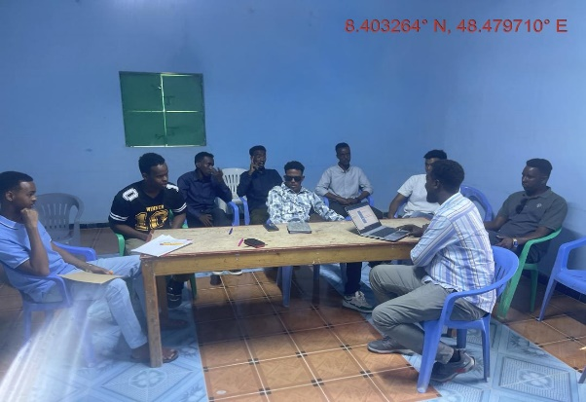
Plate 6. Photo of the FGD with the youth groups in Garowe

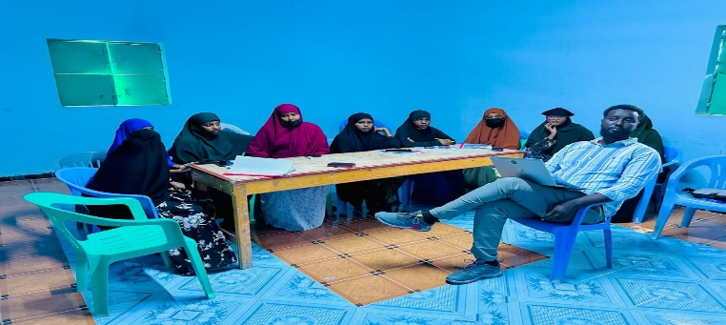
Plate 7. Photo of the FGD with the women groups in Garowe

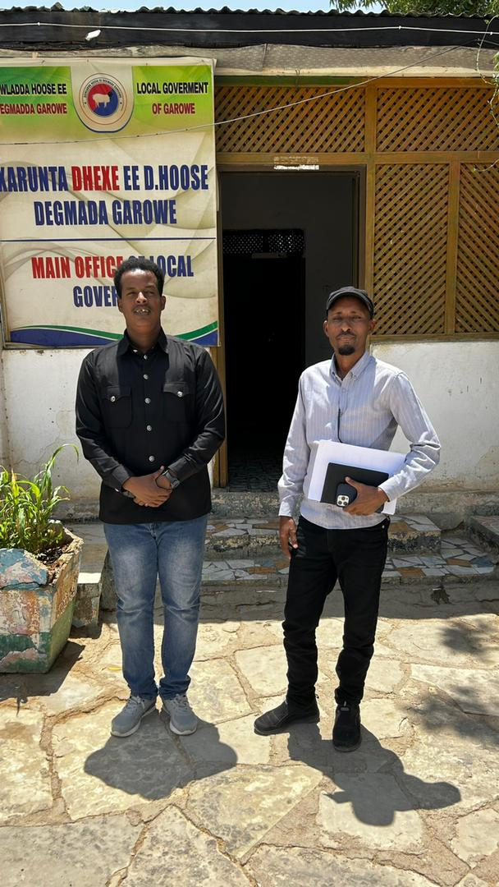
Plate 8. Photo of the interview with the Nugal Regional Administration official in Garowe

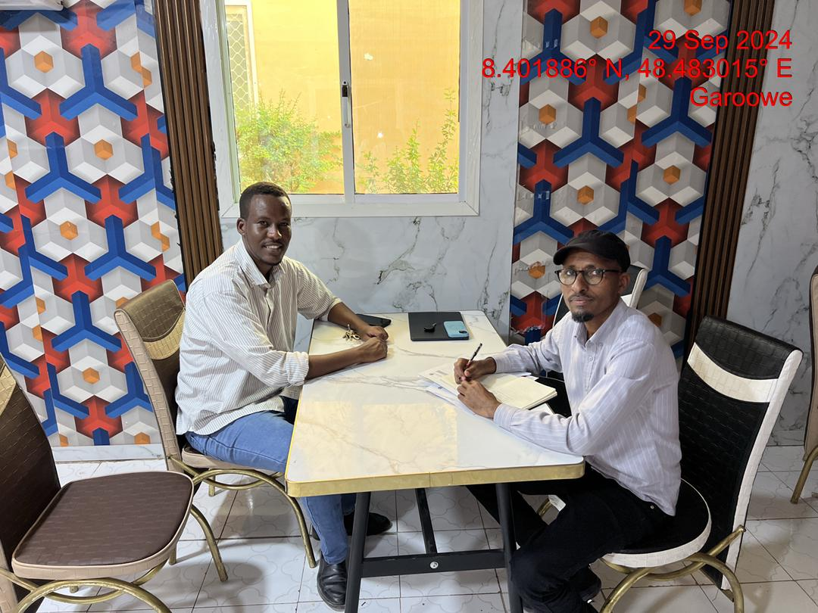
Plate 9. Photo of the interview with Nugaal Waste Management Company
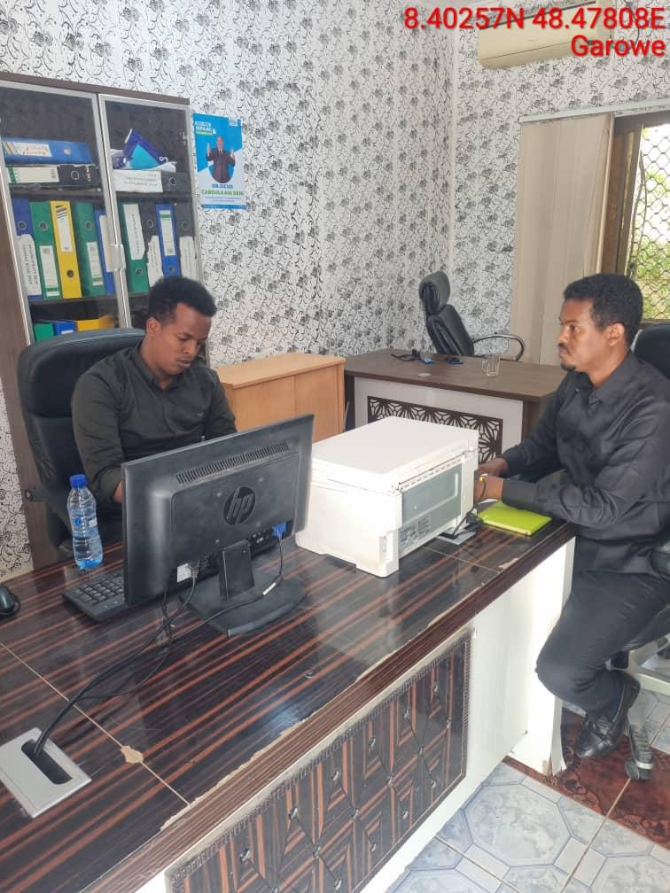
Plate 10. Photo of the interview with Garowe Municipality

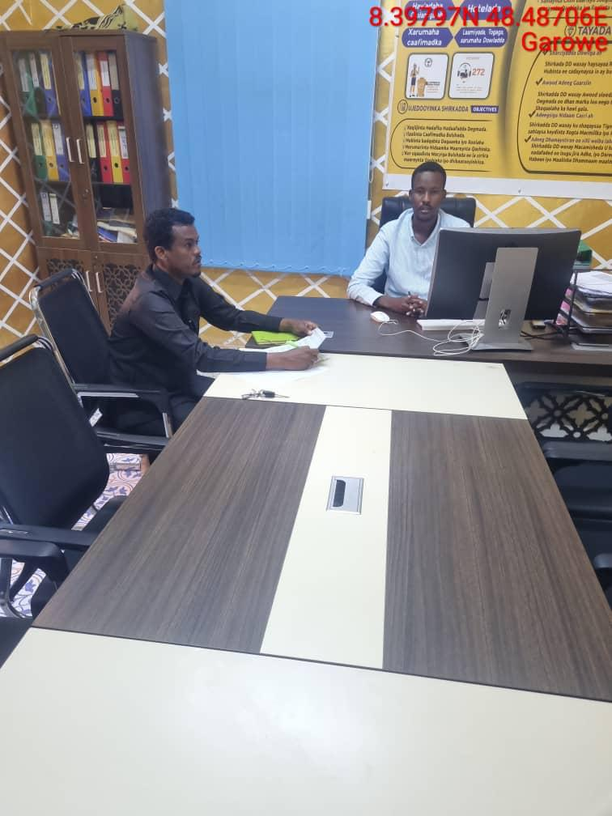
Plate 11. Photo of the interview with Private Business Company

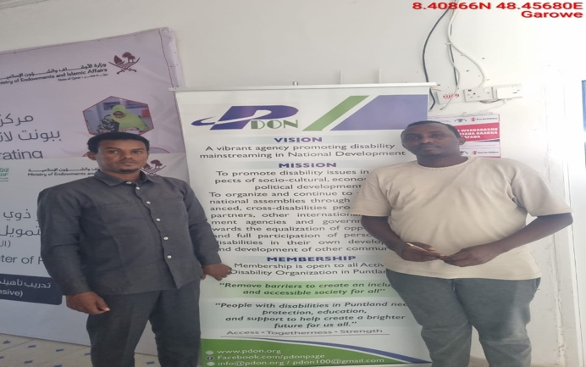

Plate 12. Photo of the interview with Puntland Disability Center

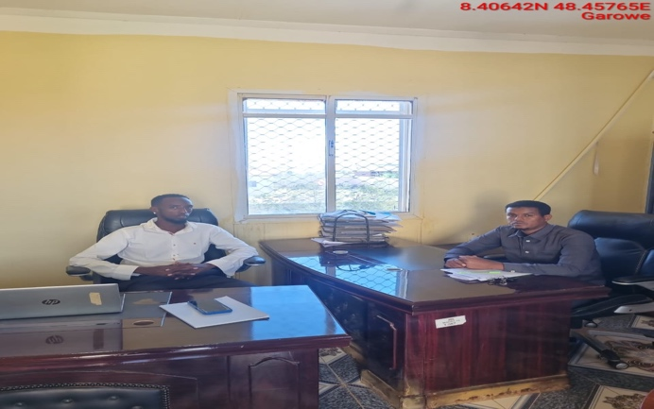

Plate 13. Photo of the interview with Ministry of Women

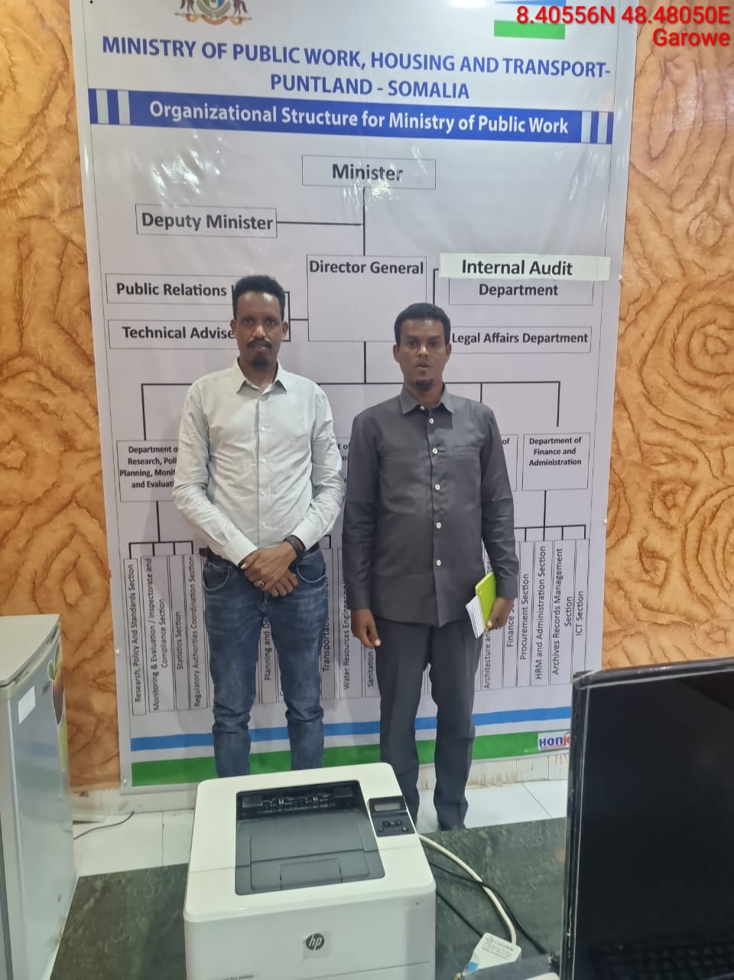

Plate 14. Photo of the interview with Ministry of Public works

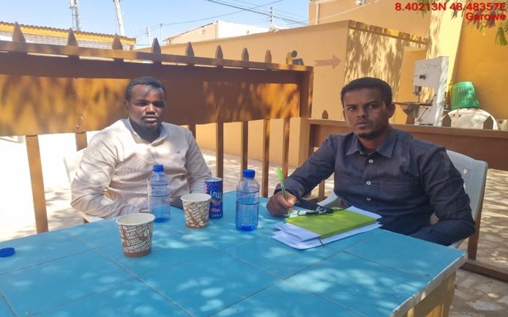

Plate 15. Photo of the engagement with Youth Organization Leader

9.5. Summary of key feedback from stakeholders
The public consultation exercise yielded various outcomes summarised below:

9.5.1. Overall perception about the proposed project
- General support for the project: Most stakeholders expressed their agreement and support for the proposed hybrid power plant, recognizing the potential benefits it will bring in terms of improved access to affordable and clean energy, job creation, and enhanced local economic development. However, there were variations of different strengths in the opinions when analysed across gender as there were feelings that the project will only directly benefit NECSOM from economic perspective
- Land activity of the project site: Project site and the area in general is used mainly for occasional grazing activities, and they do not have formal agreements with NECSOM on the occasional use of the site for grazing. The local communities consulted during the fieldwork did not express any objection to the use of the site by the developer for the proposed project as they understood the site as private and did not attach any compensatory demands on NECSOM. They expressed the existence of alternative grazing areas in the wider Garowe District that can be used for the same purposes and that the Project does not have any specific different values.
- Existence of cultural sites: There are no sacred sites or cultural heritage sites within or in close proximity to the proposed project site.
- Existence of wildlife: Due to its expansive nature and existence of pockets of vegetation dominated mainly by Acacia tortilis and Salvadora persica, the project site on regular basis hosts a variety of wildlife species, including Gerenuk, Dorcas Gazelle and snakes, especially Gungume (the African Rock Python).
- Land use conflicts: No conflicts over land/land ownership were expressed.
- Expectations for regular information sharing: A common request across all stakeholder groups was the need for ongoing, transparent communication from the NECSOM throughout the construction and operation phases of the project. Stakeholders emphasized the importance of timely updates on construction activities, any potential disruptions, and the environmental and social performance of the plant. Communities expect the ESP to establish clear channels of communication to keep them informed.
- Expectations on social responsibility programmes (SRP): implementation of SRP by NECSOM that focuses on community development projects (that addresses women groups as well) as well community needs (health, education, sanitation, water supply, transport, etc.).
- Concerns about potential disruptions: While stakeholders support the project, some concerns were raised about possible disruptions during construction, including dust, noise, and increased traffic. They expect that NECSOM will implement mitigation measures and keep them informed of any significant changes or delays.
- Employment opportunities: Local stakeholders, particularly youth and women’s groups, emphasized the need for job creation as a significant benefit of the project. They expressed an interest in local recruitment, training, and skills development opportunities provided by the project during both the construction and operational phases.
- Environmental and social performance: Some stakeholders expressed concern about the long-term environmental and social impacts of the project. They called for regular monitoring and reporting on the plant's environmental footprint, including any impacts on water resources, air quality, and land use.

9.5.2. Key concerns and recommended action by different stakeholder groups
The proposed NECSOM hybrid power plant raises several environmental and social concerns among various stakeholder groups. Local communities are particularly concerned about potential disruptions to livelihoods, such as restricted access to grazing lands and water sources, as well as the risks of gender-based violence due to the influx of workers. Other stakeholders (i.e., state government agencies, Nugal Regional Administration and Garowe Municipality) highlighted the risks of air and water pollution, including dust and vehicle emissions, as well as the impact on biodiversity. They also stressed the importance of adherence to the existing laws and fair labor practices, including preventing child and forced labor. Most recommendations across different stakeholder groups on addressing various concerns included robust stakeholder engagement, implementation of strict environmental monitoring systems, mitigation of impacts on local livelihoods to prevent exploitation and unfair practices. Additionally, continuous communication with local communities and transparency in project development are essential to foster trust and minimize conflict. Table 9-2 summarizes the key concerns and recommended actions by the key stakeholders engaged during the ESIA.

Table 9-2: The stakeholders’ concerns and recommended mitigation actions for the proposed NECSOM hybrid power plant in Garowe
Stakeholder group | Description | Key Concerns | Recommendations
Local Communities | Residents of living near the proposed project site | Key issues of concern include potential disruptions to occasional grazing area, risks of water resource depletion, dust and noise pollution, and the influx of workers potentially leading to social tensions or gender-based violence. Concerns about community safety, security risks, and impacts on local livelihoods were also significant. | Developing and implementing robust stakeholder engagement plans, ensuring transparent communication, developing mitigation strategies for potential environmental impacts such as dust control and water conservation, and providing community benefit programs. Additionally, enhancing security measures and fostering inclusive participation, especially of vulnerable groups, can help build trust and reduce conflicts.
 | Community leaders and elders | Their primary concerns included potential impacts on local grazing land that may restrict access and affect livelihoods, water consumption that could strain limited local resources, and the influx of workers, which might lead to social tensions or heightened risks of gender-based violence. | Active engagement with the community to ensure transparent communication and participatory decision-making.  Developing and implementing strict environmental management practices, sustainable water use measures, and comprehensive social safeguards to mitigate potential risks, emphasizing the importance of maintaining the well-being of local communities while achieving energy development goals.
 | Pastoralist group | Potential disruptions to grazing land, which is critical for their livestock-dependent livelihoods, as well as the risk of restricted access to water sources during construction and operation phases. Socially, they were worried about the potential for community tensions due to an influx of external workers, which could lead to competition for local resources and increased risk of gender-based violence. | Ensuring comprehensive stakeholder engagement throughout the project lifecycle, implementing water management strategies, and enhancing local employment opportunities.
 | Women’s groups | Influx of construction workers could potentially increasing GBV risks. They also expressed concerns of potential discrimination against women when it comes to job opportunities allocations. | Establishment of robust community engagement protocols, targeted GBV prevention and response measures, and proactive livelihood support initiatives to minimize disruptions. They also urged the incorporation of local women's voices in decision-making processes to ensure gender-sensitive approaches and equitable benefit distribution, especially during construction and operation phases of the project.
 | Youth groups | Potential impacts on local water and energy use, and air quality. Social concerns centered around equitable access to job opportunities, risks of gender-based violence due to worker influx, and impacts on local livelihoods, particularly related to restricted grazing land access. | Developing and implementing stringent environmental monitoring, community engagement strategies, support for local employment, and targeted safeguards to prevent social harms.
 | Vulnerable and marginalized group | Potential restricted access to grazing land, increased risk of gender-based violence (GBV) due to an influx of workers, and limited participation in decision-making processes. | Ensure inclusive stakeholder engagement as a priority to ensure the voices of the VMG are represented and considered in project planning and implementation. Develop and implement measures to support community health and safety, and establish social safeguards, such as clear reporting mechanisms for GBV and labour rights.
 | Puntland Ministry of Energy | The Ministry’s key environmental and social concerns related to the proposed hybrid power plant focused on potential impacts such as air emissions, water use, solid and liquid waste management, community health and safety, and risks to local livelihoods due to land access restrictions. | The Ministry emphasizes the importance of adhering to state and national environmental policies and legal frameworks to mitigate these effects. Ensure implementation of pollution control measures, strict monitoring of resource consumption, and social safeguards to prevent adverse outcomes like displacement or gender-based violence. Compliance with these measures will likely balance energy development with sustainable environmental and social practices.
Government Authorities | Nugal Regional Representative | Several environmental and social concerns were raised. The concerns primarily focused on the potential for negative impacts on local ecosystems, particularly soil erosion and vegetation, which could be exacerbated by construction activities. The representative has also highlighted the risk of community displacement, particularly among pastoralist communities who rely on the land for grazing. Socially, there are concerns about the influx of workers and potential disruptions to local livelihoods, including the strain on resources like water and the risk of labor disputes. | The representative recommended that the project prioritize local workforce employment; ensure the participation of local communities in decision-making processes. Additionally, robust monitoring systems shall need to be established to track environmental impacts, particularly around water use and waste management.
 | Ministry of Women and Family Affairs | The Ministry representative expressed concerns particularly with respect to gender equality, women’s safety, and the welfare of families in the surrounding areas. They highlighted the risk of increased gender-based violence (GBV) due to the influx of workers during construction and the need for measures to ensure the protection of women and children. Additionally, the representative emphasized the importance of providing employment opportunities for local women and ensuring that any workforce-related issues do not disproportionately affect families. | The Ministry recommended implementing a comprehensive GBV prevention and response plan, promoting women's involvement in the project’s labor force, and ensuring proper accommodation and safety measures for workers to mitigate any social and environmental risks associated with the project.
 | Department of Water | The Ministry raised key environmental and social concerns focusing primarily on water usage, potential groundwater depletion, and the impact on local water resources. The representative highlighted the importance of ensuring sustainable water management practices, particularly considering the region's water scarcity. Socially, there were concerns about the potential displacement of communities relying on water sources near the project site and the need for inclusive consultations with affected stakeholders. | Developing and implementing water-efficient technologies, conducting thorough hydrological studies, ensuring proper water allocation for local needs, and establishing a robust community engagement plan to address concerns and mitigate negative social impacts.
 | Garowe Municipality | The Municipality’s representative raised concerns on potential impacts on local water resources, air quality, and land. Additionally, the representative highlighted concerns about the potential environmental degradation from soil erosion, waste generation, and resource consumption. | To mitigate the concerns, the representative recommended implementing robust water management strategies, ensuring strict adherence to air quality standards, and establishing a community engagement plan to address worker influx issues. They also emphasized the need for continuous environmental monitoring and effective grievance mechanisms to ensure long-term sustainability and community well-being.
Businesses operators | Local small and medium-sized enterprises (SMEs) | There were worries about the potential social impacts of the influx of workers during the construction phase, increased pressure on local services and potential for gender-based violence. | Recommendations from SMEs included ensuring implementation of effective waste management and pollution control measures, and providing training and job opportunities for locals. There was also a call for improved communication and consultation with local businesses to ensure that the benefits of the project are shared equitably and that any negative impacts are mitigated.
 | Livestock business operator | They raised concerned that the construction and operation of the plant may limit access to traditional grazing areas, affecting livestock productivity and livelihoods. Additionally, there are worries about the contamination of water sources from plant activities, which could harm livestock health. In terms of social impacts, there was apprehension about the influx of workers, leading to possible conflicts over resources and the strain on local infrastructure. | Ensuring access to alternative grazing areas, managing water usage effectively, and conducting thorough stakeholder engagement to prevent and resolve potential conflicts. Furthermore, there will be the need to establish a grievance mechanism and ensuring that local communities benefit from employment opportunities in the plant's operation.
 | Contractors and suppliers | Key concerns raised included the risk of soil erosion, water pollution from construction runoff, and the impact of increased traffic and waste generation on local infrastructure and health. Additionally, there were worries about labor influx leading to social tensions and potential conflicts over land access. | To mitigate the identified concerns, the representative recommended the development and implementation of best environmental management practices such as erosion control measures, water quality monitoring, and waste management systems. They also advised on the need to prioritize the use of locally sourced, environmentally sustainable materials to reduce the environmental footprint and support local economies.
Non-Governmental Organizations (NGOs) | NGOs focused on humanitarian services | Key concerns raised include the potential displacement of local communities, disruption of livelihoods, particularly for pastoralists, and risks associated with water and land resource use. Environmental impacts, such as air and water pollution, as well as the potential for land degradation were also highlighted. Socially, NGOs are concerned about the influx of workers and the associated risks of gender-based violence (GBV), and the strain on local infrastructure and services. | To mitigate the risks, NGOs recommended implementing best community engagement strategies, ensuring fair compensation, and enhancing labor rights protections, and adopting strict environmental monitoring and impact assessments. They also suggested promoting local capacity building to manage potential social impacts.
 | Women’s rights and gender-focused organizations | Key concerns included the potential for increased gender-based violence (GBV) due to the influx of male workers, the risk of disruption to women's access to resources such as water and grazing land, and the lack of employment opportunities for women in the construction and operation phases. Additionally, the limited involvement of women in decision-making processes related to the project was highlighted as a concern. | They emphasized the need for the implementation of best GBV prevention measures, gender-sensitive community engagement, and the provision of equal job opportunities for women. Moreover, NGOs advocated for the establishment of monitoring mechanisms to ensure that the project’s social impacts are effectively managed, and that women's rights are upheld throughout the project lifecycle.
 | Health and safety advocacy groups | Key issues raised included the influx of workers leading to social tensions, gender-based violence, and the strain on local resources such as water and food. Health risks associated with pollution, noise, and poor sanitation during construction and operation phases were also raised as concerns. | Implementing best community engagement programs, ensuring worker safety protocols, mitigating GBV risks, and adopting clean technologies to minimize emissions. Additionally, there would be the need to promote the inclusion of local communities in decision-making processes, ensuring proper waste management, and monitoring environmental impacts throughout the project lifecycle.
Educational and Research Institutions | Universities and technical training institutes | They raised concerns about the project's effect on surrounding communities, particularly with regards to access to land for grazing, as well as the risk of increased waste generation and potential pollution. Socially, they highlighted the need for safeguards against the influx of workers and the associated risks of labor disputes, gender-based violence (GBV), and strained community relations. | They recommend conducting thorough implementation of environmental and social management plan for the project, ensuring full implementation of the recommended mitigation measures.
Workers | Construction workers | Potential health risks from dust and air pollution, and the influx of workers leading to possible social tensions. | Developing and implementing strict occupational health and safety standards, providing training for workers on environmental best practices, ensuring adequate sanitation and housing for the workforce, and engaging with local communities to address concerns and minimize disruptions. Additionally, they proposed establishing grievance mechanisms and monitoring systems to track the impact of the construction process was recommended to ensure timely resolution of emerging issues.
Utility and Infrastructure Entities | Puntland Electricity Utility | The representative expressed concerns emphasizing the potential risks to local ecosystems, water resources, and biodiversity. | Implementing stringent environmental safeguards, including effective waste management and water conservation measures, alongside robust social risk mitigation strategies such as local community engagement, labor rights protections, and GBV prevention programs.
 | Other local electricity services providers | Concerns were raised about workforce influx leading to increased social tensions, security risks, and gender-based violence. | Implement robust environmental management plans, including air and water quality monitoring, land restoration programs, and the establishment of grievance redress mechanisms. Stakeholder engagement need to be enhanced, with a focus on local communities.
 | Water and waste management service providers | Potential risks of water scarcity due to increased consumption during construction and operation, as well as the generation of liquid and solid waste that could impact the surrounding environment and community health. | Implementing efficient water use practices, ensuring proper wastewater treatment facilities, establishing a solid waste management system, and conducting regular monitoring to ensure compliance with environmental standards. Additionally, community engagement should be prioritized to address potential concerns about waste disposal and water resource impacts.
 | Transport and logistics companies | There were concerns about road infrastructure degradation due to heavy truck movement and the risk of accidents involving local communities and workers. Furthermore, logistics operations could lead to disturbances in nearby habitats, dust pollution, and noise. Socially, the influx of workers might strain local resources, potentially causing tensions over access to services. | Improving road conditions and safety measures, implementing strict monitoring of emissions from transport vehicles, engaging local communities in the planning process to address potential social impacts, and ensuring the adoption of sustainable transportation methods, such as using lower-emission vehicles and optimizing delivery routes.
Religious and Cultural Leaders | Clergy and religious groups influential in the community | Key concerns raised include the impact on possible displacement of pastoralist communities, and environmental degradation, such as water and air pollution, which may affect local health and pastoral activities. | Incorporating community-driven mitigation measures on sustainable water use practices and the prevention of pollution.
Displaced and At-Risk Populations | Internally displaced persons (IDPs) | The representative expressed environmental and social concerns particularly the potential loss of grazing land critical to their livelihoods. There were fears of increased air and water pollution from construction and operational activities, affecting health and access to clean resources. Additionally, the influx of workers could strain local resources, exacerbate competition for employment, and heighten risks of gender-based violence (GBV). | The representative recommended ensuring the protection of IDPs' rights, providing compensation for land loss, and improving access to clean water and healthcare services. Strong stakeholder engagement throughout the project lifecycle, including a focus on the inclusion of IDPs in the workforce, was emphasized to mitigate social tensions.

9.6. Expected commitments by NECSOM
In response to stakeholder feedback, the NECSOM has committed to the following actions:
- Ongoing consultations: Stakeholder consultations will continue throughout the project lifecycle, with periodic meetings held at key milestones of the construction and operation phases. The already developed SEP will be tailored to meet the expectations of this subproject.
- Public communication channels: NECSOM will establish communication channels, such as social media platforms, local radio updates, and community notice boards, to ensure that information reaches all stakeholders in a timely and accessible manner.
- Mitigation of disruptions: Detailed plans will be implemented to minimize construction-related disruptions, including dust control, noise management, and traffic regulation measures. A grievance mechanism will also be put in place to address any concerns raised by the community during the project.

9.7. Conclusion
The stakeholder consultation process for the proposed hybrid power plant in Garowe City has been positive, with stakeholders expressing broad support for the project. However, stakeholders have emphasized the importance of regular information sharing and engagement throughout the project's lifecycle. NECSOM team acknowledges this expectation and commits to maintaining transparent and consistent communication with all stakeholders, ensuring that their concerns are addressed and that the project contributes positively to the local community and environment.

10.0. Conclusion and Recommendations

10.1. Conclusion
- During the preparation of this report for the proposed development, it is observed and established that most of the negative social and environmental impacts can be mitigated and have potentially short term low significant effects. The positive impacts are highly rated and will benefit the community in the project area and Puntland State at large. The project proponent (MoEWR), the implementing entity (NECSOM) and the contractor must adhere to prudent implementation of the social and environmental and social management plan. The contractor shall commit to obtaining all necessary permits and licenses from the relevant authorities and have qualified and adequate personnel to do the project as proposed. The ESIA has proposed adequate environmental, health and safety mitigation measures as part of the relevant statutory requirements.

- The analysis of the ESIA has demonstrated that the construction and operation of the proposed power plant in Garowe will have positive impacts to the FGS, Puntland State governments, and residents of Puntland State at large. The impacts will include; Increase in reliable and sustainable clean energy, employment to local community members, increase in the national/local investment, increase in government revenue, improvement of standards of living for Garowe residents. However, despite the outlined positive impacts, the proposed development will cause some negative impacts such as; noise, dust generation, soil erosion, oil spills, fire hazards, electrocution, shocks, solid waste generation, occupational health hazards, social risks such as labour influx, demand for resources, gender-based violence, among others that need to be avoided, reduced and mitigated against.

- An Environmental and Social Management Plan (ESMP) has been developed to ensure sustainability of the project area activities from construction through operation to decommissioning. The ESMP plan provides a general outlay of the activities, associated impacts, mitigation action plans and appropriate monitorable indicators. Implementation timeframes and responsibilities are defined, and where practicable, the cost estimates for recommended measures are also provided.

- A monitoring plan that highlights some of the environmental performance indicators that should be monitored has been developed. Monitoring creates possibilities to call to attention changes and problems in environmental quality. It involves the continuous or periodic review of operational and maintenance activities to determine the effectiveness of recommended mitigation measures. Consequently, trends in environmental degradation or improvement can be established, and previously unforeseen impacts can be identified, or pre-empted and mitigation measures proposed.

- From the findings of this ESIA, the following specific conclusions can be drawn:
- The proposed project will generate socio-economic benefits which would not be realized if the ‘NO development option’’ is considered.
- The relevant stakeholders have been consulted and the relevant project information shared and the views of the stakeholders is that the project is long overdue.
- The potential adverse impacts associated with the proposed project are possible to mitigate successfully. Most impacts before implementation of mitigation measures are assessed as very low to medium low and the ratings are expected to improve further with the implementation of the proposed mitigation measures
- The impacts that will be adverse will be temporary during the construction phase and can be managed to acceptable levels with the implementation of the recommendation of the mitigation measures for the project.
- The project will be designed, constructed, and operated according to the acceptable industry norms and standards. Successful implementation of the proposed ESMP will ensure environmental sustainability.
- The proposed project design has integrated mitigation measures with a view to ensuring compliance with all the applicable laws and procedures. The proposed power plant and associated structures will be installed to the required planning/architectural/structural designs and standards. During project implementation, operation and decommissioning stages sustainable environmental management would be ensured; avoiding inadequate use of natural resources, conserving nature sensitively and guaranteeing a respectful and fair treatment of all people working on the project, general public at the vicinity and the expected PAPs of the project.
- In relation to the proposed mitigation measures that will be incorporated during construction, operational and decommissioning phases; the development’s input to the society and environment; the project is considered beneficial and important.

10.2. Recommendation
- It is strongly recommended that a concerted effort is made by the MoEWR and NECSOM in particular, to implement the ESMP provided herein. Following the commissioning of the project, statutory EHS Audits shall be carried out in compliance with the national and WB regulatory requirements. The environmental performance of the site operations shall be evaluated against the recommended measures and targets laid out in this report.
- On the basis of the findings from this ESIA, the following specific recommendations can be made:
- The NECSOM and the contractor shall adhere to relevant legal and regulatory framework to ensure compliance and success of the project
- Adherence to the mitigation measures as spelt out in the ESMP and monitoring of the same is mandatory to ensure environmental and social sustainability of the project.
- Cultivate and maintain a good working relationship with the community members, and all other relevant stakeholders.
- Ensure social inclusion of the vulnerable groups by paying attention to the most vulnerable and provide ready boards as spelt out
- Contractor to undertake habitat restoration programmes through planting of indigenous vegetation in all cleared areas to promote environmental sustainability
- Stakeholder engagement to the carried out throughout the construction and operation and decommissioning phases.
- Contractor to ensure grievance redress mechanism is established and operational
- EHS Audits shall be carried annually or as prescribed by the FGS Authority during the operational phase.
- Diligence on the part of the contractor and proper supervision by the MoEWR and NECSOM is crucial for mitigating the potential impacts and ensuring environmental, health, safety, and efficient operation of the project.

10.3. Authorization opinion
- HD believes that sufficient information has been provided in this ESIA to enable decision making on proceeding with the project. Additionally, HD have shown that the proponent’s preferred alternative and technological alternatives are generally acceptable. Furthermore, the ESIA has also assisted in the identification of essential mitigation measures that will mitigate the impacts associated with the project to within acceptable limits.
- HD is of the opinion that on purely ‘environmental’ grounds (i.e., the project’s potential socio-economic and biophysical implications) the application as it is currently articulated in the applicant’s proposal should be approved provided the essential mitigation measures are implemented. It is in the opinion of the HD that the anticipated negative impacts can be readily and effectively mitigated and the proposed project does not pose any significant threat to the Environment and may be approved to proceed.

11.0. Annexes

Annex 11.1. Land ownership document for the proposed project site
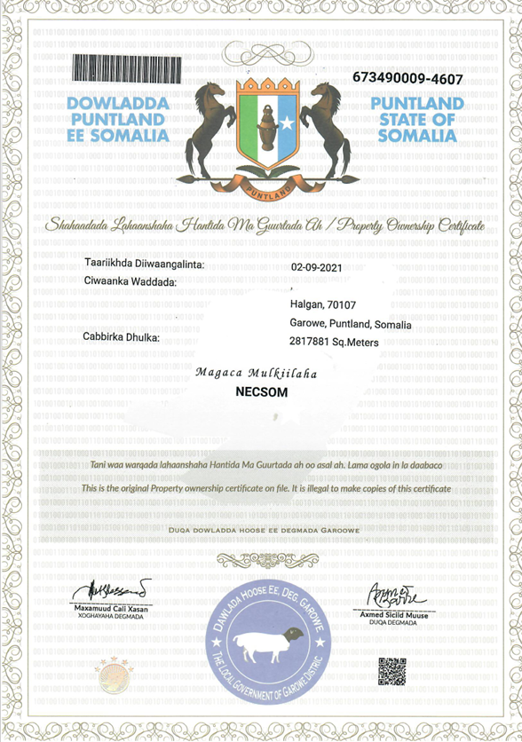

Annex 11.2. Public constultation questionnaires
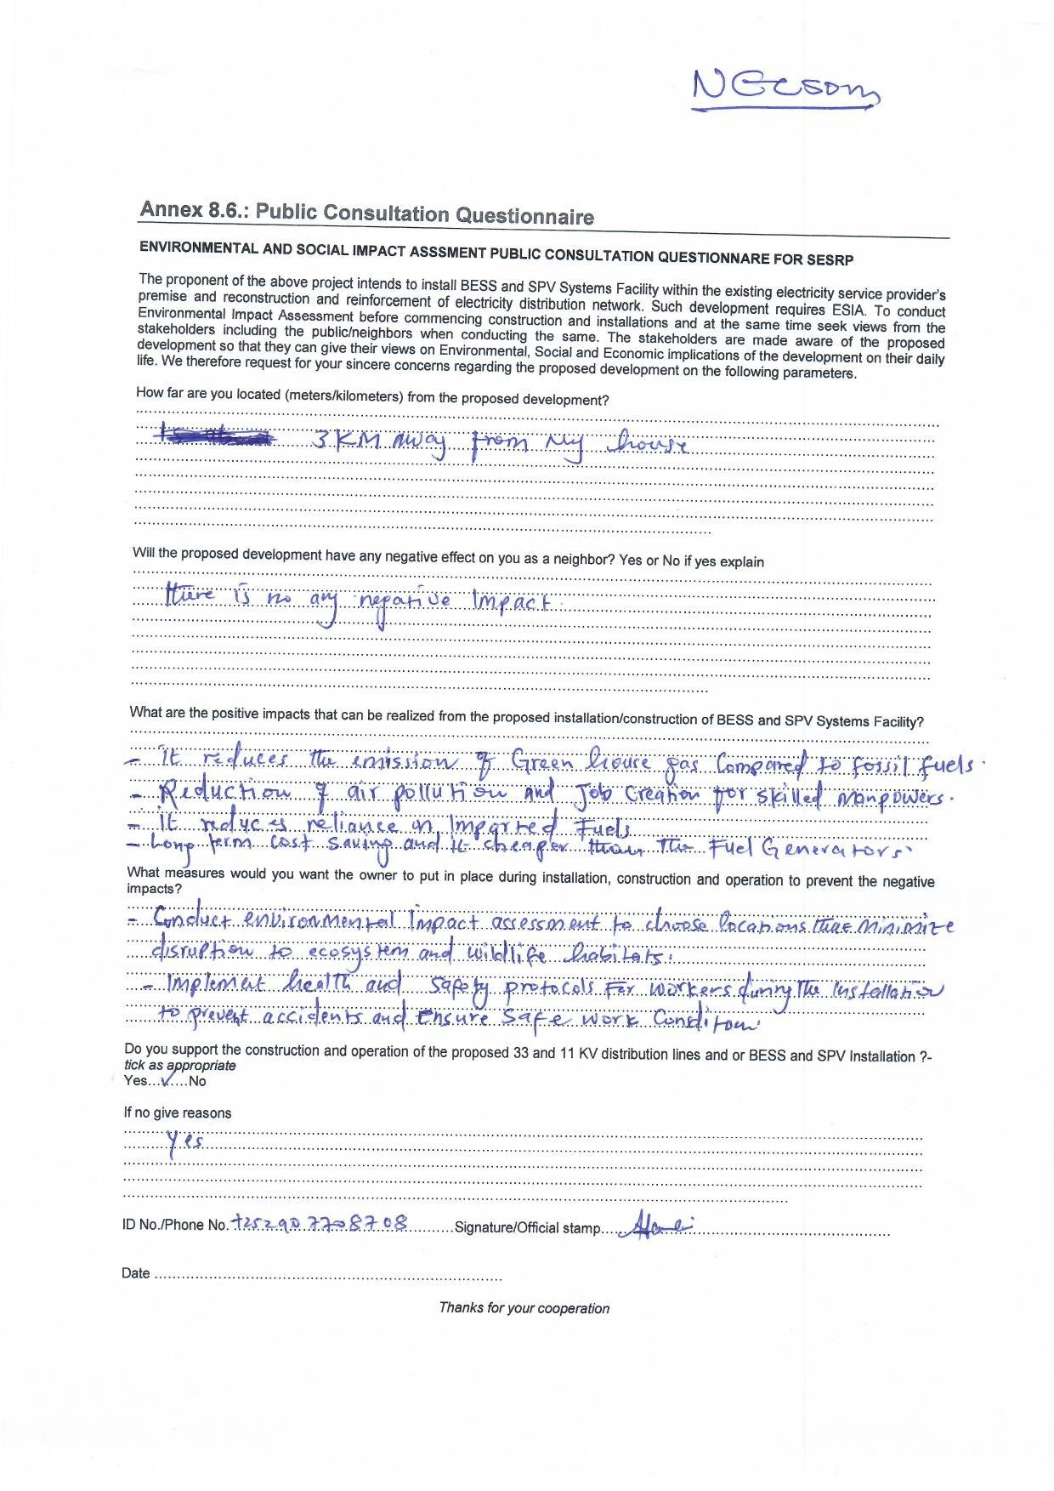

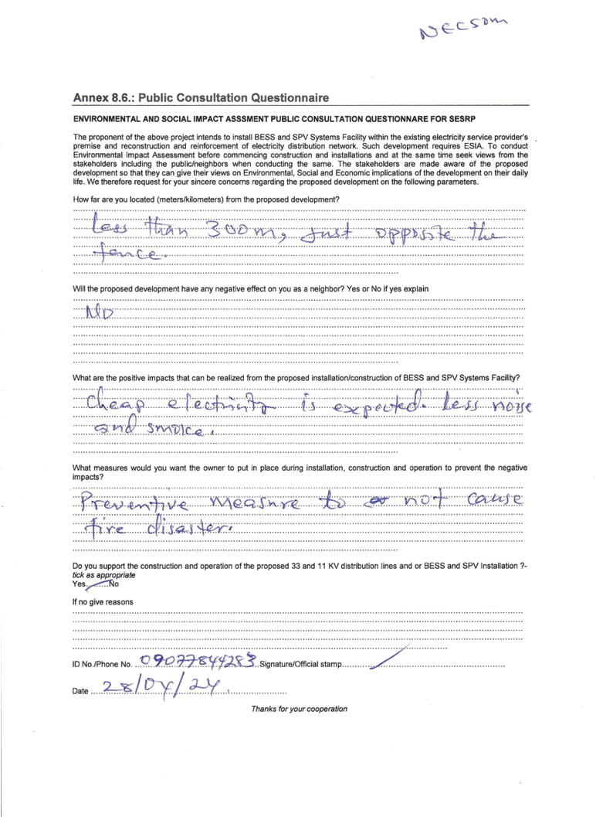

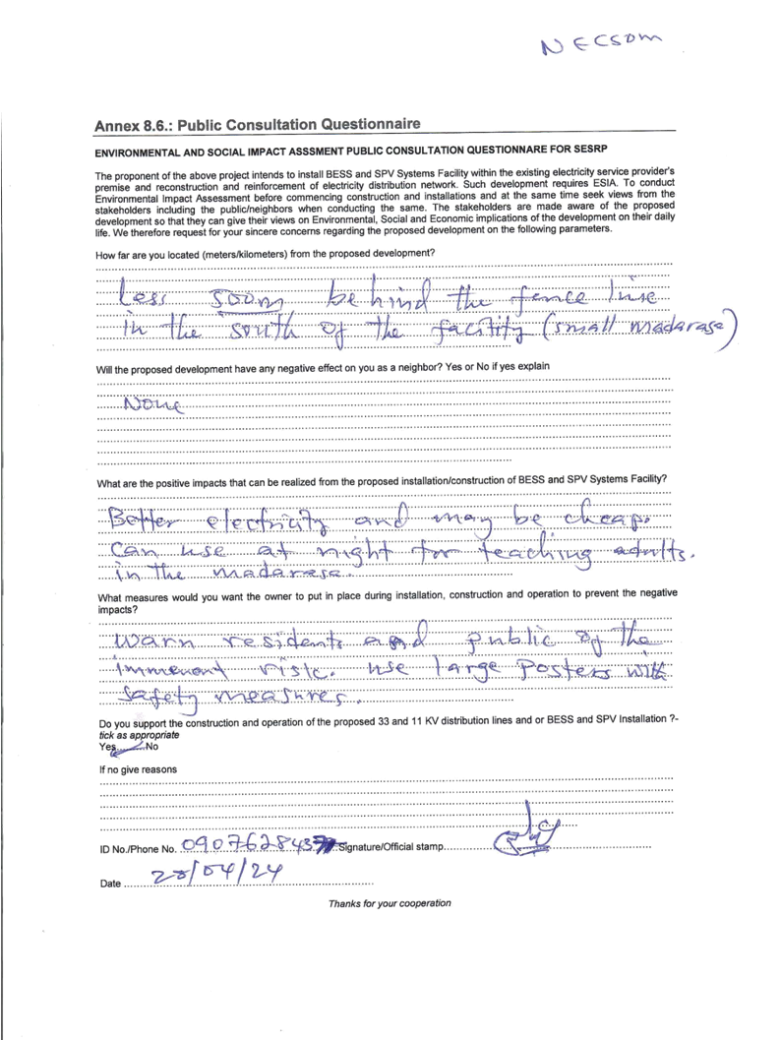

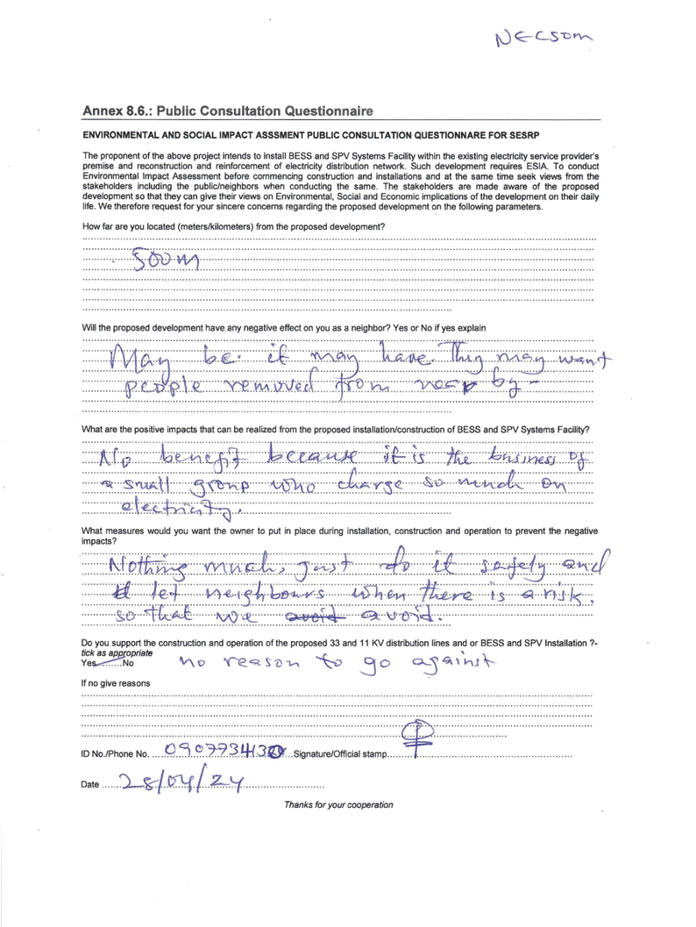

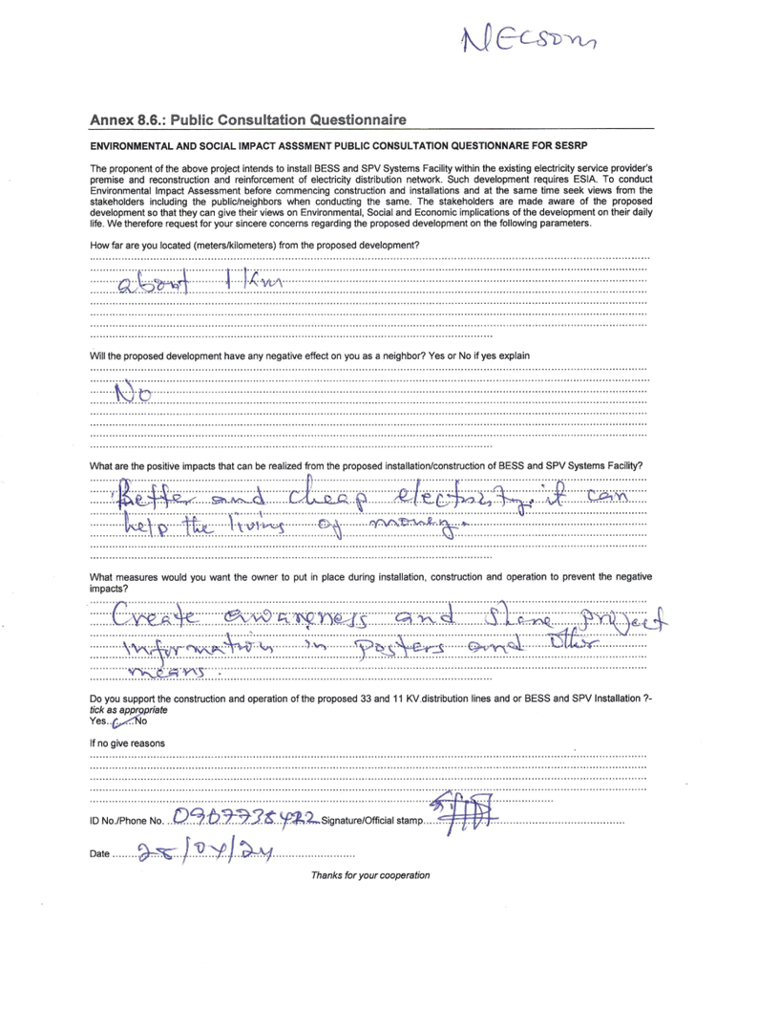

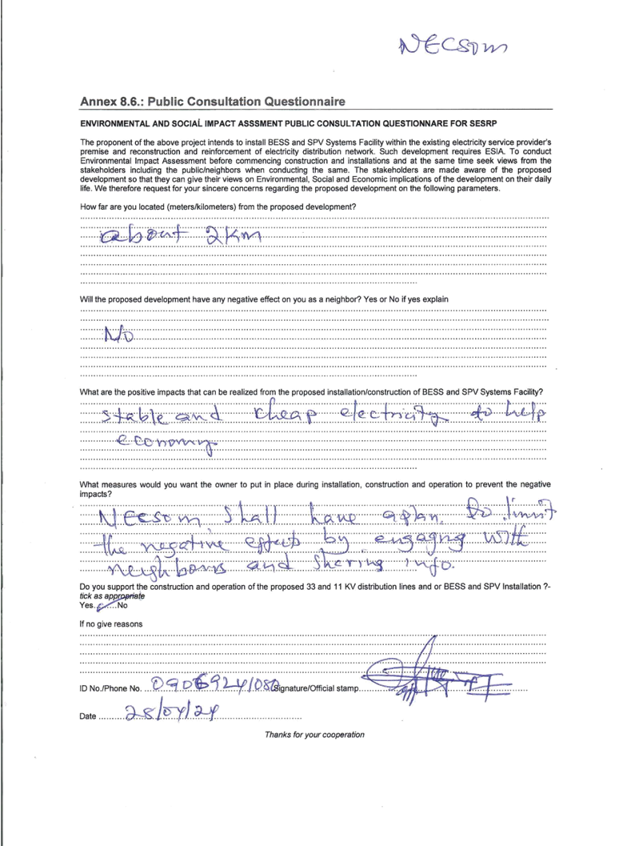

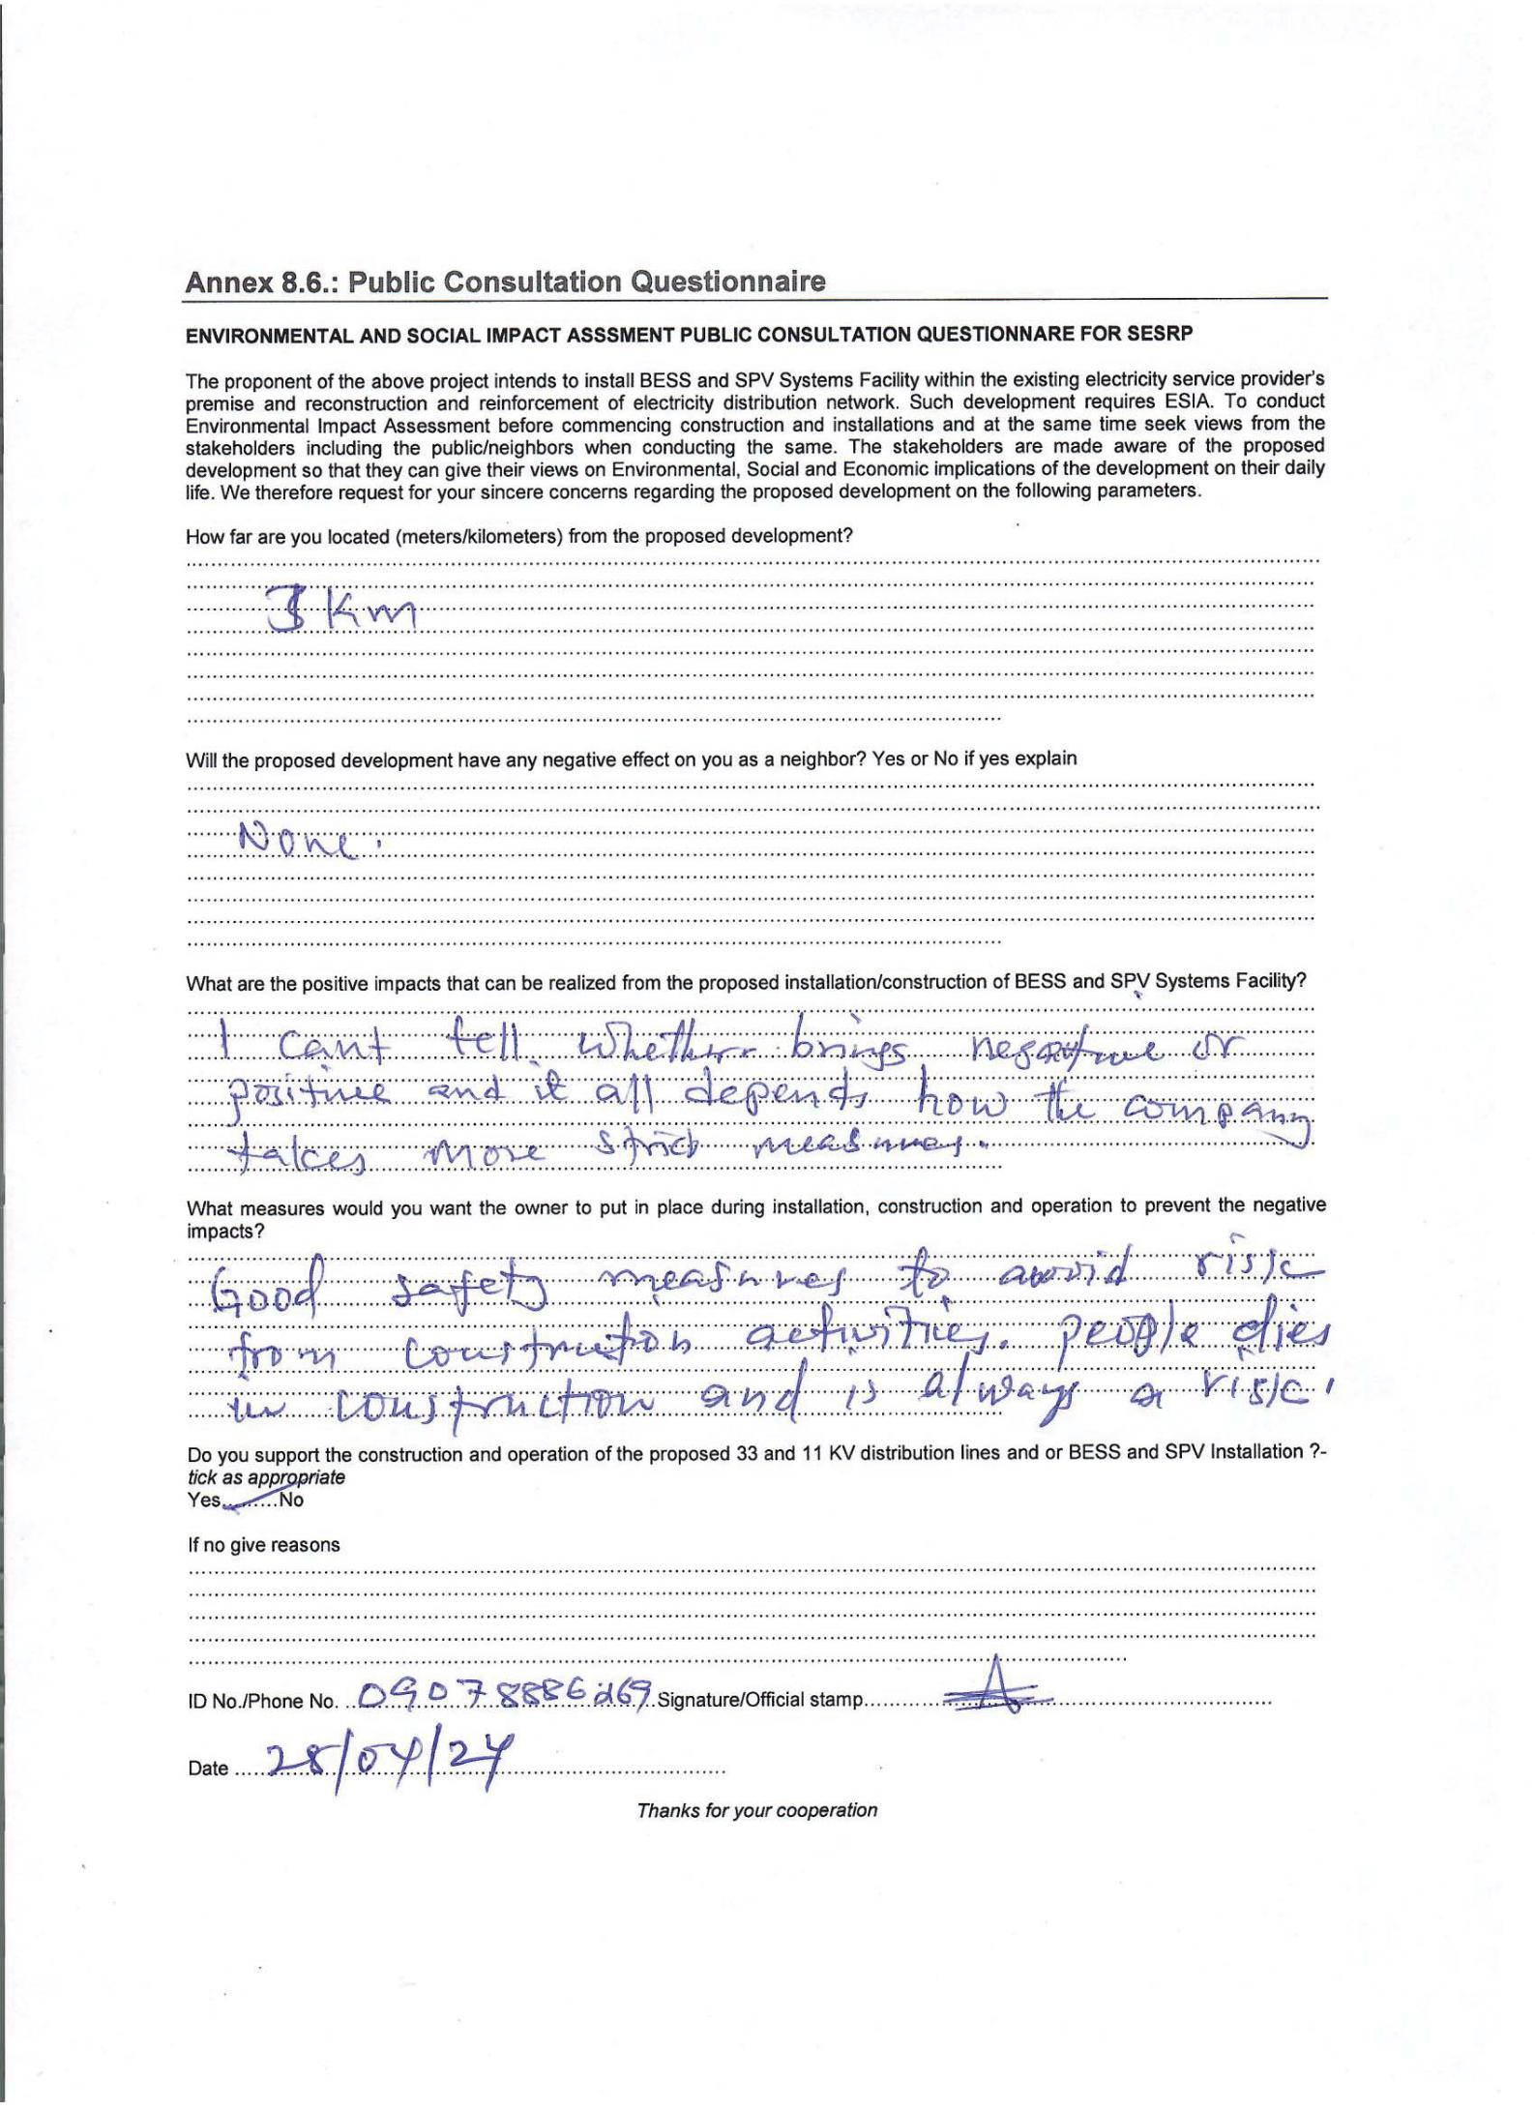

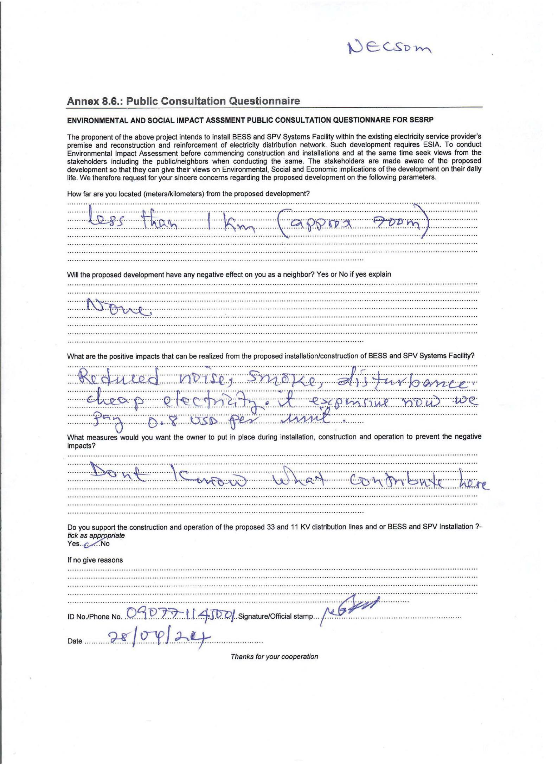

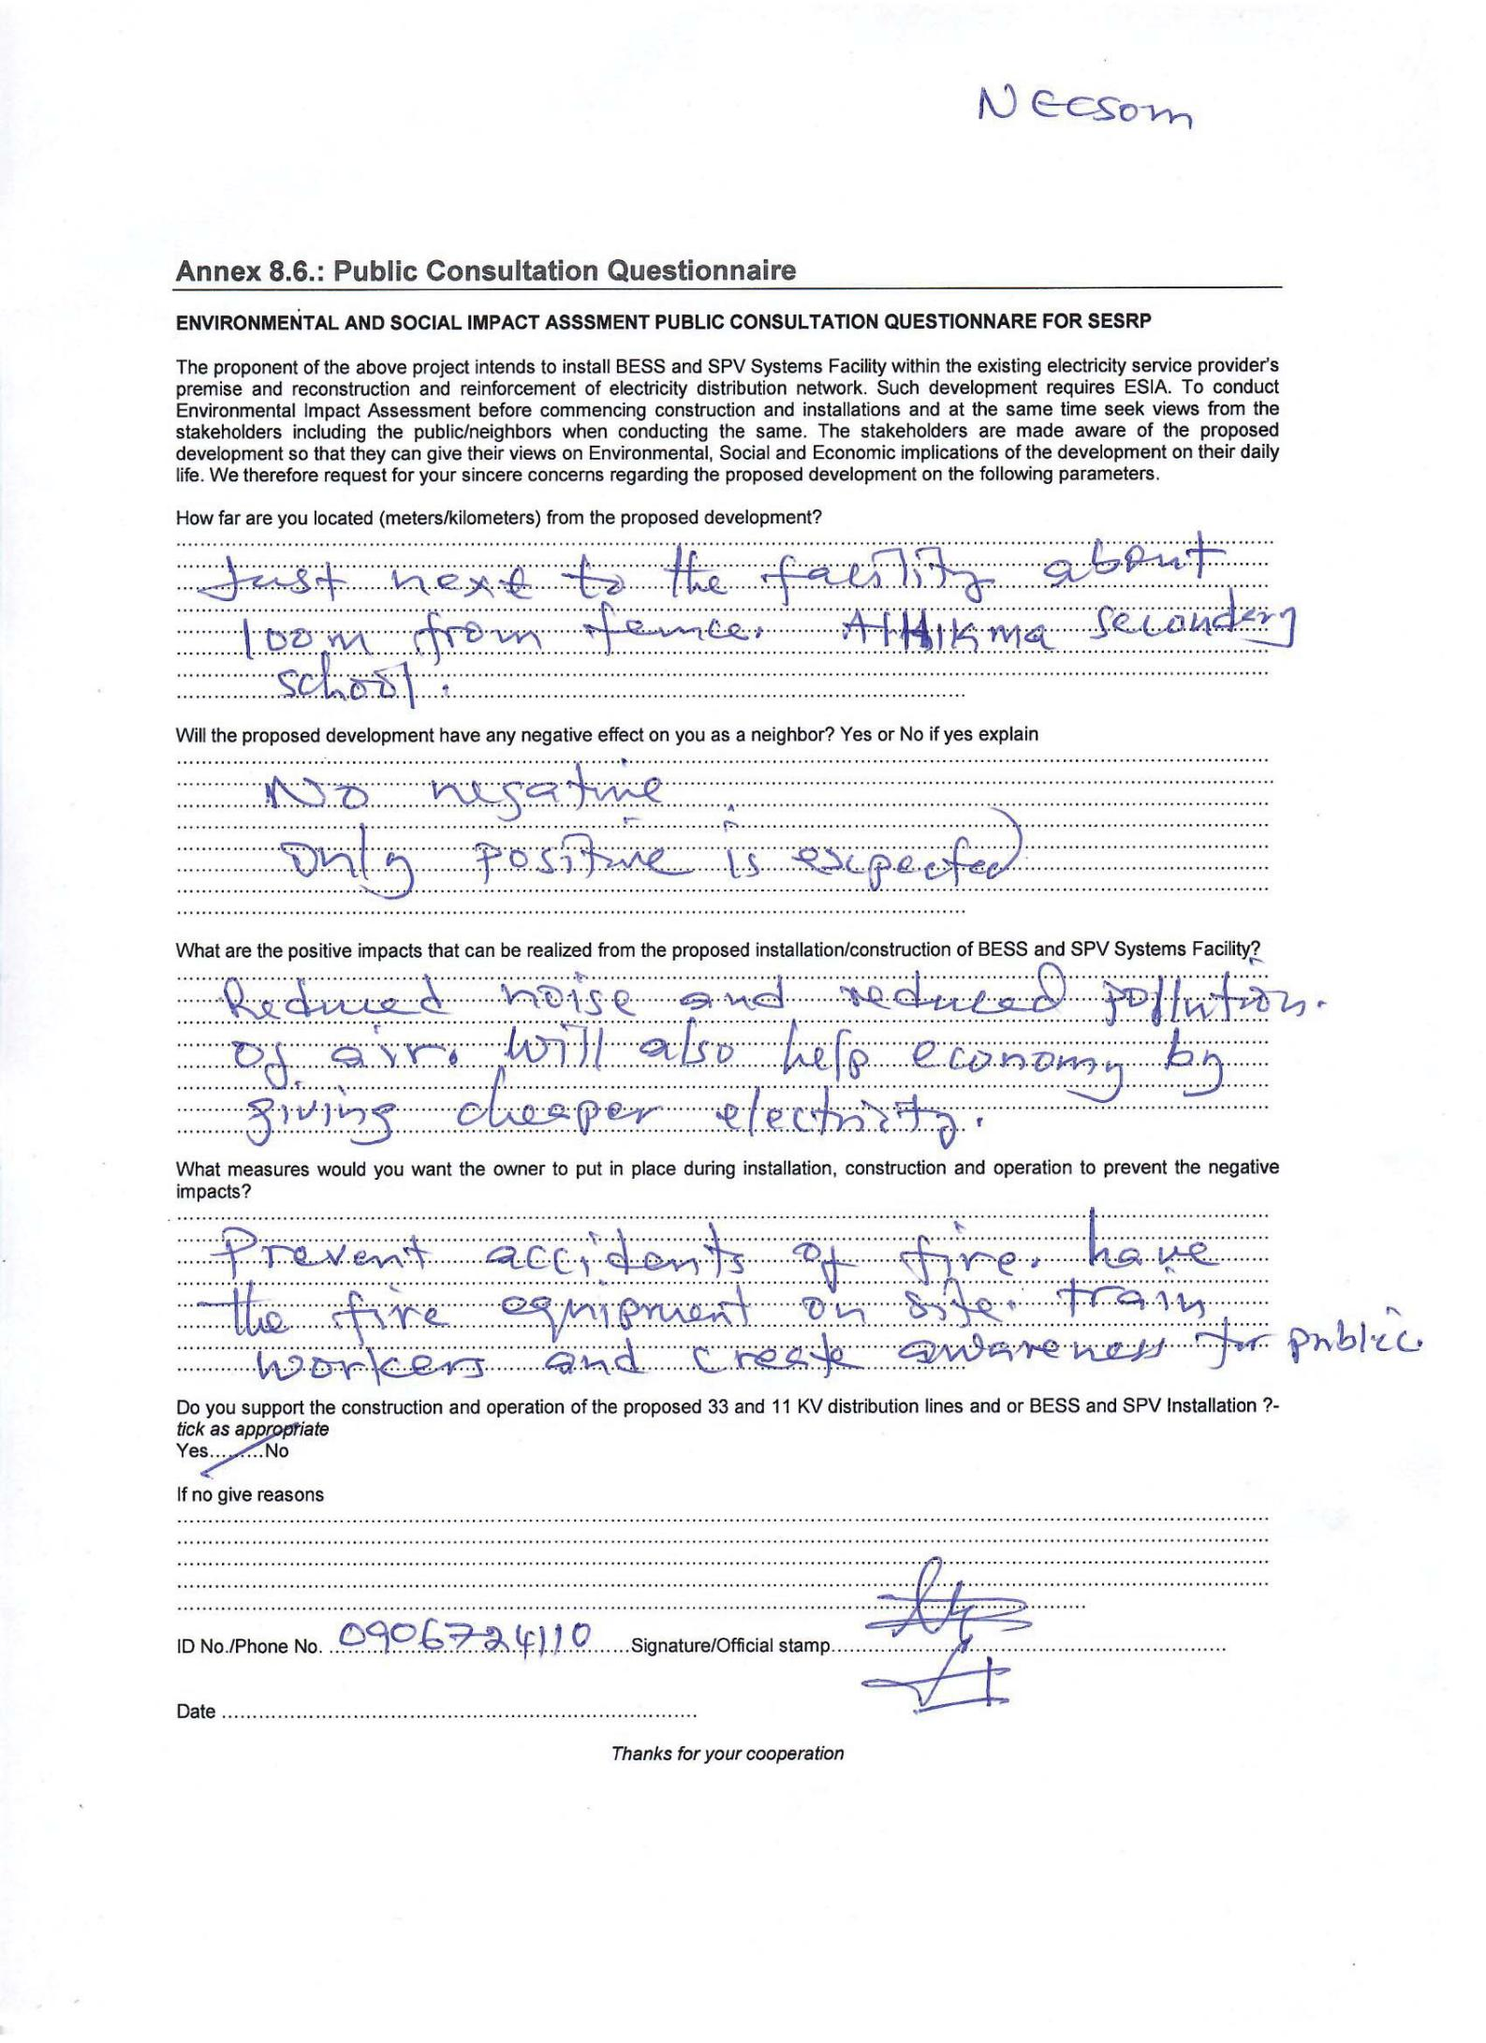

Annex 11.3. Focus group discussions outcomes
Annex 2.: Environmental and Social Assessment Checklist
Project Name: NECSOM | District/City: Garowe
Project Location: Puntland | Nature/Size: ESP
Type of activity: (e.g., New Construction, Expansion, Installation, Periodic maintenance): Expansion
Name & Signature of Evaluator: SAAD ADAN AIDED | Date of Field Evaluation: 3rd June 2024

Item |  | Appraisal | Risk / Significance rating
 |  | Yes/No | None | Low | Moderate | Substantial | High | Unknown
1. Environmental Screening (ESS3 and ESS6)
Will the project generate the following impacts?
1.1 | Loss of trees | No
1.2 | Soil erosion/siltation in the area | No
1.3 | Pollution to land by oils etc. | Yes |  |  | X
1.4 | Dust emissions | No
1.5 | Solid and liquid wastes | Yes |  | X
1.5 | Borrow pits and pools of stagnant water | No
1.6 | Rubble/heaps of excavated soils | No
1.7 | Emergence of wildfire | yes |  | x
1.8 | Invasive tree species | No
1.9 | Long term depletion of water | No
1.10 | Exposure to hazardous chemicals including PCBs | No
1.11 | Nuisance from noise or smell | Yes |  | X
1.12 | Loss of soil fertility | No
1.13 | Generation of hazardous waste including solar batteries | Yes |  | X
1.14 | Cross through, located within or nearby environmentally sensitive areas (e.g., national parks, intact natural forests, wetlands, etc.)? | No
1.15 | Cause poor water drainage and increase the risk of water-related diseases such as malaria or bilharzias? | No
1.16 | Risk of exposing the workers to extremely hazardous working conditions. | Yes |  | x
2. Social Screening (ESS5)
Will the project generate the following negative social and economic impacts?
2.1 | Loss of land by households | No
2.2 | Loss of properties –houses, structures | No
2.3 | Loss of perennial trees, fruit trees by households | No
2.4. | Loss of crops by people | No
3. ESS2, ESS4, ESS5, ESS7, ESS8
3.1 | Loss of access to river/forests/grazing area | No
3.2 | Impact heritage site, graveyard land | Yes |  | x
3.3 | Conflicts over use of local water resources | No
3.4 | Disruption of important pathways, footpath/roads | Yes |  | x
3.5 | Loss of communal facilities | No
3.6 | Loss of livelihood system | No
3.7 | Risk of encouraging child labour | No
3.8 | Risk of workers to extreme exposure for GBV | No
3.9 | Spread of HIV/AIDS and other STI’s | No
3.10 | Risk of GBV/SEA/SH to the affected communities | No
3.11 | Risk associated with Security personnel | No
4: Impacts on Historically underserved groups/Ethnic minorities |  | No

Categorisation & Recommendations:
After compiling the above, determine which risk category the sub-project falls under based on the environmental risk categories: High, Substantial, Moderate and Low risk. If the sub-project falls under “Substantial, Moderate or low” risk categories, proceed to identify the category of the sub-project based on the National EIA guidelines issued.

World Bank ESF Categorisation
Place tick in applicable | Category | Details
 | High Risk | Sub-project of the Somalia Electricity Sector Recovery Project (SESRP) likely to fall under “High Risk” rating. In the likely event that subproject falls under “High Risk” the Environmental and social Assessment should be conducted in accordance with the World Bank Environmental and Social Standards (ESSs) by preparing an ESIA study report.
 | Substantial Risk | Sub-project of the Somalia Electricity Sector Recovery Project (SESRP) likely to fall under “Substantial Risk” rating. In the likely event that subproject falls under “Substantial Risk” the Environmental and Social Assessment of the subproject should be conducted in accordance with any requirements of the ESSs that the Bank deems relevant to such subprojects by preparing an ESIA study report.
 | Moderate Risk | Environmental and Social Assessment of the subproject should be conducted in accordance with any requirements of the ESSs that the Bank deems relevant to such subprojects by preparing an ESMP.
 | Low Risk | Sub-project is not subject to environmental assessment as no potential impacts are anticipated.

Annex 3.0.: Focus Group Discussion Guide – Youths/Associations
FGD Youth /Association
Facilitator Instructions: The purpose of the meeting is to gather information on the socio-economic situation of the youth in terms of participation in decision making, employment, recreation and aspirations. There should be no more than 10 participants. Keep the discussion focused and please probe for explanations for responses (what, where, when, why, how). Take lots of pictures. The Federal Government of Somalia has secured a grant from the World Bank to implement the Somali Electricity Sector Recovery Project (SESRP). The SESRP is implemented by the Ministry of Energy and Water Resources (the MoEWR). The Project Development Objective is to increase access to lower-cost and cleaner electricity supply in the project areas and to re-establish the electricity supply industry. We are conducting an environmental and social impact study for Component 1 of the project, focusing on the sub-transmission and distribution network reconstruction, reinforcement, and operations efficiency in the major load centers of Mogadishu and Hargeisa. The purpose of this study is to collect comprehensive information to comprehend the potential impacts of the project and solicit feedback from stakeholders.
Section A: General Information |  | Responses
 | Date and time of meeting | 3rd June 2024
 | Name of facilitators (inc note taker) | Saad Adan Aided
 | Region/District | Nugaal , garowe
 | Name of Village | 1 da ogosto
 | Number/gender of participants | Males: 10 Females:10
Section B: The Project
 | Have you heard of the project before? How/when/where (if not please explain)  Do you feel that you understand the project? | No we haven’t heard this project before now. There has been bad relations between federal government of Somalia and Puntland regional administration and this has had impact on many projects so the information is not that available on upcoming projects.
 | What do you think could be the positive impacts of the project on youth, so that people benefit? | We think this project have more positive for the youth and generally the communities, because if this project implementing the youth can get jobs opportunities and also communities get cheap power which can accessible all the people. we much hope for cheaper electricity rates but there is also need to regulate if NECSOM is given investment intended for public use.
 | What other impacts to you think that the project could have on the youth and communities? | More access to electricity can improve lives of the populations in Garowe and could impact on economy  Of the region
 | How do you think that the project could minimize or avoid negative impacts? | This project can minimize the pollution of environment which causes the machines of power companies.  Also we hope to minimize the noises of machines. The company shall avoid any displacement of people  Or disturbance of roads and use of poor electricity cables and unsafe systems.
 | Do you have any questions/comments regarding the project? | Yes, there is need to have more information about the project shared publicly through various means. NECSOM doesn’t share much information to public about the project. They shall see the project as a public investment given to them to improve services and not to take it away for their own good.
Section C: Overview
 | If a youth group - When was your youth group established?  Why was it established? | Not a youth a group  None
 | What are the key priorities among the youth?  What are the main issues faced? Why? | Everyone has a personal priority but youth wants in generally a good life, better health facilities, better education and employment.  Unemployment and some security related incidents like clan revenges are some of the problems that are facing youth. Some mentioned not able to travel to their rural areas because of fear for clan revenge related issues.
 | To what extent do the youth play a role in decision making?  Do they feel that their voices are heard?  What are the main areas where they would like their opinions to be heard? | Youth in Somalia often have limited roles in decision-making processes. Traditional and political structures may not always prioritize youth involvement, leading to feelings of exclusion. In Puntland influential politicians are always rewarded and youth are mostly not considered much in decision making.  Many Somali youths feel that their voices are not adequately heard. Puntland youth and generally Somali youth would like their opinions to be heard in areas like good governance, policy making, public administration, election process and input to the way the country is managed.
 | What programmes are in place to help the youth?  How successful have they been? | There are different educational insitutions in Puntland including universities and technical training institute. NECSOM itself has technical training institute known as NTI which provides range of technical training skills to youth. But most of the programmes are costly and not free but education wise this is an area moving on well may be questions about quality exist but not bad.
Section D: Education
 | How many of the youth have completed secondary education? | About 50% completed secondary education and many went to universities for further studies but after university there are no jobs.
 | How many of the youth have been to vocational school and have qualifications?  What subjects do these apply? | Two of them have vocational skills and have qualification, electrical technicians so overall indicating small number of the youth prefer technical institutes but many go universities.  Electricial technicians, solar technicians, mechanical
 | What skills to the youth feel they have that enable them to work? | The skills which youth feel they have that enable them to work are like driver skills, electric skills , mechanic skills and also they have skills can creates business opportunities.
Section E: Unemployment
 | How many of the youth do not have a full-time salaried job? | 50% of the youth of this city garowe they haven’t full time job salaries because scarcity of jobs in this city.
 | Why do the unemployed youth not have a job?  What are they doing to find a job? Are there any barriers to finding work? What are these? | Because there are mostly no jobs and there is also corruption, only rich are growing rich and the rest are left behind.  Upgrading education and becoming more creative in business ideas is some of the things youth are focusing for achieving better life.
Section F: Employment
 | How many of the youth are working?  How many are self-employed and how many work for an employer? | Only 5 of the participants where working meaning approximately 50% are having jobs and the rest are not working.  Out of the 5 working participants 4 were working with employors and one having own small kiosk.
 | What are the main jobs that the youth have? | Different activities some are working with NGOs, others driving cars, taxi, technicians, teaching and barber shops, construction, material hardwares etc.
Section G: Aspirations
 | What aspirations/goals do the youth have?  How are they planning to achieve those goals? What, if any, are the main barriers to achieving their goals? How can they overcome these barriers? | To have good education with good quality  To have better technical training institutes that offer marketable courses,  To have better participation and representation in the national development and decision making process,  Participate in the development of their community and to keep their city clean.  Main challenge corruption where few available chances are given to those with connection like a ministry employing his own son or brother and not making fair competition for jobs.
Section H: Recreation
 | What do the youth do in their spare time? Where do they go? | They play or do different entertainment like football mostly.
 | Do they feel that they have an active social life or is there more that needs to be done to encourage them to engage in recreational/social activities? Explain response | Youth feel to be much committed to supporting their families but also still get some social life through sports which is the most active game the youth are interested. But use of mobile phones is blamed of many those suffering addition of phone use and depression and withdrawal from social life etc,
Section I: Please insert any observations/comments regarding the meeting here
 | Comments/observations (what went well/not so well, was everyone participating, were there any vulnerabilities, how motivated were the youth to participated during the meeting?) | All was ok and the youth group were really interested to participate.
Section J: Insert photos here
Please take some pictures of the meeting with a description below each photo:
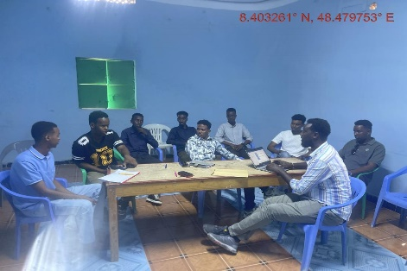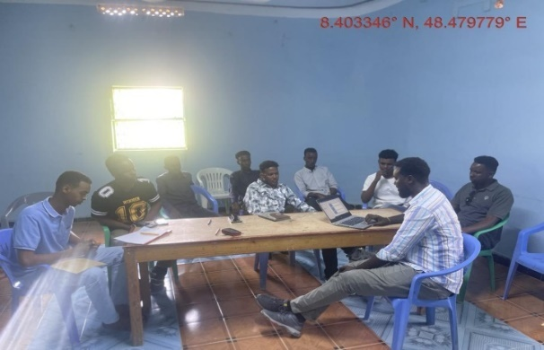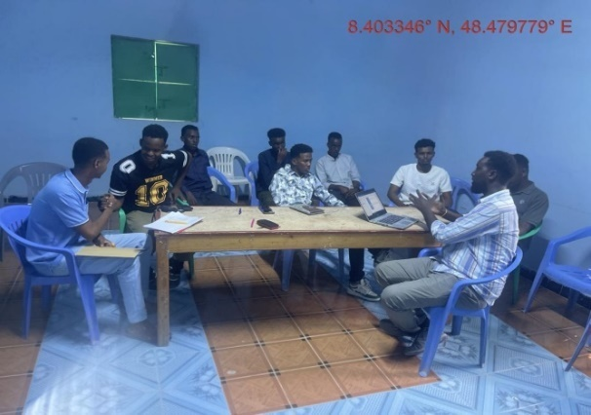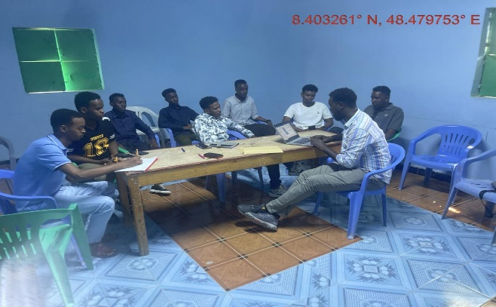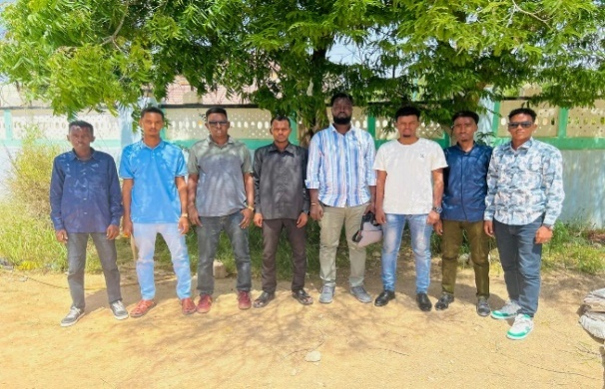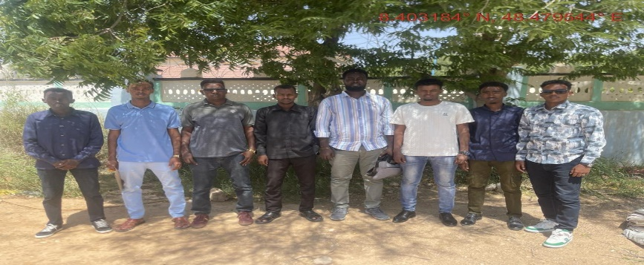

Annex 3.1.: Focus Group Discussion Guide - Female
FGD Female
Facilitator Instructions: The purpose of the meeting is to gather information on women’s role in the household, livelihoods/jobs, health issues, challenges, perceptions on quality of life, education options for children, health care and project perceptions. Introduce yourselves, the project and explain the purpose of the meeting. Gather a representative sample of a maximum of 10 women that include a combination of youth, elderly and disabled where appropriate. Keep the discussion focused and please probe for explanations for responses (what, where, when, why, how). Take lots of pictures. Ensure everyone participates in the discussion. The Federal Government of Somalia has secured a grant from the World Bank to implement the Somali Electricity Sector Recovery Project (SESRP). The SESRP is implemented by the Ministry of Energy and Water Resources (the MoEWR). The Project Development Objective is to increase access to lower-cost and cleaner electricity supply in the project areas and to re-establish the electricity supply industry. We are conducting an environmental and social impact study for Component 1 of the project, focusing on the sub-transmission and distribution network reconstruction, reinforcement, and operations efficiency in the major load centers of Mogadishu and Hargeisa. The purpose of this study is to collect comprehensive information to comprehend the potential impacts of the project and solicit feedback from stakeholders.
Show the participants the layouts/models
Section A: General Information |  |  |  |  | Responses
 | Date and time of meeting |  |  |  | 4th June 2024
 | Name of facilitators (inc note taker) |  |  |  | Saad Adan Aided
 | Name of Region  Region/District |  |  |  | Nugaal, Garowe, 1 Ogost
 | Number of participants |  |  |  | 10
 | Describe the demographics / composition of the group (age range, ethnicity and any vulnerabilities) |  |  |  | 20 – 53 and all somali community and no disability or other type of vulnerability.
 | Number of female headed households in the group?  What is the main reason for this? |  |  |  | 4  To have better representation of different women categories including those with more responsibility as female household head.
Section B: The Project
 | Have you heard of the project before? How/when/where  Do you feel that you understand the project? (if not please provide an explanation and show the site map) |  |  |  | No  The project was explained to women group, as they didn’t have any information. But they all know NECSOM as the only power supply company but they didn’t have any idea about the new project of renewable energy expansion
 | What is your view on the project?  How do you think that the project could impact women in the community positively and negatively? |  |  |  | Provided mixed reactions some feeling like being lost investment given to powerful people others feeling it will provide good benefits.
 | How do you think that the project could minimize or avoid negative impacts on women and the community? |  |  |  | We hope to minimize price of power if this project implementing,
 | Do you have any questions/comments regarding the project? |  |  |  | No
Section C: Role of Women
 | What roles do women typically undertake in the community? Please consider this in terms of the home and livelihoods.  How many hours a day do women work? what time do they typically start and finish their daily activities? |  |  |  | Women play various roles in the home, including caring for children, managing household tasks, and contributing to the family's economic well-being also they are also responsible for providing informal care to family members who are ill, and who have special needs, especially in rural areas with limited healthcare facilities.  Women always long hours from 4am in the morning to 11pm managing family and some are even working in some hours of these.
 | Do you think that men and women have equal opportunities in the community, workplace and education? |  |  |  | Women and men have not equal opportunities in the community ,workplaces or education ,because in the community always men are the ones who get respects , take decisions ,give orders and they completely have the power of the society, while the women are the ones who obey the decisions men made only. Women respect their brothers and no competition but also want share on decision and resources.
 | What resources do women mainly have control of compared to men? (eg land, assets, equipment) Please explain response |  |  |  | Mostly nothing much compared to men
 | Do women feel safe in the community?  Are there any particular crimes that are common in the community?  Have you experienced any conflicts in the community? Explain responses |  |  |  | Yes  Sometimes crimes like rape happen but not common.  Yes, mostly have seen fightings in garowe involving political disagreement between different government and opposition, army mutineers. But gorowe is peaceful city now.
 | How do women receive information about local issues and developments, news etc in the community? |  |  |  | They receive information their relatives, social media or TV and from socializing and from men and all have phones to make calls for information.
 | Do women rely on each other for support? What type of support? (eg childcare, someone to talk to, income generation etc). |  |  |  | Yes women support each other like childcare, they help income generation and when election held they vote each other.
Section D: Institutions / Community Development
 | How are women represented in the community (eg is there a female head/leader who champions their interest)? Do women contribute in decision making within the community? Are women represented at important meetings? If not, do men discuss decisions with you? |  |  |  | Yes, there is a female head/leader who champions their interest. Yes some women make decision in the community like mothers she can make some decisions about her home and her children, there are some women works in the governments or other places who can lead and can make decision about the country and her workplace.
 | Do you have any women’s traditional/cultural groups? What are they called? What is the purpose of these groups? |  |  |  | Yes, there are traditional women’s groups, often called "women Unions" or similar names. They are normally formed by organizations, and the purposes differs depending on the organizations formed them. Some are there to advocate for women rights, some for better education and some are there to make living out of problems that women face but some are genuine
 | Are there any other local associations in the area that they are aware of? If so, which ones. |  |  |  | No
 | Are any Non-Governmental Organisations working here?  If yes – which ones and what do they do? How successful have the projects been? |  |  |  | Yes, there are many organizations like save the children, ICRC, DRC, NRC, ALIGHT, ADRA, Somali red crescent and many other organizations were named having presence in Puntland. They offer different programs including health, education, wash and livelihoods supports.
Section E: Economy/Income Generation
 | What could women do to have greater economic opportunities in this area? |  |  |  | More skills and more business and more political representations can let women be more active and also there is need of unity among women to help each and other put own in power.
 | Do you have access to a bank/credit/savings account? If so, is it your own personal account or a joint account? Do women have their own money at disposal? What do they spend it on most frequently? |  |  |  | Not all but some of the participants mentioned having accounts in local banks citing like Dahabshil and Amal bank. Some have small businesses and maintain own investments but others don’t and have to rely on their husbands or relatives for living.
 | Does your family receive support from remittance or other support from family members working elsewhere? |  |  |  | Yes, 3 of the participants mentioned receiving remittance from relatives abroad.
Section F: Land Use
 | What the main land based activities that women undertake? Please complete the seasonal calendar at the back of the form. |  |  |  | Mostly house chores are the main activity but some also do businesses like teashops, shops and some are selling miraa others are employed in companies and government offices and even some working in organizations. Women are different but all of them do house chores as one common work
 | What are the main crops that you grow? What % are for household consumption and what % do you sell? If you sell crops, where do you sell them? |  |  |  | Women don’t do farming in Puntland
 | What are the main animals that people keep in the community? Is this a subsistence activity or an income-generating activity? |  |  |  | Some keep few goats but being a city it is difficult to maintain them.  Some sell milk and meat from the goats or say animal products
 | Do you collect natural resources (eg timber, herbs, firewood and roofing, fruits, etc) for subsistence and domestic use? Where do you get these from? Explain the uses.  Explore issues related to charcoal production as well as commercial extraction of natural resources |  |  |  | No, none of the participants collects firewood or other times of timber but some people in the country side may rely on that here it is a big city and not possible to do that.  Charcoal production is done by men women don’t do it but sell it in town, however, none of the participants was charcoal dealer.
 | Where does the community buy and sell agricultural produce? How far is the nearest market? What is the name of the market? |  |  |  | There is meat and vegetable market in Garowe that people sell or buy vegetable, meat and other animal products. The market known as INJI is at the centre of Garowe in Eng Khalid road. There are also other small markets in the town. People use tuk-tuk to go the market for shopping.
 | Have you experienced any conflicts in the community in relation to land? Who was involved? What was the issue? How was it resolved? Are conflicts frequent? (explain response) |  |  |  | Yes land related conflict is very common. Mostly disputed plots of land leads to armed conflict and other confrontations and is a common thing that leads to many deaths
 | If a fishing community/coastal region - Are women involved in fishing, fish processing or trading of fish?  What role do women play in fishing related activities? |  |  |  | None
Section G: Education, Literacy and Training
 | How would you describe accessibility and quality of education for children in your community?  How far are they (KM)? what are the names/levels of schools accessed |  |  |  | The accessibility and quality of education is fine. All children go to school but education is costly and privately owned schools are more expensive than public ones. Some of the schools are far others are near like Dayah primary school, Altowba, Aflah primary school, Hormud and many other schools are there.
 | Do most females in the community go to school? What level do they generally complete up to? Explain responses. Are there factors that prevent girls from continuing education?  Has anyone in the community complete vocational training or university? What subjects? (explore issues of girl child work/labour verses education. |  |  |  | Most women didn’t go to school but some females attend primary school, but dropout rates are high after that. Factors preventing continued education include early marriage, household responsibilities, and cultural norms prioritizing boys’ education but many girls are also in school these days  Few women have completed vocational trainings. Those who have usually study subjects like nursing or teaching, cooking,
 | Can girls/women in the community generally read and write? |  |  |  | Literacy rates among women are low. Many still don’t read and right.
Section H: Health
 | How and where do you access healthcare??  Do the services available meet your needs? |  |  |  | There are many hospitals private and public like garowe regional hospital, Arafat hospital and many other small privately owned hospitals but health services in private expensive and not in good quality and only after money and public hopistal is not that good and also some primary healthcare centers run by NGOs that provide some small services but not enough. Many people are sick and do not have money for hospitals
 | What are the top 3 health problems that girls and women face in the settlement? Please explain the reason for each of the health issues  Are there any particular times of the year where these issues are more challenging than others? |  |  |  | There are different problems like pneumonia, flue, urinary track infections, gastritis. These happen anytime and not specific to certain period in the year.
 | Are there any environmental issues that affect health in the community (e.g. water quality, sanitary conditions etc) Please explain |  |  |  | Water in garowe is hard and not good for drinking and fresh water is expensive and this impacts health
 | If someone in the household is ill, how do you usually treat him/her? How do you treat sick elderly, children, men and women? Are there any disabled people in the community that require care? |  |  |  | Yes, they are treated and are always taken care of by families
Section I: Access to Water
 | Where do you get your water for drinking, cooking, bathing and for livestock? |  | Description of water source |  | Walking distance from dwelling (KM) |  | Collection method (if applicable) |  | Description of quality/colour/taste/smell
 |  | Drinking: | Borehole and berket |  | Out of the town |  | Piped |  | Hard water
 |  | Cooking: | Borehole and berket |  | Out of the town |  | Piped |  | Hard water
 |  | Washing dishes: | Borehole and berket |  | Out of the town |  | Piped |  | Hard water
 |  | Bathing: | Borehole and berket |  | Out of the town |  | Piped |  | Hard water
 |  | Livestock: | Borehole and berket |  | Out of the town |  | Piped |  | Hard water
 |  | Irrigation:
 | Do you have to treat drinking water? If so, how? |  |  |  | No
 | If the community has a borehole, do they know when it was installed? Who installed it? How deep it is? How is it operated? |  |  |  | No
 | Is anyone in the community or a community water committee responsible for managing boreholes or other water sources in the community? Who? How well does this work? |  |  |  | No
Section J: Sanitation and Hygiene
 | What type of toilet facilities do households have? (eg community or private/household, ventilated pit latrine, un-ventilated pit latrine, hole in the ground, no latrine/use the bush etc) |  |  |  | Yes, there are pit latrines of different types
 | Do the toilet facilities have light? |  |  |  | Not many have lights
Hygiene & Waste
 | How / where do people dispose of household waste? (Burn, dump, put in the river or sea, other - specify) |  |  |  | It is collected by a company and some throw away to streets
Section K: Access to Power
 | What energy source do you use? Where are each of these sources these located (eg grid connection from the house, firewood, charcoal, kerosene, gas, solar etc? |  |  | Type |  | Source of energy/power |  | Location
 |  |  |  | Lighting: |  | NECSOM |  | In town
 |  |  |  | Keeping warm:
 |  |  |  | Cooking: |  | Gas, firewood, charcoal
 |  |  |  | Heating water: |  | none
 |  |  |  | Charging mobile phones: |  | Solar, NECSOM
 |  |  |  | Cooling food: |  | NECSOM
 | Do you face any challenges regarding access to power? Please explain? |  |  |  |  | It is expensive and not available in some parts of the town and you have to purchase the meter and lots of other obstructions and then sometimes the meter has a problem you pay much.
Section L: Transport and Communication
 | What are the main forms of transportation used within the community?  Please describe the quality/accessibility of transportation in the community |  |  |  |  | Vehicles, tuktuk  there is no problem of accessibility about it
 | Is there telecommunication services in the area |  |  |  |  | Use golis telecom services
Section M: Cultural heritage
 | What are the sacred/ historical or religious sites in the area? Are these accessible to women?  Where are they located? |  |  |  |  | There are no such places,
 | What are the main festivals or rituals undertaken in the community by women? Give details |  |  |  |  | International women’s day and eid festivals and some other days that people celebrate
Section N: Insert photos here
Please take some pictures of the meeting with a description below each photo:
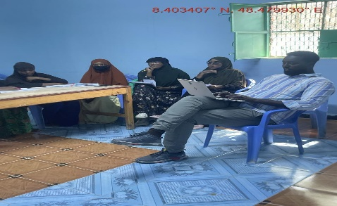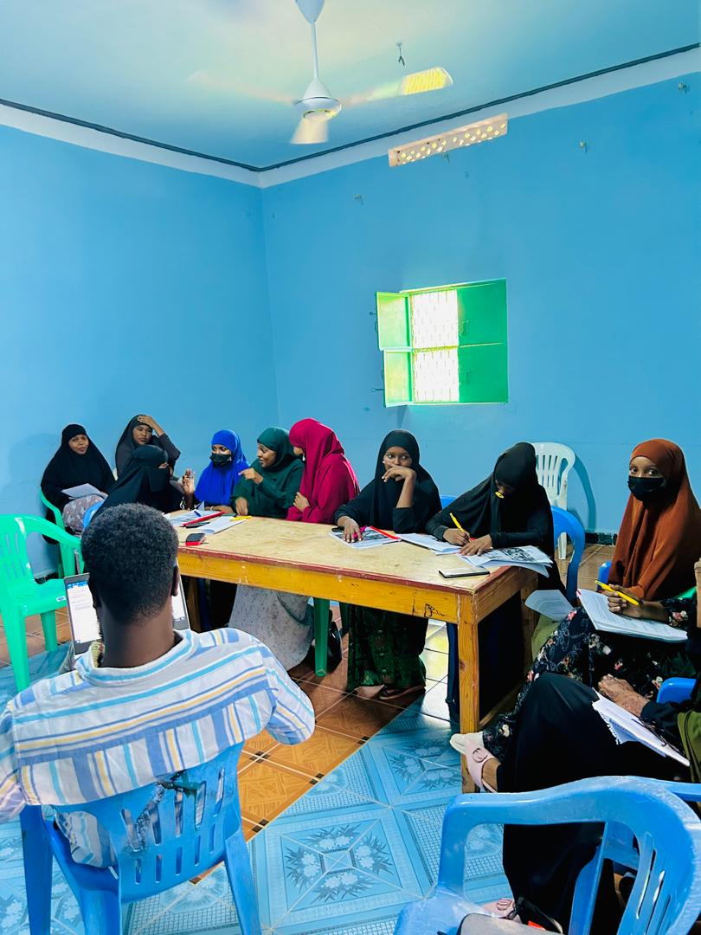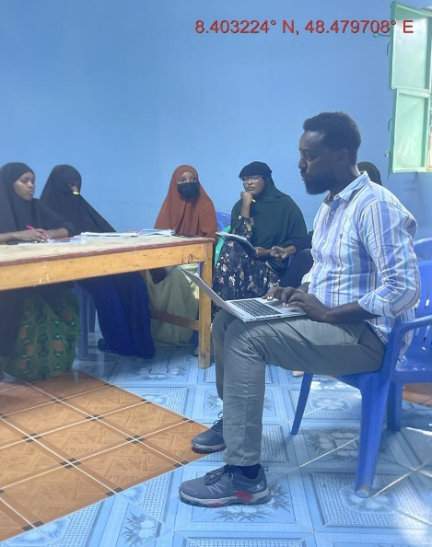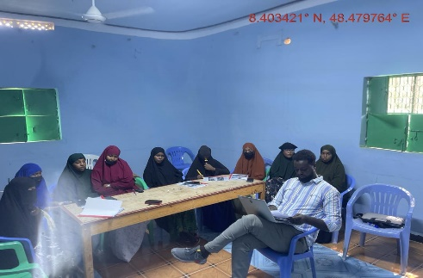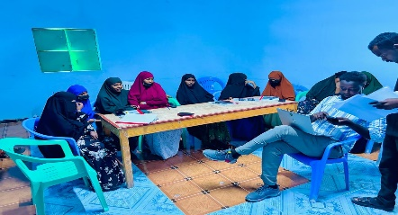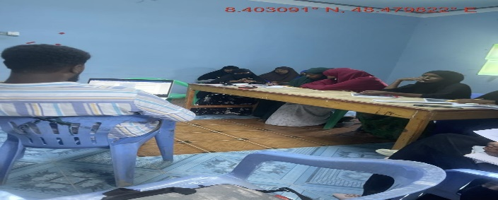

Annex 11.4. Stakeholders consultation attendance sheet (FGD)
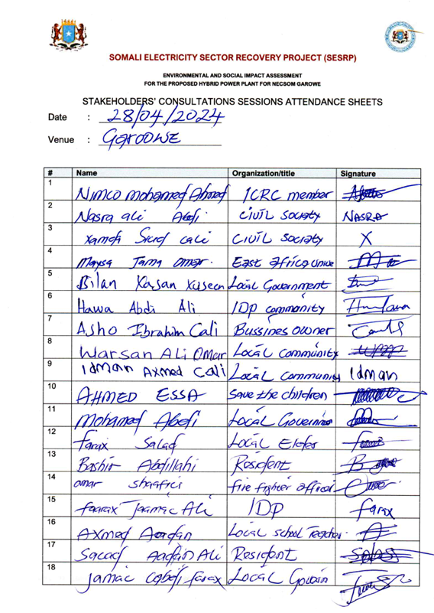

Annex 11.5. Key informants interviews data sheets
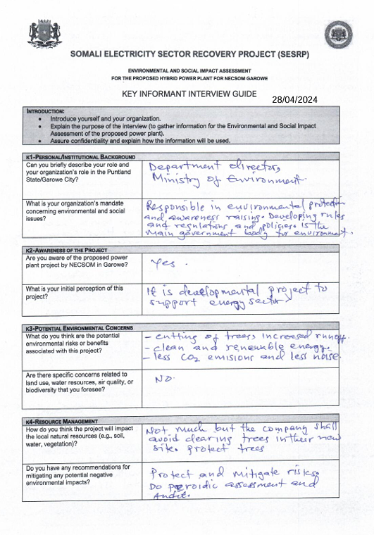

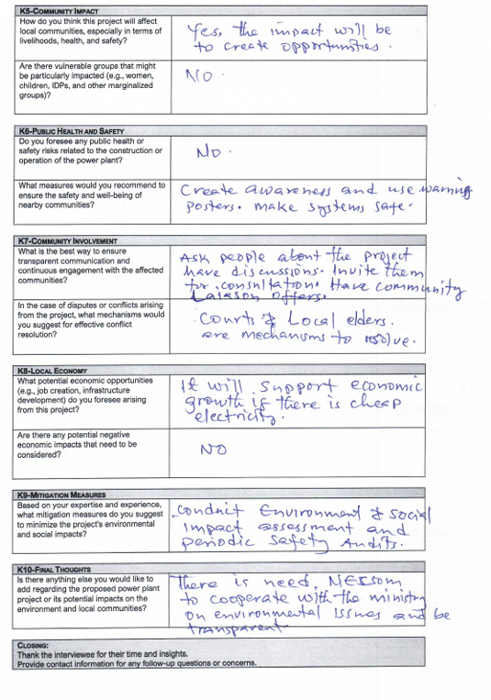

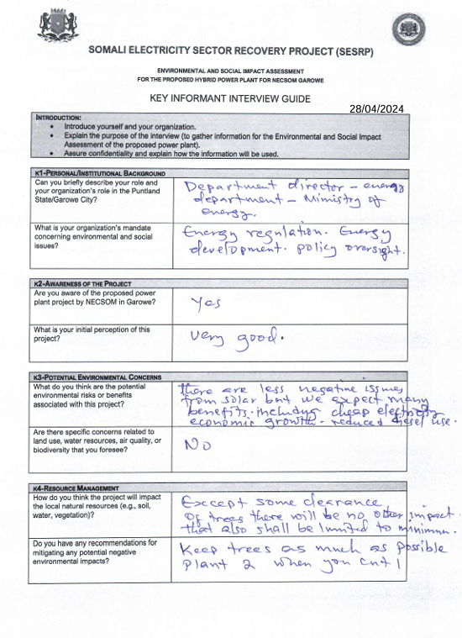

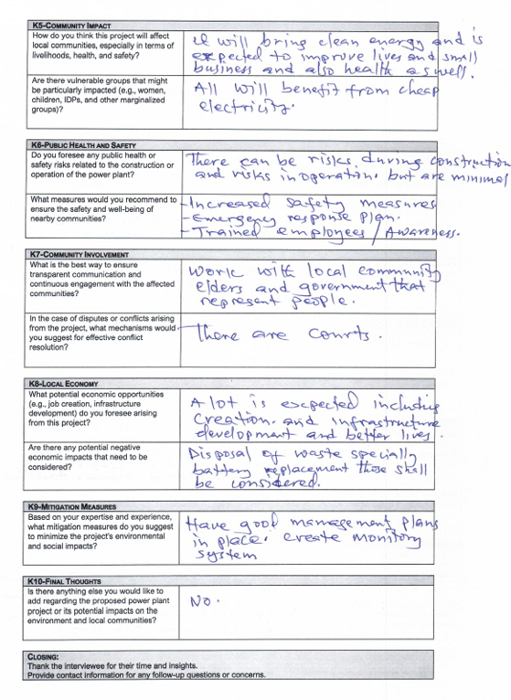

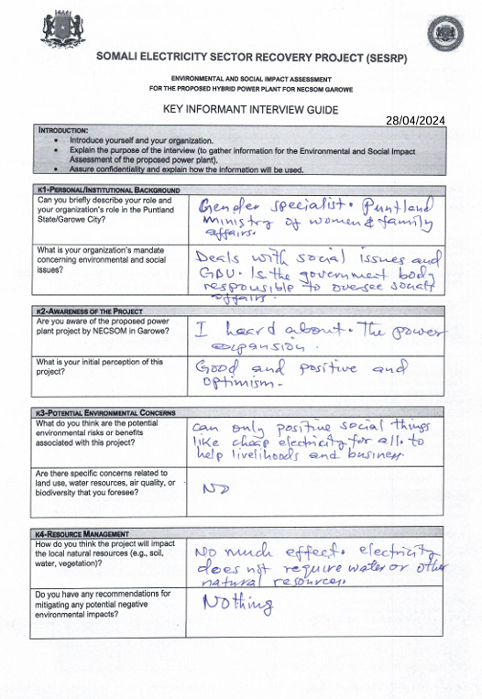

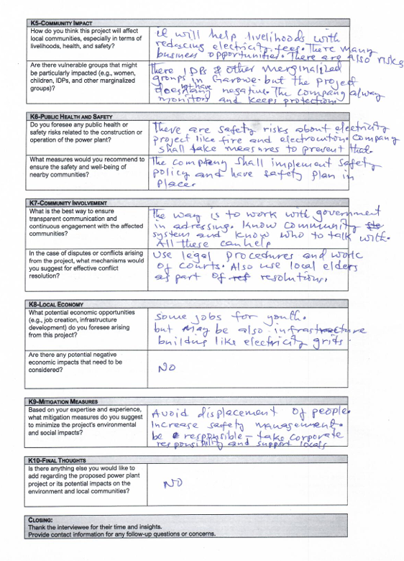

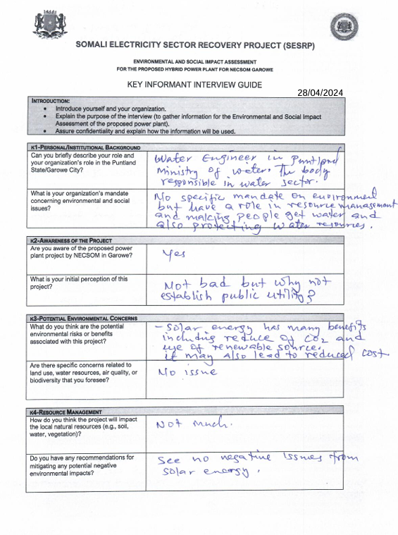

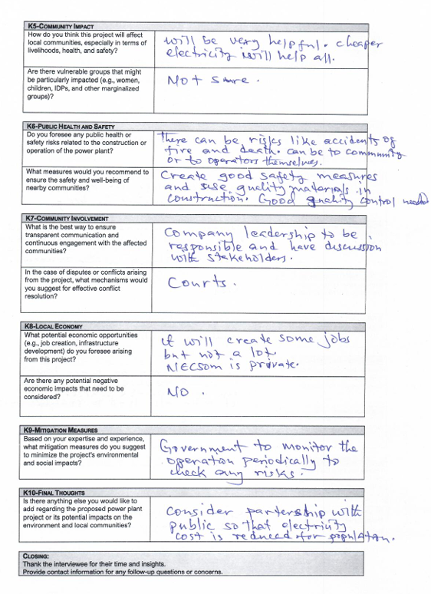

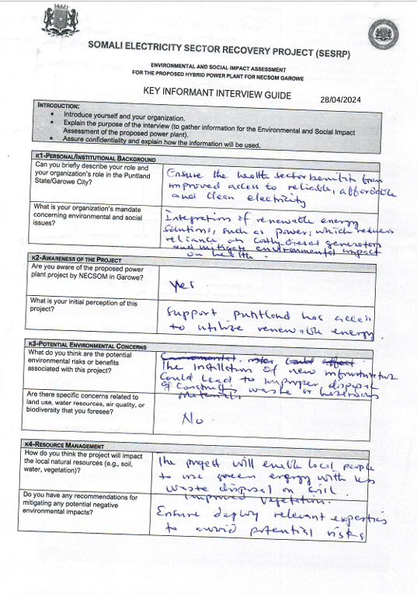

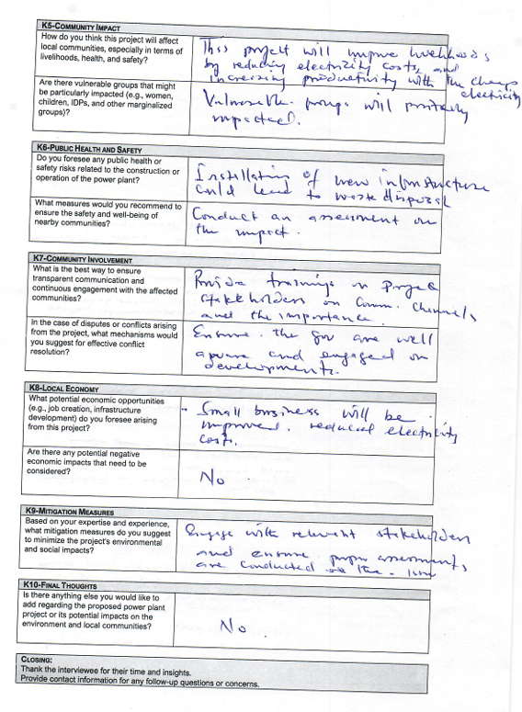

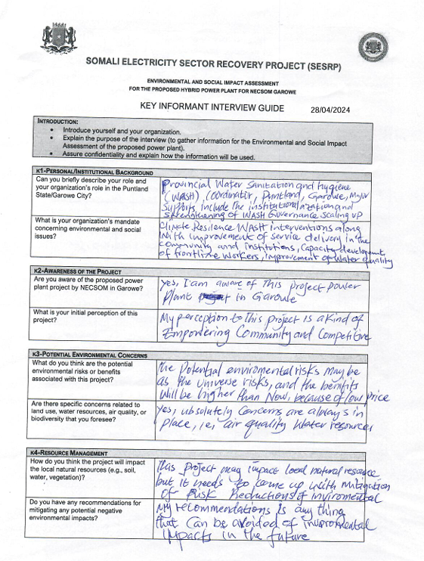

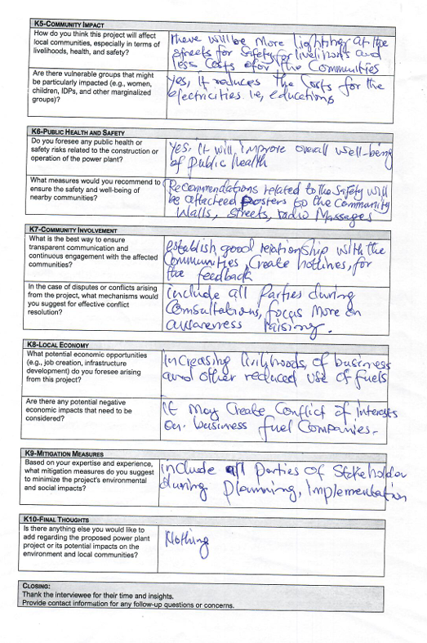
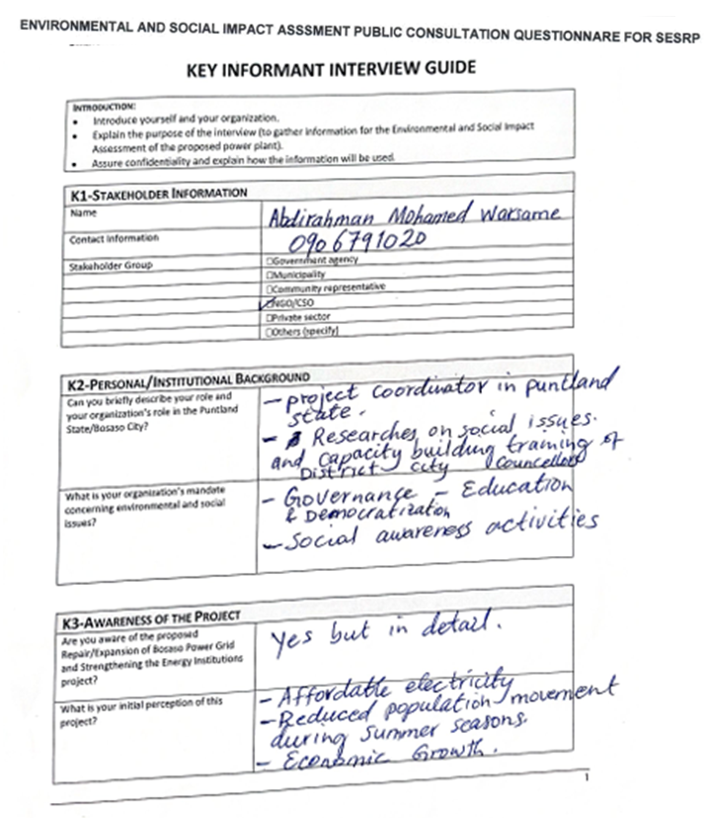
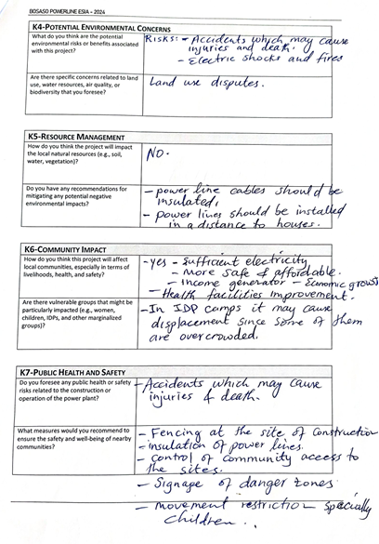
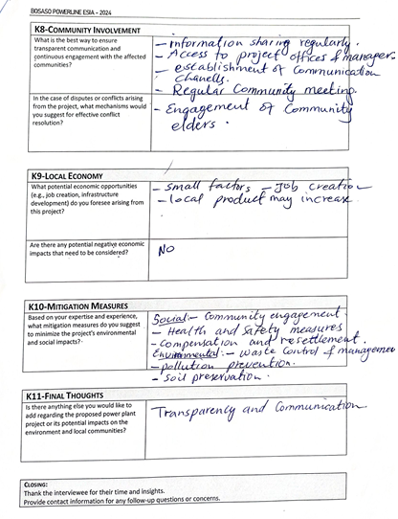

Annex 11.6. List of key informants engaged during the ESIA study for the proposed NECSOM hybrid power plant, Garowe
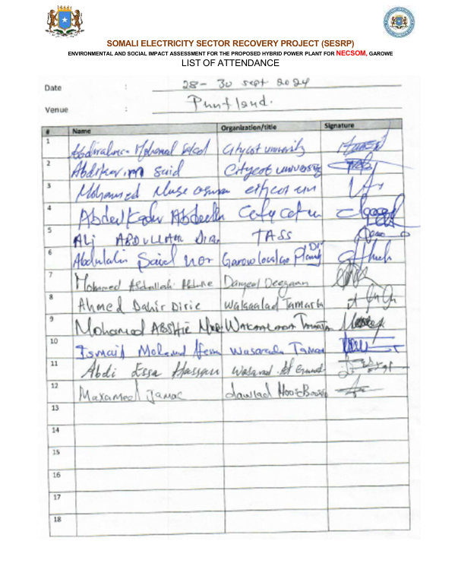

https://www.trade.gov/country-commercial-guides/somalia-energy-and-electricity
https://www.trtworld.com/opinion/somalia-encourages-foreign-investments-to-fix-its-energy-crisis-12788824
https://sominvest.gov.so/wp-content/uploads/Energy-Sector-Study.pdf
Farah, M. I., & Hassan, S. K. (2020). Soil degradation and land-use changes in semi-arid regions: A case study from Garowe, Somalia. African Journal of Soil Science, 8(2), 97-110. https://doi.org/10.1000/ajss.2020.12345
Ali, F. Y., & Ibrahim, R. H. (2019). Air quality monitoring in urban centers of Somalia: Case study of Garowe city. Environmental Research and Policy Review, 22(4), 112-125. https://doi.org/10.1080/xxxx
Mahmoud, A. S. (2018). Air pollution levels and public health implications in northern Somalia: Evidence from Garowe. International Journal of Environmental Science, 13(5), 77-89. https://doi.org/10.1111/ijes.2018.00099 Noise Quality Studies
Omar, N. M., & Farah, A. H. (2021). Noise pollution and its effects on the urban environment: A study in Garowe, Somalia. Journal of Urban Environmental Studies, 14(2), 65-78. https://doi.org/10.1007/surbes.2021.01422
Abdullahi, I. J. (2017). Noise levels and their impact on public health in Garowe city, Somalia. Environmental Health Perspectives, 19(3), 101-115. https://doi.org/10.1097/ehp.2017.10109
Yusuf, H. A., & Ahmed, B. H. (2016). Evaluation of groundwater quality in Garowe, Puntland, Somalia. Water Resources and Hydrology, 27(3), 245-260. https://doi.org/10.1002/wrh.2016.12321
Mohamed, S. I., & Warsame, H. A. (2015). Impact of human activities on water quality in the Nugaal Valley: Case of Garowe, Somalia. Journal of Water Quality Management, 9(1), 33-47. https://doi.org/10.1007/wqm.2015.01017
Ministry of Environment and Climate Change (2024). Final draft environmental and social impact assessment and audit regulations. Ministry of Environment and Climate Change, Mogadishu, Federal Republic of Somalia.
The NPD-9 is available here: http://mop.gov.so/wp-content/uploads/2019/12/NDP-9-2020-2024.pdf
file:///C:/Users/pc/Downloads/GBV%20Bulletin%20Apr%20-%20Jun%202018%20Final-1.pdf
Hassan, A.D., Mohamed M.D. & Bashir, S.H. (2023). Prevalence, patterns, and determinants of gender-based violence among women and girls in IDP camps, Mogadishu-Somalia. Journal of Migration and Health, Volume 8. https://doi.org/10.1016/j.jmh.2023.100193.
https://land.igad.int/index.php/documents-1/countries/somalia/gender-4/897-women-fearing-gender-based-violence-2018/file
See UNDP, UN Women, and UNFPA, 2018. Somalia Gender Justice and the Law. Available at https://www.undp.org/content/dam/somalia/docs/Project_Documents/Womens_Empowerment/Gender%20in% 20Somalia%20Brief%202.pdf for a review of the Penal Code (1962) provisions relevant to GBV.
https://moewr.gov.so/wp-content/uploads/2020/07/Master_plan1.pdf
See UNDP, UN Women, and UNFPA, 2018 for further discussion of how the customary system handles GBV cases as well as other barriers to access to justice for GBV survivors.
UNDP, UN Women, and UNFPA, 2018.
The Somalia National Adaptation Programme of Action: https://www.wiomsa.org/download/national-adaptation-programme-of-action-somalianapa/
The Somalia National Action Programme on UNCCD: https://knowledge.unccd.int/sites/default/files/naps/2018-06/NAP%20Full%20Report%20-%20Final%2023%20May%20digital.pdf
Archer, C. L., & Jacobson, M. Z. (2005). Evaluation of global wind power. Journal of Geophysical Research: Atmospheres, 110(D12). https://doi.org/10.1029/2004JD005462
Rawn, B., Østergaard, J., & Rosas, P. A. C. (2007). Variability of large-scale wind power from a Danish perspective. Wind Energy, 10(1), 21-28. https://doi.org/10.1002/we.208
Holttinen, H. (2005). Hourly wind power variations in the Nordic countries. Wind Energy, 8(2), 173-195. https://doi.org/10.1002/we.144
Sorensen, P., & Cutululis, N. A. (2004). Variability and predictability of large-scale wind energy production. Risø National Laboratory.
Kaldellis, J. K., & Kapsali, M. (2022). Operational and maintenance aspects of wind turbines in harsh environments. Renewable Energy, 190, 1234-1251. https://doi.org/10.1016/j.renene.2022.01.013
Hansen, M. H., & Sørensen, P. (2021). Advancements in wind turbine maintenance: Focus on harsh climate conditions. Wind Energy Science, 6(1), 345-360. https://doi.org/10.5194/wes-6-345-2021
López, J., & Martínez, F. (2023). Predictive maintenance strategies for wind turbines in extreme weather conditions. Journal of Wind Engineering and Industrial Aerodynamics, 222, 104944. https://doi.org/10.1016/j.jweia.2021.104944
Muchiri P.W. (2007), Climate of Somalia. Technical Report No W-01, FAO-SWALIM, Nairobi, Kenya.
Metz, H.C. (1992). Somalia - Geography. Washington: GPO for the Library of Congress.
Lenoir J.L., Kfister, D., Liogeois, J.R., Utke, A., Haider, A., & Matheis, G. (1994). Origin and regional significance of late Precambrian and early Palaeozoic granitoids in the Pan-African belt of Somalia. Geol Rundsch 83:624-641.
IUCN SSC Antelope Specialist Group (2016). "Litocranius walleri". IUCN Red List of Threatened Species. 2016: e.T12142A50190292. doi:10.2305/IUCN.UK.2016-2.RLTS.T12142A50190292.en. Retrieved 20 August 2024.
Lepage, Denis. "Checklist of Birds of Somalia". Bird Checklists of the World. Avibase. Retrieved 17 August 2024.
Janzen, J. H.A. and Lewis, . Ioan M. (2024, August 19). Somalia. Encyclopedia Britannica. https://www.britannica.com/place/Somalia
https://animalia.bio/index.php/lists/country/reptiles-of-somalia
UNHSP (2019). Garowe Urban Profile: Working Paper and Spatial Analyses for Urban Planning Consultations and Strategic Spatial Planning - May 2019. United Nations Human Settlements Programme (UNHSP), Nairobi, Kenya
UNHSP (2019). Garowe Urban Profile: Working Paper and Spatial Analyses for Urban Planning Consultations and Strategic Spatial Planning - May 2019. United Nations Human Settlements Programme (UNHSP), Nairobi, Kenya
https://www.cepf.net/our-work/biodiversity-hotspots/horn-africa/species
En.m.wikipedia.org
https://fsnau.org/downloads/Garowe-Urban-Baseline-Profile-May-2012.pdf
Puntland SESRP Security risk assessment and management plan (PL-SRAMP) 2024.
Baurzhan, S.; Jenkins, G.P. On-Grid Solar PV versus Diesel Electricity Generation in Sub-Saharan Africa: Economics and GHG Emissions. Sustainability 2017, 9, 372. https://doi.org/10.3390/su9030372
Barros, A. J. D., & Barros, A. (2017). Ecological impacts of solar power plants: A review. Renewable and Sustainable Energy Reviews, 67, 47-58. https://doi.org/10.1016/j.rser.2016.08.046
Wiggins, K., & Athey, J. (2019). Assessing the impact of solar arrays on local bird populations: The case of desert environments. Ecology and Evolution, 9(10), 6008-6020. https://doi.org/10.1002/ece3.5235
Zeppel, M. J. B., & Murray, B. R. (2021). Solar power and its effects on avian species: An analysis of recent data. Journal of Renewable Energy, 16(1), 45-60. https://doi.org/10.1080/15435075.2021.1942649

