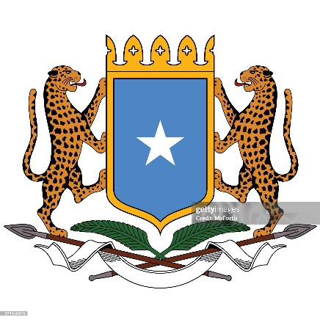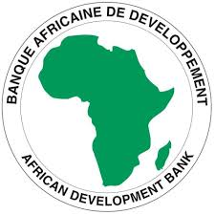
Invitation for Bids
Plant
Design, Supply and Installation
(Without Prequalification)
IFB Number: SO-MOEWR-HAREACT-003
Employer: Ministry of Energy and Water Resources
Project: Household Access to renewable Energy and advanced Cooking Technologies Project
Contract title: Design, supply, Installation of 500KW Solar PV mini-grid with associated 1000kwhr BESS and step-up transformer, Construction of 4.07km 11kV MV and 5.0km of 0.4kV & 0.24kV LV distribution network lines, installation of 2No. 100KVA and 4No. 50KVA 11kV/0.4kV distribution transformers, Customer connection to 800 No. customers, Metering and Commissioning. | Lot 3: Hirshabelle (Jowhar).
Country: Federal Government of Somalia
Grant No.: 2100155042182
Procurement Method: Open Competitive Bidding (International) (OCBI)
IFB OCBI No: SO-MOEWR-HAREACT-003-IFB
Issued on: July 28, 2025

1. The Federal Government of Somalia has received financing from the Africa Development Bank hereinafter called the Bank toward the cost of the Household Access to renewable Energy and advanced Cooking Technologies Project (HAREACT)), and intends to apply part of the proceeds toward payments under the Contract for Design, supply, Installation of 500KW Solar PV mini-grid with associated 1000kwhr BESS and step-up transformer, Construction of 4.07km 11kV MV and 5.0km of 0.4kV & 0.24kV LV distribution network lines, installation of 2No. 100KVA and 4No. 50KVA 11kV/0.4kV distribution transformers, Customer connection to 800 No. customers, Metering and Commissioning. | Lot 3: Hirshabelle (Jowhar). For this contract, the Borrower shall process the payments using the Direct Payment disbursement method, as defined in the Bank’s Disbursement Guidelines and procedures for Investment Project Financing, except for those payments, which the contract provides to be made through letter of credit.”
2. The Ministry of Energy and Water Resources now invites sealed Bids from eligible Bidders for Design, supply, Installation of 500KW Solar PV mini-grid with associated 1000kwhr BESS and step-up transformer, Construction of 4.07km 11kV MV and 5.0km of 0.4kV & 0.24kV LV distribution network lines, installation of 2No. 100KVA and 4No. 50KVA 11kV/0.4kV distribution transformers, Customer connection to 800 No. customers, Metering and Commissioning as detailed below:
Item | Description | Details
- General Project Information
 | Name of the Plant | Jowhar Solar PV Mini-grid
 | GPS Coordinates | 2°47'2.84"N, 45°29'21.84"E
 | Location | Hirshabelle (Jowhar)
 | Project Scope | Design, supply, Installation of 500KW Solar PV mini-grid with associated 1000kwhr BESS and step-up transformer, Construction of 4.07km 11kV MV and 5.0km of 0.4kV & 0.24kV LV distribution network lines, installation of 2No. 100KVA and 4No. 50KVA 11kV/0.4kV distribution transformers, Customer connection to 800 No. customers, Metering and Commissioning.
 | Available Land | 42,000M²
- Required Plant Capacity – New Equipment
 | Solar PV Capacity | 500kWac
 | Battery Energy Storage System Capacity | 500KWp/1000KWhr
 | PV Performance Ratio | 90%
- System Optimization and Monitoring
 | Module Mounting Structure Type | Fixed Tilt type
 | The design life of the Minigrid | 25 years
 | Monitoring | SCADA/Cloud monitoring
 | Step-up transformer | 630KVA 0.4KV/11KV
 | Point of Interconnection | PV yard substation
The project’s delivery period is Twelve (12) months from the effective date.
3. Bidding will be conducted through the Open Competitive Bidding (International), OCBI procedures as specified in the Bank’s Procurement Framework for Group Funded Operations dated October 2015, and the IFB is open to all eligible Bidders as defined in the Procurement Framework.
4. Interested eligible Bidders may obtain further information from Household Access to renewable Energy and advanced Cooking Technologies Project (HAREACT)), Attn: Mr. Mohamed Ali, e-mail piumoer22@gmail.com and inspect the bidding document during office hours from 8.30 am to 4.00 pm at the address given below.
5. The bidding document in English may be obtained free of charge by interested eligible Bidders at https://moewr.gov.so or upon the submission of a written application to the address below.
6. A Pre-bid conference shall be conducted virtually by the Employer, the Ministry of Energy and Water Resources, Mogadishu, Somalia on August 14, 2025 at 11.00 am Mogadishu Local Time through the following link: https://us06web.zoom.us/j/88065971664?pwd=xS79c6zZaiJOwNfw75Z7Msgv8ML3ab.1
7. Bids must be delivered to the address below on or before 11:00 am on September 11, 2025. Electronic bidding will not be permitted. Late Bids will be rejected. Bids will be publicly opened in the presence of the Bidders’ designated representatives and anyone who chooses to attend at the address below on September 11, 2025 at 11:15 am.
8. All Bids must be accompanied by a Bid Security of United States Dollars Thirty-four Thousand (USD 34,000.00).
9. Attention is drawn to the Procurement Framework requiring the Borrower to disclose information on the successful bidder’s beneficial ownership, as part of the Contract Award Notice, using the Beneficial Ownership Disclosure Form as included in the bidding document.
10. The address(es) referred to above is (are):

Attention:
Mr. Mohamed Ali
Ministry of Energy and Water Resources
Afgoye Road, KM5, Wadajir District Mogadishu, Somalia
P.O. Box 24 Mogadishu,
Federal Republic of Somalia
Contact: +252770781945
Website: https://moewr.gov.so
Email address: piumoer22@gmail.com Copy: dg@moewr.gov.so

