


Federal Government of Somalia, Ministry of Energy and Water Resources
GROUNDWATER FOR RESILIENCE PROJECT (GW4R) PROJECT
Environmental and Social Management Plan (ESMP)
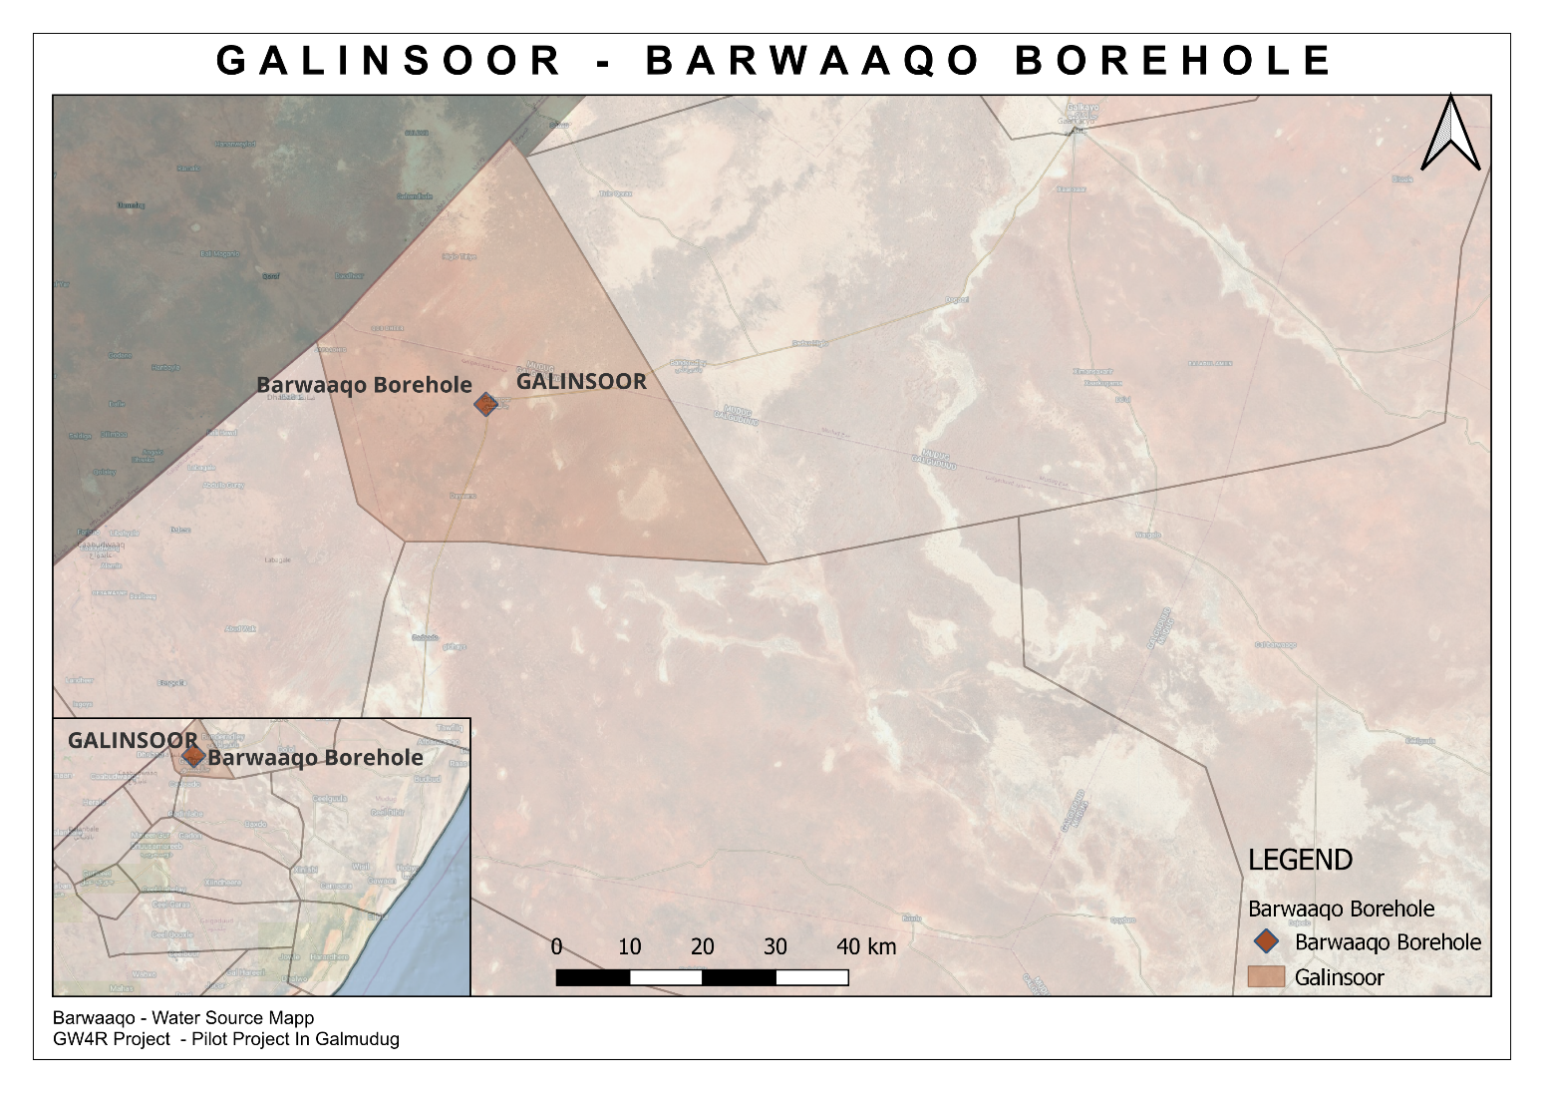
Barwaaqo Borehole, Galinsoor district, Galmudug State of Somalia
Date: 8th July 2025

INTRODUCTION
Scope of the project and activity
The GW4R Project aims to improve groundwater access and management in the borders of the Horn of Africa in an environmentally conscious way. The project consists of three main components: (1) inclusive groundwater services to priority areas (2) groundwater data generation and national and regional groundwater institution improvement and (3) project management, knowledge-sharing, and operations support. There are sub-components and related actions for every component. Project beneficiaries will be communities that suffer from poor water conditions and that face increasingly future difficult conditions relating to climate change, a rapidly growing population, and increasing conflicts over scarce resources. The total number of beneficiaries in Somalia is estimated at 350,000. They will include rural communities, livestock owners, women and girl-children, and urban populations of Somalia.
As part of the Galmudug State Groundwater for Resilience (GW4R) project, the Ministry of Energy and Water Resources is planning to rehabilitate five strategic boreholes throughout Galmudug State including Barwaaqo site in Galinsoor district. This site is located in Barwaaqo village within Galinsoor Location. Before the rehabilitation begins, it is essential to have the required documentation in place. In accordance with World Bank standards, an Environmental and Social Management Plan (ESMP) is mandatory. The ESMP is a crucial document designed to identify and mitigate potential environmental and social risks and impacts associated with the rehabilitation of the borehole. An ESMP identifies and mitigates potential environmental and social risks and impacts associated with construction activities. Furthermore, the following reasons make this plan crucial:
- Identifying and Mitigating Environmental and Social Impacts: The ESMP helps identify potential environmental and social impacts that the bore hole rehabilitation workers may have on its surroundings. The ESMP ensures that appropriate mitigation measures are in place to minimize any negative effects.
- Compliance with World Bank d Standards: The World Bank requires projects it funds to adhere to environmental and social standards aimed at protecting the environment and local communities. The ESMP ensures that the site rehabilitation aligns with these standards, making the project eligible for financial support from the World Bank.
- Worker Safety and Health (OHS): Construction activities inherently pose health and safety risks to workers. The ESMP helps identify potential Occupational Health and Safety (OHS) risks and establishes measures to safeguard the well-being of workers involved in the project.
- Stakeholder Engagement and Transparency: The ESMP emphasizes stakeholder engagement and communication. It ensures that local communities and relevant stakeholders are consulted about the project's potential impacts and help shape the mitigation measures as well as have a chance to voice their concerns or grievances. This fosters transparency and builds trust among stakeholders.
- Project Success and Sustainability: Addressing environmental and social considerations through the ESMP contributes to the overall success and sustainability of the project. By minimizing negative impacts and engaging with stakeholders, the project is more likely to progress smoothly, avoiding conflicts and delays that may arise from unaddressed issues.
- Legal and Regulatory Compliance: An ESMP ensures that the project complies with relevant national environmental and social laws and regulations. Non-compliance can lead to legal complications and project disruptions.
- Long-term Environmental and Social Performance: The ESMP lays the groundwork for ongoing monitoring and reporting on the project's environmental and social performance. This helps in making necessary adjustments and improvements throughout the project's lifecycle.

1.2 Site Description
Galinsoor, situated in North of Adado district is a town located in the Galgaduud region of central Somalia, near the border with the Mudug region and GPS coordinator of water point is (Latitude: 6.42553°N, Longitude: 46.70109°E), is a rural community consisting of 3500 households (21,000 individual beneficiaries). The public infrastructures within the borehole site are a Secondary school, Health Center, police station and district Commissioner office run by the government and NGO respectively. They are relying on limited infrastructure to meet its water and sanitation needs. An IDP settlement called in Hiiraan IDP Center is also situated in the area hosting 70 households.
The geographic layout indicates a clustered residential pattern concentrated around key water points, particularly the existing borehole, highlighting the community’s heavy reliance on this essential resource. Given that the local economy depends primarily on livestock, challenges related to water accessibility and infrastructure maintenance are significant, emphasizing the urgency of the proposed rehabilitation efforts. The accompanying maps illustrate the district remoteness and reinforce the critical need for enhanced infrastructure to ensure sustainable water access and improved living conditions for its residents.

Site visits conducted by NPCU, and PIU, along with recent surveys and previous Rapid Field Assessments (RFA) involving a UNDP engineer, have thoroughly evaluated Barwaaqo water infrastructure, emphasizing its crucial role in supporting both human and livestock needs. Given that the community's livelihood and survival are heavily dependent on livestock farming, ensuring sustainable water access is essential to preserving their way of life.

Barwaaqo remains the primary water source. Years of poor maintenance have left the community with limited alternatives, forcing reliance on distant and costly water sources. To address these issues, the proposed intervention includes comprehensive rehabilitation of existing infrastructure, such as repairing three water kiosks, restoring three livestock troughs, renovating the generator and caretaker rooms. These proposed rehabilitation works requires technical expertise, quality materials, and resources that the community may not have access to. Additionally, proper design and construction are essential to ensure the generator rooms and apron slab effectively withstand floods and comply with safety standards.

Currently, the water kiosks and livestock troughs, storage tank, generator and caretaker room still in use but in poor condition. All these structures require urgent repairs to restore proper functionality. To address this issue, extending the water pipeline closer to the village is recommended to ensure safer and more convenient access to clean water.

To enhance the efficiency of the water supply system, a new Deutz diesel generator will be installed to replace the existing faulty unit. A new submersible pump will also be installed to increase water extraction capacity. To address current storage limitations, a new water storage tank will be constructed, as the existing tank cannot meet daily demand. Although the current tanks are structurally sound and do not require full rehabilitation, they do require repainting to protect the concrete from direct sunlight and potential cracking, and to ensure that the feasibility markings or inscriptions on the tank remain clearly visible and to preserve their condition and extend their service life.
Furthermore, the pipeline network will be extended with a total estimated distance of 3km using 3” diameter pipe which will be the main distribution pipe to underserved areas of the village that previously lacked water distribution despite the availability of connections. The pipeline extension will significantly reduce water collection distances, particularly easing the burden on women and children who are primarily responsible for water collection.
A new solar-powered system will be installed to replace the previous one, which has completely failed and is no longer present on-site due to poor management and lack of maintenance. This will be prevented in the future by reviewing the community’s management approach, which previously failed to sustain the facility, and by ensuring that all installed equipment aligns with the approved design and adheres to the required quality standards. This upgrade aims to reduce dependence on fossil fuels, lower operational costs, and promote long-term sustainability. This intervention aims to significantly improve water access, sanitation, and overall living conditions for the Galinsoor community, ensuring a more resilient and reliable water supply.

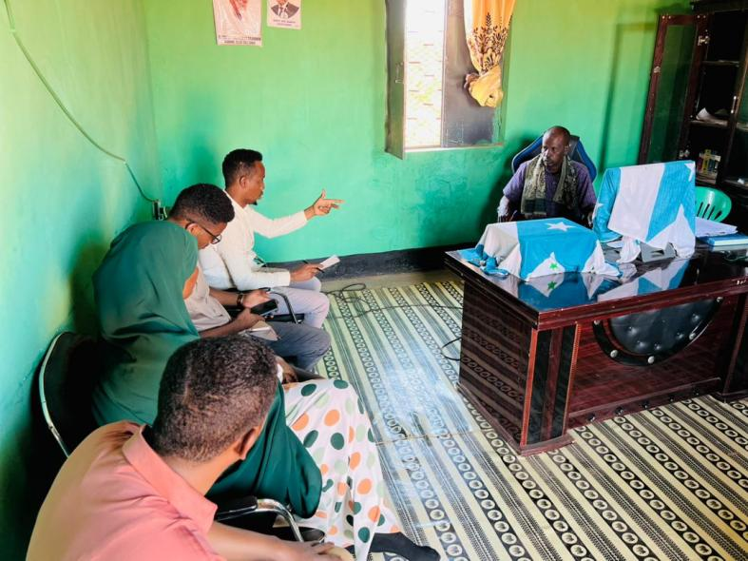
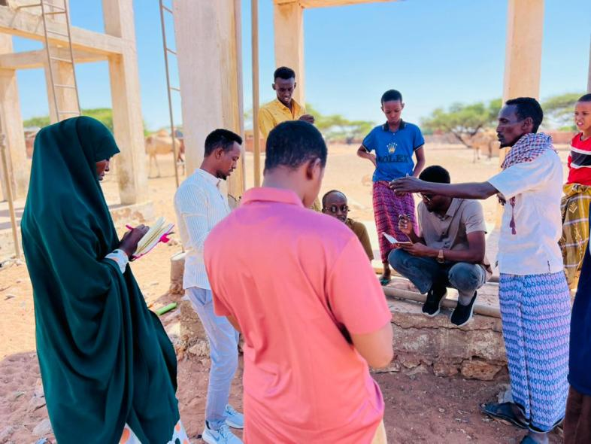
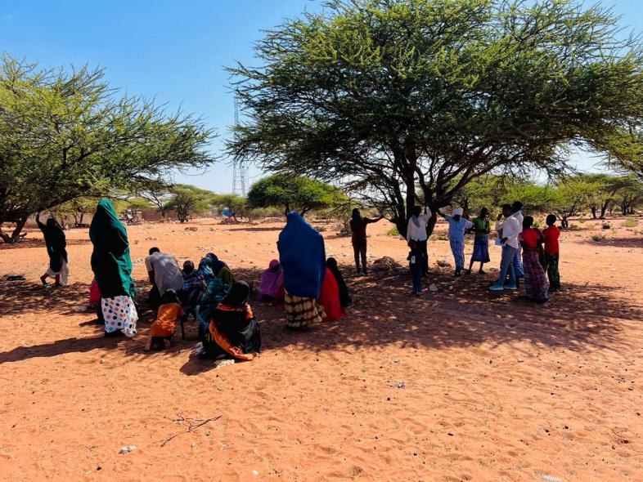
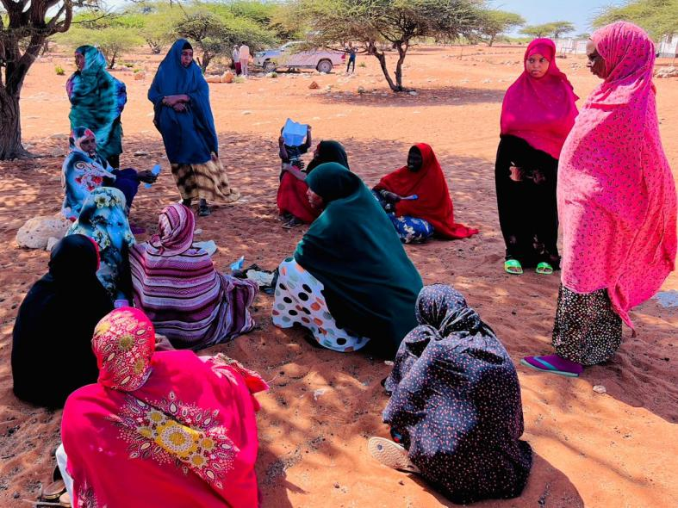
Site photo

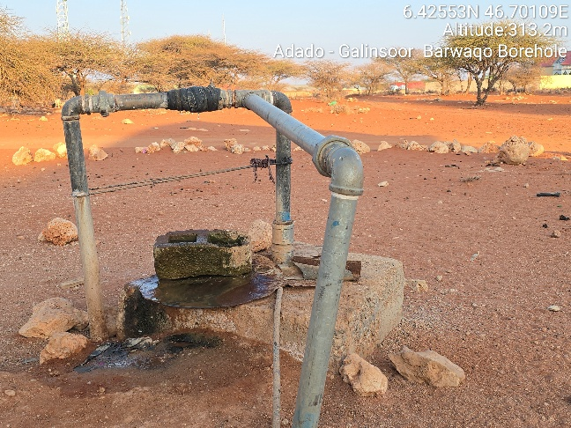
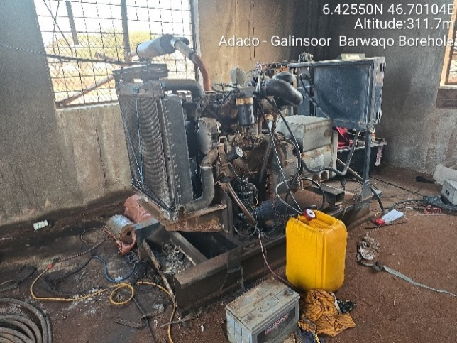
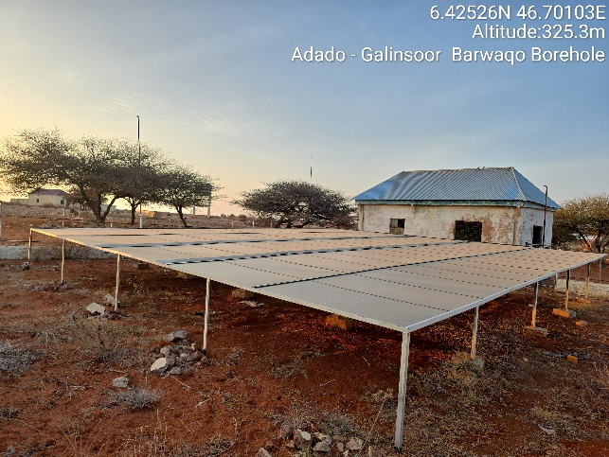
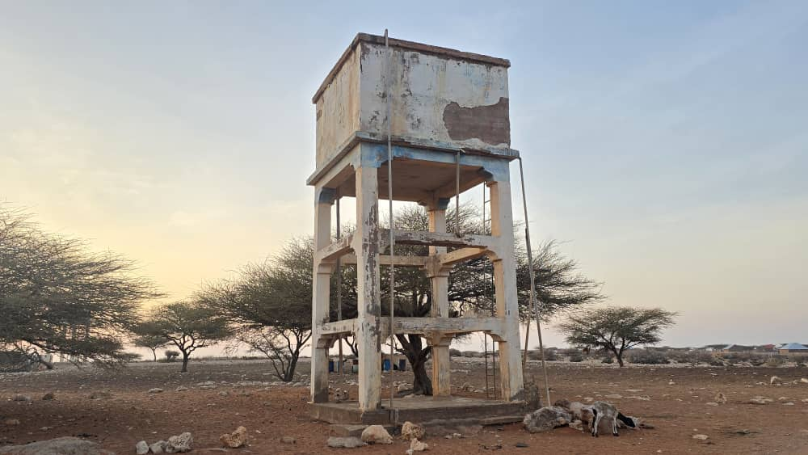
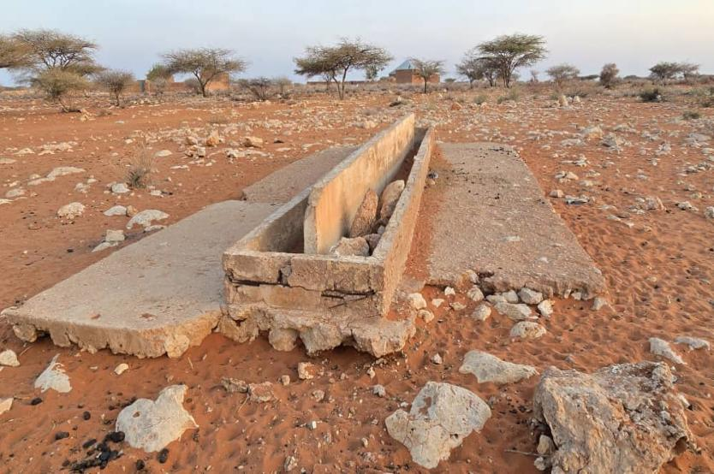
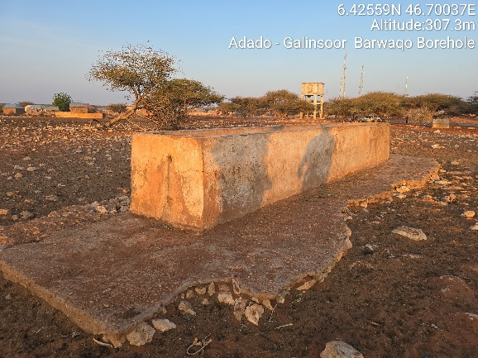

PART A: General Project and Site Information
INSTITUTIONAL & ADMINISTRATIVE
Country | Somalia -Galmudug state-Galinsoor District.
Project title | GW4R Project: Rehabilitation and Upgrading of Barwaaqo Borehole in Galinsoor district of Galmudug State.
Scope of project and activity | Is a rural community consisting of 3500 households (21,000 individual beneficiaries), the public infrastructures are a Secondary school, Health Center, police station and district Commissioner office run by the government and NGO respectively of relying on limited infrastructure to meet its water and sanitation needs and an IDP settlement called in Hiiraan IDP Center hosting 70 HHs.  Proposed Activities  - Upgrading a solar-powered hybrid energy system.  - Construction of new reinforced concrete water tanks (40 m³ capacity, 12 meters in height).  - Extension of the main water distribution network by laying 3 km of 90mm Diameter pipelines to improve community access and future household connection.  - Rehabilitation of the existing three water kiosks, 3 existing livestock troughs (two for camels, another for sheep, goats, and cattle), rehabilitation of existing generator/caretaker rooms and of water point apron slab for flood protection.  - Construction of 2 new water kiosks equipped with protective chain-link fencing and soak pits for wastewater management.  - Construction of 2 new additional livestock troughs (one for camels and another for sheep, goats, and cattle).  - Erection of a 40x40-meter chain-link fence to secure the water facility.  - A new 50kVA Deutz diesel generator will be provided to replace the outdated and unreliable existing unit, which frequently fails and is difficult to maintain due to the limited availability of technicians in the area and delays in accessing repair services.  - Based on information from the borehole caretaker indicating that the pump and riser pipes had been previously repaired, it was decided to replace the faulty well equipment. This includes installing a new 11kW (18Hp) submersible pump and 75mm pressure-rated uPVC Column riser pipes (heavy duty) with fittings, in order to improve water extraction efficiency. Construction of two gender-segregated latrines complete with hand washing station and connected to water supply (one for women, one for men) adhering to WASH standards.
Institutional  arrangements  (Name and contacts) | Project Management PIU – at Ministry of Energy and Water Resource  Mohamed Abdirahman  Ground Water for Resilience Galmudug state operation manager.  Email: hanadsom@gmail.com |  | Project Owner  Ministry of Energy and Water Resource
SITE DESCRIPTION
Name of site | Site Name: Rehabilitation and Upgrading of Barwaaqo Borehole in Galinsoor district, Galmudug State.
Describe site location | GPS location  Latitude 6.42553°N  Longitude: 46.70109°E
Attach evidence of government ownership of land or land acquisition process and RAP | Government Land/Ministry Energy and Water Resource of Galmudug’s Land.  The land certificate, duly approved by the Barwaaqo district commissioner is attached and included as part of the ESMP. The designated land for Barwaaqo borehole rehabilitation is owned by the Barwaaqp community with approval of DC certification letter in line with MOU as well as the VLD form agreed by the community with Ministry of Energy and Water Resources of the Galmudug State, Somalia. The signed VLD form is attached in Annex 1.
Has a site been visited by the social specialist to confirm that there will be no physical or economic displacement or disturbance including of squatters or informal traders? (when and conclusion) | - Yes, The E&S team including the Social/ CDD specialist, Environmental specialist, have visited the site to confirm that there will be no physical or economic displacement or disturbance including of residents or informal traders.  - The visit occurred two time on 04/01/2024 and 14/08/2024. In conclusion, the ES has implemented several measures to ensure that the project will not cause any significant or major social impacts. These measures include:  - Conducted a thorough site visit and verified ES screening checklist and confirmed that there will be no major physical or economic displacement or disturbance.  - Formulating a comprehensive monitoring plan to assess the effectiveness of the mitigation measures in place.  - Establishing a robust grievance mechanism that enables affected communities to voice their concerns and seek resolution in a transparent and accessible manner.  - Shared GRM postures including hotline number, which they can communicate us during and after the implementation/rehabilitation stage  - To facilitate effective communication during and after the implementation/rehabilitation stage, PIU GM focal points will regularly monitor and register any concerns/complaints regarding Barwaaqo Water Point.
Description of geographic, physical, biological, geological, hydrographic and socio-economic context | Geographic Context  The site is located in the central part of Somalia within Galmudug State, part of the Mudug region. It lies along a strategic north-south corridor connecting southern and northern parts of the country.  Physical Context  The site is largely arid to semi-arid, characterized by flat terrain with sparse vegetation. It has a dry climate with occasional seasonal rainfall during the Gu and Deyr rainy seasons.  Biological Context  The site has no significant plants and animal species present at the rehabilitation site and the surrounding areas. The grazing areas surrounding the site are primarily used by seasonal pastoralists. These areas will be mapped and assessed during site implementation to ensure water point development does not negatively impact grazing zones. A mitigation plan will be proposed in collaboration with local pastoralist representatives.  Geological Context  The site lies on sedimentary basins with underlying limestone and sandstone formations. The geology is suitable for groundwater storage but requires further hydrogeological assessments for sustainable extraction.  Socio-Economic Context  The population is primarily pastoralist, relying on livestock such as camels, goats, and sheep. The economy is informal and shaped by remittances, small scale trade, and humanitarian assistance. Access to basic services like education, healthcare, and water infrastructure remains limited, but improving gradually through development programs.
Locations and distance for material sourcing, especially aggregates, water, stones? | Distance for Material Sourcing: Construction material, especially aggregate, water and stones will be sourced from Galinsoor main town. Further details are outlined in the below table below. The project should aim to source materials as locally as possible to reduce transport costs and environmental impact.
The locations and distances for material sourcing, especially aggregates, water, stones, for the Barwaaqo Borehole Rehabilitation will be:
- Aggregates: The aggregates for the project will be sourced from a quarry located about 15 kilometers from the wells site. The quarry is open to public and has been operating for several years. The aggregates from the quarry are of good quality and are suitable for use in the construction of the well. To mitigate against child labor of these sites, the project will ensure that all material sourcing sites, particularly the quarry and the stonemason, are verified for compliance with child labor requirements. The TPM will conduct periodic unannounced spot checks to monitor this, and a clause on child labor compliance will be incorporated in the procurement contracts.
- Water: The water for the project will be sourced from the borehole.
- Stones: The stones for the project will be sourced from a local stonemason. The stonemason has been in business for many years and has a good reputation for providing quality stones. The stones will be used to rehabilitate the top protection of the well. The stonemason’s operations will be reviewed as part of the due diligence process. Verification will be done in coordination with local authorities and civil society actors to ensure the absence of child labor.

Material | Location | Distance from the borehole site
Aggregates | Quarry | 15 kilometers
Water | Well | Water point
Stones | Stonemason | 3 kilometers

The project team will need to obtain permits from the local government to source materials from these locations. The team will also need to ensure that the materials are sourced sustainably, are free from legal disputes, and that extraction activities comply with national environmental regulations and do not lead to land degradation, biodiversity loss, or community conflict.
LEGISLATION
Identify national & local legislation & permits that apply to project activity | - Somalia National Gender Policy (2016)  - National Climate Change Policy, 2020  - National Environmental Policy (2020)  - The Federal Republic of Somalia Provisional Constitution, 2012  - National Water Resource Strategy (2021 – 2025)  - Environmental Protection and Management Act (2024)  - Environmental and Social Impact Assessment and Audit Regulations (ESIA) 2024  - National Adaptation Programme of Action on Climate Change (NAPA) 2013  - The Labour Code of 2025  - The Somali Penal Code of 1962  - The Urban Land Distribution Law of 1973  - Draft Environmental Management Policy of FGS.  - Environmental Impact Assessment Law of Somalia.  - Civil laws of FGS  - Galmudug Water Law  - Other laws by Ministries of Public works at Galmudug state.
PUBLIC CONSULTATION
When / where did the public consultation process take place (attach minutes describing how many people attended, what was discussed (including plans and potential social and economic impacts, GM and GBV) and categories and photos of the meeting) | During the Community consultation Meeting for the Bawaaqo borehole Rehabilitation in Galinsor District, Galguduud region, Somalia, various representatives came together to discuss the rehabilitation needs. The meeting aimed to gather input and support from the community, ensuring the project's success and sustainability. The community engagement meetings were conducted on January 4th 2024 and 14th August 2024.  Key points discussed during the meeting included water management challenges, inadequate access to clean and safe water sources as reported by women and long distances to water points. For further details referrer from the SSR and CER.  The meeting participated and discussed with different representatives of the local community. The groups included the district administration and village administration, elders, youth, and women from the agropastoral communities. This inclusive approach aimed to ensure that all members of the community had a chance to provide their needs and voice their concerns and interest.  Throughout the community consultation process, several Environment and Social (E&S) activities and tools were completed. This included screening checklist, community consultation minutes, safeguard summary, and an Environmental and Social Management Plan (ESMP) specifically designed for the borehole rehabilitation project. These tools aimed to assess potential E&S impacts, as well as put in place measures to mitigate any adverse effects.  Separate Women Meeting.  On 4th January 2024, A GBV Specialist in Galmudug State organized a separate consultation session for local Women community members living in Barwaaqo borehole site to discuss Water Management, GBV Risks and how to mitigate those risks.  The main reason of the Meeting was to assess the current water management challenges in the Aato area and to identify key gender-based violence risks associated with water access and discuss potential mitigation strategies to ensure women’s safety and participation in water-related decision-making.  Key Issues discussed included water management challenges, women reported inadequate access to clean and safe water sources. They also mentioned that there is a long distance to water points, Existing water points are poorly maintained, leading to contamination and health concerns.  One of the challenges also mentioned was that women are largely excluded from decision-making processes related to water resource management. Women expressed a strong interest in participating in local water committees and being trained on water resource management.  During the meeting it was reported that Gender-Based Violence Risks exists in which it was reported that there is Increased risk of harassment and assault while fetching water from distant or isolated water points, particularly during early morning or late evening hours. It was noted that there is limited awareness among community members about GBV prevention and available support services.  During this meeting, some of the GBV mitigation measures highlighted were: Improved Infrastructure and Enhanced Safety Measures like Install lighting and promotion of community-based security around water points. Community sensitization campaigns on GBV risks and reporting mechanisms is needed.  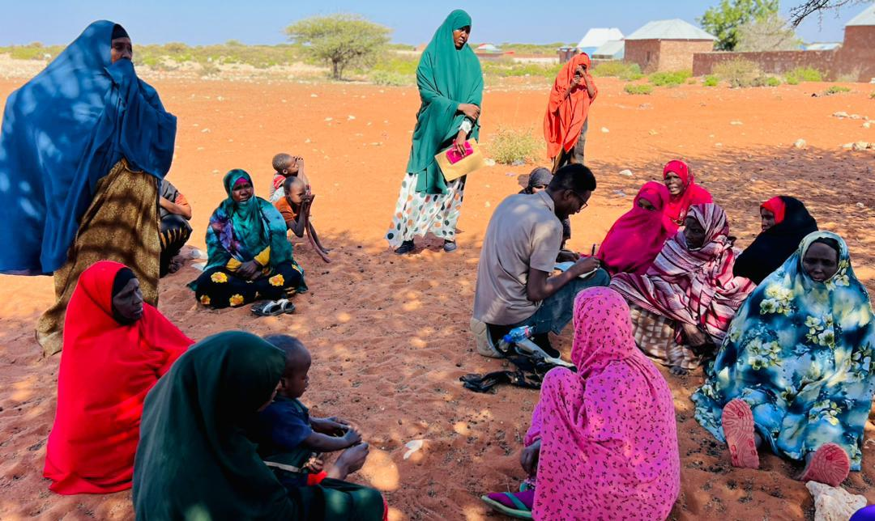
E&S management
Who will orient and monitor E&S requirements of the project? | The project E&S unit together with the NPCU safeguard team specialists will orient & monitor the E&S requirements of the project.
Who will be the onsite focal point for grievances with the contractor? | The contractor will have his own grievance focal point who will be closely working with the GW4R project grievance focal person. | PIU grievances focal Person Hotline number (9992)  Galmudug has the following FMS GW4R GM and GBV emails:  GM Email: gm.gw4r.grm@gmail.com  GBV Email: gm.gw4r.gbv@gmail.com  GBV grievances focal person  Fatima Abdullahi Ahmed
Will GM, GBV and Code of conduct posters be provided before works start? | Yes, GM, GBV and Code of conduct posters will be provided before work start.
When will the contractor be oriented on the Geo-enabling Initiative for Monitoring and Surveillance (GEMS) form for monthly submission | Before the rehabilitation activity start or during the induction training for E&S Instruments.

Associated Project Activity | E&S Risks and Impact | Mitigation Measures | Responsibility for implementation | Timing for mitigation | Monitoring Indicators | Mitigation Budget | Monitoring Responsibility | Monitoring Frequency
ESS 1: Environmental and Social Assessments
ESS1 | Social conflict | - Regular meetings on process and progress with VDC and elders.  - Transparency and neutrality and prompt resolution of concerns.  - Increased awareness and adherence to the measures outlined in the Memorandum of Understanding (MoU) between the community and the PIU.  - Reinforcing customary regulations. | PIU | During construction | Number of conflict incidents  Meetings minutes and sent with ESMP report | No additional costs | FGS | Monthly
ESS1 | No permanent settlement or rangeland degradation as a result of the water point | - Ensure elders, VDC and local government have robust measures in place to mitigate and limit impact of influx of people and livestock including strengthening of bylaws, agreements and penalties. They are:  Strengthening Community Bylaws and Natural Resource Management Protocols  - Clear Use Agreements by develop and enforce seasonal access protocols that define who can use the water point, when, and under what conditions.  - Zoning Regulations example, designate specific areas for watering, grazing, and rest zones to prevent overuse and allow rangeland regeneration.  - Settlement Restrictions Explicitly prohibit any form of permanent settlement near the water point through locally endorsed bylaws.  Controlled Livestock Access and Mobility Management  - Livestock Quotas example, introduce rotational access schedules and livestock quotas during peak periods to avoid overcrowding.  - Nomadic Route Preservation like Maintain traditional migratory routes and avoid fencing or structures that hinder pastoral mobility.  Penalty and Enforcement Mechanisms  - Graduated Sanctions like Implement a tiered system of fines or sanctions for individuals or groups violating bylaws, with community consensus on enforcement.  - Conflict Resolution Committees e.g., reactivate or support existing customary institutions to handle disputes and violations efficiently. | PIU | Preparation and operation | No large scale influx of people or livestock | No additional costs | Contractor/ PIU | Monthly
ESS1 | Groundwater contamination | - The proposed pit latrine at the drilling site will be completely lined and carefully emptied on a regular basis utilizing a fully equipped vacuum truck designated for this purpose. The pit latrines will be gender segregated for both male and females. | Contractor | During construction and operation | Record of appropriate measures taken | No additional costs | / PIU | Monthly
 | Disturbance of land or assets | - Limit the vehicle movement and disturbance of areas.  - Use the appropriate roads and not create irregular paths during the rehabilitation.  - Make good any disturbance of soil, vegetation and assets | Contractor | During the implementation | All disturbance is rectified by the end of construction.  No additional roads created during the rehabilitation works | No additional costs | PIU | Weekly
 | Risk of vegetation clearance | - Avoid unnecessary clearance of vegetation  - Limit vegetation clearing strictly to the footprint of the borehole, pipelines, water troughs, water kiosks and other project related infrastructure.  - Landscaping/greening of site following the construction works | Contractor | During construction | Reduction of vegetation/unattractive landscape | No additional cost | PIU | Monthly
ESS 2: Labor and Working Conditions
 | Lack of occupational health and safety (OHS) for workers deployed at construction sites | - Carry out a safety risk assessment and management plan and implement  - Provide OHS training/ Orientation for all the workers every week and visitors  - Train all workers in safe handling of equipment and use of PPE  - Limit extended work under direct sunlight, especially during excavation works and installation of solar panels.  - Provide necessary personal protective equipment (PPE) to all workers  - Provide necessary PPE for workers working at height during construction of elevated water tank  - Posters displayed on key OHS hazards  - Implement procedure of dealing with accidents and exposures  - Record all incidents and corresponding Root Cause Analysis  - Follow WBG environmental Health and Safety guidelines  - Implement and monitor LMP in accordance with national law and international standards  - Comply with Somalia OHS related laws and procedures.  - Evacuation, medical treatment and compensation of all injuries sustained during construction activities are met by contractor.  - Ensure that all site personnel are provided with an adequate supply of safe drinking water at all times | Contractor | Before construction | - Safety risk assessment and management plan and implementation record  - Training of workers on OHS including safe handling of equipment, traffic safety, security measures and use of PPEs  - Daily toolbox meetings reinforce key safety protocols;  - All incidents recorded  - PPE issuance register  - Monitoring reports  - Pictures of posters displayed | TBD | PIU | Daily by the contractor site supervisor  Monthly visits from PIU
ESS2 | Security risk for Project Workers | - Implement and monitor the Security Management Plan (Sec MP). The Site SMP has been developed, and contractors are required to adhere it. The SMP/SRA will be shared with contractors as they are on boarded.  - Contractor’s security orientation by the Security Specialist/SRMC before Commencement of any activity. | Contractor | During construction | Number of security incidents reported and impacts | TBD | PIU/security officer | Weekly
ESS2 | Traffic accidents cause injury or death of workers or community | - All drivers undergo safe driving checks.  - Traffic safety protocols are closely adhered to. | Contractor | During construction | Checks on drivers documented;  Traffic safety awareness raising and monitoring are documented. | TBD | PIU | Weekly
ESS2 | Risks of child and forced labour | - Strict age verification process and documentation for all workers  - Ensure that all contracts have contractual provisions to comply with the minimum age requirements including penalties for non-compliance  - Include minimum age (18 years) in procurement documents.  - Raise awareness on child protection with contractors and in the communities.  - Posters prohibiting child labour at all sites | site supervisor | During implementation | - Labor register showing age and sex of persons engaged  - Worker’s GRM in place  - Provisions in the contracts  - Records of awareness sessions  - Pictures of posters displayed | TBD | PIU | Weekly
ESS2 | Unfair employment practices and discrimination | - Employment of project workers under the project will be based on the principle of equal opportunity and fair treatment,  - No discrimination based on personal characteristics unrelated to inherent job requirements with respect to any aspects of the employment relationship, such as recruitment and hiring, terms of employment (including wages and benefits), termination and access to training/promotion.  - Awareness raising of all project implementers, contractors and primary suppliers on the requirements for equal opportunity and fair treatment.  - Provision of maternity leave and nursing breaks  - Provision of sufficient and suitable toilet and washing facilities, separate for men and women workers. | Contractor | During implementation | - Records of workers and recruitment processes and criteria.  - All employment related grievances and resolution times are logged. | No additional cost | PIU | Monthly
ESS2 | Delayed payment of workers | - Implement and monitor payment of workers as per contracts.  - Communication/awareness campaign of payment mechanisms  - Disseminate and orient the rights of workers  - Comply with Somaliland employment laws and procedures. | Contractor/ PIU | During implementation | Record of appropriate measures taken | No additional costs | PIU | As and when occurs
 | Lack of proper grievances channels | - All workers have access to an impartial and functional grievance mechanism and there is an appeals process  - Channels for complaints and grievances are convenient for workers. To enable this, the project will have several channels for complaints and grievances including email, phone calls, texts, blogs, hotline and letter writing that will also be accessible to all workers.  - Information on the project GM will be made available to workers at all facilities.  - Posters on GM mechanism and channel displayed at all sites | Contractor/ PIU | During implementation | All grievances and resolution times are logged.  GEM E&S monitoring form is filled every month  Picture of posters displayed on GM | No additional cost | PIU | Monthly
 | Workers are not observing safety requirements | - Sensitize workers on importance of adherence to site safety protocols  - All workers sign a code of conduct including responsibilities and rights regarding GBV, Grievances, observing OHS and security protocols etc. | Contractor | Before implementation | - Proper records of all signed forms  - Training records | No additional costs, posters will be provided by the project | PIU | Periodically
ESS 3: Resource Efficiency and Pollution Prevention Management
ESS3 | Generation of solid waste | - Implement site solid waste management plan to include measures to:  - Reuse and recycling of the waste generated  - Provide on-site or off-site transportation of waste to prevent or minimize spills, releases and exposure to employees and public  - Appropriate designation of areas for disposal of solid waste consistent with the local and international requirements | Contractor | During implementation | - Waste management plan  - Records of amount of solid waste re-used, recycled, and disposed of | No additional cost | PIU | Monthly
ESS3 | Generation of dust and noise  Decreased air quality  Increased levels of vibration from construction machinery | - Where feasible, construction sites, diversions and materials handling sites to be water-sprayed on dry and windy days to contain dust;  - Cordon off construction sites to minimize dust migration to nearby facilities by wind;  - Staff working in dust generating activities shall be provided with Personal Protective Equipment (PPE)  - Use equipment with lower noise emissions  - Routine maintenance of the vehicles to reduce noise and air pollution  - Installing suitable mufflers on engine exhausts and compressor components  - Installing acoustic enclosures for equipment casing  - Planning activities in consultation with local communities so that activities with the greatest potential to generate noise are planned during periods of the day that will result in least disturbance | Contractor | During implementation | - Number of sound machinery and equipment  - Frequency of  watering of  surfaces to reduce  dust related  - Frequency & maintenance plan | No additional cost | PIU  •Project  Engineer  /supervising  consultant  •Environmental Specialist | Weekly
ESS3 | Oil and lubricant contamination | - Properly store oil and lubricants  - Avoid irregular dumping of used oil and lubricants.  - All machinery and equipment be regularly maintained and serviced to avoid leak oils  - Designate a garage or workshop for oil change far from the water source. | Contractor | During the implementation | Proper records of oil & lubricant change.  Proper dumping | TBD | Project Engineer/supervising consultant  Environmental Specialist | Monthly
ESS 4: Community Health and Safety
ESS4 | Increased GBV/SEAH cases | - Training of all workers on GBV/SEAH  - Enforce total adherence to the code of conduct  - Confidential reporting measures for SEA/SH | Contractor / PIU/ SPTs/ MDAs | During implementation | - Audit report in place  - Records in place | No additional cost | PIU | Monthly
ESS4 | Exposure of community members to physical/biological hazards on the project site, including unauthorized access | - Undertake safety precautions to address safety hazards for the nearby community, including, safety/warning signage, safety barrier around the construction site, and safe driving practices  - Restrict access to construction and allow only authorized personnel  - Safety barrier around the construction site  - Safe driving practices  - Proper use & regular cleaning of the pit latrines  - Limit open defecation in the borehole area.  - Awareness raising & promotion of hygiene practices in the community and communicable diseases. | Contractor | Prior to and during implementation | Records to show community sensitization on safety, in place | TBD | PIU | Prior to start of works, monthly during implementation
ESS4 | Exposure of risk of communicable diseases
ESS4 | Exposure of risk of communicable diseases |  | Contractor/ VDC | During implementation and post construction | - Records to shows the awareness raising and sanitation, hygiene promotion | TBD | PIU | Whenever there is work onsite
ESS4 | Use of waste by community may cause harm | - Ensure all waste is properly recorded, sorted and segregated, proper handling and disposal, and health and safety measures | Contractor | During implementation | - Waste management procedure in place  - Records of amount of waste disposed available | No additional cost | PIU | Weekly
 | Heat related illness | - Limit the direct sun exposure during the mid time  - Advise the community members to stay hydrated  - Availability of potable water on site | PIU | During the summer months | - Awareness raising records | No additional costs | PIU | Weekly
ESS 5: Land Acquisition, Restrictions on Land Use and Involuntary Resettlement
 | Physical or economic displacement of legal and illegal residents or traders in or around the construction sites | - Physical visit by social specialist before construction and confirmation during community meeting and ongoing monitoring and development of RAP/resettlement audit | PIU | Before construction starts | Documentation by social specialist | Costed as per RAP and not paid for by project funds | PIU | monthly
ESS5 | Blocked access to people in the area | - Ensure that the local routes, drainage and community access are not blocked by construction | Contractor | During construction | There have been no complaints on blocked access to the people in the area | No additional cost | PIU | Weekly
 | Conflict over land | - Before signing land agreements, consult all owners (private land) or users and residents (community land) and ensure that agreements and certificates are in place | PIU | Before construction starts | Land agreements and certificates.  Records of consultations with land owners and users | No additional budget is required. | PIU | Whenever necessary
ESS 10: Stakeholder Engagement and Information Disclosure
ESS10 | Inadequate, ineffective, and inappropriate stakeholder and community engagements and disclosure of information | - Keep community leaders informed of progress/delays or activities that may impact community.  - Conduct regular community consultations as necessary  - Consultation to be held in culturally appropriate means and language | PIU and contractor | Before and during construction | No outstanding complaints. Complaints resolved within 7 days | No additional cost | PIU | Monthly
ESS10 | Poor access or low trust in GM | - Poster of GM and contacts displayed outside site at all times.  - All complaints are logged and resolved within 7 days  - Undertake consultations on the effectiveness of the GM | PIU and contractor | Prior to and during implementation | Availability of posters  Number of GRM cases addressed within 7 days  Minutes of meetings discussing GM issues with the community | No additional cost | PIU | Weekly

GM Contacts and awareness raising
Galmudug has the following FMS GW4R GM and GBV emails,
- GM Email: gm.gw4r@gmial.com mailto:
- GBV Email: gm..gw4r.gbv@gmail.com
GW4R GRM & GBV EMAILS | LOCATION | REMARKS
E-mails | Category | State
gm.gw4r.grm@gmail.com | Main GRM email | State Level
gm.gw4r.gbv@gmail.com | GBV/SEAH complaints | State Level
HOTLINE NUMBER (FREE) | 9992 | National Level
 |  | The free hotline number functions within 24 hours of the Project

These emails are managed by the PIU Social Safeguard and GBV specialists of the Ministry. Any complaints related to the Galmudug GW4R project implementation issues will be handled and registered according to GM procedures and regulations.
Additionally, Galmudug MOEWR plans to establish a state-level toll-free number for stakeholders and individuals with complaints to contact. Until this toll-free line is operational, clients will be able to access the national toll-free number at the FGs level (9992).

Code of Conduct Obligations of the Project Contractors
Under the Horn of Africa Groundwater for Resilience Project failure to follow Environmental, Social and healthy Safety (ESHS) and Occupational and healthy Safety Standards (OHS), or partaking in GBV or VAC activities, constitutes acts of gross misconduct and is therefore grounds for sanctions, penalties, or potential termination of employment. Prosecution of those who commit Sexual harassment (SH) or Sexual Exploitation, Abuse and Harassment (SEAH) or other types of GBV, or Violence against children (VAC) may be pursued if appropriate.

I,_____________________________________________acknowledge that adhering to environmental, social, health and safety (ESHS) standards, following the project’s occupational health and safety (OHS) requirements, and preventing gender-based violence (GBV) ESHS (VAC) is important. All forms of GBV or VAC are unacceptable in the workplace or when interacting with communities.
Under the Horn of Africa Groundwater for Resilience Project failure to follow Environmental, Social and healthy Safety (ESHS) and Occupational and healthy Safety Standards (OHS), or partaking in GBV or VAC activities, constitutes acts of gross misconduct and is therefore grounds for sanctions, penalties, or potential termination of employment. Prosecution of those who commit Sexual harassment (SH) or Sexual Exploitation, Abuse and Harassment (SEAH) or other types of GBV, or Violence against children (VAC) may be pursued if appropriate.
I agree that while working on the Project I will:
- Attend an orientation training session related to ESHS, OHS, HIV/AIDS, GBV and VAC as requested by my employer.
- Follow my employers’ guidance on prevention of the spread of infectious diseases.
- Follow my employers’ guidance on security and safety including not causing conflict or exposing myself, other colleagues, stakeholders including community members, project facilities or assets to risks.
- Treat women, children (persons under the age of 18), and men with respect regardless of race, color, language, religion, political or other opinion, national, ethnic or social origin, property, disability, birth or other status.
- Not use language or behavior towards women, children or men that is inappropriate, harassing, abusive, sexually provocative, demeaning or culturally inappropriate.
- Not participate in sexual contact or activity with children (anyone age 18 or under)– including grooming or contact through digital media. Mistaken belief regarding the age of a child is not a defense. Consent from the child is also not a defense or excuse.
- Not engage in any form of sexual harassment to a co-worker - for instance, making unwelcome sexual advances, requests for sexual favors, and other verbal or physical conduct, of a sexual nature, including subtle acts of such behavior e.g., looking somebody up and down; kissing, howling or smacking sounds; hanging around somebody; whistling and catcalls; giving personal gifts; making comments about somebody’s sex life etc. Sexual harassment constitutes acts of serious misconduct and are therefore grounds for disciplinary measures, including summary dismissal
- Not engage in any form of sexual exploitation or abuse for instance, exchanging money, employment, goods or services for sex or sexual favors, or making promises or favorable treatment dependent on sexual acts or other forms of humiliating, degrading or exploitative behavior. This includes any project-related assistance due to community members. Sexual exploitation and sexual abuse constitute acts of serious misconduct and are therefore grounds for disciplinary measures, including summary dismissal.
- Report through the Reporting Mechanism to any suspected or actual GBV or VAC to company management and employer, or any breaches of this Code of Conduct.
- The standards set out above are not intended to be an exhaustive list. Other types of sexually exploitive or sexually abusive behavior may be grounds for administrative action.
With regard to children under the age of 18, I will:
- Wherever possible, ensure that another adult is present when working in the proximity of children.
- Not invite unaccompanied children unrelated to my family into my home, unless they are at immediate risk of injury or in physical danger.
- Not use any computers, mobile phones, video and digital cameras to exploit or harass children or access child pornographic material (see also “Use of children's images for work related purposes” below).
- Refrain from physical punishment or discipline of children.
- Refrain from hiring children for domestic or other labor which is inappropriate given their age or developmental stage, or places them at significant risk of injury.
- Comply with all relevant local legislation, including Somali national labor laws in relation to child labor.
Use of children’s images for work related purposes
When photographing or filming a child for work related purposes, I will:
- Before photographing or filming a child, assess and endeavor to comply with local traditions or restrictions for reproducing personal images;
- Before photographing or filming a child, obtain informed consent from the child and a parent or guardian of the child. As part of this, I must explain how the photograph or film will be used;
- Ensure photographs, films and videos present children in a dignified and respectful manner and not in a vulnerable or submissive manner. Children should be adequately clothed and not be seen as sexually suggestive;
- Ensure images are honest representations of the context and the facts.
- Ensure file labels do not reveal identifying information about a child when sending images electronically.
THE NEAREST GBV SERVICE PROVIDERS FOR HEALTH, PSYCHO-SOCIAL AND LEGAL SUPPORT IN THE AREA OF Barwaaqo site :
- SSWC provides GBV Prevention and Response, Medical Care Services operated in Galinsoor district which is nearest GBV services of Barwaaqo site.
- USWRO organization provided legal aid services operating in Galinsoor district.
- Ministry of Women and Human Rights Development provides Dignity kit, pep kit, health services, and PSS.
- Galinsoor General Hospital is the main hospital for referrals in Galinsoor district.

Annex-1 Attachments

- Land Certificate and Voluntary Land Donation (VLD)
- Community Consultation minutes
- Attendance Sheet of Participants
- MOU
- WMC/VDC appointment letter

Annex 2: ENGINEERING INFRASTRUCTURE DESIGNS AND SPECIFICATIONS

