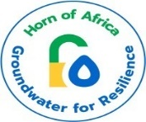

**Southwest State of Somalia**

**Ministry Of Energy and water resources**

Groundwater for Resilience Project-Somalia

**ENVIRONMENTAL AND SOCIAL MANAGEMENT PLAN (ESMP) FOR THE CONSTRUCTION OF A NEW PIU OFFICE.**

**January 2025**

**1. Introduction**

**1.1 Scope of the project and activity**

The GW4R Project aims to improve groundwater access and management in the borders of the Horn of Africa in an environmentally conscious way. The project consists of three main components: (1) inclusive groundwater services to priority areas (2) groundwater data generation and national and regional groundwater institution improvement and (3) project management, knowledge-sharing, and operations support. There are sub-components and related actions for every component. **Project beneficiaries** will be communities that suffer from poor water conditions and that face increasingly future difficult conditions relating to climate change, a rapidly growing population, and increasing conflicts over scarce resources. The total number of beneficiaries in Somalia is estimated at 350,000. They will include rural communities, livestock owners, women and girl-children, and urban populations of Somalia.

As part of the Southwest State Groundwater for Resilience (GW4R) project, the Ministry of Energy and water resources is planning to construct a new office for the Project Implementation Unit (PIU). This office will serve as a dedicated workspace for the GW4R project and will be located within the Ministry of energy and water resources in Baidoa. Construction is scheduled to start in June 2025, with completion expected by December 2025. The new office will act as a central hub for project activities, playing a key role in ensuring the project's success.

Before construction begins, it is essential to have the required documentation in place. In accordance with World Bank standards, an Environmental and Social Management Plan (ESMP) is mandatory. The ESMP is a crucial document designed to identify and mitigate potential environmental and social risks and impacts associated with the construction. An ESMP identifies and mitigates potential environmental and social risks and impacts associated with construction activities. Furthermore, the following reasons make this plan crucial:

1. Identifying and Mitigating Environmental and Social Impacts: The ESMP helps identify potential environmental and social impacts that the construction may have on its surroundings. While the construction itself may not cause significant issues, there could still be localized impacts such as dust, noise, and vibration could still affect nearby areas or sensitive ecosystems. The ESMP ensures that appropriate mitigation measures are in place to minimize any negative effects.
2. Compliance with World Bank Safeguard Policies: The World Bank requires projects it funds to adhere to specific safeguard policies aimed at protecting the environment and local communities. The ESMP ensures that the office construction aligns with these policies and standards, making the project eligible for financial support from the World Bank if required.
3. Worker Safety and Health (OHS): Construction activities inherently pose health and safety risks to workers. The ESMP helps identify potential Occupational Health and Safety (OHS) risks and establishes measures to safeguard the well-being of workers involved in the project.
4. Stakeholder Engagement and Transparency: The ESMP emphasizes stakeholder engagement and communication. It ensures that local communities and relevant stakeholders are informed about the project's potential impacts and have a chance to voice their concerns or grievances. This fosters transparency and builds trust among stakeholders.
5. Project Success and Sustainability: Addressing environmental and social considerations through the ESMP contributes to the overall success and sustainability of the project. By minimizing negative impacts and engaging with stakeholders, the project is more likely to progress smoothly, avoiding conflicts and delays that may arise from unaddressed issues.
6. Legal and Regulatory Compliance: An ESMP ensures that the project complies with relevant national environmental and social laws and regulations. Non-compliance can lead to legal complications and project disruptions.
7. Long-term Environmental and Social Performance: The ESMP lays the groundwork for ongoing monitoring and reporting on the project's environmental and social performance. This helps in making necessary adjustments and improvements throughout the project's lifecycle.

#### Site Description

The construction site for the Project Implementation Unit (PIU) office extensions is situated within the Ministry of Energy and Water Resources (MoEWR) compound in Southwest State, Somalia. This strategic location is vital for facilitating collaboration and coordination among various departments involved in water sector initiatives.

Existing Infrastructure: The site is adjacent to the main administrative buildings of the Southwest MoEWR, providing easy access for staff and stakeholders. This proximity is essential for effective communication and timely decision-making.

Land Area the designated area for the PIU office extensions is ample, allowing for the construction of a multi-functional facility while leaving room for future expansion.

The PIU office extensions will comprise;

Administrative Offices:Designed to accommodate staff and facilitate daily operations, these offices will be equipped with modern amenities to support productivity.

Sanitary Facilities:Modern sanitary facilities will ensure a comfortable working environment for all personnel on site.

The building will feature a durable concrete slab foundation, selected for its strength and longevity. This foundation will support the structure and allow for future expansion as project needs grow.

architectural design will prioritize adaptability, ensuring that the facility can evolve alongside the demands of the water sector.

The site is accessible via established roads, ensuring smooth transportation of construction materials and personnel. Adequate logistics planning will be implemented to minimize disruptions to the surrounding area.

All construction activities will adhere to safety regulations, including site security, worker safety protocols, and environmental considerations, ensuring a safe working environment for all involved.

**Site GPS and MAP**

|  |  |
| --- | --- |
| **Latitude** | **Longitude** |
| **3.112538** | **43.645052°** |

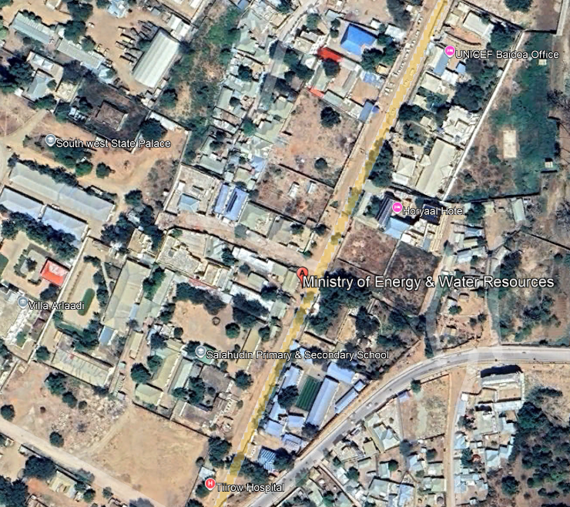

Figure 1 MoEWR Office Location

**Current Status Photos**

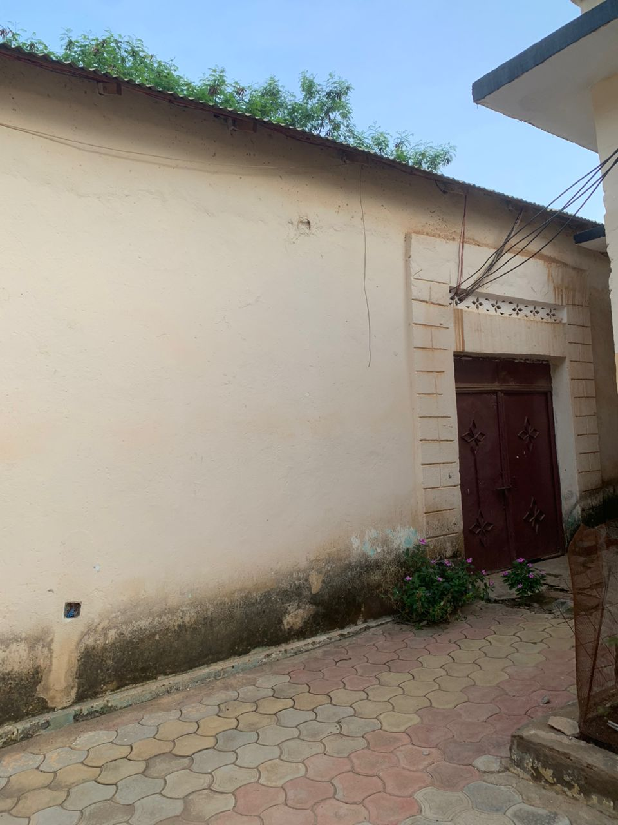

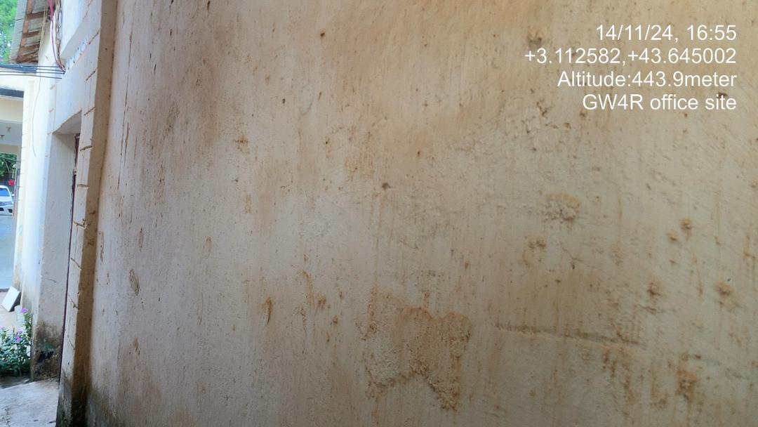

**PART A:** General Project and Site Information

|  |  |  |  |  |
| --- | --- | --- | --- | --- |
| **INSTITUTIONAL & ADMINISTRATIVE** | | | | |
| Country | **Somalia –SWS State** | | | |
| Project title | **Construction of the GW4R PIU Office-Baidoa** | | | |
| Scope of project and activity | This project aims to establish a fully functional and well-equipped facility that will serve as a center for groundwater-related activities. The Office will be a G+1 concrete building, with the ground floor designed for housing the GW4R project team office rooms, and the office has two latrines, one kitchen and a store. | | | |
| Institutional  arrangements  (Name and contacts) | Project Management Unit  PIU – at Southwest MOEWR at State level.  Mohamed Omar  Operation Manger  E-mail: [momarow@gmail.com](mailto:momarow@gmail.com) | | | **Project Owner**  SWS Ministry of Energy and water resources |
| **SITE DESCRIPTION** | | | | |
| Name of site | Ministry of Energy and Water resource of Southwest state( MoEWR ) | | | |
| Describe site location | Ministry of energy and Water and energy of SWS State Compound in Baidoa.  GPS location:lat 3.112538 long 43.645052° | | | |
| Attach evidence of government ownership of land or land acquisition process and RAP | Government Land/Ministry Energy and water resources’ Land. | | | |
| Description of geographic, physical, biological, geological, hydrographic and socio-economic context | **Site**: New offices construction & General rehabilitation of the Ministry compound view  Area: 8.2m x 12.3m  **Local climate**  the site experiences semi arid climate hot and dry most of the year. The seasonal rainfall is limited with two main rainy seasons at the site.  **Biological environment**  There are no significant plants and animal species present at the site of construction and the surrounding areas at the site.  **Social**  Has a distinct population with various ethnic groups. The primary economic activities mainly driven by livestock rearing, and in site is has with basic services like water supply, electricity, and sanitation being reliable. Road networks to the site are developed. | | | |
| Locations and distance for material sourcing, especially aggregates, water, stones? | The contractor shall provide water and other construction materials. The contractor is obliged to comply with the WB standards and Somalia existing legal framework.  The contractor is obliged to safeguard the environment and public safety while sourcing the construction material such as Sand, aggregates and stones, etc. | | | |
| **LEGISLATION** | | | | |
| Identify national & local legislation & permits that apply to project activity | 1. Somalia National Gender Policy (2016)ci 2. National Climate Change Policy, 2020 3. National Environmental Policy (2020) 4. The Federal Republic of Somalia Provisional Constitution, 2012 5. National Water Resource Strategy (2021 – 2025) 6. National Adaptation Programme of Action on Climate Change (NAPA) 2013 7. The Labour Code of 2025 8. The Somali Penal Code of 1962 9. The Urban Land Distribution Law of 1973 10. The Urban Land Distribution Law of 1973 11. Environmental Act Management FGS 12. Environmental Management Policy of FGS. 13. Environmental Impact Assessment Law of Somalia 14. Environmental Management Law in Somalia 15. Civil laws of FGS 16. Southwest Water Law 17. Other laws by Ministries of Public works at Southwest state. | | | |
| **PUBLIC CONSULTATION** | | | | |
| Identify when / where the public consultation process took place | The Southwest state GW4R PIU team held a meeting with the MoEWR on the E&S instruments for Southwest Ground Water for Resilience Project on 15th November 2024 in the Ministry Building, Baidoa- Southwest state.   * The public hearing organized at the MoEWR Office on 15th November 2024 to the surrounding compounds and stakeholders, including representatives from neighboring Immigration department, Horyal Hotel, , and civil society organization. Some of these offices are located in neighboring areas, while representatives from civil society organizations were also invited to participate, and they provided their suggestions and recommendations regarding the office construction process." * How to prevent any physical damage to the adjacent Government offices? * How to schedule the first site clearing activity as they disturb the working environment of the Ministry of planning next to proposed construction site? * How will the project manage any physical damage risks during the site clearance and use of drilling equipment for demolition? * Labor risks with local contractors and how to mitigate them, etc.   During the consultation and awareness session was conducted to provide information about the construction, it’s objective and safeguarding measures. Key points such as environmental protection, waste management, and the overall impact of construction on the community and their inclusivity were discussed and they were encouraging to provide their suggestions and valuable recommendations.   1. Waste management  * Implement effective waste management protocols during and after the construction process to address construction and demolition debris. * Ensure the environment remains clean and safe for the community during the demolition, construction and after the construction process.  1. Noise Management  * Minimize noise level during demolition and construction, particularly during working hours, resting hours in the midday, late hours to maintain community practice and maintain rest.  1. Traffic management  * Take measures to prevent traffic congestion around the construction site especially during transport of materials and movements of trucks.  1. Signage and awareness  * Install clear signage around the construction site and provide ongoing updates to community about the construction activities to ensure public awareness and safety.  1. Safeguarding measures  * Adopt strict adherence to waste management protocols to safeguard the environment and protect community health during and after construction activities.   It was also emphasized that neighboring institutions, including government offices, were consulted, and their suggestions and proposed mitigation measures were taken into consideration. It is important to note that the planned new building will be located within the ministry compound.  Finally, the consultation with neighboring institutions and community representatives, the (DG) of the MOEWR pledged full support, reaffirming the ministry's commitment to actively collaborate with the GW4R project in advancing various initiatives within the Southwest state. The DG emphasized the ministry's readiness to engage meaningfully and highlighted the importance and potential outcomes of the consultation meeting. He further assured participants that the ministry would implement and uphold the proposed mitigation measures put forward by the representatives, both during and after the construction process, to ensure sustainable and inclusive manner.    Top of Form | | | |
| **E&S MAANAGMENT** | | | | |
| Who will orient and monitor E&S requirements of the project? | The project E&S unit together with the operation manager and will orient the E&S requirements of the project. | |  | |
| Who will be the onsite construction focal point for grievances with the contractor? | Omar degale  Faduma bare  Suado gudow |  | | |
| Will GM, GBV and Code of conduct posters be provided before works start? | Yes see attached. |
| When with the contractor be oriented on the GEMS form for monthly submission | Before the construction start or during the induction training for E &S Instruments. |

| **Associated Project Activity**  **office** | **E&S Risks and Impact** | **Mitigation Measures** | **Responsibility for implementation** | **Timing for mitigation** | **Monitoring Indicators** | | **Mitigation Budget** | **Monitoring Responsibility** | **Monitoring Frequency** |
| --- | --- | --- | --- | --- | --- | --- | --- | --- | --- |
| **ESS 1: Environmental and Social Assessments** | | | | | | | | | |
| **ESS1** | All E&S risks and impacts including those that arise during construction are minimized mitigated/compensated. | Measures outlined below are implemented and reported on and new issues through implementation and monitoring are addressed and monthly reports submitted to the PIU | contractor | Throughout implementation | | Measures implemented | No additional cost | PIU | monthly |
| Risk of vegetation and clearance | Avoid unnecessary clearance of vegetation  Landscaping/greening of site following the construction works. | Contractor/MOEWR | During the implementation phase | | Reduction of vegetation/unattractive landscape | No additional cost | PIU | Weekly |
|  | Disturbance of land or assets | Limit the vehicle movement and disturbance of areas.  Use the appropriate roads and not create irregular paths during the construction.  Make good any disturbance of soil, vegetation and assets | Contractor | During the implementation | | All disturbance is rectified by the end of construction.  No additional roads created during the rehabilitation works | No additional costs | Contractor | Weekly |
| **ESS 2: Labor and Working Conditions** | | | | | | | | | |
|  | Lack of occupational health and safety (OHS) for workers deployed at construction sites | * Carry out a safety risk assessment and management plan and implement * Provide OHS training/ Orientation for all the workers every week and visitors * Train all workers in safe handling of equipment and use of PPE * Provide necessary personal protective equipment (PPE) to all workers * Posters displayed on key OHS hazards * Implement procedure of dealing with accidents and exposures * Record all incidents and corresponding Root Cause Analysis * Follow WBG environmental Health and Safety guidelines * Implement and monitor LMP in accordance with national law and international standards * Comply with Somalia OHS related laws and procedures. * Evacuation, medical treatment and compensation of all injuries sustained during construction activities are met by contractor | Contractor | Before construction | | * Safety risk assessment and management plan and implementation record * Training of workers on OHS including safe handling of equipment, traffic safety, security measures and use of PPEs * Daily toolbox meetings reinforce key safety protocols; * All incidents recorded * PPE issuance register * Monitoring reports * Pictures of posters displayed | TBD | PIU | Daily by the contractor site supervisor/  Weekly visits from PIU |
| **ESS2** | Security risk for Project Workers | Implementation of a specific risk assessment for office construction.  - SMP is not a requirement for PIU’s office construction since the office is within the Ministry compound.  - The following are mitigation measures in place for sites  -Access control  -24hrs Security guards on project site   * - Emergency plan in case of security related incident like fire and work place injuries. | Contractor and PIU | During construction | | Number of security incidents reported and impacts | TBD | Contractor/ PIU | Weekly |
| Traffic accidents cause injury or death of workers or community | * All drivers undergo safe driving checks. * Traffic safety protocols are closely adhered to. | Contractor and PIU | During construction | | Checks on drivers documented;  Traffic safety awareness raising and monitoring are documented. | TBD | Contractor/ PIU | Weekly |
| Risks of child and forced labour | * Strict age verification process and documentation for all workers * Ensure that all contracts have contractual provisions to comply with the minimum age requirements including penalties for non-compliance * Include minimum age (18 years) in procurement documents. * Raise awareness on child protection with contractors and in the communities. * Posters prohibiting child labour at all sites | PIU site supervisor | During implementation | | * Labor register showing age and sex of persons engaged * Worker’s GRM in place * Provisions in the contracts * Records of awareness sessions * Pictures of posters displayed | TBD | PIU | Weekly |
| Unfair employment practices and discrimination | * Employment of project workers under the project will be based on the principle of equal opportunity and fair treatment, * No discrimination based on personal characteristics unrelated to inherent job requirements with respect to any aspects of the employment relationship, such as recruitment and hiring, terms of employment (including wages and benefits), termination and access to training/promotion. * Awareness raising of all project implementers, contractors and primary suppliers on the requirements for equal opportunity and fair treatment. * Provision of maternity leave and nursing breaks * Provision of sufficient and suitable toilet and washing facilities, separate for men and women workers. | Contractor | During implementation | | * Records of workers and recruitment processes and criteria. * All employment related grievances and resolution times are logged. | No additional cost | PIU | Monthly |
| Delayed payment of workers | * Implement and monitor payment of workers as per contracts. * Communication/awareness campaign of payment mechanisms * Disseminate and orient the rights of workers * Comply with Somaliland employment laws and procedures. | Contractor/ PIU | During implementation | | Record of appropriate measures taken | No additional costs | PIU | As and when occurs |
|  | Lack of proper grievances channels | * All workers have access to an impartial and functional grievance mechanism and there is an appeals process * Channels for complaints and grievances are convenient for workers. To enable this, the project will have several channels for complaints and grievances including email, phone calls, texts, blogs, hotline and letter writing that will also be accessible to all workers. * Information on the project GM will be made available to workers at all facilities. * Posters on GM mechanism and channel displayed at all sites | Contractor/ PIU | During implementation | | All grievances and resolution times are logged.  GEM E&S monitoring form is filled every month  Picture of posters displayed on GM | No additional cost | PIU | Monthly |
|  | Workers are not observing safety requirements | * Sensitize workers on importance of adherence to site safety protocols * All workers sign a code of conduct including responsibilities and rights regarding GBV, Grievances, observing OHS and security protocols etc. | Contractor | Before implementation | | * Proper records of all signed forms * Training records | No additional costs, posters will be provided by the project | PIU | Periodically |
| **ESS 3: Resource Efficiency and Pollution Prevention Management** | | | | | | | | | |
| **ESS3** | Generation of solid waste | * Implement site solid waste management plan to include measures to:   + Reuse and recycling of the waste generated   + Provide on-site or off-site transportation of waste to prevent or minimize spills, releases and exposure to employees and public   + Appropriate designation of areas for disposal of solid waste consistent with the local and international requirements | Contractor | During implementation | | * Waste management plan * Records of amount of solid waste re-used, recycled, and disposed of | No additional cost | PIU | Monthly |
| Generation of dust and noise  Decreased air quality  Increased levels of vibration from construction machinery | * Where feasible, construction sites, diversions and materials handling sites to be water-sprayed on dry and windy days to contain dust; * Cordon off construction sites to minimize dust migration to nearby facilities by wind; * Staff working in dust generating activities shall be provided with Personal Protective Equipment (PPE) * Use equipment with lower noise emissions * Routine maintenance of the vehicles to reduce noise and air pollution * Installing suitable mufflers on engine exhausts and compressor components * Installing acoustic enclosures for equipment casing * Planning activities in consultation with local communities so that activities with the greatest potential to generate noise are planned during periods of the day that will result in least disturbance | Contractor | During implementation | | * Number of sound machinery and equipment * Frequency ofwatering ofsurfaces to reducedust related * Frequency & maintenance plan | No additional cost | PIU  •ProjectEngineer  /supervisingconsultant  •Environmental Specialist | Weekly |
| Oil and lubricant contamination | * Properly store oil and lubricants * Avoid irregular dumping of used oil and lubricants. * All machinery and equipment be regularly maintained and serviced to avoid leak oils * Designate a garage or workshop for oil change far from the water source. | Contractor | During the implementation | | Proper records of oil & lubricant change.  Proper dumping | TBD | •Project Engineer  /supervising consultant  •Environmental Specialist | Monthly |
| **ESS 4: Community Health and Safety** | | | | | | | | | |
| **ESS4** | Increased GBV/SEAH cases | * Training of all workers on GBV/SEAH * Enforce total adherence to the code of conduct in workers * Confidential reporting measures for SEA/SH * Awareness raising on GBV complaints channels – posters or meetings. | Contractor / PIU/ | During implementation | | * Monitoring of SEAH measures * Records in place | No additional cost | PIU | Monthly |
| Exposure of community members to physical/biological hazards on the project site, including unauthorized access | * Undertake safety precautions to address safety hazards for the nearby community, including, safety/warning signage, safety barrier around the construction site, and safe driving practices * Restrict access to construction and allow only authorized personnel * Safety barrier around the construction site * Safe driving practices * Proper use & regular cleaning of the pit latrines * Limit open defecation in the borehole area. * Awareness raising & promotion of hygiene practices in the community and communicable diseases. | Contractor | Prior to and during implementation | | Records to show community sensitization on safety, in place | TBD | PIU | Prior to start of works, monthly during implementation |
| Exposure of risk of communicable diseases |
| Contractor/ VDC | During implementation | | * Records to shows the awareness raising and sanitation, hygiene promotion | TBD | PIU | Whenever there is work onsite |
| Use of waste by community may cause harm | Ensure all waste is properly recorded, sorted and segregated, proper handling and disposal, and health and safety measures | Contractor | During implementation | | * Waste management procedure in place * Records of amount of waste disposed available | No additional cost | PIU | Weekly |
|  | Heat related illness | Limit the direct sun exposure during the mid time  Advise the community members to stay hydrated  Availability of potable water on site | PIU | During the summer months | | * Awareness raising records | No additional costs | PIU | Weekly |
| **ESS 5: Land Acquisition, Restrictions on Land Use and Involuntary Resettlement** | | | | | | | | | |
|  | Physical or economic displacement of legal and illegal residents or traders in or around the construction sites | Physical visit by social specialist before construction and confirmation during community meeting and ongoing monitoring and development of RAP/resettlement audit | PIU | Before construction starts | | Documentation by social specialist | Costed as per RAP and not paid for by project funds | PIU | monthly |
| **ESS5** | Blocked access to people in the area | Ensure that the local routes, drainage and community access are not blocked by construction | Contractor | During construction | | There have been no complaints on blocked access to the people in the area | No additional cost | PIU | Weekly |
|  | Conflict over land | Before signing land agreements, consult all owners (private land) or users and residents (community land) and ensure that agreements and certificates are in place | PIU | Before construction starts | | Land agreements and certificates.  Records of consultations with land owners and users | No additional budget is required. | PIU | Whenever necessary |
| **ESS 10: Stakeholder Engagement and Information Disclosure** | | | | | | | | | |
| **ESS10** | Inadequate, ineffective, and inappropriate stakeholder and community engagements and disclosure of information | * Keep community leaders informed of progress/delays or activities that may impact community. * Conduct regular community consultations as necessary * Consultation to be held in culturally appropriate means and language | PIU and contractor | Before and during construction | | No outstanding complaints. Complaints resolved within 21 days | No additional cost | PIU | Monthly |
| Poor access or low trust in GM | Poster of GM and contacts displayed outside site at all times.  All complaints are logged and resolved within 21 days  Undertake consultations on the effectiveness of the GM | PIU and contractor | Prior to and during implementation | | Availability of posters  Number of GRM cases addressed within 21days  Minutes of meetings discussing GM issues with the community | No additional cost | PIU | Weekly |

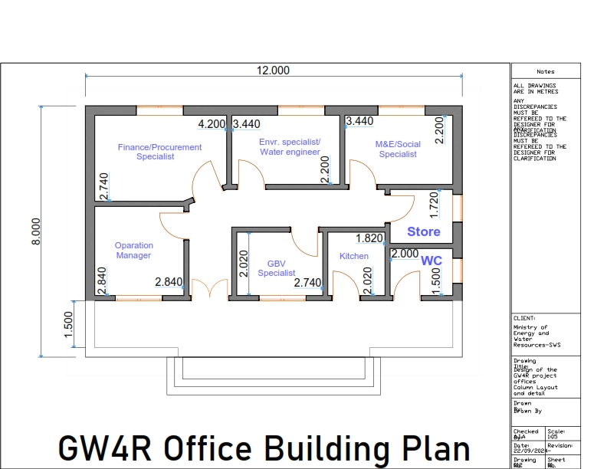

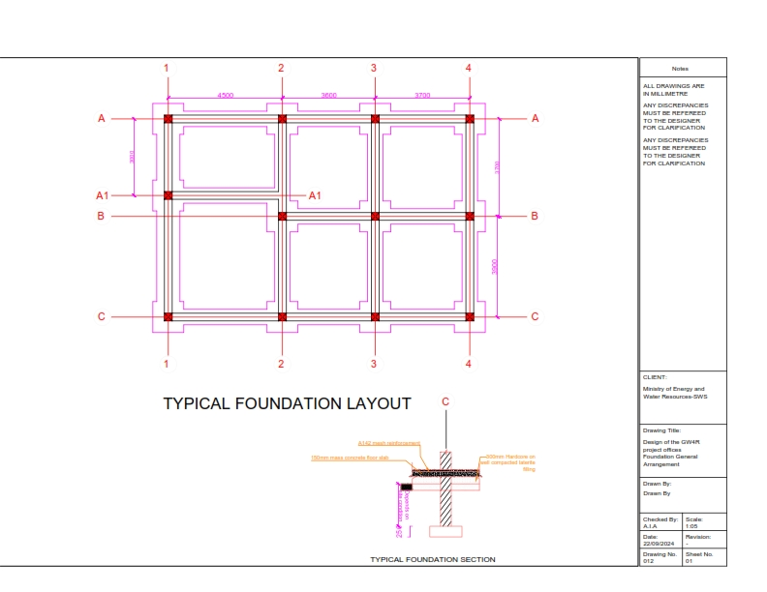

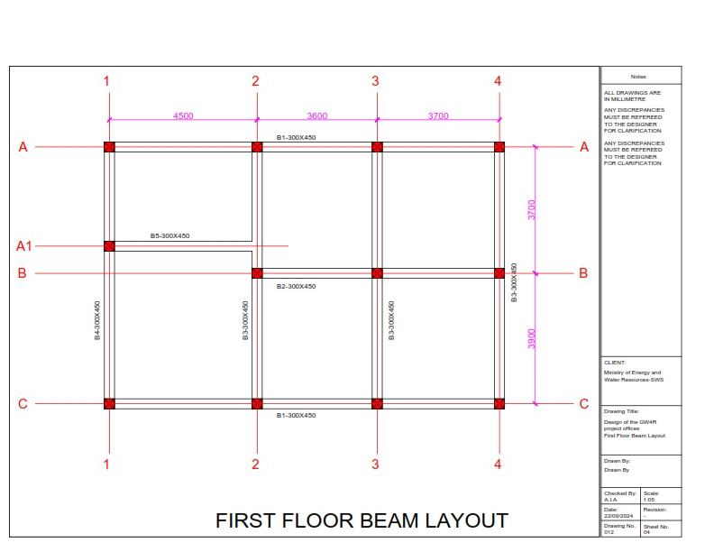

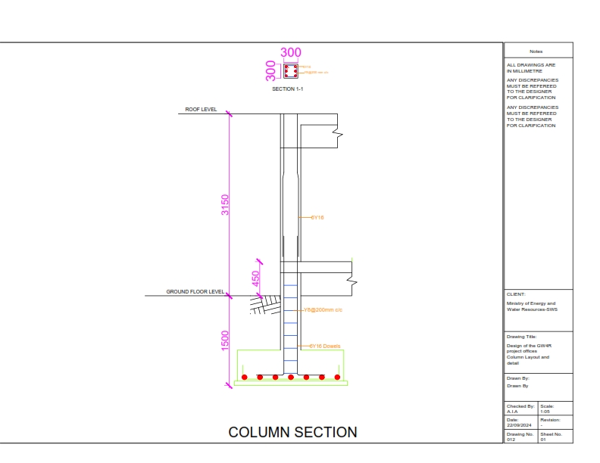

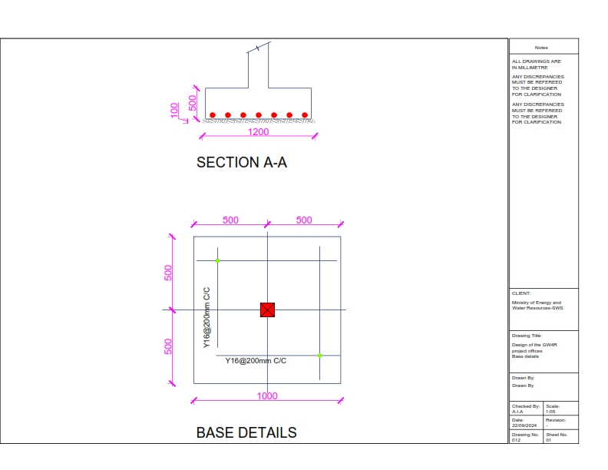

**Annex 2. minutes of public consultation**

**Introduction & Scope of the activity**

The Ministry of Energy and Water Resources southwest state (MoEWR) is responsible for overseeing and managing Southwest State Somalia's energy and water sectors. Its mandate encompasses a broad range of duties aimed at ensuring the sustainable and efficient use of these vital resources for the country's benefit. This includes developing and implementing policies and strategies to optimize energy production, distribution, and consumption, as well as managing water resources responsibly. MoEWR is essential in promoting sustainable development practices by advocating for responsible energy and water use, addressing resource scarcity issues, and ensuring equitable access to these critical resources. The ministry is dedicated to balancing the needs of the current population while safeguarding the availability of energy and water for future generations.

The severe damage to the MoEWR building, particularly the compromised roof and the weakness/poor quality of the building stutus, requires urgent demolishing and construction of new concrete building for several key reasons. Firstly, the structural integrity and safety of the building are at risk, making it essential to address the damage promptly to protect the well-being of employees and visitors. Secondly, rehabilitating the building is critical for preserving valuable assets, including important documents, equipment, and technology housed within the ministry. If left unaddressed, the damage could lead to further deterioration of these assets.

Additionally, a rehabilitated building ensures the continuity of MoEWR's operations, fostering a safe and comfortable work environment for employees and enhancing public confidence in the ministry's ability to fulfill its mandate effectively. The damaged building poses a significant threat to operational continuity, potentially hindering the ministry's normal functions. By addressing this issue, the reconstruction of the new office building will help restore normalcy and maintain service delivery to the public. Furthermore, neglecting this rehabilitation may result in more extensive problems over time. Timely rehabilitation/reconstruction not only prevents further damage but also ensures compliance with safety and construction standards, allowing the ministry to operate within legal frameworks.

**Site GPS and Map.**

|  |  |
| --- | --- |
| **Latitude** | **Longitude** |
| **3.112538** | **43.645052°** |
|  |  |



**Meeting Minute**s

Community Consultation on the Environmental and Social Management Plan (ESMP) for the office construction of the Ministry of Energy and Water Resource of South West State of Somalia .

Date: 15th November 2024

Venue: Ministry of Energy and Water Resource Conference Hall in Baidoa

**Objective & Approach**

The consultation aimed to engage various stakeholders and institutions potentially impacted by the rehabilitation of the Ministry of Water, ensuring comprehensive engagement. Attendees included staff from neighboring institutions such as the Immigration Department office, Horyal Hotel, and ATMISsection office which are close to the ministry building and the MoEWR staff at the compound. Held on 15th November 2024, the consultation sought to emphasize the importance of effective stakeholder engagement in enhancing environmental and social sustainability of projects and fostering project acceptance.

**Presentation on ESMP**

Fatuma Bare, Community Development/Social Safeguard Specialist for SW GW4R Project, delivered a concise overview of the Environmental and Social Management Plan (ESMP). She outlined potential project risks and proposed mitigation measures, stressing the necessity of analyzing and incorporating efficient pollution control measures. Additionally, Mr. Omar Hussein Digale who is the Environmental specialist highlighted the significance of selecting equipment with lower noise emissions and implementing routine vehicle maintenance to mitigate noise and air pollution. In the presence of engineers, he underscored the importance of scheduling activities with high disturbance potential during periods of minimal impact. Throughout the meeting the safeguards team explained ESS1, ESS2, ESS4, and ESS5 to the participants.

**Stakeholder Engagement**

Representatives from the Ministry of Water expressed gratitude to the GW4R safeguard team for organizing the meeting and facilitating consultation, emphasizing its importance in addressing their concerns. Twenty-three members including 5 members from neighboring residence both from the community and the SW ministries participated, expressing their concerns and ideas regarding the rehabilitation project. The DG from MoEWR pledged support, affirming the ministry’s commitment to collaborate with the GW4R project in supporting various projects within the Southwest state. The Director-General from the Ministry also expressed readiness to engage and highlighted the potentiality of the meeting.

**Community Readiness**

Stakeholder representatives, including the Immigration office, Horyal Hotel and residents closest to the ministry building, pledged their readiness and commitment to engage with the project, emphasizing the importance of fully implementing the environmental and social management plan to mitigate all negative impacts during the implementation phase. The meeting concluded with a commitment from all participants.

Finally, the MOEWR leadershipemphasized the ministry's readiness to engage meaningfully and highlighted the importance and potential outcomes of the consultation meeting. He further assured participants that the ministry would implement and uphold the proposed mitigation measures put forward by the representatives, both during and after the construction process, to ensure sustainable and inclusive manner.

**GBV Awareness**

Separate consultation meeting for women was held during office construction consultation process. The first meeting was attended by all representative from the ministry of water, representative from the immigration department, representative from horyal guest house and the GR4R PIU staff. In this separate meeting was meant for women only, Women's issues were discussed separately spearheaded by the GBV specialist Ms Suado Gudow. the women who attended the meeting were of 9 women from the local community and the MoEWRstaff,

Agendas and suggestions discussed are summarized below-:

1. Ensure that woman facilities are prioritized in the design phase of the construction process.
2. Women participate in consultation and decision-making process
3. The mitigation measures suggested by the women were that GBV response services is available in the areas and should be aware and communicated when every GBV cases are received
4. Regular consultation of women leading the PIU GBV specialist and those around the ministry compound.
5. Scheduling work hours limiting or giving notice of the construction activities to specific hours to minimize disturbances
6. To have sufficient female facilities in the new office construction, such as separated female washroom facilities.
7. Among the other agendas with women includes sexual exploitation abuse and harassment (SEA/H) and free line for reporting in the case of an incident and the contact person to be reported.

During the separate meetings with the women Confidentiality and referral are two key important things to ensure the safety and support of individual affected by GBV areas highlighted as the following

* Ensuring that women's facilities are prioritized in the design phase of the construction process
* Women participated in the consultation and decision-making process of office construction, which was achieved during the office design process.
* The mitigation measures suggested by women representatives were that GBV response service is available in the areas should be aware and communicated whenever GBV cases are received
* The PIU GBV focal point who can provide support to PIU and MOEWR SWS.
* Regular consultation of women leading by the PIU GBV and those around the ministry compound as well as nearby offices
* Scheduling work hours, Limiting or giving notice of construction activities to specific hours to minimize disturbances.
* To educate the community about potential GBV risks and preventive measures
* To have sufficient female facilities in the new office construction, such a separate female washroom.
* Guidance for construction activities to minimize hazards to nearby shops.
* Clear GM process for nearby shops to report concerns or incidents related to construction activities, ensuring timely responses.
* To Schedule meetings between women representatives and district GBV service providers during or after construction process. These meetings will serve as a platform to discuss the available services, allowing participants to provide their input and suggestions on how these services can be improved to better meet the needs of the community, particularly women
* As planned with the support national GBV specialist will be organized orientations on GBV service providers and what to do in case of SEAH for local SEAH service.
* They have suggested organizing workshops to educate community members about SEAH, and GBV-related cases, the case of SEAH and the local SEA services providers
* PIU GBV focal point has taken and assigned the follow-up role with the support of the project leadership and NPCU GBV specialist

During the consultation with female representatives, it was proposed and agreed to include orientations and, if possible, to organize a workshop at the nearest GBV service providers, such as Bay regional hospital and SOS district hospital

**Separate Women Participations Photos**

|  |  |
| --- | --- |
|  |  |

**Meeting Participant List and Land Certificate Letter**



**GM Contacts and awareness raising**

South West State has the following FMS GW4R GM and GBV emails,

* GM Email: [sw.gw4r.grm@gmail.com](mailto:sw.gw4r.grm@gmail.com)
* GBV Email: [sw.gw4r.gbvs@gmail.com](mailto:sw.gw4r.gbvs@gmail.com)

|  |  |  |
| --- | --- | --- |
| **GW4R GRM & GBV EMAILS** | **LOCATION** | **REMARKS** |
| **E-mails** | **Category** | **State** |
| sw.gw4r.grm@gmail.com | Southwest State of Somalia | State Level |
| sw.gw4r.gbvs@gmail.com | Southwest State of Somalia | State Level |
| **HOTLINE NUMBER (FREE)** | **9992** | **National Level** |
|  |  | The free hotline number functions within 24 hours of the Project |

These emails are managed by the PIU Social Safeguard and GBV specialists of the Ministry. Any complaints related to the Galmudug GW4R project issues will be handled and registered according to GM procedures and regulations.

Furthermore , Southwest MOEWR plans to establish a state-level toll-free number for stakeholders and individuals with complaints to contact. Until this toll-free line is operational, clients will be able to access the national toll-free number at the FGs level (9992).

**GM Awareness Raising**

1. ***An accessible and functional grievance mechanism is*** important in addressing community or stakeholder concerns as well as receiving ***feedback on a project so that it can be improved***. It is a requirement for all World Bank projects and the responsibility of all project staff, any of whom may receive the grievance.
2. It is ***preferable that grievances are resolved in person at the lowest level***, however, different levels and channels of registering grievances should be available so that ***even the most marginalized person feels comfortable raising a grievance. GBV/SEAH-related complaints should be referred immediately to the GBV focal points at FMS or FGS level.***
3. Grievances should be dealt with ***confidentially, on a need-to-know basis only, and without fear of backlash.***
4. Grievances can be raised by ***community members, workers, and other stakeholders*** concerning project implementation including adverse social or environmental impacts, misuse of funds; staff behavior, workers’ conditions or safety, quality of service issues, sexual exploitation and abuse, forced or child labor etc.
5. **Confidentiality and timelines:** Grievances can be submitted anonymously by any complainant, and personal data should be anonymized for all complainants who raise GBV issues. Grievances will be ***acknowledged within a week (7 days) of receipt and resolved if possible, within 21 days including feedback to the complainant.*** The complaint will be addressed as fully and precisely as possible focusing on specific facts and events, ***showing understanding and never dismissing or belittling a complaint.***
6. **Cases of GBV/SEAH:** Such cases will be only handled by GBV focal points trained in survivor-centric complaints handling and treated with ***utmost confidence, respect, and empathy and managed in line with the complainants’ express wishes,*** including whether the complaint is registered and referred. The complaint will be anomymised, indicating a reference number rather than the name of the complainant.
7. Project fully assumes a survivor-centered approach, no information can be passed on without the survivor’s consent.

**Code of Conduct Obligations of the Project Contractors**

Under the Horn of Africa Groundwater for Resilience Projectfailure to follow Environmental, Social and healthy Safety **(ESHS)** and Occupational and healthy Safety Standards **(OHS), or** partaking in **GBV or VAC** activities, constitutes acts of gross misconduct and is therefore grounds for sanctions, penalties, or potential termination of employment. Prosecution of those who commit Sexual harassment **(SH)** or Sexual Exploitation, Abuse and Harassment **(SEAH)** or other types of GBV, or Violence against children **(VAC)** may be pursued if appropriate.

I,_____________________________________________acknowledge that adhering to environmental, social, health and safety (ESHS) standards, following the project’s occupational health and safety **(OHS)** requirements, and preventing gender-based violence **(GBV) ESHS (VAC)** is important. All forms of **GBV or VAC** are unacceptable in the workplace or when interacting with communities.

Under the Horn of Africa Groundwater for Resilience Projectfailure to follow Environmental, Social and healthy Safety **(ESHS)** and Occupational and healthy Safety Standards **(OHS), or** partaking in **GBV or VAC** activities, constitutes acts of gross misconduct and is therefore grounds for sanctions, penalties, or potential termination of employment. Prosecution of those who commit Sexual harassment **(SH)** or Sexual Exploitation, Abuse and Harassment **(SEAH)** or other types of GBV, or Violence against children **(VAC)** may be pursued if appropriate.

**I agree that while working on the Project I will:**

1. Attend an orientation training session related **to ESHS, OHS, HIV/AIDS, GBV and VAC as** requested by my employer.
2. Follow my employers’ guidance on prevention of the spread of infectious diseases.
3. Follow my employers’ guidance on security and safety including not causing conflict or exposing myself, other colleagues, stakeholders including community members, project facilities or assets to risks.
4. Treat women, children (persons under the age of 18), and men with respect regardless of race, color, language, religion, political or other opinion, national, ethnic or social origin, property, disability, birth or other status.
5. Not use language or behavior towards women, children or men that is inappropriate, harassing, abusive, sexually provocative, demeaning or culturally inappropriate.
6. Not participate in sexual contact or activity with children (anyone age 18 or under)– including grooming or contact through digital media. Mistaken belief regarding the age of a child is not a defense. Consent from the child is also not a defense or excuse.
7. Not engage in any form of sexual harassment to a co-worker - for instance, making unwelcome sexual advances, requests for sexual favors, and other verbal or physical conduct, of a sexual nature, including subtle acts of such behavior e.g., looking somebody up and down; kissing, howling or smacking sounds; hanging around somebody; whistling and catcalls; giving personal gifts; making comments about somebody’s sex life etc. Sexual harassment constitutes acts of serious misconduct and are therefore grounds for disciplinary measures, including summary dismissal
8. Not engage in any form of sexual exploitation or abuse – for instance, exchanging money, employment, goods or services for sex or sexual favors, or making promises or favorable treatment dependent on sexual acts – or other forms of humiliating, degrading or exploitative behavior. This includes any project-related assistance due to community members. Sexual exploitation and sexual abuse constitute acts of serious misconduct and are therefore grounds for disciplinary measures, including summary dismissal.
9. Report through the Reporting Mechanism to any suspected or actual GBV or VAC to company management and employer, or any breaches of this Code of Conduct.

The standards set out above are not intended to be an exhaustive list. Other types of sexually exploitive or sexually abusive behavior may be grounds for administrative action.

With regard to children under the age of 18, I will:

1. Wherever possible, ensure that another adult is present when working in the proximity of children.
2. Not invite unaccompanied children unrelated to my family into my home, unless they are at immediate risk of injury or in physical danger.
3. Not use any computers, mobile phones, video and digital cameras to exploit or harass children or access child pornographic material (see also “Use of children's images for work related purposes” below).
4. Refrain from physical punishment or discipline of children.
5. Refrain from hiring children for domestic or other labor which is inappropriate given their age or developmental stage, or places them at significant risk of injury.
6. Comply with all relevant local legislation, including Somali national labor laws in relation to child labor.

Use of children’s images for work related purposes

When photographing or filming a child for work related purposes, I will:

1. Before photographing or filming a child, assess and endeavor to comply with local traditions or restrictions for reproducing personal images;
2. Before photographing or filming a child, obtain informed consent from the child and a parent or guardian of the child. As part of this, I must explain how the photograph or film will be used;
3. Ensure photographs, films and videos present children in a dignified and respectful manner and not in a vulnerable or submissive manner. Children should be adequately clothed and not be seen as sexually suggestive;
4. Ensure images are honest representations of the context and the facts; and
5. Ensure file labels do not reveal identifying information about a child when sending images electronically.

# Summary report for building rehabilitation for GW4R projects (max 5 pages). Please annex ESIA/ESMP, voluntary land donation/agreement documentation, community meeting minutes

**Proposed sub-project: Construction of: PIU Office at MOEWR Compound Baidoa-Southwest –Somalia**

## Overview of the project location and key features within 400m of works (to understand impacts)

The head quarter of Ministry of Energy and Water Resource of Southwest state has a blank space/plot planned to be construct any building extensions as per requirements. Therefore, construction of new PIU Office is to be built at the Ministry Compound.

## Current use or occupation of the building:

|  |  |  |  |  |
| --- | --- | --- | --- | --- |
| **Describe use of building (include for residence, livelihoods, other purposes e.g. school, health center, community meeting place)** | **No of individuals resident or regularly using the building/plot** | | | **Proposed design of new Office Construction** |
| This building is planned to be constructed at Ministry compound | There is no any individual | inhabitant | the | This design has been proposed by PIU with the |
| owned by MoEWR and there was no any external residence living | construction planned space |  |  | help of Ministry Engineer’s consultation, NPCU and WB review |
| in the compound in Hargeisa town. |  |  |  |  |
| Construction of new PIU Office had been designed to be a |  |  |  |  |
| multipurpose building, such as: administrative offices, a well- |  |  |  |  |
| Furnished conference hall, and modern sanitary facilities for PIU Staff |  |  |  |  |
| Its strategic location within the MOEWR |  |  |  |  |
| compound ensures seamless coordination and collaboration with |  |  |  |  |
| other departments, fostering efficient decision-making and project |  |  |  |  |
| implementation. |  |  |  |  |

1. **Has there been any conflict over the ownership or use of this building in the past? If so please describe, what measures the project will take to ensure that it does not exacerbate conflict.**

This compound is a government owned land hence it’s a property for the MoEWR Southwest State,

1. **Consultations with the community on the sub-project (to ensure broad agreement, ownership and risk identification and mitigation)**

|  |  |  |  |  |  |  |  |  |
| --- | --- | --- | --- | --- | --- | --- | --- | --- |
|  | **Date** | **Village** | **Total number of people involved** | **No. of women** | **No. of youth** | **No. of minority group or IDP representative**  **s (please** | **Main concerns raised and how they will be addressed** | **Challenges in consulting with people**  **e.g. migration, conflicting** |

|  |  |  |  |  |  |  |  |  |
| --- | --- | --- | --- | --- | --- | --- | --- | --- |
|  |  |  |  |  |  | **specify group/s)** |  | **event, insecurity** |
| **Initial discussions for Community consultations** | 15/11/2024 | Ministry meeting Hall | 23 including the PIU & Representatives from the Immigration department and Horyal Hotel, | 9 members | 15 | N/A | No Major issues raised during the discussions | There was no major challenge |
| **Separate women consultation** | 15/11/2024 | Ministry compound | 9 representative from the schools, women association, business centers around, neighboring house and PIU |  |  |  | Below are the summarized suggestions and mitigation measures suggested? Ensuring that women's facilities are prioritized in the design phase of the construction process  Women participated in the consultation and decision-making process of office construction, which was achieved during the office design process.  The mitigation measures suggested by women representatives were that GBV response service is available in the areas should be aware and communicated whenever GBV cases are received  The PIU GBV focal point who can provide support to PIU and MOEWR SWS.  Regular consultation of women leading by the PIU GBV and those around the ministry compound as well as nearby offices  Scheduling work hours, Limiting or giving notice of construction activities to specific hours to minimize disturbances.  To educate the community about potential GBV risks and preventive measures  To have sufficient female facilities in the new office construction, such a separate female washroom.  Guidance for construction activities to minimize hazards to nearby shops.  Clear GM process for nearby shops to report concerns or incidents related to construction activities, ensuring timely responses. | There was no major challenge |

|  |  |  |  |  |  |  |  |  |
| --- | --- | --- | --- | --- | --- | --- | --- | --- |
| **Other – meetings (specify)** |  |  |  |  |  |  |  |  |

1. **Has a safeguards field visit been undertaken to the site? Y/N Date of visit: Yes** **Title of visiting officer PIU Staff**
2. **Ownership of building for construction and maintenance?**

|  |  |  |
| --- | --- | --- |
| **a. Government** | Title deed/confirmation document attached? | YES/NO/EXPLANATION  **Yes** |
| **b. Community** | Community agreement on future use of building and maintenance responsibility? | YES/NO/EXPLANATION  **No** |
| **c. Private** | Donation form and agreement by government officials? | YES/NO/EXPLANATION  **No** |

1. **GRM: Has the GRM process and contact information for focal points been disseminated to the community? If so, how and to whom (numbers and groups). If not, when will this be done?**

## During the office/site construction consultation process, participants were provided with the GRM protocols and procedures for the project/ministry, including GM contact details and information on raising awareness about GM. The SWS PIU, under the leadership of the Operations Manager, has assumed responsibility for monitoring and following up on this matter

## **GBV/SEAH: Has awareness been carried out on GBV, service providers and confidential survivor centric GBV complaints mechanism? If so, how and to whom (numbers and groups). If not, when will this be done?**

a separate awareness session for women took place on 15th/11/2024, involving ten local women from i.e. neighbor’s, schools, women associations and staff from the Ministry of Energy and Water Resources of SWS State. The total number of participants from the ministry staff, including the GW4R PIU, was 23 members.

## **Sustainable management: Who will manage and maintain the sub-project, and how will repairs be funded?**

The Office will be handed over to the Ministry as the PIU Office to run GW4R project. Thus, it is the Ministry's responsibility to maintain and repair the building

## **Describe the nearest GBV service providers for health, psycho-social and legal support (to inform the site supervisor and stakeholder in the area):**

The nearest GBV service providers for the construction of PIU Office activities, are number of cooperative institutions such as:

1. Bay Regional hospital 600m away from the construction site which will serve as the primary GBV service provider
2. SOS Hospital around 800m from the Ministry compound and serves as the major GBV service provider in Baidoa and surrounding villages.