


DOWLAD GOBOLEEDKA JUBALAND

EE SOOMAALIYA
MARTA

A
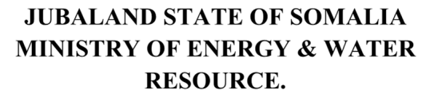


WASAARADA TA

& BIYAH

GROUNDWATER FOR RESILIENCE PROJECT (GW4R) PROJECT
Environmental and Social Management Plan (ESMP)
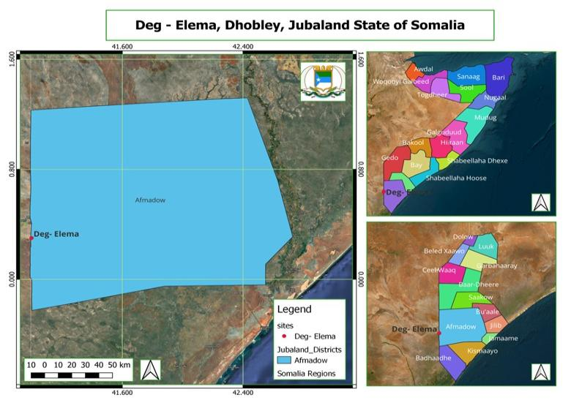
Date: 3rd June 2025

INTRODUCTION

Scope of the project and activity

The GW4R Project aims to improve groundwater access and management in the borders of the Horn of Africa in an environmentally conscious way. The project consists of three main components: (1) inclusive groundwater services to priority areas (2) groundwater data generation and national and regional groundwater institution improvement and (3) project management, knowledge-sharing, and operations support. There are sub-components and related actions for every component. Project beneficiaries will be communities that suffer from poor water conditions and that face increasingly future difficult conditions relating to climate change, a rapidly growing population, and increasing conflicts over scarce resources. The total number of beneficiaries in Somalia is estimated at 350,000. They will include rural communities, livestock owners, women and girl-children, and urban populations of Somalia.

As part of the Jubaland (JL)State Groundwater for Resilience (GW4R) project, the Ministry of Energy and Water Resources is planning to rehabilitate five strategic boreholes throughout JL State including Degaleme in Dhoobley district. This site is located in Degalame village within Dhoobley Location. Before the rehabilitation begins, it is essential to have the required documentation in place. In accordance with World Bank standards, an Environmental and Social Management Plan (ESMP) is mandatory. The ESMP is a crucial document designed to identify and mitigate potential environmental and social risks and impacts associated with the construction. An ESMP identifies and mitigates potential environmental and social risks and impacts associated with construction activities. Furthermore, the following reasons make this plan crucial:

- Identifying and Mitigating Environmental and Social Impacts: The ESMP helps identify potential environmental and social impacts that the bore hole rehabilitation workers may have on its surroundings. The ESMP ensures that appropriate mitigation measures are in place to minimize any negative effects.
- Compliance with World Bank Safeguard Standards: The World Bank requires projects it funds to adhere to environmental and social safeguard standards aimed at protecting the environment and local communities. The ESMP ensures that the site rehabilitation aligns with these policies and standards, making the project eligible for financial support from the World Bank if required.
- Worker Safety and Health (OHS): Construction activities inherently pose health and safety risks to workers. The ESMP helps identify potential Occupational Health and Safety (OHS) risks and establishes measures to safeguard the well-being of workers involved in the project.
- Stakeholder Engagement and Transparency: The ESMP emphasizes stakeholder engagement and communication. It ensures that local communities and relevant stakeholders are consulted about the project's potential impacts and help shape the mitigation measures as well as have a chance to voice their concerns or grievances. This fosters transparency and builds trust among stakeholders.
- Project Success and Sustainability: Addressing environmental and social considerations through the ESMP contributes to the overall success and sustainability of the project. By minimizing negative impacts and engaging with stakeholders, the project is more likely to progress smoothly, avoiding conflicts and delays that may arise from unaddressed issues.
- Legal and Regulatory Compliance: An ESMP ensures that the project complies with relevant national environmental and social laws and regulations. Non-compliance can lead to legal complications and project disruptions.
- Long-term Environmental and Social Performance: The ESMP lays the groundwork for ongoing monitoring and reporting on the project's environmental and social performance. This helps in making necessary adjustments and improvements throughout the project's lifecycle.

Site Description
This is a rural borehole scheme located 12km South of Dhobley Town. The Deg-Elema Water Facility serves approximately 1,800 residents in Jubaland, along with 2,000 pastoralists and thousands of livestock, including 1,500 camels, 3,000 shoats, 500 cattle, and 170 donkeys. Despite its importance, the facility is plagued by deteriorating infrastructure, an inadequate water distribution system, and an unreliable power supply. The community relies on a single borehole, drilled in March 2015 by Adeso, a local NGO, at a depth of 220 meters. However, due to poor maintenance and lack of alternative water sources, the borehole’s efficiency has declined, leaving the community vulnerable to frequent water shortages. The facility, managed by the Deg-Elema Water Management Committee (WMC), includes a pumping unit, two non-functional generators, dilapidated solar system, water storage tanks, a communal water point, and livestock troughs. However, the aging infrastructure and lack of a proper water distribution system have significantly hindered its ability to meet the growing demand for clean water.

As part of Groundwater for Resilience (GW4R) project, the rehabilitation and upgrading of the Deg-Elema water infrastructure will directly support the transboundary water investment initiative in Dhobley-Liboi. The project will revitalize the existing borehole, ensuring its sustainability and efficiency by replacing outdated borehole equipment, installing a new 45 kVA Deutz/Parkin diesel generator, and integrating a solar-powered system to reduce reliance on fossil fuels. To enhance water storage and distribution, the initiative will rehabilitate two non-functional storage tanks and extend the pipeline network, improving household access to clean water and reducing the distance that women and children must travel to fetch water. Additionally, the project will construct a communal water kiosk and rehabilitate four livestock troughs two designated for camels, one for sheep and goats, and one for cattle to support the region’s pastoralist communities.

To enhance sanitation and security, the facility will be enclosed with a chain-link fence, and a latrine will be constructed to improve hygiene conditions. These upgrades will ensure that the Deg-Elema Water Facility operates efficiently, sustainably, and reliably, securing long-term water access for residents, livestock, and pastoralists. By addressing the challenges of poor maintenance, limited storage, and inadequate distribution, the project aligns with IGAD’s broader goal of strengthening climate resilience, promoting regional water cooperation, and improving the livelihoods of communities along the Somalia-Kenya border.
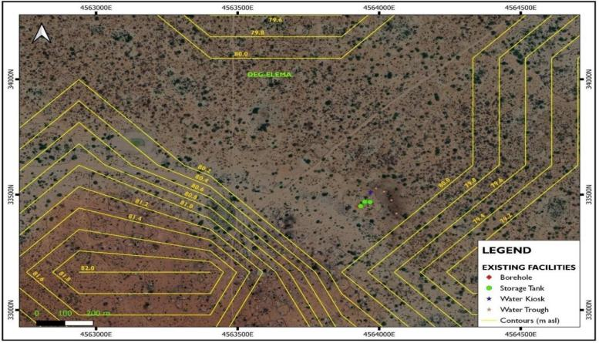
Site GPS Coordinates and MAP:
Deg- Elema contour map showing the Settlement Pattern, Geographical Coordinates and altitudes in m asl

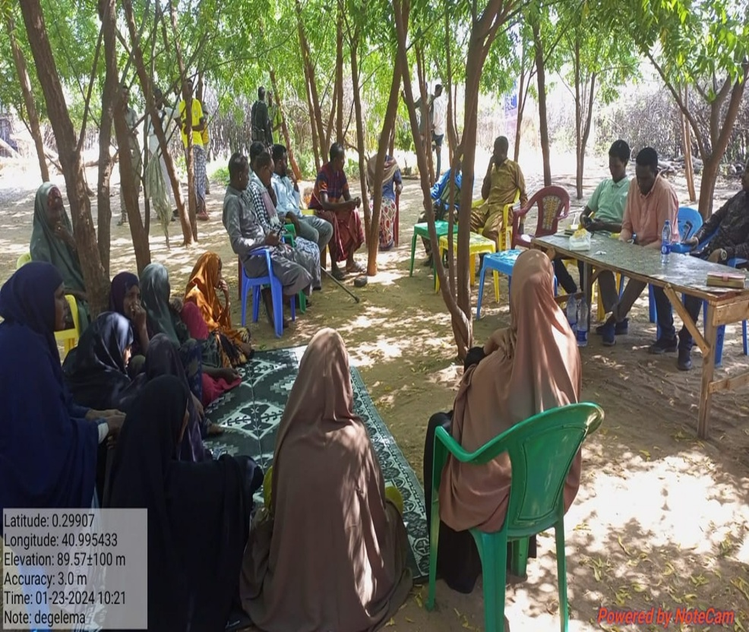
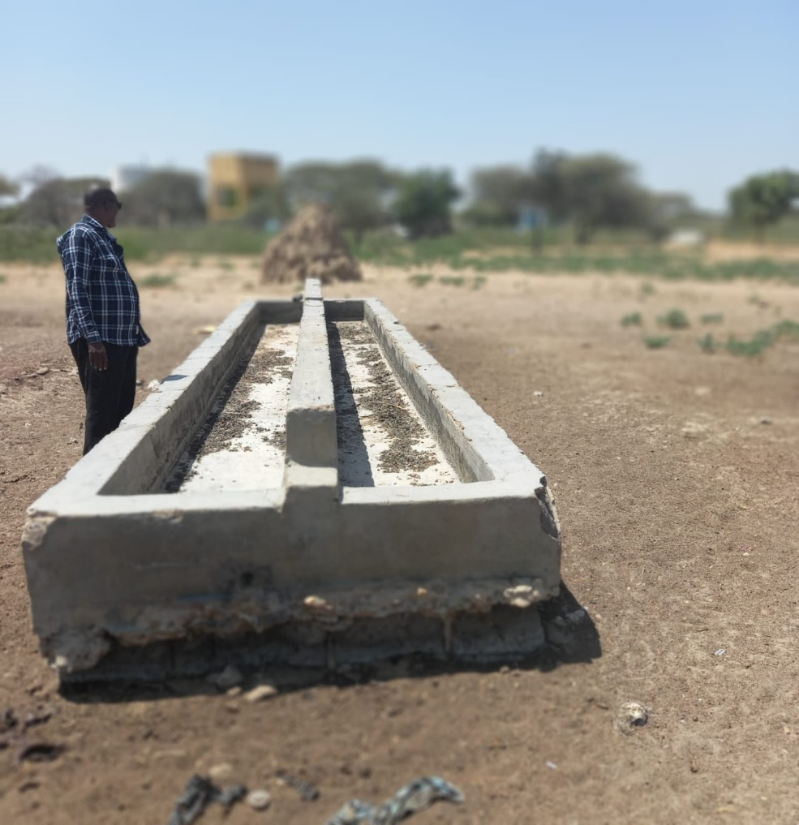
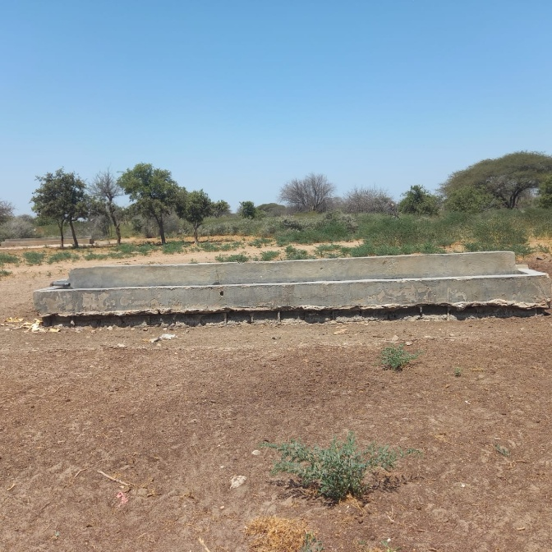
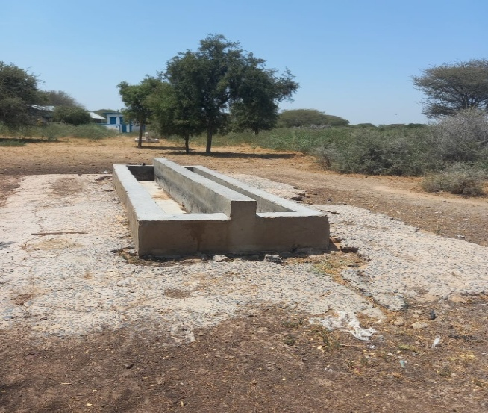
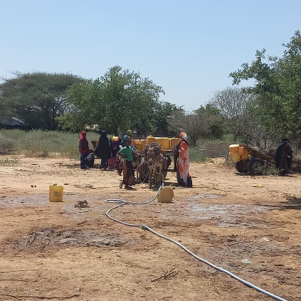
SITE PHOTOS
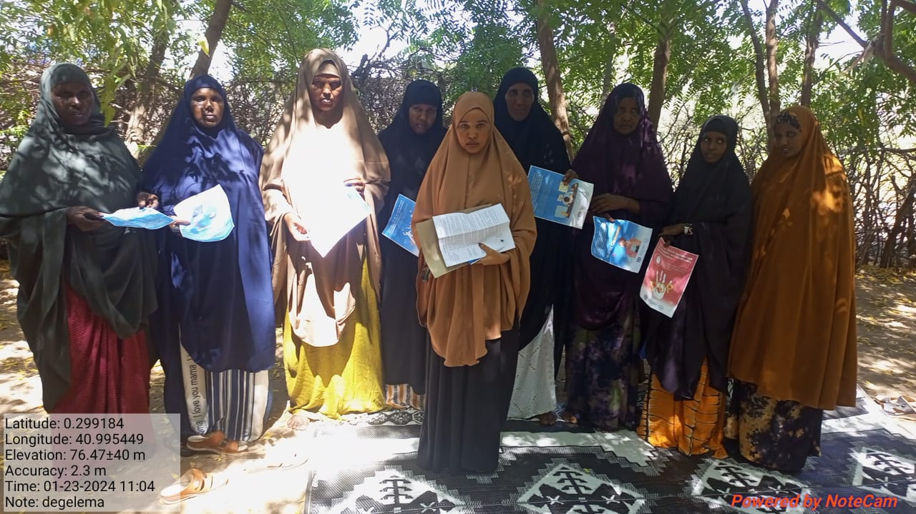
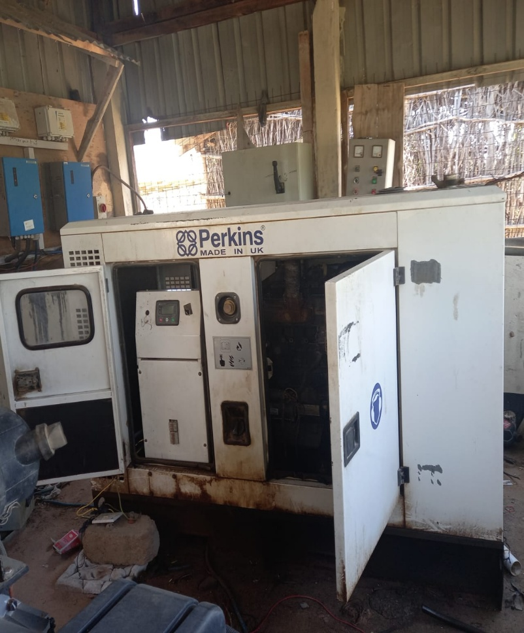
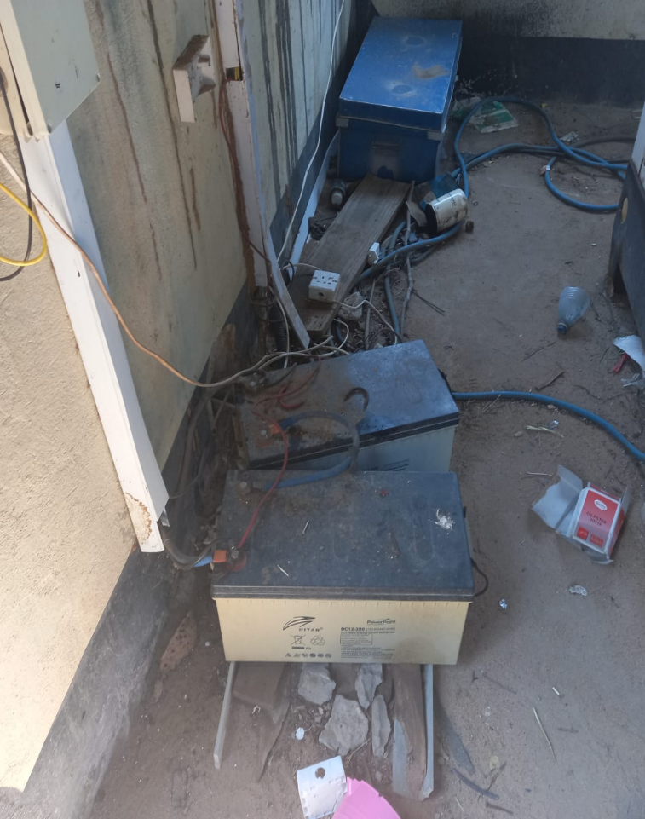
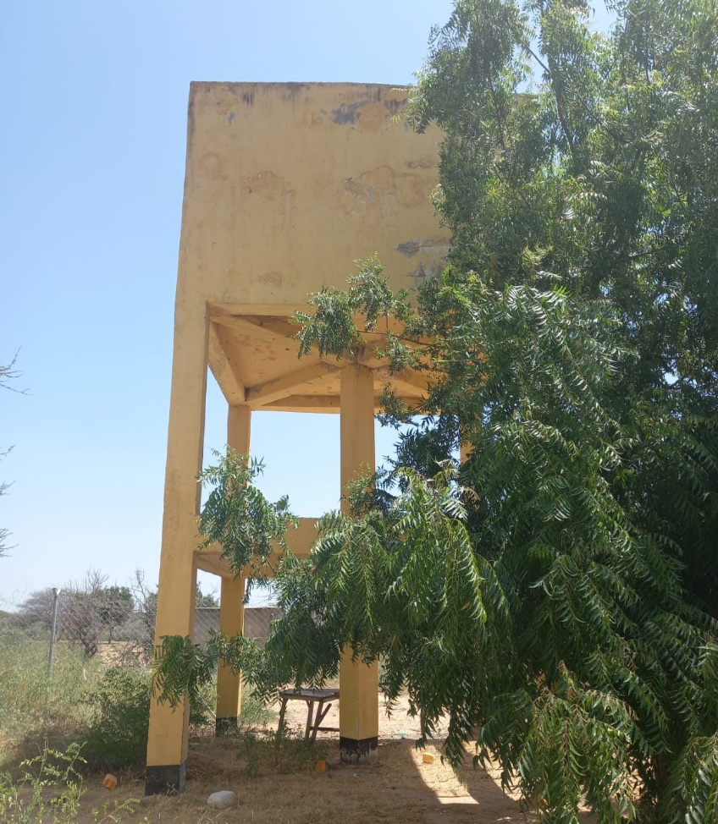
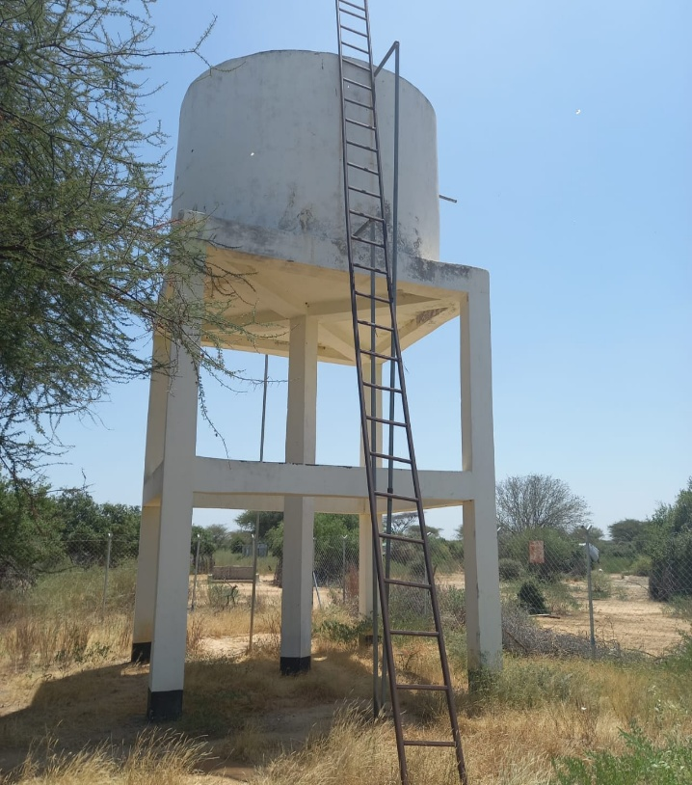
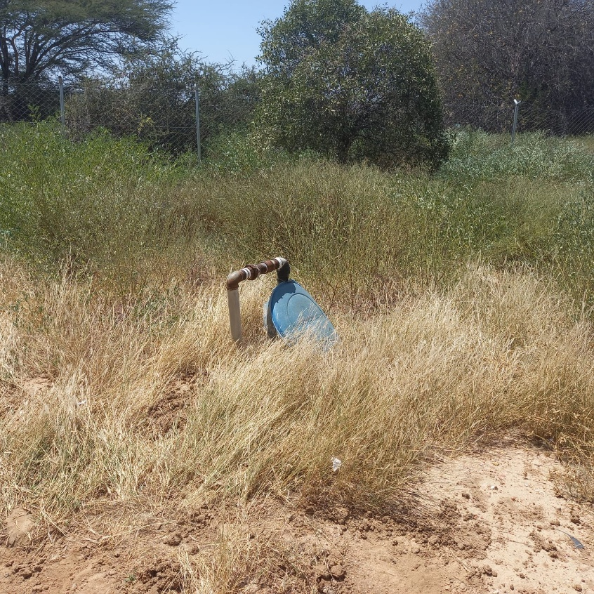
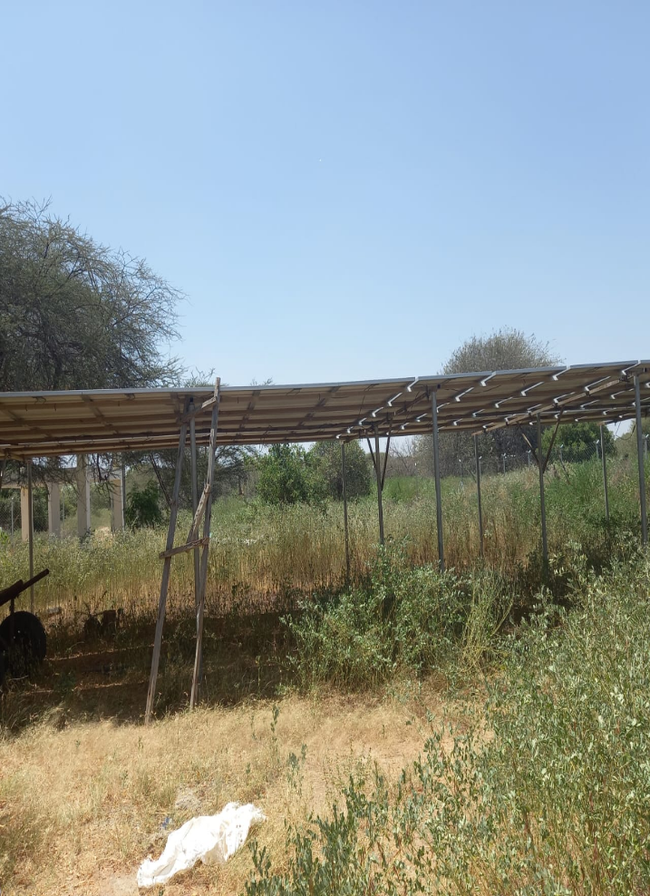

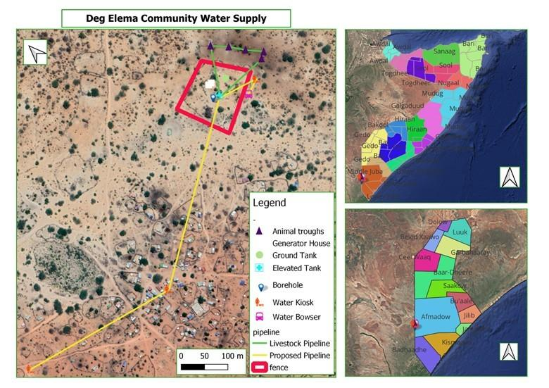

ENGINEERING INFRASTRUCTURE DESIGNS AND SPECIFICATIONS

PART A: General Project and Site Information
INSTITUTIONAL & ADMINISTRATIVE
Country | Somalia -Jubaland state-DHoobley district lower Juba juba
Project title | GW4R: Rehabilitation and Upgrading of Degalame -DHoobley town Existing Borehole
Scope of project and activity | Deg-Elema village, located south of Dhobley town at Latitude: 0.30049ºN, Longitude: 40.99845ºE, is home to approximately 300 households (about 1,800 permanent residents). The population primarily consists of 333 pastoralist households whose livelihoods depend on livestock farming. However, severe limitations in water supply infrastructure have led to chronic shortages, posing serious threats to both human and animal survival while undermining the economic stability of the community.  The proposed investment is subdivided into Ten components:  - Provision of 13kW submersible pump to leverage demand.  - Provision of solar system pumping tech for daytime pumping.  - Supply and installation 45KVA generator for peak demand/night activity.  - Provision of High Density UPVC down pipe of 2-inch that withstand harsh climatic conditions.  - Construction of a water kiosk at the borehole site.  - Construction of a water point for the water bowsers at the site.  - Rehabilitation of 2 Nr. camel troughs, 1No. goat trough and 1 No. cattle trough.  - Rehabilitation of 2Nr. elevated reinforced concrete tanks, 40 cubic meters each.  - Chain-link fence with flood protection, and proper gate. The chain-link fence will be installed for security and to prevent floodwater from entering the facility, with a 50 cm hollow block foundation being constructed.  - Provision of operation and maintenance tools, capacity building for solar operators and non-revenue water (NRW) management.
Institutional  arrangements  (Name and contacts) | Project Management PIU – at Ministry of Energy and Water Resource  Abdinasir Elmoge  Ground Water for Resilience JL state operation manager  elmoge.mower@gmail.com |  | Project Owner  Ministry of Energy and Water Resource
SITE DESCRIPTION
Name of site | Site Name: Deg-elema Borehole Rehabilitation, Dhoobley District of Lower juba -Region, Jubaland State of Somalia.
Describe site location | Degalame borehole is located in Dhoobely District lower juba Somalia. The land size measures 10,000 square meters with specific GPS coordinates: Lat: 0.30049 Long: 40.99845.
Attach evidence of government ownership of land or land acquisition process and RAP | Government Land/Ministry Energy and Water Resource of Juba Land’s Land.  The land certificate, duly approved by the Dhoobley district commissioner is attached and included as part of the ESMP. The designated land for Degaleme borehole rehabilitation is owned by the Degalame community with approval of DC certification letter in line with MOU as well as the VLD form agreed by the community with Ministry of Energy and Water Resources of the Juba Land State, Somalia. The signed VLD form is attached in Annex 1.
Has a site been visited by the social specialist to confirm that there will be no physical or economic displacement or disturbance including of squatters or informal traders? (when and conclusion) | - Yes, The E&S team including the Social/ CDD specialist, Environmental specialist, have visited the site to confirm that there will be no physical or economic displacement or disturbance including of residents or informal traders.  - The visit occurred on 23/01/2024. In conclusion, the ES has implemented several measures to ensure that the project will not cause any significant or major social impacts. These measures include:  - Conducted a thorough site visit and verified ES screening checklist and confirmed that there will be no major physical or economic displacement or disturbance.  - Formulating a comprehensive monitoring plan to assess the effectiveness of the mitigation measures in place.  - Establishing a robust grievance mechanism that enables affected communities to voice their concerns and seek resolution in a transparent and accessible manner.  - Shared GRM postures including hotline number, which they can communicate us during and after the implementation/rehabilitation stage  - To facilitate effective communication during and after the implementation/rehabilitation stage, PIU GM focal points will regularly monitor and register any concerns/complaints regarding Degaleme Water Point
Description of geographic, physical, biological, geological, hydrographic and socio-economic context | Climate  Degaleme site experiences an arid to semi-arid climate characterized by high temperatures and low, erratic rainfall. The area has two rainy seasons, Gu April to June, Deyr October–December and two dry seasons including Jilaal from December to March, Hagaa from July–September. Prolonged droughts are common, affecting water availability and vegetation.  Biological Environment  The site's vegetation consists mainly of drought resistant shrubs, acacia trees, and grassland patches. There are no significant plants and animal species present at the site of construction and the surrounding areas at the site. The grazing areas surrounding the site are primarily used by seasonal pastoralists. These areas will be mapped and assessed during site implementation to ensure water point development does not negatively impact grazing zones. A mitigation plan will be proposed in collaboration with local pastoralist representatives.  Social Environment  The site is a home to pastoralist and agro pastoralist communities that rely on livestock and small scale farming. The population is relatively sparse, with seasonal migration influencing settlement patterns. Basic infrastructure, such as water points, health facilities, and schools, is limited. Cross border trade with Kenya is an essential economic activity. The establishment of a water point is expected to improve access to water for both human and livestock use, potentially increasing pressure on nearby vegetation. To mitigate overuse, community based water management committees were established, and seasonal usage patterns will be integrated into water access planning.  Geological Environment  The site's geology is dominated by sedimentary formations, with shallow aquifers and deep groundwater reserves playing a critical role in water supply. Soils are generally sandy and loamy, with low fertility and susceptibility to erosion. Erosion control will be addressed through site design features such as proper drainage channels, vegetation buffers, and, where necessary. Routes used by seasonal pastoralists will be monitored and supported with awareness raising and physical measures to reduce degradation, in coordination with local authorities. Groundwater exploration is essential for water security, especially during prolonged dry periods.  Hydrogeology  Locally, the site has six main hydrogeological systems that form the Merti Aquifer system with the Luuq- Mandera Depression. They are as follows:  - Alluvial deposits (saline water when overlying Anoole Formation).  - Within the strata, fractures, granular spaces of sandstones, (Ambar/ Yesomma sandstones)  - Karstified limestone recharged by sinkholes.  - In caliche formed from deeply weathered limestone In interlayered marls within the limestone beds.  - In the gypsite beds of Beled Hawo formaton Fracture aquifers in fault zones widened by karstification to provide increased groundwater storage.
Locations and distance for material sourcing, especially aggregates, water, stones? | Distance for Material Sourcing: The construction material, especially aggregate, water and stones will be sourced from Dhoobley Town- Lower Jubba, approximately 12km away. The project should aim to source materials as locally as possible to reduce transport costs and environmental impact.
The locations and distances for material sourcing, especially aggregates, water, stones, for the Deg-Elema Borehole Rehabilitation will be from Dhoobley Town- Lower Jubba:
- Aggregates: The aggregates for the project will be sourced from a quarry located about 12 kilometers from the wells site. The quarry is open to public and has been operating for several years. The aggregates from the quarry are of good quality and are suitable for use in the construction of the well. To mitigate against child labor of these sites, the project will ensure that all material sourcing sites, particularly the quarry and the stonemason, are verified for compliance with child labor requirements. The TPM will conduct periodic unannounced spot checks to monitor this, and a clause on child labor compliance will be incorporated in the procurement contracts.
- Water: The water for the project will be sourced from the borehole.
- Stones: The stones for the project will be sourced from a local stonemason. The stonemason has been in business for many years and has a good reputation for providing quality stones. The stones will be used to rehabilitate the top protection of the well. The stonemason’s operations will be reviewed as part of the due diligence process. Verification will be done in coordination with local authorities and civil society actors to ensure the absence of child labor.

Material | Location | Distance from the borehole site
Aggregates | Quarry | 12 kilometers
Water | Well | Water point
Stones | Stonemason | 4 kilometers

The project team will need to obtain permits from the local government to source materials from these locations. The team will also need to ensure that the materials are sourced sustainably, are free from legal disputes, and that extraction activities comply with national environmental regulations and do not lead to land degradation, biodiversity loss, or community conflict.

LEGISLATION
Identify national & local legislation & permits that apply to project activity | - Somalia National Gender Policy (2016)  - National Climate Change Policy, 2020  - National Environmental Policy (2020)  - The Federal Republic of Somalia Provisional Constitution, 2012  - National Water Resource Strategy (2021 – 2025)  - Environmental Protection and Management Act (2024)  - Environmental and Social Impact Assessment and Audit Regulations (ESIA) 2024  - National Adaptation Programme of Action on Climate Change (NAPA) 2013  - The Labour Code of 2025  - The Somali Penal Code of 1962  - The Urban Land Distribution Law of 1973  - Draft Environmental Management Policy of FGS.  - Environmental Impact Assessment Law of Somalia  - Jubbaland Environmental Protection and Management Code (2018)  - Civil laws of FGS  - Juba land Water Law  - Other laws by Ministries of Public works at Juba land State.
PUBLIC CONSULTATION
When / where did the public consultation process take place (attach minutes describing how many people attended, what was discussed (including plans and potential social and economic impacts, GM and GBV) and categories and photos of the meeting) | - How will the project manage the physical damage risks as the walls of the adjacent  Stakeholder consultations for the ESMP of the Jubaland GW4R Degalame site rehabilitation were conducted on 23 January 2024 and 30 July 2024. These consultations involved local community members, village elders, women and youth representatives, and technical partners. The community in Deg-elema village expressed their satisfaction with the proposed rehabilitation and upgrade of the target borehole. This intervention will benefit the village population as well as a large number of pastoral communities and their livestock from the surrounding villages, including those near Degelema and across the border in Kenya, especially during drought periods. The environmental and social (ES) screening did not identify any major conflicts or environmental issues that would limit the feasibility of investing in this site. This ESMP has incorporated environmental management measures to mitigate degradation of rangeland from increased number of livestock and degradation from stone and aggregate extraction. This includes limiting extraction to approved sites, enforcing rehabilitation plans, and engaging the community in sustainable practices.  Separate Women Meeting.  - During the site field visit, the Jubaland gender/GBV Specialist, with the support from other State PIU, organized separate consultations with the local women. The key suggestions, interests, and concerns raised are outlined below.  - Construction of gender segregated latrines (one for women, one for men) that adhere to WASH standards to improve sanitation and hygiene  - The women undertake a challenging long km journey’s while carrying a heavy jerrycan of 20 liters on their heads. The trip normally takes one and half hours to complete. The rehabilitation of the borehole expected to ease this burden. The proposed infrastructure design includes features to ensure accessibility for jerrycan users, including raised platforms and ramps to accommodate both women and children. The infrastructure will be assessed for user friendliness during both design finalization and post construction monitoring. The design has also taken care of accessibility, safety, privacy and cultural appropriateness.  - Water Shortage: - The shortage of water sources is a pressing concern that affects all the Degalame village in Dhoobley district. Although the whole community is devastated by this burden, it affects women in particular. Despite their efforts to find enough water, the existing wells and sites are woefully inadequate, and families rely on these water points for drinking, cooking, and hygiene. Addressing this issue isn’t just about convenience, it’s about survival.  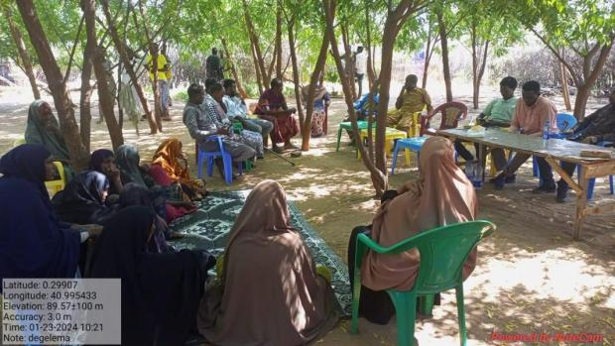
E&S management
Who will orient and monitor E&S requirements of the project? | The project E&S unit together with the NPCU safeguard team specialists will orient & monitor the E&S requirements of the project.
Who will be the onsite focal point for grievances with the contractor? | The contractor will have his own grievance focal point who will be closely working with the GW4R project grievance focal person. | PIU grievances focal Person Hotline number (9992)  Juba land has the following FMS GW4R GM and GBV emails:  GM Email: js.gw4r.grm@gmail.com  GBV Email: jl.gw4r.gbv7@gmail.com  GBV grievances focal person  Khadra Hassan Ali
Will GM, GBV and Code of conduct posters be provided before works start? | Yes, GM, GBV and Code of conduct posters will be provided before work start.
When will the contractor be oriented on the Geo-enabling Initiative for Monitoring and Surveillance (GEMS) form for monthly submission | Before the rehabilitation activity start or during the induction training for  E&S Instruments.

Associated Project Activity  office | E&S Risks and Impact | Mitigation Measures | Responsibility for implementation | Timing for mitigation | Monitoring Indicators |  | Mitigation Budget | Monitoring Responsibility | Monitoring Frequency
ESS 1: Environmental and Social Assessments
ESS1 | Social conflict | - Regular meetings on process and progress with VDC and elders.  - Transparency and neutrality and prompt resolution of concerns.  - Increased awareness and adherence to the measures outlined in the Memorandum of Understanding (MoU) between the community and the PIU.  - Reinforcing customary regulations. | PIU | During construction |  | Number of conflict incidents  Meetings minutes and sent with ESMP report | No additional costs | FGS | Monthly
 | No permanent settlement or rangeland degradation as a result of the water point | - Ensure elders, VDC and local government have robust measures in place to mitigate and limit impact of influx of people and livestock including strengthening of bylaws, agreements and penalties. They are:  Strengthening Community Bylaws and Natural Resource Management Protocols  - Clear Use Agreements by develop and enforce seasonal access protocols that define who can use the water point, when, and under what conditions.  - Zoning Regulations example, designate specific areas for watering, grazing, and rest zones to prevent overuse and allow rangeland regeneration.  - Settlement Restrictions Explicitly prohibit any form of permanent settlement near the water point through locally endorsed bylaws.  Controlled Livestock Access and Mobility Management  - Livestock Quotas example, introduce rotational access schedules and livestock quotas during peak periods to avoid overcrowding.  - Nomadic Route Preservation like Maintain traditional migratory routes and avoid fencing or structures that hinder pastoral mobility.  Penalty and Enforcement Mechanisms  - Graduated Sanctions like Implement a tiered system of fines or sanctions for individuals or groups violating bylaws, with community consensus on enforcement.  - Conflict Resolution Committees e.g., reactivate or support existing customary institutions to handle disputes and violations efficiently. | PIU | Preparation and operation |  | No large scale influx of people or livestock | No additional costs | Contractor/ PIU | Monthly
 | Groundwater contamination | - The proposed pit latrine at the drilling site will be completely lined and carefully emptied on a regular basis utilizing a fully equipped vacuum truck designated for this purpose. The pit latrines will be gender segregated for both male and females. | Contractor | During construction and operation |  | Record of appropriate measures taken | No additional costs | / PIU | Monthly
 | Disturbance of land or assets | - Limit the vehicle movement and disturbance of areas.  - Use the appropriate roads and not create irregular paths during the rehabilitation.  - Make good any disturbance of soil, vegetation and assets | Contractor | During the implementation |  | All disturbance is rectified by the end of construction.  No additional roads created during the rehabilitation works | No additional costs | PIU | Weekly
 | Risk of vegetation clearance | - Avoid unnecessary clearance of vegetation  - Landscaping/greening of site following the construction works | Contractor | During construction |  | Reduction of vegetation/unattractive landscape | No additional cost | PIU | Monthly
ESS 2: Labor and Working Conditions
 | Lack of occupational health and safety (OHS) for workers deployed at construction sites | - Carry out a safety risk assessment and management plan and implement  - Provide OHS training/ Orientation for all the workers every week and visitors  - Train all workers in safe handling of equipment and use of PPE  - Limit extended work under direct sunlight, especially during excavation works and installation of solar panels.  - Provide necessary personal protective equipment (PPE) to all workers  - Posters displayed on key OHS hazards  - Implement procedure of dealing with accidents and exposures  - Record all incidents and corresponding Root Cause Analysis  - Follow WBG environmental Health and Safety guidelines  - Implement and monitor LMP in accordance with national law and international standards  - Comply with Somalia OHS related laws and procedures.  - Evacuation, medical treatment and compensation of all injuries sustained during construction activities are met by contractor.  - Ensure that all site personnel are provided with an adequate supply of safe drinking water at all times | Contractor | Before construction |  | - Safety risk assessment and management plan and implementation record  - Training of workers on OHS including safe handling of equipment, traffic safety, security measures and use of PPEs  - Daily toolbox meetings reinforce key safety protocols;  - All incidents recorded  - PPE issuance register  - Monitoring reports  - Pictures of posters displayed | TBD | PIU | Daily by the contractor site supervisor  Monthly visits from PIU
ESS2 | Security risk for Project Workers | - Implement and monitor the Security Management Plan (Sec MP). The Site SMP has been developed, and contractors are required to adhere it. The SMP/SRA will be shared with contractors as they are on boarded.  - Contractor’s security orientation by the Security Specialist/SRMC before Commencement of any activity. | Contractor | During construction |  | Number of security incidents reported and impacts | TBD | PIU/security officer | Weekly
 | Traffic accidents cause injury or death of workers or community | - All drivers undergo safe driving checks.  - Traffic safety protocols are closely adhered to. | Contractor | During construction |  | Checks on drivers documented;  Traffic safety awareness raising and monitoring are documented. | TBD | PIU | Weekly
 | Risks of child and forced labour | - Strict age verification process and documentation for all workers  - Ensure that all contracts have contractual provisions to comply with the minimum age requirements including penalties for non-compliance  - Include minimum age (18 years) in procurement documents.  - Raise awareness on child protection with contractors and in the communities.  - Posters prohibiting child labour at all sites | site supervisor | During implementation |  | - Labor register showing age and sex of persons engaged  - Worker’s GRM in place  - Provisions in the contracts  - Records of awareness sessions  - Pictures of posters displayed | TBD | PIU | Weekly
 | Unfair employment practices and discrimination | - Employment of project workers under the project will be based on the principle of equal opportunity and fair treatment,  - No discrimination based on personal characteristics unrelated to inherent job requirements with respect to any aspects of the employment relationship, such as recruitment and hiring, terms of employment (including wages and benefits), termination and access to training/promotion.  - Awareness raising of all project implementers, contractors and primary suppliers on the requirements for equal opportunity and fair treatment.  - Provision of maternity leave and nursing breaks  - Provision of sufficient and suitable toilet and washing facilities, separate for men and women workers. | Contractor | During implementation |  | - Records of workers and recruitment processes and criteria.  - All employment related grievances and resolution times are logged. | No additional cost | PIU | Monthly
 | Delayed payment of workers | - Implement and monitor payment of workers as per contracts.  - Communication/awareness campaign of payment mechanisms  - Disseminate and orient the rights of workers  - Comply with Somaliland employment laws and procedures. | Contractor/ PIU | During implementation |  | Record of appropriate measures taken | No additional costs | PIU | As and when occurs
 | Lack of proper grievances channels | - All workers have access to an impartial and functional grievance mechanism and there is an appeals process  - Channels for complaints and grievances are convenient for workers. To enable this, the project will have several channels for complaints and grievances including email, phone calls, texts, blogs, hotline and letter writing that will also be accessible to all workers.  - Information on the project GM will be made available to workers at all facilities.  - Posters on GM mechanism and channel displayed at all sites | Contractor/ PIU | During implementation |  | All grievances and resolution times are logged.  GEM E&S monitoring form is filled every month  Picture of posters displayed on GM | No additional cost | PIU | Monthly
 | Workers are not observing safety requirements | - Sensitize workers on importance of adherence to site safety protocols  - All workers sign a code of conduct including responsibilities and rights regarding GBV, Grievances, observing OHS and security protocols etc. | Contractor | Before implementation |  | - Proper records of all signed forms  - Training records | No additional costs, posters will be provided by the project | PIU | Periodically
ESS 3: Resource Efficiency and Pollution Prevention Management
ESS3 | Generation of solid waste | - Implement site solid waste management plan to include measures to:  - Reuse and recycling of the waste generated  - Provide on-site or off-site transportation of waste to prevent or minimize spills, releases and exposure to employees and public  - Appropriate designation of areas for disposal of solid waste consistent with the local and international requirements | Contractor | During implementation |  | - Waste management plan  - Records of amount of solid waste re-used, recycled, and disposed of | No additional cost | PIU | Monthly
 | Generation of dust and noise  Decreased air quality  Increased levels of vibration from construction machinery | - Where feasible, construction sites, diversions and materials handling sites to be water-sprayed on dry and windy days to contain dust;  - Cordon off construction sites to minimize dust migration to nearby facilities by wind;  - Staff working in dust generating activities shall be provided with Personal Protective Equipment (PPE)  - Use equipment with lower noise emissions  - Routine maintenance of the vehicles to reduce noise and air pollution  - Installing suitable mufflers on engine exhausts and compressor components  - Installing acoustic enclosures for equipment casing  - Planning activities in consultation with local communities so that activities with the greatest potential to generate noise are planned during periods of the day that will result in least disturbance | Contractor | During implementation |  | - Number of sound machinery and equipment  - Frequency of  watering of  surfaces to reduce  dust related  - Frequency & maintenance plan | No additional cost | PIU  •Project  Engineer  /supervising  consultant  •Environmental Specialist | Weekly
 | Oil and lubricant contamination | - Properly store oil and lubricants  - Avoid irregular dumping of used oil and lubricants.  - All machinery and equipment be regularly maintained and serviced to avoid leak oils  - Designate a garage or workshop for oil change far from the water source. | Contractor | During the implementation |  | Proper records of oil & lubricant change.  Proper dumping | TBD | •Project Engineer  /supervising consultant  •Environmental Specialist | Monthly
ESS 4: Community Health and Safety
ESS4 | Increased GBV/SEAH cases | - Training of all workers on GBV/SEAH  - Enforce total adherence to the code of conduct  - Confidential reporting measures for SEA/SH | Contractor / PIU/ SPTs/ MDAs | During implementation |  | - Audit report in place  - Records in place | No additional cost | PIU | Monthly
 | Exposure of community members to physical/biological hazards on the project site, including unauthorized access | - Undertake safety precautions to address safety hazards for the nearby community, including, safety/warning signage, safety barrier around the construction site, and safe driving practices  - Restrict access to construction and allow only authorized personnel  - Safety barrier around the construction site  - Safe driving practices  - Proper use & regular cleaning of the pit latrines  - Limit open defecation in the borehole area.  - Awareness raising & promotion of hygiene practices in the community and communicable diseases. | Contractor | Prior to and during implementation |  | Records to show community sensitization on safety, in place | TBD | PIU | Prior to start of works, monthly during implementation
 | Exposure of risk of communicable diseases
 |  |  | Contractor/ VDC | During implementation and post construction |  | - Records to shows the awareness raising and sanitation, hygiene promotion | TBD | PIU | Whenever there is work onsite
 | Use of waste by community may cause harm | - Ensure all waste is properly recorded, sorted and segregated, proper handling and disposal, and health and safety measures | Contractor | During implementation |  | - Waste management procedure in place  - Records of amount of waste disposed available | No additional cost | PIU | Weekly
 | Heat related illness | - Limit the direct sun exposure during the mid time  - Advise the community members to stay hydrated  - Availability of potable water on site | PIU | During the summer months |  | - Awareness raising records | No additional costs | PIU | Weekly
ESS 5: Land Acquisition, Restrictions on Land Use and Involuntary Resettlement
 | Physical or economic displacement of legal and illegal residents or traders in or around the construction sites | - Physical visit by social specialist before construction and confirmation during community meeting and ongoing monitoring and development of RAP/resettlement audit | PIU | Before construction starts |  | Documentation by social specialist | Costed as per RAP and not paid for by project funds | PIU | monthly
ESS5 | Blocked access to people in the area | - Ensure that the local routes, drainage and community access are not blocked by construction | Contractor | During construction |  | There have been no complaints on blocked access to the people in the area | No additional cost | PIU | Weekly
 | Conflict over land | - Before signing land agreements, consult all owners (private land) or users and residents (community land) and ensure that agreements and certificates are in place | PIU | Before construction starts |  | Land agreements and certificates.  Records of consultations with land owners and users | No additional budget is required. | PIU | Whenever necessary
ESS 10: Stakeholder Engagement and Information Disclosure
ESS10 | Inadequate, ineffective, and inappropriate stakeholder and community engagements and disclosure of information | - Keep community leaders informed of progress/delays or activities that may impact community.  - Conduct regular community consultations as necessary  - Consultation to be held in culturally appropriate means and language | PIU and contractor | Before and during construction |  | No outstanding complaints. Complaints resolved within 7 days | No additional cost | PIU | Monthly
 | Poor access or low trust in GM | - Poster of GM and contacts displayed outside site at all times.  - All complaints are logged and resolved within 7 days  - Undertake consultations on the effectiveness of the GM | PIU and contractor | Prior to and during implementation |  | Availability of posters  Number of GRM cases addressed within 7 days  Minutes of meetings discussing GM issues with the community | No additional cost | PIU | Weekly

GM Contacts and awareness raising
Jubaland has the following FMS GW4R GM and GBV emails,
- GM Email: js.gw4r.grm@gmail.com
- GBV Email: jl.gw4r.gbv7@gmail.com
GW4R GRM & GBV EMAILS | LOCATION | REMARKS
E-mails | Category | State
js.gw4r.grm@gmail.com | Main GRM email | State Level
jl.gw4r.gbv7@gmail.com | GBV/SEAH complaints | State Level
HOTLINE NUMBER (FREE) | 9992 | National Level
 |  | The free hotline number functions within 24 hours of the Project

These emails are managed by the PIU Social Safeguard and GBV specialists of the Ministry. Any complaints related to the Jubaland GW4R project implementation issues will be handled and registered according to GM procedures and regulations.
Additionally, Jubaland MOEWR plans to establish a state-level toll-free number for stakeholders and individuals with complaints to contact. Until this toll-free line is operational, clients will be able to access the national toll-free number at the FGs level (9992).
Code of Conduct Obligations of the Project Contractors
Under the Horn of Africa Groundwater for Resilience Project failure to follow Environmental, Social and healthy Safety (ESHS) and Occupational and healthy Safety Standards (OHS), or partaking in GBV or VAC activities, constitutes acts of gross misconduct and is therefore grounds for sanctions, penalties, or potential termination of employment. Prosecution of those who commit Sexual harassment (SH) or Sexual Exploitation, Abuse and Harassment (SEAH) or other types of GBV, or Violence against children (VAC) may be pursued if appropriate.

I,_____________________________________________acknowledge that adhering to environmental, social, health and safety (ESHS) standards, following the project’s occupational health and safety (OHS) requirements, and preventing gender-based violence (GBV) ESHS (VAC) is important. All forms of GBV or VAC are unacceptable in the workplace or when interacting with communities.
Under the Horn of Africa Groundwater for Resilience Project failure to follow Environmental, Social and healthy Safety (ESHS) and Occupational and healthy Safety Standards (OHS), or partaking in GBV or VAC activities, constitutes acts of gross misconduct and is therefore grounds for sanctions, penalties, or potential termination of employment. Prosecution of those who commit Sexual harassment (SH) or Sexual Exploitation, Abuse and Harassment (SEAH) or other types of GBV, or Violence against children (VAC) may be pursued if appropriate.
I agree that while working on the Project I will:
- Attend an orientation training session related to ESHS, OHS, HIV/AIDS, GBV and VAC as requested by my employer.
- Follow my employers’ guidance on prevention of the spread of infectious diseases.
- Follow my employers’ guidance on security and safety including not causing conflict or exposing myself, other colleagues, stakeholders including community members, project facilities or assets to risks.
- Treat women, children (persons under the age of 18), and men with respect regardless of race, color, language, religion, political or other opinion, national, ethnic or social origin, property, disability, birth or other status.
- Not use language or behavior towards women, children or men that is inappropriate, harassing, abusive, sexually provocative, demeaning or culturally inappropriate.
- Not participate in sexual contact or activity with children (anyone age 18 or under)– including grooming or contact through digital media. Mistaken belief regarding the age of a child is not a defense. Consent from the child is also not a defense or excuse.
- Not engage in any form of sexual harassment to a co-worker - for instance, making unwelcome sexual advances, requests for sexual favors, and other verbal or physical conduct, of a sexual nature, including subtle acts of such behavior e.g., looking somebody up and down; kissing, howling or smacking sounds; hanging around somebody; whistling and catcalls; giving personal gifts; making comments about somebody’s sex life etc. Sexual harassment constitutes acts of serious misconduct and are therefore grounds for disciplinary measures, including summary dismissal
- Not engage in any form of sexual exploitation or abuse for instance, exchanging money, employment, goods or services for sex or sexual favors, or making promises or favorable treatment dependent on sexual acts – or other forms of humiliating, degrading or exploitative behavior. This includes any project-related assistance due to community members. Sexual exploitation and sexual abuse constitute acts of serious misconduct and are therefore grounds for disciplinary measures, including summary dismissal.
- Report through the Reporting Mechanism to any suspected or actual GBV or VAC to company management and employer, or any breaches of this Code of Conduct.
- The standards set out above are not intended to be an exhaustive list. Other types of sexually exploitive or sexually abusive behavior may be grounds for administrative action.
With regard to children under the age of 18, I will:
- Wherever possible, ensure that another adult is present when working in the proximity of children.
- Not invite unaccompanied children unrelated to my family into my home, unless they are at immediate risk of injury or in physical danger.
- Not use any computers, mobile phones, video and digital cameras to exploit or harass children or access child pornographic material (see also “Use of children's images for work related purposes” below).
- Refrain from physical punishment or discipline of children.
- Refrain from hiring children for domestic or other labor which is inappropriate given their age or developmental stage, or places them at significant risk of injury.
- Comply with all relevant local legislation, including Somali national labor laws in relation to child labor.
Use of children’s images for work related purposes
When photographing or filming a child for work related purposes, I will:
- Before photographing or filming a child, assess and endeavor to comply with local traditions or restrictions for reproducing personal images;
- Before photographing or filming a child, obtain informed consent from the child and a parent or guardian of the child. As part of this, I must explain how the photograph or film will be used;
- Ensure photographs, films and videos present children in a dignified and respectful manner and not in a vulnerable or submissive manner. Children should be adequately clothed and not be seen as sexually suggestive;
- Ensure images are honest representations of the context and the facts.
- Ensure file labels do not reveal identifying information about a child when sending images electronically.
THE NEAREST GBV SERVICE PROVIDERS FOR HEALTH, PSYCHO-SOCIAL AND LEGAL SUPPORT IN THE AREA OF DEGALAME SITE:

- The nearest GBV service provider for Deg-elema site is about 12KM in Dhobley district which is Bosnia MCH supported by ALIGJT.
- Main GBV service available in Dhobley includes the PEP kit treatment, psycho-social, GBV awareness raising, GBV Case Management.
- For serious injury cases or any medical cases which require specialized care, the contractor shall coordinate with the nearest referral health facility and arrange for emergency transport.

Annex-1 Attachments

- Land Certificate and Voluntary Land Donation (VLD)
- Community Consultation minutes
- Attendance Sheet of Participants
- MOU
- WMC/VDC appointment letter

