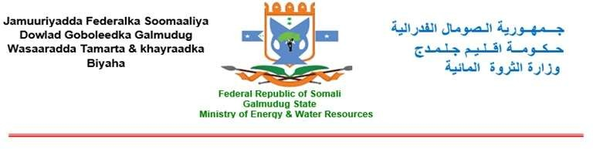

**HORN OF AFRICA GROUND WATER FOR RESILIENCE PROJECT (GW4R)**

**Environmental and Social Management Plan (ESMP) for**

**Construction of a new office for the PIU to serve as a**

**Working space for the GW4R project at the Ministry of**

**Energy and Water Resource of Galmudug State of Somalia**

**Coordinates: 5°31'54"N, 46°22'56"E**

**1. Introduction**

**1.1 Scope of the project and activity**

The GW4R Project aims to improve groundwater access and management in the borders of the Horn of Africa in an environmentally conscious way. The project consists of three main components: (1) inclusive groundwater services to priority areas (2) groundwater data generation and national and regional groundwater institution improvement and (3) project management, knowledge-sharing, and operations support. There are sub-components and related actions for every component. **Project beneficiaries** will be communities that suffer from poor water conditions and that face increasingly future difficult conditions relating to climate change, a rapidly growing population, and increasing conflicts over scarce resources. The total number of beneficiaries in Somalia is estimated at 350,000. They will include rural communities, livestock owners, women and girl-children, and urban populations of Somalia.

As part of the Galmudug State Groundwater for Resilience (GW4R) project, the Ministry of Energy and Water Resources is planning to construct a new office for the Project Implementation Unit (PIU). This office will serve as a dedicated workspace for the GW4R project and will be located within the Ministry of Energy and Water Resources in Dhusamareb. Construction is scheduled to start in October 2024, with completion expected by April 2025. The new office will act as a central hub for project activities, playing a key role in ensuring the project's success.

Before construction begins, it is essential to have the required documentation in place. In accordance with World Bank standards, an Environmental and Social Management Plan (ESMP) is mandatory. The ESMP is a crucial document designed to identify and mitigate potential environmental and social risks and impacts associated with the construction. An ESMP identifies and mitigates potential environmental and social risks and impacts associated with construction activities. Furthermore, the following reasons make this plan crucial:

1. Identifying and Mitigating Environmental and Social Impacts: The ESMP helps identify potential environmental and social impacts that the construction may have on its surroundings. While the construction itself may not cause significant issues, there could still be localized impacts such as dust, noise, and vibration could still affect nearby areas or sensitive ecosystems. The ESMP ensures that appropriate mitigation measures are in place to minimize any negative effects.
2. Compliance with World Bank Safeguard Policies: The World Bank requires projects it funds to adhere to specific safeguard policies aimed at protecting the environment and local communities. The ESMP ensures that the office construction aligns with these policies and standards, making the project eligible for financial support from the World Bank if required.
3. Worker Safety and Health (OHS): Construction activities inherently pose health and safety risks to workers. The ESMP helps identify potential Occupational Health and Safety (OHS) risks and establishes measures to safeguard the well-being of workers involved in the project.
4. Stakeholder Engagement and Transparency: The ESMP emphasizes stakeholder engagement and communication. It ensures that local communities and relevant stakeholders are informed about the project's potential impacts and have a chance to voice their concerns or grievances. This fosters transparency and builds trust among stakeholders.
5. Project Success and Sustainability: Addressing environmental and social considerations through the ESMP contributes to the overall success and sustainability of the project. By minimizing negative impacts and engaging with stakeholders, the project is more likely to progress smoothly, avoiding conflicts and delays that may arise from unaddressed issues.
6. Legal and Regulatory Compliance: An ESMP ensures that the project complies with relevant national environmental and social laws and regulations. Non-compliance can lead to legal complications and project disruptions.
7. Long-term Environmental and Social Performance: The ESMP lays the groundwork for ongoing monitoring and reporting on the project's environmental and social performance. This helps in making necessary adjustments and improvements throughout the project's lifecycle.

**1.2 Site Description**

The newly planned PIU office construction, set constructed within the Ministry of Energy and Water Resources Galmudug State compound, will serve as a pivotal center for overseeing key development projects in the water sector. This office will be designed to accommodate a variety of functions, including administrative offices, a well-equipped meeting hall, and modern sanitary facilities. Its strategic location within the MoEWR compound ensures seamless coordination and collaboration with other departments, fostering efficient decision-making and project implementation.

Having a dedicated PIU office within the MoEWR compound is of great importance. It will streamline communication between different departments and teams, ensuring effective project planning and execution. The proximity of this office to the ministry’s main administrative buildings will support the exchange of essential information, provide timely updates, and facilitate critical consultations. This will promote synergy and unity of purpose in water resource development initiatives.

Structurally, the building will feature a robust concrete slab foundation, allowing for future expansion. This is a vital aspect as it enables the PIU office to maximize the use of available land within the MoEWR compound, optimizing space utilization. With the potential growth in the water sector and the likelihood of undertaking additional projects, this forward-thinking design will future-proof the office, sparing it from costly renovations or the need for new constructions to meet expansion needs. The flexible and expandable nature of the concrete slab foundation aligns perfectly with the office’s vision of adaptability and scalability to meet the evolving demands of water resource development in the years to come.

**Site GPS and MAP**

|  |  |  |
| --- | --- | --- |
| **Latitude** | **Longitude** | **Elevation** |
| **5°31'54"N** | **46°22'56"E** |  |

**5°31'54"N 46°22'56"E**

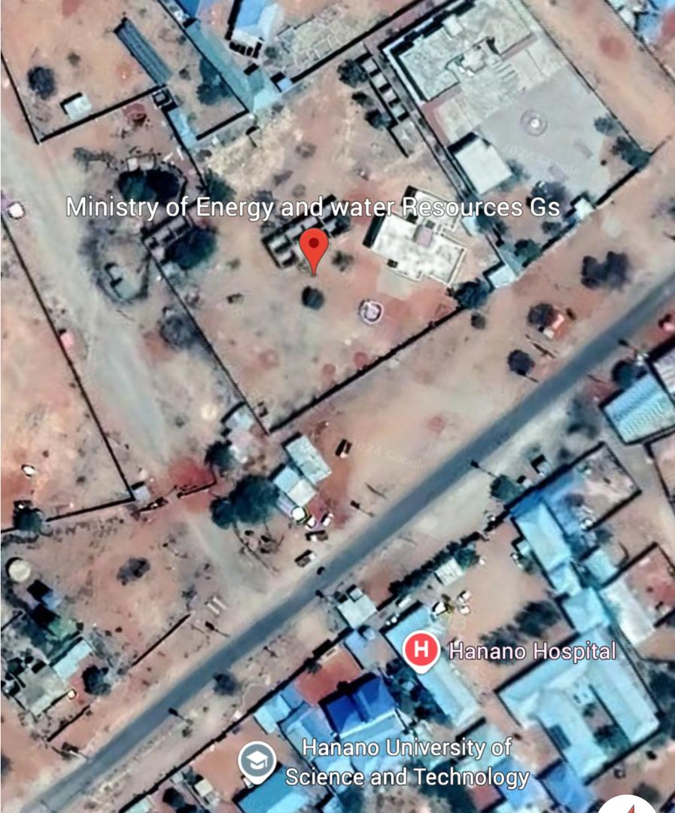

**Current Building Status Photos**

The building, constructed in the late 1970s, has an unknown roofing material, as it was likely lost during the civil war. The primary building material is concrete. Once demolished, the concrete debris will be taken to the landfill; It’s the contractors responsibility as PIUs will do an oversight monitoring.

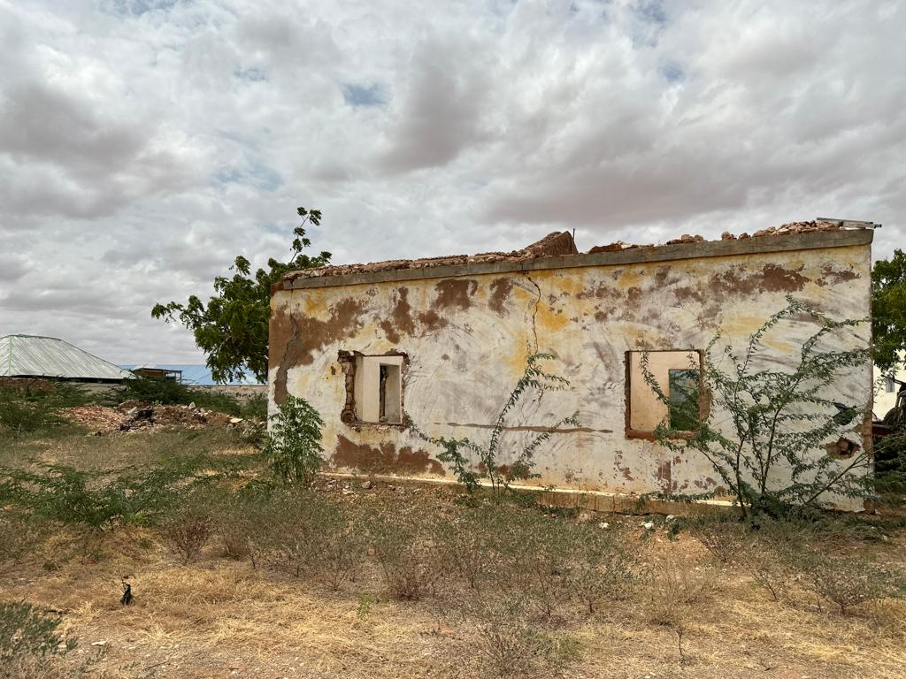

**PART A:** GENERAL PROJECT AND SITE INFORMATION

|  |  |  |  |
| --- | --- | --- | --- |
| **INSTITUTIONAL & ADMINISTRATIVE** | | | |
| Somalia/State | **Somalia –Galmudug State** | | |
| Project title | **Construction of the GW4R PIU Office-Galmudug** | | |
| Scope of project and activity | This project aims to establish a fully functional and well-equipped facility that will serve as a center for groundwater-related activities. The Office will be a G+1 concrete building, with the ground floor designed for housing the GW4R project team office rooms, and the office has two halls and five offices. | | |
| Institutional arrangements  (Name and contacts) | WB:  (Project Team Leader) | Project Management Unit  PIU – at Galmudug MOEWR at State level.  PIU – Galmudug MOEWR at State level.  Mohammed Abdurehman-Operation Manager Galmudug PIU Email: hanadsom@gmail.com | |
| Implementation arrangements  (Name and contacts) | The GW4R -PIU will oversee and coordinate the implementation of the project and will guide and train the PIU staff, as well as provide templates for reporting. | | Contactor TBD |
| **SITE DESCRIPTION** | | | |
| Name of the site | Ministry of Energy and Water resource of Galmudug State ( MoEWR ) | | |
| Describe site  location | The office construction is in the Ministry of Energy and Water Resource of Galmudug State Compound. The MoEWR is located in a government institutional area, surrounded by the Ministry of Planning to the north, the Parliament Building to the west, the Ministry of Fisheries to the south, and the main highway to the east.  GPS location: **5°31'54"N, 46°22'56"E** | | |
| Who owns the  land? | **Government Land/Ministry Energy and Water Resource of Galmudg’s Land Attached is the land certificate from the LG government's Public Works office. The Minister of Energy and Water Resources also approved the land offer, certifying that the land office will serve as a dedicated workspace for the GW4R project located within the Ministry of Energy and Water Resources in Dhuusamareeb.** | | |
| Description of geographic, physical, biological,  geological, hydrographic and socio-economic  context | **Current construction site:**  The land on which the construction site is located was previously vacant. The site previously housed old structures, likely offices, which will be demolished to make way for the new project.  **Local Climate:**  Site experiences a hot, arid climate with high temperatures, particularly during the dry season. Rainfall is highly variable and unpredictable, with periods of drought interspersed with short, intense rainfall events. The site is susceptible to extreme weather events, especially droughts.  **Biological Environment:**  **There are no significant plants and animal species present at the site of construction and the surrounding areas at the site.**  **Social and Environment:**  Has a diverse population with various ethnic groups. The primary economic activities in the region include livestock herding and trade, often disrupted by recurrent droughts and conflicts. Infrastructure in site is limited, with basic services like water supply, electricity, and sanitation being unreliable. Road networks are underdeveloped, especially in rural areas. | | |

|  |  |
| --- | --- |
|  | * There is no obvious presence of asbestos found on site. * It is the responsibility of the contractor to manage all generated Solid waste from the construction activities, and it should be dumping as per the standards. * Investigate potential salvaging on existing waste management on |

Site.

The Contractor will investigate, and PIU will monitor overall waste management during the demolition and construction phase process

|  |
| --- |
| * Access road is available |
| Locations and distance for material sourcing,  especially aggregates, water,  stones? | The contractor shall provide water and other construction materials. The contractor is obliged to comply with the WB standards and Somalia existing legal framework.  The contractor is obliged to safeguard the environment and public safety while sourcing the construction material such as Sand,  aggregates and stones, etc. |
| **LEGISLATION** | |
| Identify national & local legislation & permits that apply to project activity | 1. Somalia National Gender Policy (2016)ci 2. National Climate Change Policy, 2020 3. National Environmental Policy (2020) 4. The Federal Republic of Somalia Provisional Constitution, 2012 5. National Water Resource Strategy (2021 – 2025) 6. National Adaptation Programme of Action on Climate Change (NAPA) 2013 7. The Labour Code of 1972 8. The Somali Penal Code of 1962 9. The Urban Land Distribution Law of 1973 10. The Urban Land Distribution Law of 1973 11. Environmental Act Management FGS 12. Environmental Management Policy of FGS. 13. Environmental Impact Assessment Law of Somalia 14. Environmental Management Law in Somalia 15. Civil laws of FGS 16. Galmudug Water Law 17. Other laws by Ministries of Public works at Galmudug State. |
| Identify when / where the public consultation process took place | * During consultations with nearby shops and government offices adjacent to the Ministry of Water and Energy Resources (MOWER), as well as through separate meetings with women representatives and the PIU GBV specialist, participants provided valuable input and recommendations concerning potential E&S) impacts and mitigation measures during the office construction process. The discussions primarily focused on concerns related to noise generated during the demolition and construction phases of the site. Some of their suggestions included  1. Dust control: When demolishing some parts of the house, use local government-registered garbage collectors to clean up as soon as the garbage collected 2. Nose Management: Representatives from nearby shops and other government offices, as well as a representative from women's separate meetings, suggested reducing noise disturbance during daytime construction activities, and PIU MOEWR followed up on this matter during the work. 3. They requested additional information about the GW4R project, and the MOEWR Galmudug gave them an overview. MOEWR Galmudug also planning to hold regular consultations with the local community to inform them about the project and implementation process.   It was agreed during the consultation process to install clear signage and barriers around the construction site to ensure the safety of pedestrians and residents, especially when vehicles transporting construction materials are using the surrounding roads |
|  | The nearest GBV Service provider is Hanano Hospital approximately 500m away from the construction site which will serve as the primary GBV service provider for referral purposes in the location and surrounding areas in general   * Certainly, separate consultations were held with local women representatives in Dhusamareb as part of the consultation process facilitated by the PIU GBV specialist. The recommendations and suggestions from these consultations were carefully considered and incorporated into our overall design and construction plan. * In addition, nearby shops and other affected institutions, including government offices, were also consulted and considered for their suggestions and mitigation measures suggested. It is important to note that the ministry is situated in a government institutional area, which is distinct from the nearby residential neighborhoods. |

|  |  |
| --- | --- |
|  | * How will the project manage any physical damage risks during the site clearance and use of drilling equipment for demolition? * Labor risks with local contractors and how to mitigate them, etc. |
| **INSTITUTIONAL CAPACITY BUILDING** | |
| Will there be any capacity building? | [ ]N or [**X**]Y if Yes, Attachment 2 includes the capacity building program   1. Upcoming office construction 2. GW4R staff trainings |

**Part C: The potential risks and the mitigation measure**

|  |  |  |  |  |  |  |  |  |
| --- | --- | --- | --- | --- | --- | --- | --- | --- |
| **Associated Project Activity**  office | **E&S Risks and Impact** | **Mitigation Measures** | **Responsibility for implementation** | **Timing for mitigation** | **Monitoring Indicators** | **Mitigation Budget** | **Monitoring Responsibility** | **Monitoring Frequency** |
| **ESS 1: Environmental and Social Assessments** | | | | | | | | |
|  | **All E&S risks and impacts including those that arise during construction are minimized mitigated/compensated.** | **Measures outlined below are implemented and reported on and new issues through implementatation and monitoring are addressed and monthly reports submitted to the PIU** | **contractor** | **Throughout implementation** |  |  | **PIU** | **monthly** |
| **ESS1** | Risk of vegetation clearance | Avoid unnecessary clearance | Contractor/MOEWR | During the implementation/initial phase | Measures implemented | No additional cost | PIU | Weekly |
| HIV, disease transmission and other public health issues; | * Proactively identify clusters or increasing trends to investigate and address earlier. * Preventive measures should be taken against drugs on site | Contractor/ MOEWR | During the implementation | Measures implemented | No additional cost | PIU | periodic monitoring |
| **ESS 2: Labor and Working Conditions** | | | | | | | | |

12

|  |  |  |  |  |  |  |  |  |
| --- | --- | --- | --- | --- | --- | --- | --- | --- |
| **Associated Project Activity**  office | **E&S Risks and Impact** | **Mitigation Measures** | **Responsibility for implementation** | **Timing for mitigation** | **Monitoring Indicators** | **Mitigation Budget** | **Monitoring Responsibility** | **Monitoring Frequency** |
| Risks of child and forced labor | * Ensure that labor for the project will be sourced and managed responsibly including the set-up of a workers’ GRM. This includes strict age verification, fair employment practices, monitoring and reporting mechanisms, training and   compliance with labor laws. | PIU site supervisor | During implementation | * Labor register showing age and sex of persons engaged * Worker’s GRM   in place | 1000 | PIU | Weekly |
| Lack of occupational health and safety (OHS) for workers deployed at construction sites | * Provide necessary personal protective equipment (PPE) to all field officers as necessary * Training on use of PPE and accident prevention measures * Implement procedure of dealing with accidents and exposures * List of hours worked, recordable incidents and corresponding Root Cause Analysis | Contractor | During implementation | * PPE provided Training held * Incidents recorded * Lists of dates, number of trainees, and topics available | 1500 | PIU | Daily/ periodic visits from PIU |

13

|  |  |  |  |  |  |  |  |  |
| --- | --- | --- | --- | --- | --- | --- | --- | --- |
| **Associated Project Activity**  office | **E&S Risks and Impact** | **Mitigation Measures** | **Responsibility for implementation** | **Timing for mitigation** | **Monitoring Indicators** | **Mitigation Budget** | **Monitoring Responsibility** | **Monitoring Frequency** |
|  |  | * Develop and implement OHS Plan for workers. In addition, conduct safety risk assessment of work site and provide safety talk * Implement and monitor LMP in accordance to national law and   international standards |  |  |  |  |  |  |
| Delayed payment of workers or community workers leading to complaints and conflict | * Payment mechanism and timing should be communicated before contract signing of all workers. * Implement and monitor payment of workers * Communication / awareness campaign of payment mechanisms | Contractor/ PIU/  PIU’s site supervisor | During implementation | Record of appropriate measures taken | No additional costs | PIU/PIU | As and when occurs |
| Unfair recruitment practices | * Recruitment of workers should be objective and transparent with local employment and consideration for employment of vulnerable and marginalized groups where possible. |  |  |  |  |  |  |
| Poor working conditions: unsafe work environment due to large workforce | * Conduct safety risk assessment of work site/ sub-project and provide safety talks * Implement and monitor the LMP | PIU site supervisor | Before and during implementation | * A record of Safety Risk Assessment Reports * A record of safety talks conducted – as part of the OHS Plan * PPE provided * Lost time incidents or near miss incidents recorded * Training provided on OHS | No additional costs | PIU/PIU | Weekly |
| Activity includes a construction component with a work | Implement and monitor the LMP | PIU site supervisor | During implementation | Audit report available | No additional cost | PIU/PIU | Monthly |

14

|  |  |  |  |  |  |  |  |  |
| --- | --- | --- | --- | --- | --- | --- | --- | --- |
| **Associated Project Activity**  office | **E&S Risks and Impact** | **Mitigation Measures** | **Responsibility for implementation** | **Timing for mitigation** | **Monitoring Indicators** | **Mitigation Budget** | **Monitoring Responsibility** | **Monitoring Frequency** |
|  | force less than 100 workers per site.  Labor standards are not in accordance with national laws and international standards |  |  |  |  |  |  |  |
| Workers rights and obligations |  | All workers should have contracts stating their rights and obligations and sign the standard COC. |  |  |  |  |  |  |
| Worker complaints mechanism | Workers’ complaints are not addressed impartially. | All workers should have access to a trusted and impartial complaints mechanism for resolution of employment related complaints as well as the project complaints mechanism.  All workers should be oriented on the channels of the workers complaints mechanism and the project complaints mechanisms including the process for complaints resolution before contract signing.  The contractor should maintain an anonymised complaints log which should be available for inspection at all times by the PIU and provide to the PIU together with the monthly E&S report.  Allegations of Sexual exploitation, abuse, and sexual harassment between workers should be reported directly to the National GBV specialist through a devoted hotline. Should not be logged or investigated by anyone. Complainants should be directed to the following health, legal and psycho-social services: xxxx | Contractor | Before construction starts. | All complaints are logged, resolved impartially within 21 days and a summary report provided to the PIU every month. |  | PIU | Before construction starts and monthly |
| **ESS 3: Resource Efficiency and Pollution Prevention Management** | | | | | | | | |
| ESS3 | Generation of solid waste | * Appropriate designated areas for disposal of solid waste shall be identified consistent with the local and international requirements * Implement solid waste management plan for   construction and demolition waste | Contractor/ PIU site supervisor | During implementation | Record of actual sites | No additional cost | PIU/PIU | Monthly |
| Decreased air quality | * Construction contractors should operate only well maintained engines, vehicles, trucks and equipment.   A routine maintenance program for all equipment, vehicles, trucks and power generating engines should be in place. | PIU Site supervisor/ Environmental specialist | During implementation | * as part of the OHS Plan * PPE provided * Lost time incidents or near miss incidents recorded | No additional cost | PIU | Weekly |

15

|  |  |  |  |  |  |  |  |  |
| --- | --- | --- | --- | --- | --- | --- | --- | --- |
| **Associated Project Activity**  office | **E&S Risks and Impact** | **Mitigation Measures** | **Responsibility for implementation** | **Timing for mitigation** | **Monitoring Indicators** | **Mitigation Budget** | **Monitoring Responsibility** | **Monitoring Frequency** |
|  |  | * The contractor must ensure the use of good quality fuel and lubricants. * Limited wetting of sites especially during dry season. * Contractors should provide protection gears to the construction workers |  |  | Training provided on OHS |  |  |  |
| Risks of Chlorine fumes present in the site | * Before construction begun, the proper storage and fencing of chlorine powder must ensured | MOEWR/PIU | During the implementation  /first phase | Measures implemented | No additional cost | PIU | Weekly |
| Generation of dust and noise  Increased levels of vibration from construction machinery | * Resource efficiency pollution control measures will be analysed and incorporated. * Selecting equipment with lower noise emissions * Routine maintenance of the vehicles to reduce noise and air pollution * Installing suitable mufflers on engine exhausts and compressor components | Contractor | During implementation | Measures implemented | No additional cost | PIU | Weekly |

16

|  |  |  |  |  |  |  |  |  |
| --- | --- | --- | --- | --- | --- | --- | --- | --- |
| **Associated Project Activity**  office | **E&S Risks and Impact** | **Mitigation Measures** | **Responsibility for implementation** | **Timing for mitigation** | **Monitoring Indicators** | **Mitigation Budget** | **Monitoring Responsibility** | **Monitoring Frequency** |
|  | Project to produce air pollution | * Installing acoustic enclosures for equipment casing * Planning activities in consultation with local communities so that activities with the greatest potential to generate noise are planned during periods of the day that will result in least disturbance * Provisional and use of appropriate PPE |  |  |  |  |  |  |
| **ESS 4: Community Health and Safety** | | | | | | | | |
| ESS4 | Increased GBV/SEAH cases | * Implement SEA/SH prevention and response action plan including the accountability and response framework * Impacts of labor influx driven by the small-medium scale infrastructure works will be managed by the LMP, including a code of conduct for project workers. * All workers should be oriented that SEA/SH will not be tolerated in any form with severe sanctions to themselves and the project. * Promote nonviolent work environment where GBV /SEA/SH is unacceptable * Allegations of Sexual exploitation, abuse, and sexual harassment between workers should be reported directly to the National GBV specialist through a devoted hotline. Should not be logged or investigated by anyone. Complainants should be directed to the following health, legal and psycho-social services: * Hanano Hospital approximately 500m away from the construction site which will serve as the primary GBV service provider * Galgaduud General Hospital around 800m from the Ministry compound and serves as the major GBV service provider in Dhusamareeb and surrounding villages. * The Dhuusamareeb Police Station is located approximately 1 km from the north Ministry, providing justice services and criminal investigations for Dhuusamareeb and its surrounding areas. * xxxx * Arrange enough and suitable toilet and washing facilities, separate from men and women workers. | Contractor / PIU | During implementation | * Successful implementation of agreed SEA/SH Prevention and Response Action Plan * Audit report in place * Records in place | No additional cost | PIU/ PIU | Monthly |
| Exposure of community members to physical hazards on the project site, including unauthorized access | * Undertake safety precautions to address safety hazards for the nearby community, including, safety/warning signage, safety barrier around the construction site, and safe driving practices | Contractor | Prior to and during implementation | Records to show community sensitization on safety, in place |  | PIU/PIU | Prior to start of works, monthly during implementati on |

17

|  |  |  |  |  |  |  |  |  |
| --- | --- | --- | --- | --- | --- | --- | --- | --- |
| **Associated Project Activity**  office | **E&S Risks and Impact** | **Mitigation Measures** | **Responsibility for implementation** | **Timing for mitigation** | **Monitoring Indicators** | **Mitigation Budget** | **Monitoring Responsibility** | **Monitoring Frequency** |
|  | Traffic and road safety hazards | * Safety barrier around the construction site and safe driving practices * Informing public about potential construction risks * Safe driving practices | Contractor | During implementation | * Safety warning signs in place * Traffic management plan in place * Training for road workers on risks conducted * GRM in place |  | PIU/PIU | Whenever there is work onsite |
| Debris removal that may pose a safety hazard for the community | Implement and monitor waste management procedures based on World Bank Group Environmental, Health, and Safety General Guidelines. This would include sorting and segregating, proper handling and disposal, and health and safety measures | Contractor | During implementation | * Waste management procedure in place * Records of amount of waste disposed available | No additional cost | PIU/PIU | Weekly |
|  | Exposure of community members to disturbance | Implementing the whole activities in day time and limit the vehicle movements | Contractor |  | Measures implemented | No additional cost | PIU | Daily/weekly |
| **ESS 5: Land Acquisition, Restrictions on Land Use and Involuntary Resettlement** | | | | | | | | |
|  | Blocked access to people in the area | Ensure that the local routes, drainage and community access are not blocked by construction  Any damage to property or assets as a result of the project must be rectified by the contractor | Contractor | During implementation | Zero complaint on blocked access to people in the area | No additional cost | PIU/PIU | Weekly |

|  |  |  |  |  |  |  |  |  |
| --- | --- | --- | --- | --- | --- | --- | --- | --- |
| **Associated Project Activity**  office | **E&S Risks and Impact** | **Mitigation Measures** | **Responsibility for implementation** | **Timing for mitigation** | **Monitoring Indicators** | **Mitigation Budget** | **Monitoring Responsibility** | **Monitoring Frequency** |
| **ESS5** | Economic or physical displacement of indviduals due to construction including squatter and hawkers | Any economic or physical displacement should be immediately reported to the PIU and be mitigated and compensated so no one is left worse off. | Contractor | Before construction |  |  |  |  |
| **ESS 10: Stakeholder Engagement and Information Disclosure** | | | | | | | | |

18

|  |  |  |  |  |  |  |  |  |
| --- | --- | --- | --- | --- | --- | --- | --- | --- |
| **Associated Project Activity**  office | **E&S Risks and Impact** | **Mitigation Measures** | **Responsibility for implementation** | **Timing for mitigation** | **Monitoring Indicators** | **Mitigation Budget** | **Monitoring Responsibility** | **Monitoring Frequency** |
| **ESS10** | Inadequate, ineffective, and inappropriate stakeholder and community engagements and disclosure of information can lead to the exclusion of truly vulnerable, marginalized and minority members of the community from project benefits, amplified by the context of limited resources against widespread need | * All groups potentially affected by the constructed should be consulted on potential environmental and social impacts and mitigation measures.Conduct additional community consultations as necessary | PIU/ MOEWR/ PIU | Before Implementation and ongoing | That community are satisfied with construction and no one is left worse off by the project. | No additional cost | PIU | Monthly |
| Poor access to beneficiaries leads to less meaningful community engagements and difficulty in monitoring for social harm | GM posters showing local contacts should be displayed at site.  Contractor should maintain a log of complaints and resolution. SEAH complaints should be directed to the FMS or national GBV focal point. Implementation and monitoring of GRM | Contractor | Prior to and during implementation | GM contacts displatyed at all times at the site  Anonymised GM log maintained by the contractor and shared with the PIU every month.  Complaints resolved impartially and satisfactorily within 21 days  To date, no GM cases related to the GW4R PIU in Galmudug have been received | No additional cost | PIU/PIU | Weekly |

****

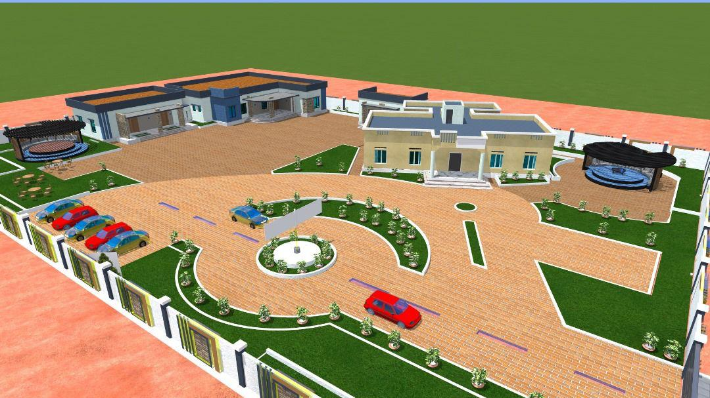

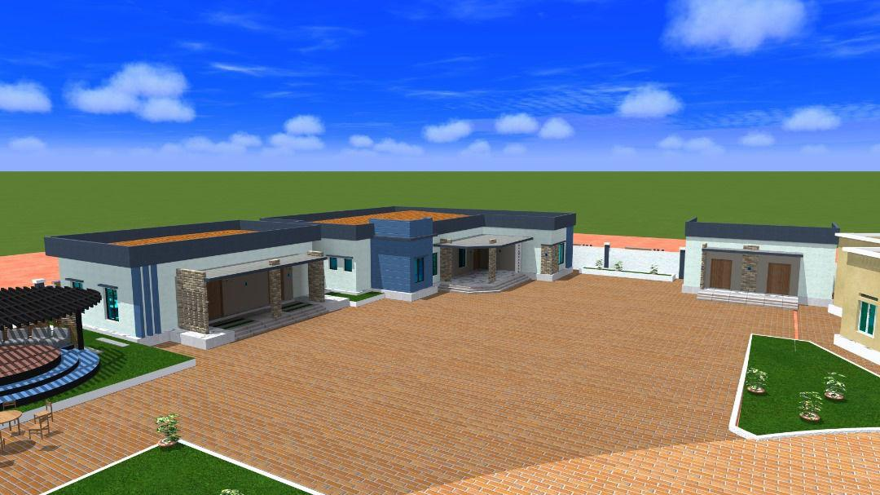

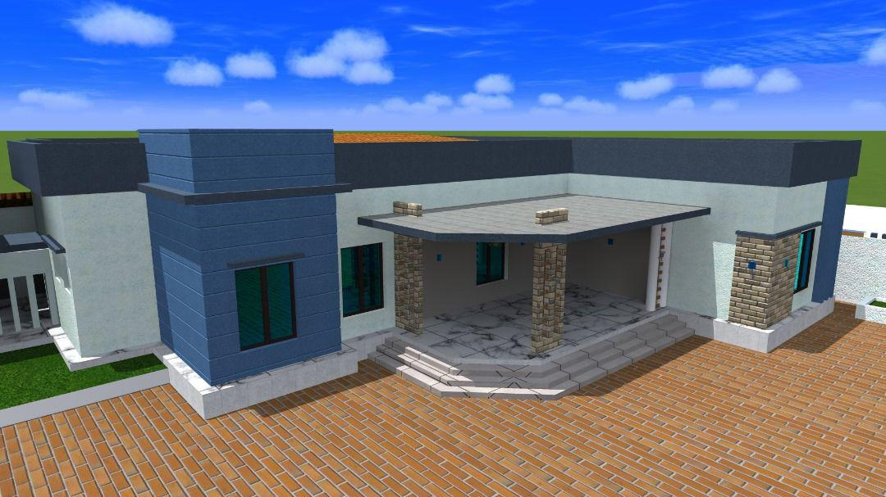

**Annex 2. minutes of public consultation**

The Ministry of Energy and Water Resources (MEWR) is tasked with overseeing and managing the energy and water sectors in Somalia. MEWR's mandate involves a comprehensive set of responsibilities aimed at ensuring the sustainable and efficient utilization of energy and water resources for the benefit of the country. This includes the development and implementation of policies and strategies to optimize energy production, distribution and consumption, as well as the responsible management of water resources. MEWR plays a crucial role in fostering sustainable development practices by promoting the responsible use of energy and water, addressing issues related to resource scarcity, and ensuring the equitable distribution of these essential resources. The ministry is committed to balancing the needs of the present population whilesafeguardingtheavailabilityofenergyandwaterforfuturegenerations. The severe damage to the Ministry of Energy and Water Resources (MEWR) building, notably the compromised roof, necessitates urgent rehabilitation for several crucial reasons. Firstly, the structural integrity and safety of the building are at risk, making it imperative to address the damage promptly to safeguard the well-being of employees and visitors. Secondly, the rehabilitation effort is crucial for preserving valuable assets housed within the ministry, including important documents, equipment and technology. Neglecting the rehabilitation may lead to further deterioration of these assets. Additionally, a rehabilitated building ensures the continuity of the ministry's operations, promoting a safe and comfortable work environment for employees and contributing to public confidence in the ministry's ability to fulfill its mandate effectively. The damaged roof poses a significant threat to the operational continuity of MEWR, potentially impeding the normal functioning of the ministry, by addressing this issue, the rehabilitation contributes to restoring normalcy and maintaining service delivery to the public. Furthermore, neglecting the rehabilitation could leadto more extensive problems over time, with water leaks and exposure to the elements causing additional damage to the building's structure and interior. Timely rehabilitation not only prevents further damage but also brings the building into compliance with safety and construction standards, ensuring the ministry operates within legal frameworks.

Site GPS and Map.

|  |  |  |
| --- | --- | --- |
| **Latitude** | **Longitude** | **Elevation** |
| **5°31'54**"N | **46°22'56"E** | 315m |

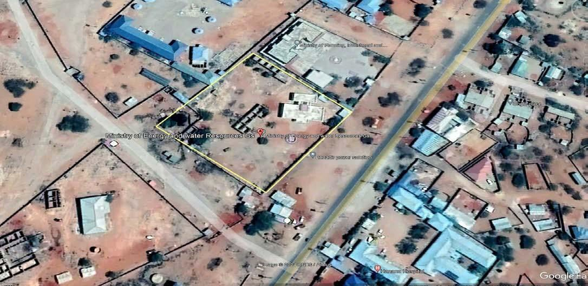

18



**Meeting Minute**s

Stakeholder Engagement on the Environmental and Social Management Plan (ESMP) for the Rehabilitation of Ministry of Energy and Water Resources in Galmudug Line Ministries

**Date: 05-Feb-2024**

Venue: Ministry of Energy and Water Resource Meeting Hall, Dhusamareb

Objective & Approach

The consultation aimed to engage various stakeholders and institutions potentially impacted by the rehabilitation office construction of the Ministry of Water, ensuring comprehensive engagement. Attendees included staff from neighboring institutions such as the Ministry of Planning, Office of the Galmudug Parliament, and Ministry of Fisheries & Marine Resources, as well as nearby shop owners, and separate women's meetings were conducted. Held on February 5, 2024, the consultation sought to underscore the importance of effective stakeholder engagement in enhancing the environmental and social, and GBV sustainability of the project and fostering project acceptance.

* **During the separate women's meeting, participants recommended incorporating dedicated women's facilities into the design and construction plan. We carefully considered their suggestions and ensured that the final plan adequately included these facilities.**
* **The MOEWR GBV Specialist from the PIU, the HR Officer, and representatives from the rural water sector were also actively involved in the consultation process. They contributed valuable suggestions to ensure that the design adequately includes facilities for women. Additionally, the MOEWR Galmudug emphasized the importance of providing equal services and facilities for both women and men.**
* **Female representatives from the nearby shops were also included in the meeting, where they provided recommendations and suggestions, as well as mitigation measures**.

**Meeting Participants:**

|  |  |  |
| --- | --- | --- |
| **S/N** | **Name of participants** | **Title** |
| **1** | Mohammed Abdurehman | Operation Manager |
| **2** | Mohamed Abdikarim Shidane | Environment Specialist |
| **3** | Fadumo Abdullahi Elmi | GBV Specialist |
| **4** | Yusuf Mohamud Mohamed | Social Safeguard Specialist |
| **5** | Eng Mohamed Abdullahi Ali | Groundwater Project Engineer |
| **6** | Abdulkadir Ibrahim Ahmed | M&E Specialist |
| **7** | Abshir Mohamed Nor | Representative from the ministry of planning |
| **8** | Malyun Said Xoor | Office of Galmudug Parliament |
| **9** | Ahmed Hassan Farah | Ministry of Fisheries & Marine Resources |
| **10** | Ibrahim Abdulkadir Mohamed | DG MoEWR |
| **11** | Abdulkadir Abdullahi Mohamed | Director of Water |
| **12** | Abdikarim Moalim Ali | Wash Unit |
| **13** | Haboon Mohamed Hassan | HR Officer |
| **14** | Muno Abdi Ali | Rural Water Officer |
| **15** | Ahmed Abdinoor Abdullahi | M&E Officer |
| **16** | Caydiid Abdulkadir Yusuf | IT Officer |
| **17** | Asho Nor Elmi | Representative from Shop Owners |

**Presentation on ESMP**

Mohamed Abdikarim, Environmental Safeguard Specialist for the GW4R Project, delivered a concise overview of the Environmental and Social Management Plan (ESMP). He outlined potential project risks and proposed mitigation measures, stressing the necessity of analyzing and incorporating efficient pollution control measures. Additionally, Mr. Mohamed highlighted the significance of selecting equipment with lower noise emissions and implementing routine vehicle maintenance to mitigate noise and air pollution. In the presence of engineers, he underscored the importance of scheduling activities with high disturbance potential during periods of minimal impact. Throughout the meeting the safeguards team explained ESS1, ESS2, ESS4, and ESS5 to the participants.

19

**Stakeholder Engagement**

Representatives from the Ministry of Water expressed gratitude to the GW4R safeguard team for organizing the meeting and facilitating consultation, emphasizing its importance in addressing their concerns. Thirteen members from neighboring communities participated, expressing their concerns and ideas regarding the rehabilitation project. The Director of Public Works of the Dhusamareb administration pledged support, affirming the administration's commitment to collaborate with the Barwaqo project in supporting various institutions within the Galmudug state. The Director-General from the Ministry also expressed readiness to engage and highlighted the potentiality of the meeting.

**Community Readiness**

**Stakeholder representatives, including nearby shop owners and separate women meeting was conducted during the consultation process, emphasizing the importance of fully implementing the environmental and social management plan and GBV/SEAH to mitigate all negative impacts during the implementation phase. The meeting concluded with a commitment from all participants.**

**GBV Awareness**

**Two consultation meetings were held during office construction consultation process at the MOEWR Galmudug compound. The first meeting included participation from the PIU, local shop owners, and representatives from government offices. Additionally, a separate session for women took place on February 5th, involving nine local women and staff from the Ministry of Energy and Water Resources of Galmudug State. The total number of participants from the ministry staff, including the GW4R PIU, was 13 members. Below are the summarized suggestions and mitigation measures suggested?**

* **Ensuring that women's facilities are prioritized in the design phase of the construction process**
* **Women participated in the consultation and decision-making process of office construction, which was achieved during the office design process.**
* **The mitigation measures suggested by women representatives were that GBV response service is available in the areas should be aware and communicated whenever GBV cases are received**
* **The PIU GBV focal point who can provide support to PIU and MOEWR Galmudug.**
* **Regular consultation of women leading by the PIU GBV and those around the ministry compound as well as nearby offices**
* **Scheduling work hours, Limiting or giving notice of construction activities to specific hours to minimize disturbances.**
* **To educate the community about potential GBV risks and preventive measures**
* **To have sufficient female facilities in the new office construction, such a separate female washroom**
* **Guidance for construction activities to minimize hazards to nearby shops.**
* **Clear GM process for nearby shops to report concerns or incidents related to construction activities, ensuring timely responses.**
* **To Schedule meetings between women representatives and district GBV service providers during or after construction process. These meetings will serve as a platform to discuss the available services, allowing participants to provide their input and suggestions on how these services can be improved to better meet the needs of the community, particularly women**
* **As planned with the support national GBV specialist will be organized orientations on GBV service providers and what to do in case of SEAH for local SEAH service.**
* **They have suggested organizing workshops to educate community members about SEAH, and GBV-related cases, the case of SEAH and the local SEA services providers**
* **PIU GBV focal point has taken and assigned the follow-up role with the support of the project leadership and NPCU GBV specialist**
* **During the consultation with female representatives, it was proposed and agreed to include orientations and, if possible, to organize a workshop at the nearest GBV service providers, such as Hanano Hospital, Galgaduud General Hospital, and Dhuusamareeb Police Station.**

**To emphasize the importance of GIBV risk awareness, and to continue to hold these awareness sessions.**

**Women meeting Photos**

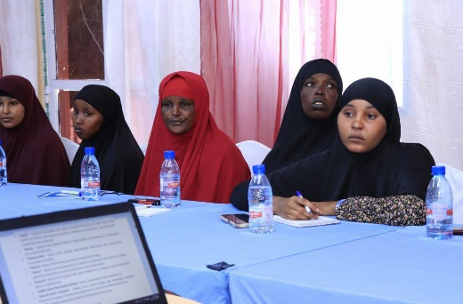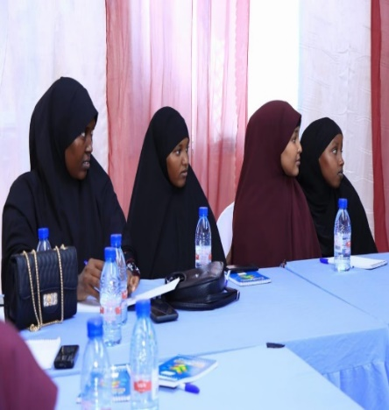

**GM Contacts and awareness raising**

Galmudug has the following FMS GW4R GM and GBV emails,

* GM Email: [gm.gw4r.grm@gmail.com](mailto:gm.gw4r.grm@gmail.com" \t "_blank)
* GBV Email: gm.gw4r.gbv@gmail.com

|  |  |  |
| --- | --- | --- |
| **GW4R GRM & GBV EMAILS** | **LOCATION** | **REMARKS** |
| **E-mails** | **Category** | **State** |
| gm.gw4r.grm@gmail.com | Main GRM email | State Level |
| gm.gw4r.gbv@gmail.com | GBV/SEAH complaints | **State Level** |
| **HOTLINE NUMBER (FREE)** | **9992** | **National Level** |
|  |  | The free hotline number functions within 24 hours of the Project |

These emails are managed by the PIU Social Safeguard and GBV specialists of the Ministry. Any complaints related to the Galmudug GW4R project issues will be handled and registered according to GM procedures and regulations.

Additionally, Galmudug MOEWR plans to establish a state-level toll-free number for stakeholders and individuals with complaints to contact. Until this toll-free line is operational, clients will be able to access the national toll-free number at the FGs level (9992).

**GM Awareness Raising**

1. ***An accessible and functional grievance mechanism is*** important in addressing community or stakeholder concerns as well as receiving ***feedback on a project so that it can be improved***. It is a requirement for all World Bank projects and the responsibility of all project staff, any of whom may receive the grievance.
2. It is ***preferable that grievances are resolved in person at the lowest level***, however, different levels and channels of registering grievances should be available so that ***even the most marginalized person feels comfortable raising a grievance. GBV/SEAH-related complaints should be referred immediately to the GBV focal points at FMS or FGS level.***
3. Grievances should be dealt with ***confidentially, on a need-to-know basis only, and without fear of backlash.***
4. Grievances can be raised by ***community members, workers, and other stakeholders*** concerning project implementation including adverse social or environmental impacts, misuse of funds; staff behavior, workers’ conditions or safety, quality of service issues, sexual exploitation and abuse, forced or child labor etc.
5. **Confidentiality and timelines:** Grievances can be submitted anonymously by any complainant, and personal data should be anonymized for all complainants who raise GBV issues. Grievances will be ***acknowledged within a week (7 days) of receipt and resolved if possible, within 21 days including feedback to the complainant.*** The complaint will be addressed as fully and precisely as possible focusing on specific facts and events, ***showing understanding and never dismissing or belittling a complaint.***
6. **Cases of GBV/SEAH:** Such cases will be only handled by GBV focal points trained in survivor-centric complaints handling and treated with ***utmost confidence, respect, and empathy and managed in line with the complainants’ express wishes,*** including whether the complaint is registered and referred. The complaint will be anomymised, indicating a reference number rather than the name of the complainant.
7. Project fully assumes a survivor-centered approach, no information can be passed on without the survivor’s consent.

**Code of Conduct Obligations of the Project Contractors**

Under the Horn of Africa Groundwater for Resilience Projectfailure to follow Environmental, Social and healthy Safety **(ESHS)** and Occupational and healthy Safety Standards **(OHS), or** partaking in **GBV or VAC** activities, constitutes acts of gross misconduct and is therefore grounds for sanctions, penalties, or potential termination of employment. Prosecution of those who commit Sexual harassment **(SH)** or Sexual Exploitation, Abuse and Harassment **(SEAH)** or other types of GBV, or Violence against children **(VAC)** may be pursued if appropriate.

I,\_\_\_\_\_\_\_\_\_\_\_\_\_\_\_\_\_\_\_\_\_\_\_\_\_\_\_\_\_\_\_\_\_\_\_\_\_\_\_\_\_\_\_\_\_acknowledge that adhering to environmental, social, health and safety (ESHS) standards, following the project’s occupational health and safety **(OHS)** requirements, and preventing gender-based violence **(GBV) ESHS (VAC)** is important. All forms of **GBV or VAC** are unacceptable in the workplace or when interacting with communities.

Under the Horn of Africa Groundwater for Resilience Projectfailure to follow Environmental, Social and healthy Safety **(ESHS)** and Occupational and healthy Safety Standards **(OHS), or** partaking in **GBV or VAC** activities, constitutes acts of gross misconduct and is therefore grounds for sanctions, penalties, or potential termination of employment. Prosecution of those who commit Sexual harassment **(SH)** or Sexual Exploitation, Abuse and Harassment **(SEAH)** or other types of GBV, or Violence against children **(VAC)** may be pursued if appropriate.

**I agree that while working on the Project I will:**

1. Attend an orientation training session related **to ESHS, OHS, HIV/AIDS, GBV and VAC as** requested by my employer.
2. Follow my employers’ guidance on prevention of the spread of infectious diseases.
3. Follow my employers’ guidance on security and safety including not causing conflict or exposing myself, other colleagues, stakeholders including community members, project facilities or assets to risks.
4. Treat women, children (persons under the age of 18), and men with respect regardless of race, color, language, religion, political or other opinion, national, ethnic or social origin, property, disability, birth or other status.
5. Not use language or behavior towards women, children or men that is inappropriate, harassing, abusive, sexually provocative, demeaning or culturally inappropriate.
6. Not participate in sexual contact or activity with children (anyone age 18 or under)– including grooming or contact through digital media. Mistaken belief regarding the age of a child is not a defense. Consent from the child is also not a defense or excuse.
7. Not engage in any form of sexual harassment to a co-worker - for instance, making unwelcome sexual advances, requests for sexual favors, and other verbal or physical conduct, of a sexual nature, including subtle acts of such behavior e.g., looking somebody up and down; kissing, howling or smacking sounds; hanging around somebody; whistling and catcalls; giving personal gifts; making comments about somebody’s sex life etc. Sexual harassment constitutes acts of serious misconduct and are therefore grounds for disciplinary measures, including summary dismissal
8. Not engage in any form of sexual exploitation or abuse – for instance, exchanging money, employment, goods or services for sex or sexual favors, or making promises or favorable treatment dependent on sexual acts – or other forms of humiliating, degrading or exploitative behavior. This includes any project-related assistance due to community members. Sexual exploitation and sexual abuse constitute acts of serious misconduct and are therefore grounds for disciplinary measures, including summary dismissal.
9. Report through the Reporting Mechanism to any suspected or actual GBV or VAC to company management and employer, or any breaches of this Code of Conduct.

The standards set out above are not intended to be an exhaustive list. Other types of sexually exploitive or sexually abusive behavior may be grounds for administrative action.

With regard to children under the age of 18, I will:

1. Wherever possible, ensure that another adult is present when working in the proximity of children.
2. Not invite unaccompanied children unrelated to my family into my home, unless they are at immediate risk of injury or in physical danger.
3. Not use any computers, mobile phones, video and digital cameras to exploit or harass children or access child pornographic material (see also “Use of children's images for work related purposes” below).
4. Refrain from physical punishment or discipline of children.
5. Refrain from hiring children for domestic or other labor which is inappropriate given their age or developmental stage, or places them at significant risk of injury.
6. Comply with all relevant local legislation, including Somali national labor laws in relation to child labor.

Use of children’s images for work related purposes

When photographing or filming a child for work related purposes, I will:

1. Before photographing or filming a child, assess and endeavor to comply with local traditions or restrictions for reproducing personal images;
2. Before photographing or filming a child, obtain informed consent from the child and a parent or guardian of the child. As part of this, I must explain how the photograph or film will be used;
3. Ensure photographs, films and videos present children in a dignified and respectful manner and not in a vulnerable or submissive manner. Children should be adequately clothed and not be seen as sexually suggestive;
4. Ensure images are honest representations of the context and the facts; and
5. Ensure file labels do not reveal identifying information about a child when sending images electronically.



# Summary report for building rehabilitation for GW4R projects (max 5 pages). Please annex ESIA/ESMP, voluntary land donation/agreement documentation, community meeting minutes

**Proposed sub-project: Construction of: PIU Office at MOEWR Compound Dhusamareb-Galmudug –Somalia**

## Overview of the project location and key features within 400m of works (to understand impacts)

The head quarter of Ministry of Energy and Water Resource of Galmudug State has a blank space/plot planned to be construct any building extensions as per requirements. Therefore, construction of new PIU Office is to be built at the Ministry Compound.

## Current use or occupation of the building:

|  |  |  |  |  |
| --- | --- | --- | --- | --- |
| **Describe use of building (include for residence, livelihoods, other purposes e.g. school, health centre, community meeting place)** | **No of individuals resident or regularly using the building/plot** | | | **Proposed design of new Office Construction** |
| This building is planned to be constructed at Ministry compound | There is no any individual | inhabitant | the | This design has been proposed by PIU with the |
| owned by ministry and there was no any external residence living | construction planned space |  |  | help of Ministry Engineer’s consultation, NPCU and WB review |
| in the compound in Dhuusamarebtown. |  |  |  |  |
| Construction of new PIU Office had been designed to be a |  |  |  |  |
| multipurpose building, such as: administrative offices, a well- |  |  |  |  |
| Furnished conference hall, and modern sanitary facilities for PIU Staff |  |  |  |  |
| Its strategic location within the MOEWR |  |  |  |  |
| compound ensures seamless coordination and collaboration with |  |  |  |  |
| other departments, fostering efficient decision-making and project |  |  |  |  |
| implementation. |  |  |  |  |

## Has there been any conflict over the ownership or use of this building in the past? If so please describe, what measures the project will take to ensure that it does not exacerbate conflict. This Plot belongs MOEWR there is no any resident families inside or around the building

## Consultations with the community on the sub-project (to ensure broad agreement, ownership and risk identification and mitigation)

|  |  |  |  |  |  |  |  |  |
| --- | --- | --- | --- | --- | --- | --- | --- | --- |
|  | **Date** | **Village** | **Total number of people involved** | **No. of women** | **No. of youth** | **No. of minority group or IDP representative**  **s (please** | **Main concerns raised and how they will be addressed** | **Challenges in consulting with people**  **e.g. migration, conflicting** |

|  |  |  |  |  |  |  |  |  |
| --- | --- | --- | --- | --- | --- | --- | --- | --- |
|  |  |  |  |  |  | **specify group/s)** |  | **event, insecurity** |
| **Initial discussions**  **Second discussions** | 05/02/2024 | Ministry meeting Hall | 17 including the PIU & Representatives from the Ministries of Planning, fisheries, Galmudug Parliament and new shop owners  Nine female members from the district, along with representatives from nearby shops and government offices such as the Ministry of Planning, Fisheries, the Office of the Parliament, and MOEWR PIU GBV focal person participated in a separate women's meeting at the MOEWR Galmudug compound.  They discussed the status and women facilities in the design women of the MOEWR office construction and provided their input on GBV risks and mitigation measures. | 5 members  9 members |  | N/A | No Major issues raised during the discussions | There was major challenge |
|  |  |  |  |  |  |  |  |  |

|  |  |  |  |  |  |  |  |  |
| --- | --- | --- | --- | --- | --- | --- | --- | --- |
| **Other – meetings (specify)** |  |  |  |  |  |  |  |  |

## Environmental and social impacts and mitigation measures identified by the community (only put those not captured in the contractors ESMP)

|  |  |  |  |  |
| --- | --- | --- | --- | --- |
| **Social and environmental impacts of sub-project** | **Mitigation measures** | **Costing** | **Time frame** | **Responsible agency** |
| There is any old testing well nearby the site which need to be aware off | Should carefully handle the demolishing activities | It was  included in  Bill of  Quantity | Monitoring with the demolishing and construction works | Contractor with the Environmental and Social team guidance |
| There are no surrounding schools, and the nearest Hospital is around 500m from the construction site and located the other side of the main highway | Implement specific construction hours to avoid peak noise-sensitive times, like early mornings or late evenings | None | This should be fed back to the stakeholders who raised the concern and monitored | Contractor with the Environmental and Social team guidance |
| Stakeholders have expressed minimal concerns as most construction activities are taking place within the Ministry compound. To minimize disruptions to neighboring government institutions, it is advisable to limit construction work during standard business hours. These buildings are typically unoccupied outside of working hours | Activities of the construction will take place inside the compound of the Ministry and no feasible damage to the other buildings | None | This should be fed back to the stakeholders who raised the concern | MOEWR |
| Risk of SEAH by construction workers to women working in the office compound. | All construction workers will be oriented on zero tolerance of SEAH and monitored carefully | None | Before construction started | GBV/gender officer |
|  |  |  |  |  |
|  |  |  |  |  |

## Has a safeguards field visit been undertaken to the site? Y/N Date of visit: --YES\_Title of visiting officer PIU Galmudug

1. **Ownership of building for construction and maintenance?**

|  |  |  |
| --- | --- | --- |
| **a. Government** | Title deed/confirmation document attached? | YES/NO/EXPLANATION  **Yes** |
| **b. Community** | Community agreement on future use of building and maintenance responsibility? | YES/NO/EXPLANATION  **No** |
| **c. Private** | Donation form and agreement by government officials? | YES/NO/EXPLANATION  **No** |

## GRM: Has the GRM process and contact information for focal points **been disseminated to the community? If so, how and to whom (numbers and groups). If not, when will this be done?**

## During the office/site construction consultation process, participants were provided with the GRM protocols and procedures for the project/ministry, including GM contact details and information on raising awareness about GM. The Galmudug PIU, under the leadership of the Operations Manager, has assumed responsibility for monitoring and following up on this matte

## GBV/SEAH: Has awareness been carried out on GBV, service providers and confidential survivor centric GBV complaints mechanism? If so, how and to whom (numbers and groups). If not, when will this be done?

## During the consultation with female representatives, it was suggested to include orientations and, if feasible, to organize a workshop at nearby GBV service providers, such as Hanano Hospital, Galgaduud General Hospital, and the Dhuusamareeb Police Station.To emphasize the importance of GBV risk awareness, PIU Galmudug will organize these awareness sessions throughout and after the office construction process.

## Sustainable management: Who will manage and maintain the sub-project, and how will repairs be funded?

## The Office will be handed over to the Ministry as the PIU Office to run GW4R project. Thus, it is the Ministry's responsibility to maintain and repair the building

## Describe the nearest GBV service providers for health, psycho-social and legal support (to inform the site supervisor and stakeholder in the area):

## The nearest GBV service providers for the construction of PIU Office activities, are number of cooperative institutions such as:

## Hanano Hospital approximately 500m away from the construction site which will serve as the primary GBV service provider

## Galgaduud General Hospital around 800m from the Ministry compound and serves as the major GBV service provider in Dhusamareeb and surrounding villages.

## The Dhuusamareeb Police Station is located approximately 1 km from the north Ministry, providing justice services and criminal investigations for Dhuusamareeb and its surrounding areas.